CORSICA Collaborative Outline
Red Team
Old Dominion University
August 29th, 2014
CS 411 Lab 1

Table of Contents

1 INTRODUCTION (PATRICK)...................................................................................... 3

2 CORSICA PRODUCT DESCRIPTION (NICK).......................................................... 4

2.1 Key Product Features and Capabilities (NICK)................................................ 5

2.2 Major Components (Hardware/Software) (LATIMER).................................. 6

3 IDENTIFICATION OF CASE STUDY (LATIMER).................................................. 8

4 CORSICA PRODUCT PROTOTYPE DESCRIPTION (TONY).............................. 9

4.1 Prototype Architecture (Hardware/Software) (TONY).................................. 10

4.2 Prototype Features and Capabilities (BITASEME)........................................ 14

4.3 Prototype Development Challenges (LOOKMAI).......................................... 17

Glossary……………………………………………………………………………….……….. 19

References……………………………………………………………………………….…….. 21

Figures

Figure 1 - Hardware Components…………………………………………...…………...…. 7

Figure 2 - Real World Product and Prototype Comparison…………………...…………. 10

Figure 3 - Major Functional Components Diagram……………………………...……..… 11

Figure 4 - Description of Algorithms…………………………..………………………..…. 12

Figure 5 - Risk Table and Matrix……….……………………………...………….……..... 16

Figure 6 - Prototype Challenges………………………………………...………….……..... 17

CS 411W LAB I - PRODUCT DESCRIPTION DOCUMENT

1 INTRODUCTION

2 CORSICA PRODUCT DESCRIPTION

2.1 Key Product Features and Capabilities

2.2 Major Components (Hardware/Software)
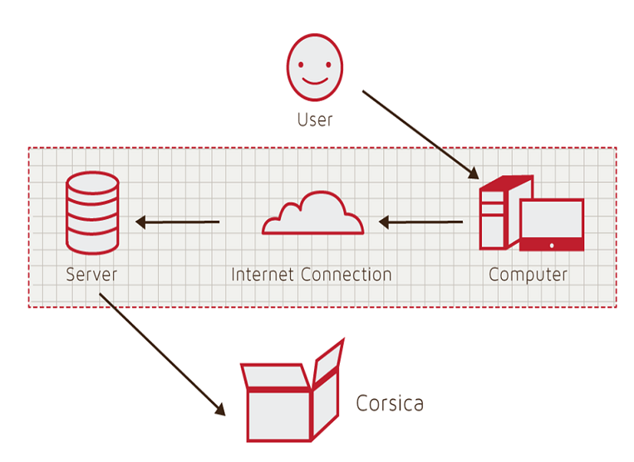
Figure 1
Hardware Components

3 IDENTIFICATION OF CASE STUDY

4 CORSICA PRODUCT PROTOTYPE DESCRIPTION

 | Real World Product | Prototype
Environments for all Users: | Yes | No  · Will demonstrate student, admin, and scheduler users
Notification System | Yes | No  · Will be simulated with text box
Check for available seats | Yes | Yes
Add Student to Wait-list | Yes | Yes
Drop Student from Wait-list | Yes | Yes
Fair process | Yes | Yes
Alert System | Yes | No  · Will be simulated with text box
Mostly automated | Yes | No  · Will rely heavily on user interaction
Link to Banner | Yes | No  · Will be loaded with data.txt files instead
Link to Leo-Online | Yes | No  · Will be simulated with command box menu
GUI | Yes | Very Basic (Text System)
Seat Analysis System | Yes | No

Figure 2
Real World Product and Prototype Comparison

4.1 Prototype Architecture (Hardware/Software)

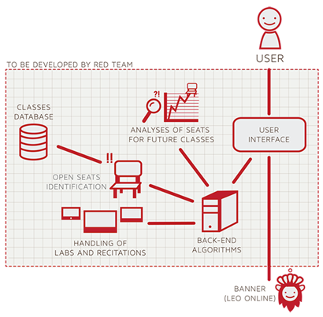
Figure 3
Prototype Major Functional Components Diagram

Algorithm | How it functions
Load Enrollment Data Files | Course data files are loaded into CORSICA.  Files contain course: Capacity, Number of Enrollments, and Available seats.
Open Course | An Administrator or Scheduler user logs into Banner and opens a course for students to enroll in.  Banner database is updated  CORSICA database is notified of change and is updated
Check for Open Seats | Once a course becomes full, a wait-list is activated for it by CORSICA  CORSICA will continually reference the current course capacity and amount of students enrolled.  If the amount of students enrolled is less than course capacity, a seat has become available.  CORSICA database updates  Calls notification algorithm
Add Student to Wait-list | Student X wishes to enroll in Course Y’s wait-list  CORSICA receives this request and adds Students X to wait-list queue  Course Y’s wait-list is updated
Notification | The check for open seats algorithm completes and returns true for an available seat  All students on the wait-list queue are notified of opening  Students respond
Drop Student from Wait-list | Student X wishes to be dropped from Course Y’s wait-list or the time window for that student has expired  CORSICA receives this request and removes Student X from the wait-list queue  Course Y’s wait-list is updated
Increase Course Capacity | Administrator logs into Banner and increases course capacity for Course Y  Banner database is updated  CORSICA database is notified of change and is updated
Close Course | An Administrator or Scheduler user logs into Banner and closes a course as an available option for students to enroll in  Banner database is updated  CORSICA database is notified of change is updated

Figure 4
Description of Algorithms

4.2 Prototype Features and Capabilities

Customer Risks | Technical Risks
C1: Department Use Rejection | T1: Ability to Integrate with Banner
C2: Transition to New GUI | T2: Software Upgrades
C3: Cost of Product | T3: Availability of Server Storage
C4: Product Interest | T4: Security Vulnerability
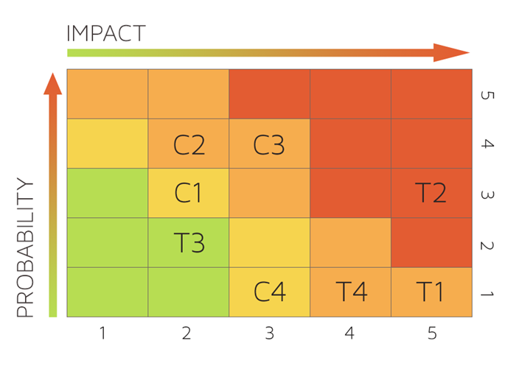
Figure 5
Risk Table and Matrix

4.3 Prototype Development Challenges

Objectives | Prototype | Challenges
Environments for all Users: | No  · Will demonstrate student, admin, and scheduler users | Working out all the bugs in CORSICA to allow all users to use CORSICA as intended
Notification System | No  · Will be simulated with text box | Allowing CORSICA to sync EXACTLY with the University’s Clock
Alert System | No  · Will be simulated with text box | Making the Alert System actually recognize each change to help ensure intentional changes
Mostly automated | No  · Will rely heavily on user interaction | Users need to be knowledgeable of CORSICA
Link to Banner | No  · Will be loaded with data.txt files instead | Using Black Box Testing to certify the text file compatibility
Link to LEO Online | No  · Will be simulated with command box menu | Maintaining LEO Online’s layout while appending the CORSICA option on the course registration screen
GUI | Very Basic (Text System) | Coding a GUI that looks professional and is simple to navigate

Figure 6
Prototype Challenges

Glossary

*Algorithm - A set of steps that are followed in order to solve a mathematical problem or to complete a computer process.

***Banner - Old Dominion University's centralized academic and administrative records system.

*Browser - A computer program that is used to find and look at information on the Internet.

**C++ - A general purpose programming language that is free-form and compiled.

**Cascading Style Sheets (CSS) - A style sheet language used for describing the look and formatting of a document written in a markup language.
**Corsica Database (CDB) - Corsica’s prototype database that simulates Banner

*Computer - An electronic machine that can store and work with large amounts of information.

*Database - A collection of pieces of information that is organized and used on a computer.

*E-mail - A system for sending messages from one computer to another computer.

*Graphical User Interface (GUI) - A program that allows a person to work easily with a computer by using a mouse to point to small pictures and other elements on the screen.

HyperText Markup Language (HTML) - A computer language that is used to create documents or Web sites on the Internet.

*Internet - An electronic communications network that connects computer networks and organizational computer facilities around the world.

**Javascript - A dynamic computer programming language, used as part of web browsers, whose implementations allow client-side scripts to interact with the user.

*Laboratory - A room or building with special equipment for doing scientific experiments and tests.

*Lecture - A talk or speech given to a group of people to teach them about a particular subject.

**MySQL - A database management system.

*Notification - The act of notifying someone.

*ODU - Old Dominion University, a public 4-year university in Norfolk, Virginia.

**PHP - A server-side scripting language designed for web development.

*Prototype - An original or first model of something from which other forms are copied or developed.

*Recitation - A class period especially in association with and for review of a lecture.

*Server - The main computer in a network which provides files and services that are used by the other computers.

**SQL - A programming language designed for managing data held in a relational database management system.

*Text Message - A short message that is sent electronically to a cell phone or other device.

***University Identification Number (UIN) - A unique identification number given out to students at Old Dominion University.

*Wait-list - To be put on a waiting list.

*Found at http://www.merriam-webster.com/
** Found at http://en.wikipedia.org/wiki/
*** Found at https://www.odu.edu

References

1. (March 24, 2014). Employment Projections. Bureau of Labor Statistics. Retrieved May 1, 2014, from http://www.bls.gov/emp/ep_chart_001.htm

2. Yu, R. (2012, September 3). Voice mail in decline with rise of text, loss of patience. USATODAY.COM. Retrieved April 27, 2014, from http://usatoday30.usatoday.com/tech/news/story/2012-09-03/voicemail-decline/57556358/1

