CS 411W Lab IV

Prototype User’s Manual
For


Prepared by: Red Group

Date: 12/11/2007

Table of Contents

1 Introduction (David Mirra, Rusty Udan) 1
2 Getting Started (Ben Blowe, Mark Polansky) 4
3 Using the Product/Prototype (David Mirra) 5
3.1 CertAnon Website (Ben Blowe, Rusty Udan & Sean Alcos) 5
3.1.1 CertAnon Account Registration 6
3.1.2 Logging into a CertAnon Account 9
3.1.3 CertAnon Account Management 11
3.1.4 Partner Site Management 12
3.1.4.1 Adding a Partner Site Account 12
3.1.4.2 Deleting a Partner Site Account 13
3.2 Partner Sites (Mark Polansky, David Leonard) 14
3.2.1 Logging into a Partner Site Account Using CertAnon 16
3.2.2 Logging into a Partner Site Account Using Legacy Authentication 18
3.2.3 Failed Login Attempts 18
3.2.4 Partner Site Account Preferences 20
3.2.4.1 Configuring an Account to Use CertAnon 20
3.2.4.2 Configuring an Account to Use Legacy Authentication 21
4 Error Messages (David Leonard, David Mirra) 24
5 Glossary of Terms (David Mirra, Ben Blowe) 25
6 References (David Mirra, Mark Polansky) 27

List of Figures

Figure 1. Phase 1 prototype major functional component diagram 2
Figure 2. CertAnon home page (Alcos & Blowe, 2007) 4
Figure 3. CertAnon help page (Blowe, 2007) 5
Figure 4. CertAnon account registration (Alcos & Blowe, 2007) 7
Figure 5. CertAnon account registration errors (Blowe, 2007) 8
Figure 6. CertAnon registration invalid username error (Mirra, 2007) 8
Figure 7. CertAnon registration invalid PIN error (Mirra, 2007) 9
Figure 8. CertAnon account login fields (Alcos & Blowe, 2007) 9
Figure 9. CertAnon account page (Alcos & Blowe, 2007) 10
Figure 10. Failed CertAnon account login (Blowe, 2007) 10
Figure 11. CertAnon account lockout error (Mirra, 2007) 10
Figure 12. CertAnon account management (Alcos & Blowe, 2007) 11
Figure 13. Partner site management (Alcos & Blowe, 2007) 12
Figure 14. Adding a partner site (Alcos & Blowe, 2007) 13
Figure 15. Confirming deletion of a partner site account (Blowe, 2007) 14
Figure 16. Partner site 1 home page (Polansky, 2007) 15
Figure 17. Partner site 2 home page (Polansky, 2007) 15
Figure 18. Logging into a partner site account using CertAnon (Polansky, 2007) 16
Figure 19. Partner site account page (Polansky, 2007) 17
Figure 20. Logging into a partner site account using a password (Polansky, 2007) 18
Figure 21. Partner site failed account login error (Polansky, 2007) 19
Figure 22. Partner site account lockout error (Leonard, 2007) 19
Figure 23. CertAnon authentication timeout error (Leonard, 2007) 20
Figure 24. Configuring a partner site account to use CertAnon (Polansky, 2007) 21
Figure 25. Partner site account configured to use CertAnon (Polansky, 2007) 22
Figure 26. Configuring a partner account to use a password (Polansky, 2007) 22
Figure 27. Partner site invalid password change error (Mirra, 2007) 23

List of Tables

Table 1. Pre-seeded token codes for token serial number 10000411 (Mirra, 2007) 6
Table 2. Sample partner site credentials (Mirra, 2007) 16
Table 3. CertAnon error messages (Leonard, 2007) 24

Introduction (David Mirra, Rusty Udan)
Fraud and identity theft struck 8.9 million victims in 2006. Total annual losses jumped by $2.2 billion from 2005 to 2006, and the mean resolution time per incident skyrocketed from 28 to 40 hours per victim (VeriSign, n.d.). One of the main tools in the arsenal of identity thieves is phishing, the practice of spoofing e-mail and websites of consumer businesses in order to trick users into divulging information such as usernames and passwords. According to the Anti-Phishing Working Group, a record high 55,643 unique phishing sites were identified in April 2007 (APWG, n.d.). Account credentials may also be disseminated through theft by insiders or through corporate network intrusions.
Such crimes are occurring more frequently as Internet users move more and more of their lives online with only passwords to protect them. Online services such as banking, stock trading, shopping, and travel planning are all account-based activities that are commonly protected by passwords. This single-factor authentication method is easily compromised and endangers the security of online accounts. Passwords are insecure, difficult to manage, and increasingly vulnerable to fraud.
CertAnon is an anonymous Wide-Area Network (WAN) authentication service conceived by the Old Dominion University (ODU) CS410 Red Group. The service is designed to replace the password, the weak link in online account authentication, with an enterprise-grade two-factor authentication solution that is available to the everyday Internet user. CertAnon can be integrated with any account-based web portal to provide an instant security boost for a site's customers. Available, affordable, and proven technology is utilized within an innovative and scalable framework. CertAnon targets the large and growing markets of individual Internet users and security-conscious businesses, and it offers clear benefits to both.
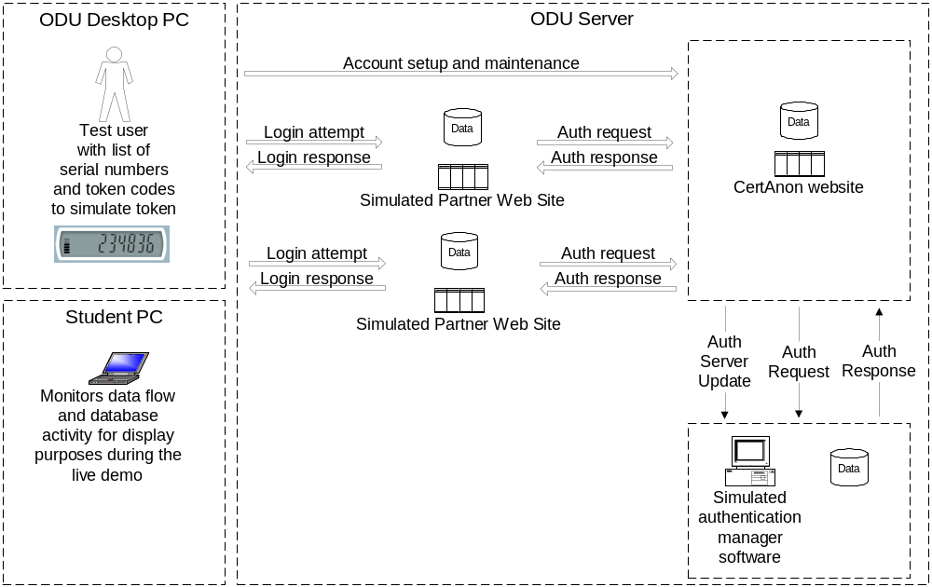
Figure 1. Phase 1 prototype major functional component diagram
The prototype of the CertAnon service, shown in Figure 1, is intended to demonstrate the feasibility of using a centralized two-factor authentication system with multiple independent users and multiple independent partner websites. The first functional objective is to successfully demonstrate the use of a mid-tier, the CertAnon website, to extend the functionality of a two-factor authentication solution across multiple independent partner sites. Two-factor authentication credentials entered by an end user on a partner site must be linked to a particular token. The credentials, consisting of a partner site username and a passcode, will be sent to the CertAnon mid-tier and cross-referenced against configured accounts to identify the associated token. The token serial number and the passcode are then sent to the authentication server for validation. The authentication response is passed back through the mid-tier and on to the partner site. It is this mid-tier innovation that allows CertAnon to offer a solution that permits a customer to securely access all participating online accounts using a single access method.
The second objective is to demonstrate the CertAnon service using a simulated hardware token that does not require any client software. In order to highlight the ease of use and cross-platform availability of this solution, it will be shown that the service is not limited to specific client hardware or operating systems and that it needs no special software installed by the user.
Third, user registration and account maintenance will be handled in an anonymous fashion while still providing strong account authentication. Account access must be limited to a specific token holder without collecting or using personal information such as a real name, a street address, or a credit card number. This feature will allay consumer fears of information misuse or theft and attract additional customers who value the privacy that CertAnon provides.
The final objective is to show the ease of integration of this third party system with a potential partner website. The aim is to illustrate the relative simplicity of incorporating a pre-built PHP module into an existing site in order to offer the CertAnon service. A short and straightforward integration process is an important aspect of the service and will be a valuable selling point for commercial partners.

Getting Started (Ben Blowe, Mark Polansky)
The CertAnon website is located at http://cs.odu.edu/~411red/CertAnon/. The home page is shown in Figure 2.
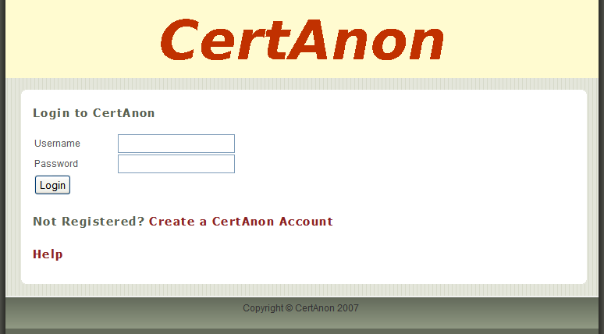
Figure 2. CertAnon home page (Alcos & Blowe, 2007)
From this home page, you can log into an existing CertAnon account. You can also create a new account by clicking on the link labeled Create a CertAnon Account. For additional information about the CertAnon service, you can click on the link labeled Help. This link will provide answers to a number of frequently asked questions, and it will eventually provide contact information for customer service and technical support for the production CertAnon service. This contact information is not available for the prototype. A section of this help page is shown in Figure 3.
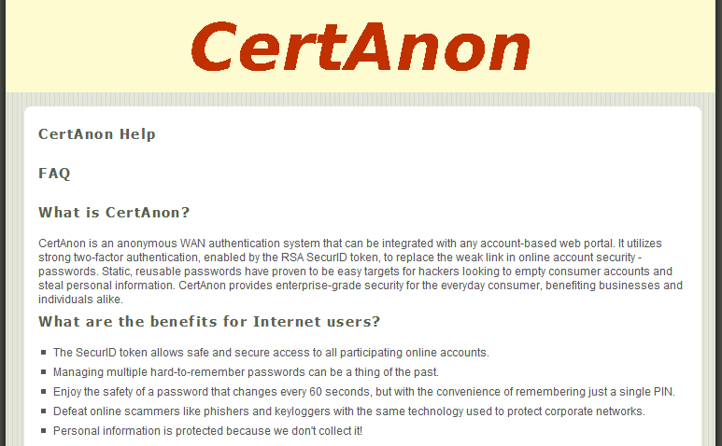
Figure 3. CertAnon help page (Blowe, 2007)

Using the Product/Prototype (David Mirra)
The following section of the manual will discuss detailed instructions for performing all of the tasks required to operate the CertAnon prototype. The procedures are broken up into separate sections for the CertAnon website and partner sites. Within each section are step-by-step instructions for the operational aspects of the prototype.

CertAnon Website (Ben Blowe, Rusty Udan & Sean Alcos)
The CertAnon website, as mentioned in section 2, is the starting point for account registration and maintenance. The following activities will each begin from the CertAnon home page shown in Figure 2.

CertAnon Account Registration
In order to begin using the CertAnon prototype, you must first obtain and configure a CertAnon account. You must possess a valid token serial number that has not yet been registered. You must also have a list of pre-assigned token codes for that serial number. Table 1 shows an example of such a list containing the pre-seeded token codes for the serial number 10000411. These token codes may be used in any order, but each code can only be used once.
Serial Number | Token Code
10000411 | 649243
10000411 | 458401
10000411 | 399615
10000411 | 891438
10000411 | 296057
10000411 | 286229
10000411 | 708319
10000411 | 611287
10000411 | 461915
10000411 | 277677
10000411 | 013801
10000411 | 310439
10000411 | 840509
10000411 | 903794
10000411 | 611577
Table 1. Pre-seeded token codes for token serial number 10000411 (Mirra, 2007)
Once you have this information for the serial number that you wish you register, you can begin the account creation process.
- Access the CertAnon home page at http://cs.odu.edu/~411red/CertAnon/.
- Click on the link labeled Create a CertAnon Account.
- Fill in the following fields on the registration page shown in Figure 4:
  - Username: An alphanumeric string up to 80 characters in length. This username will be used only for accessing your CertAnon account when logging in through the CertAnon website.
  - PIN: An alphanumeric string between four and 25 characters in length. This code will be combined with a token code when logging into sites using CertAnon for authentication. The value that you enter will be displayed on the screen as you type it. The value is intentionally not masked to facilitate data validation in the prototype.
  - Serial Number: A unique eight digit numeric value assigned to the “token” in your possession.
  - Security Questions and Answers: Choose three security questions and answers to be used to confirm your identity for access to your CertAnon account in the case of a forgotten PIN or lost token. For example, “Q: What is your first pet’s name? A: Spot” or “Q: What is your favorite sports team? A: Giants” would be valid entries.

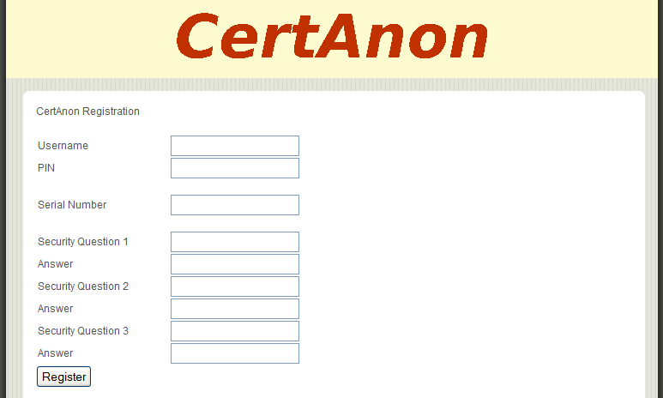
Figure 4. CertAnon account registration (Alcos & Blowe, 2007)
- Click the Register button. Upon successful registration, you will be returned to the CertAnon home page to log in using your new credentials.

If the registration cannot be completed, you may receive one or more of the errors shown in Figure 5. In this particular example, the username newuser1 was already registered by someone else. The token serial number 10000411 has also been rejected as invalid. This value may already be registered, or it may simply be an invalid number. Registration also failed because not all required fields on the account registration page were populated. Other potential reasons for failure include the use of invalid characters in the username or PIN or violation of length constraints on those fields. See Figure 6 and Figure 7 for these additional error messages. Correct the erroneous values and click the Register button to try again.
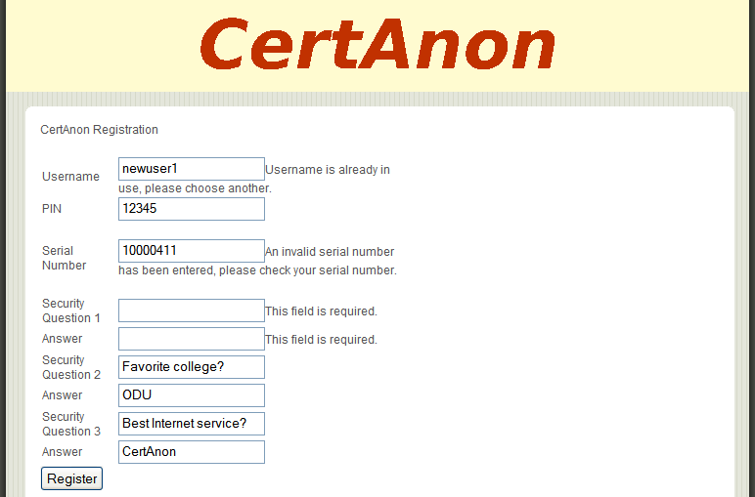
Figure 5. CertAnon account registration errors (Blowe, 2007)
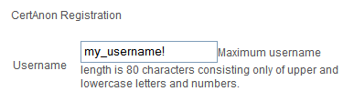
Figure 6. CertAnon registration invalid username error (Mirra, 2007)
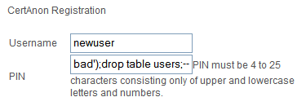
Figure 7. CertAnon registration invalid PIN error (Mirra, 2007)

Logging into a CertAnon Account
Figure 8 shows the login fields presented on the CertAnon home page.
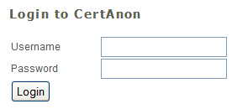
Figure 8. CertAnon account login fields (Alcos & Blowe, 2007)
- Access the CertAnon home page at http://cs.odu.edu/~411red/CertAnon/.
- Enter your CertAnon username in the Username field.
- Enter your PIN followed immediately by a six-digit token code in the Password field. The token code should be selected from the unused codes on the list provided for your token serial number. The value that you enter will be displayed on the screen as you type it. The value is intentionally not masked to facilitate data validation in the prototype.
- Click the Login button.

If the login attempt is successful, you will be redirected to the CertAnon account page shown in Figure 9. This page provides options to manage your CertAnon account and related partner sites.
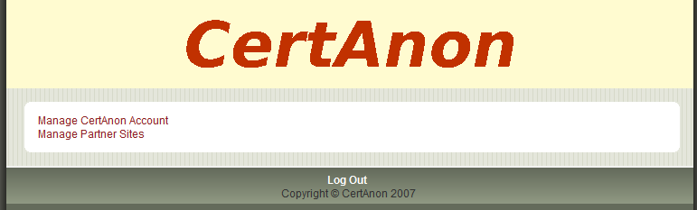
Figure 9. CertAnon account page (Alcos & Blowe, 2007)
You will receive the error shown in Figure 10 if an invalid username, PIN, or token code is used. Re-enter your username and password and click the Login button to try again.
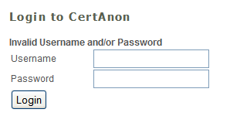
Figure 10. Failed CertAnon account login (Blowe, 2007)
In the event of three consecutive bad login attempts, your CertAnon account will be temporarily locked. You will receive the error message shown in Figure 11, asking you to contact CertAnon for assistance. That assistance is out of scope for this prototype because it involves standard online account customer service.
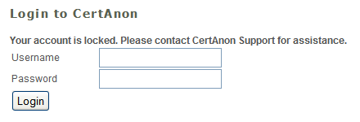
Figure 11. CertAnon account lockout error (Mirra, 2007)

CertAnon Account Management
This option allows you to change your PIN or update your security questions.
- From the CertAnon account page shown in Figure 9, click the link labeled Manage CertAnon Account. This action will bring you to the account management page shown in Figure 12.
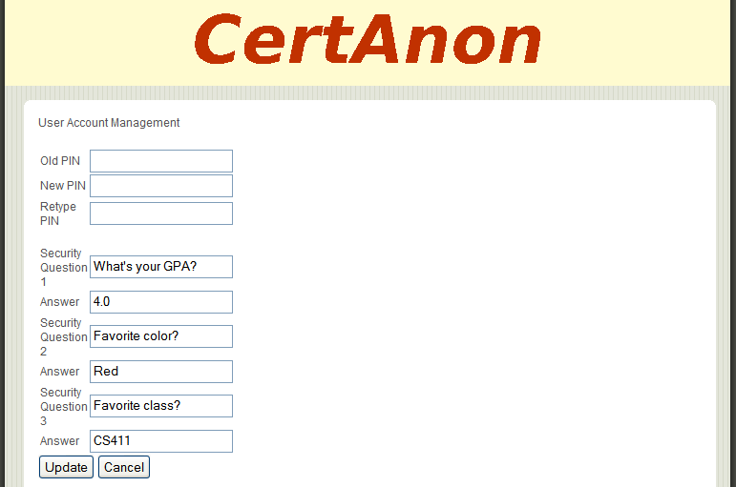
Figure 12. CertAnon account management (Alcos & Blowe, 2007)
- To change your PIN, first enter your Old PIN. Enter your new PIN in the New PIN field and again in the Retype PIN field to ensure that you have typed it correctly. The new PIN must be an alphanumeric string between four and 25 characters in length.
- To change any of your security questions, type a new question and answer in the appropriate fields. You may change any number of questions at one time.
- Click the Update button to save your changes. Any fields left blank or unchanged will not be updated. You will be returned to your CertAnon account page.
Clicking the Cancel button at any time will return you to the CertAnon account page without saving any changes.

Partner Site Management
This option allows you to add, modify, and remove the partner site accounts associated with your CertAnon account. You can log into each properly configured partner site account using your CertAnon token. From the CertAnon account page shown in Figure 9, click the link labeled Manage Partner Sites. This action will bring you to the partner site management page shown in Figure 13. This page displays the list of participating partner site URL’s and corresponding usernames associated with your CertAnon account.
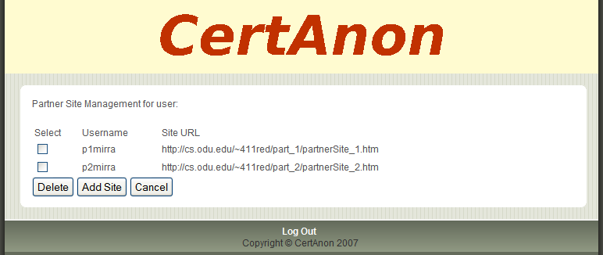
Figure 13. Partner site management (Alcos & Blowe, 2007)

Adding a Partner Site Account
In order to use your CertAnon token for authentication on a partner site, you must first link your partner site account to your CertAnon account.
- To add a partner site account, click the button labeled Add Site. This action will bring you to the partner site addition page shown in Figure 14.

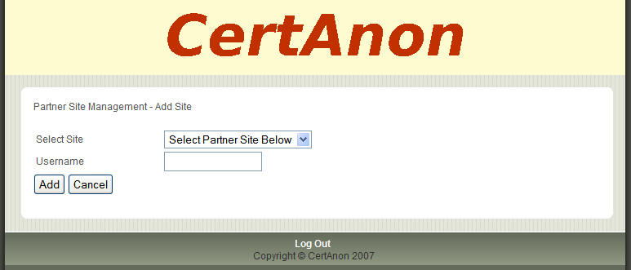
Figure 14. Adding a partner site (Alcos & Blowe, 2007)
- Select an entry from the menu of participating partner sites in the Select Site field.
- Enter the username that you use with that partner site in the Username field.
- Click the Add button to link this site and username to your CertAnon account. You will then be returned to the partner site management page.
Clicking the Cancel button at any time will return you to your CertAnon account page without saving any changes.

Deleting a Partner Site Account
You may occasionally need to delete an existing partner site account. Deletion of an account will prevent you from accessing that account using your CertAnon token. Reasons for doing so might include cancellation of that partner site account or switching back to legacy password authentication.
- From the CertAnon account page shown in Figure 9, click the link labeled Manage Partner Sites. This action will bring you to the partner site management page shown in Figure 13.
- To delete a partner site account, check the Select box on the row next to that account and click the Delete button.
- Click OK in the confirmation dialog box shown in Figure 15 to proceed with the deletion.

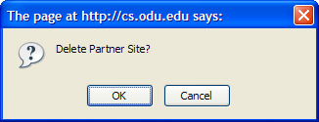
Figure 15. Confirming deletion of a partner site account (Blowe, 2007)
- The page will then refresh, and the deleted account will be gone.
Clicking the Cancel button at any time will return you to your CertAnon account page without saving any changes.

Partner Sites (Mark Polansky, David Leonard)
The CertAnon prototype includes two sample partner sites. They represent generic online account-based websites which have integrated the CertAnon authentication module to allow registered users to use the CertAnon system for account authentication. The home page of the partner site shown in Figure 16 below is located at http://cs.odu.edu/~411red/part_1/partnerSite_1.htm.
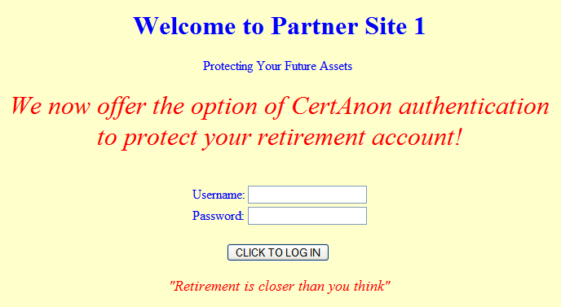
Figure 16. Partner site 1 home page (Polansky, 2007)
The home page of the second partner site shown in Figure 17 below is located at http://cs.odu.edu/~411red/part_2/partnerSite_2.htm.
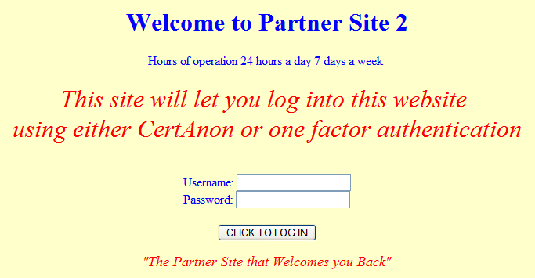
Figure 17. Partner site 2 home page (Polansky, 2007)

Logging into a Partner Site Account Using CertAnon
The following instructions cover the steps needed to log into an account on one of the simulated partner sites using CertAnon for authentication. The same procedures apply to both partner sites. You must have a pre-defined username registered with the target partner site. You must also have the CertAnon PIN for that user and a list of pre-defined token codes for the related serial number. Table 2 shows an example of such a list. A given token code may be used on either partner site, but it may only be used once.
URL | Username | SerialNumber | PIN | TokenCode
http://cs.odu.edu/~411red/part_1/partnerSite_1.htm | p1newuser1 | 10000411 | abc411 | 649243
http://cs.odu.edu/~411red/part_2/partnerSite_2.htm | p2newuser1 | 10000411 | abc411 | 649243
http://cs.odu.edu/~411red/part_1/partnerSite_1.htm | p1newuser1 | 10000411 | abc411 | 458401
http://cs.odu.edu/~411red/part_2/partnerSite_2.htm | p2newuser1 | 10000411 | abc411 | 458401
http://cs.odu.edu/~411red/part_1/partnerSite_1.htm | p1newuser1 | 10000411 | abc411 | 399615
http://cs.odu.edu/~411red/part_2/partnerSite_2.htm | p2newuser1 | 10000411 | abc411 | 399615
http://cs.odu.edu/~411red/part_1/partnerSite_1.htm | p1newuser1 | 10000411 | abc411 | 891438
http://cs.odu.edu/~411red/part_2/partnerSite_2.htm | p2newuser1 | 10000411 | abc411 | 891438
Table 2. Sample partner site credentials (Mirra, 2007)
Once you have this information, you can attempt the account login process.
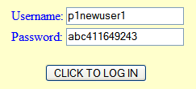
Figure 18. Logging into a partner site account using CertAnon (Polansky, 2007)
- Access the partner site home page.
- Enter your partner site username in the Username field. This partner site username is not the same as your CertAnon username. Figure 18 shows an example of a user with the username p1newuser1 attempting to log into the first partner site.
- Enter your PIN followed immediately by a six-digit token code in the Password field. In Figure 18, the PIN abc411 is used in conjunction with the token code 649243.
- Click the button labeled CLICK TO LOG IN.

If the login attempt is successful, you will be redirected to the partner site account page shown in Figure 19. This page provides two buttons which allow you to log out or manage your user preferences for this partner site account. It also displays a welcome message with the username used to log into the account.
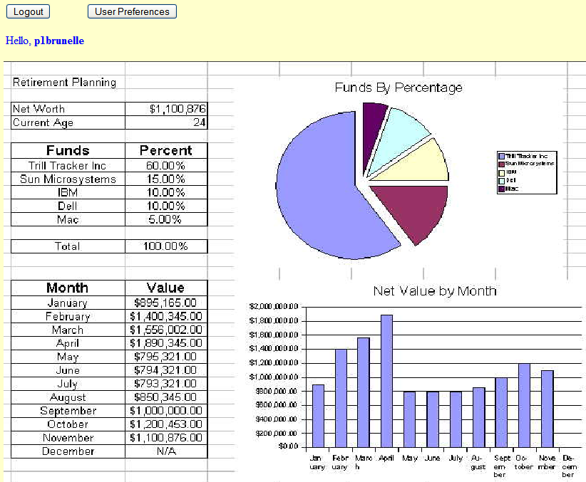
Figure 19. Partner site account page (Polansky, 2007)

Logging into a Partner Site Account Using Legacy Authentication
If the partner site account that you are using is not configured to use CertAnon, a simple password will be used instead of a PIN and token code combination.
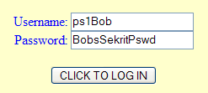
Figure 20. Logging into a partner site account using a password (Polansky, 2007)
- Access the partner site home page.
- Enter your partner site username in the Username field. This partner site username is not the same as your CertAnon username. Figure 20 shows an example of a user with the username ps1Bob attempting to log into the first partner site.
- Enter your password in the Password field. In Figure 20, the password BobsSekritPswd is used.
- Click the button labeled CLICK TO LOG IN.

If the login attempt is successful, you will be redirected to the partner site account page shown in Figure 19. This page provides two buttons which allow you to log out or manage your user preferences for this partner site account.

Failed Login Attempts
Regardless of the authentication method configured for your account, you will receive the error shown in Figure 21 if an invalid username, PIN, token code, or password is used. For a CertAnon-enabled account, this error will also be received if you are attempting to reuse a token code. Click the button labeled Please Press this Button to go back in order to try again.
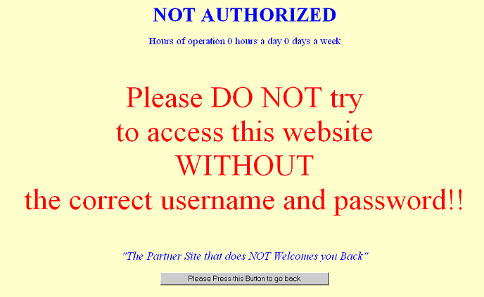
Figure 21. Partner site failed account login error (Polansky, 2007)
In the event of three consecutive bad login attempts, your CertAnon account will be temporarily locked. You will receive the error message shown in Figure 22, asking you to contact CertAnon for assistance. That assistance is out of scope for this prototype because it involves standard online account customer service.
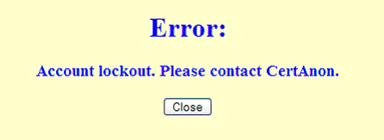
Figure 22. Partner site account lockout error (Leonard, 2007)
If the partner site fails to receive a response to an authentication request from the CertAnon service, you will receive the error message shown in Figure 23. This error might occur if the mid-tier or authentication manager processes are temporarily unavailable. Network congestion or local network connectivity may also be a factor. Waiting for a short period of time before trying again is recommended. If this error continues to persist, CertAnon Support should be contacted for assistance. That support is out of scope for this prototype because it involves standard online customer service.
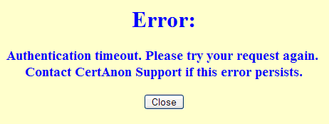
Figure 23. CertAnon authentication timeout error (Leonard, 2007)

Partner Site Account Preferences
There are two primary partner site user preferences which matter to the CertAnon service. The first is the option to use CertAnon for authentication. The second is the ability to set a legacy password if the account user elects not to use CertAnon for authentication. These two options can be set on the partner site account preferences page as shown in Figure 24 and Figure 25.

Configuring an Account to Use CertAnon
This procedure demonstrates how to convert a partner site account to use CertAnon for authentication. The password currently in place for the account will be eliminated, and a CertAnon PIN and token code will be used for future authentication attempts.
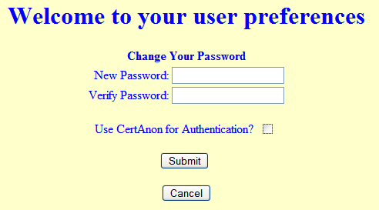
Figure 24. Configuring a partner site account to use CertAnon (Polansky, 2007)
- From the partner site account page shown in Figure 19, click the button labeled User Preferences. This action will bring you to the user preferences page shown in Figure 24.
- The Cancel button can be clicked at any time to return to the partner site account page without saving any changes.
- Check the box labeled Use CertAnon for Authentication. The password fields should disappear.
- Click the Submit button. You will be returned to your partner site account page.
- Access to this account can now be accomplished with a CertAnon PIN and token code. The previous legacy password will no longer work.

Configuring an Account to Use Legacy Authentication
This procedure demonstrates how to revert a partner site account to use legacy authentication. A password will be chosen to replace the PIN and token code combination used with CertAnon.
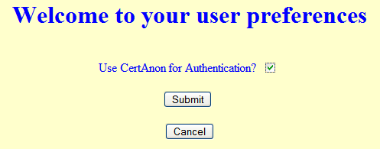
Figure 25. Partner site account configured to use CertAnon (Polansky, 2007)
- From the partner site account page shown in Figure 19, click the button labeled User Preferences. This action will bring you to the user preferences page shown in Figure 25.
- The Cancel button can be clicked at any time to return to the partner site account page without saving any changes.
- Clear the box labeled Use CertAnon for Authentication, as shown in Figure 26. The password fields will become visible.
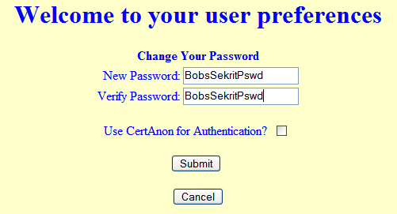
Figure 26. Configuring a partner account to use a password (Polansky, 2007)
- Enter a new password in the field labeled New Password. In the example in Figure 26, the value BobsSekritPswd has been entered. This password must be an alphanumeric string no more than 25 characters in length.
- Enter the same password in the field labeled Verify Password. Failing to enter the same password in both fields or using invalid characters will generate the error shown in Figure 27. You will then be redirected back to the user preferences page.
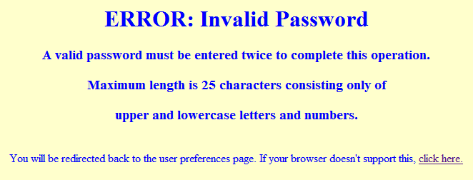
Figure 27. Partner site invalid password change error (Mirra, 2007)
- Click the Submit button. This action will return you to the partner site account page. Access to this account can now be accomplished with the password that was just entered.

Error Messages (David Leonard, David Mirra)
Table 3 shows the error conditions, messages, and resolutions for the CertAnon prototype.
ID | Error | Condition | Resolution
CertAnon Account Setup
0 | This field is required | A required field on the registration form has not been populated. | Fill in any blank fields and resubmit
1 | Username is already in use, please choose another | The entered username has already been registered by another user | Enter another username and resubmit
2 | An invalid serial number has been entered, please check your serial number | The entered serial number is either already in use or is an invalid value | Check with a CertAnon team member to ensure that the serial number is a valid, unused value
3 | Maximum username length is 80 characters consisting only of upper and lowercase letters and numbers | The new username entered by the user violates the field constraints | Enter another username and resubmit
4 | PIN must be 4 to 25 characters consisting only of upper and lowercase letters and numbers | The new PIN entered by the user violates the field constraints | Enter another PIN and resubmit
CertAnon Account Login
10 | Login Failed | CertAnon account login attempt was unsuccessful | Click the browser’s back button and reeenter valid username, PIN, and token code values
Partner Sites/Authentication Module
20 | Not Authorized | Partner site account login attempt was unsuccessful | Click the button labeled “Please Press this Button to go back,” and re-enter a valid username and password
21 | Account Lockout | Three consecutive bad login attempts have been recorded for a CertAnon-enabled account | Contact a CertAnon team member for assistance
22 | Authentication Timeout | The partner site has failed to receive a response to an authentication request from the CertAnon service | Wait a short period of time and try to authenticate again; if this error persists, contact a CertAnon team member for assistance
23 | Invalid password – A valid password must be entered twice to complete this operation. Maximum length is 25 characters consisting only of upper and lowercase letters and numbers | The new password entered by the user violates the field constraints, or different values were entered in the password and verify password fields | Enter another password and resubmit
Table 3. CertAnon error messages (Leonard, 2007)

Glossary of Terms (David Mirra, Ben Blowe)
Key fob: A decorative or functional item attached to a key ring or key chain, such as an RSA SecurID token
Keylogging: The use of software or hardware to capture a computer user's keystrokes, also known as keystroke logging
Load balancing: Tuning a network to evenly distribute data among available resources
MySQL: An open source multi-user database management system
Partner website: Any organization with an Internet presence that contracts to use CertAnon technology for user authentication
Passcode: A type of password, often purely numeric. In the case of CertAnon, it is the combination of a user selected PIN plus the pseudo-random token code provided by the RSA token.
Perl: A high-level scripting language well-suited for process, file, and text manipulation
Phishing: The act of sending an e-mail to a user falsely claiming to be an established legitimate enterprise in an attempt to scam the user into surrendering private information that will be used for identity theft. The e-mail directs the user to visit a website where they are asked to update personal information such as passwords and credit card, social security, and bank account numbers. The website is a bogus site designed to capture this user information for purposes of identity theft or other financial fraud.
Personal Identification Number (PIN): A personal identification number normally used to secure a user account
PHP: A server-side programming language designed for building dynamic web pages
Proprietary system: A system that is used, produced, or marketed under exclusive legal right of the inventor, maker, or operator
Pseudo-random: Being or involving entities (such as numbers) that are selected by a definite computational process, but that satisfy one or more standard tests for statistical randomness
RSA: The security division of EMC Corporation, a provider of corporate information infrastructure technology and solutions
RSA SecurID: A two-factor authentication solution offered by the company RSA
RSA Authentication Manager: Server-side software by RSA used to verify authentication requests and centrally administer authentication policies for enterprise networks
Single-factor authentication (SFA): The traditional security process that requires a username and password before granting access to the user
Token: A physical device that an authorized user of computer services is given to aid in authentication, also known as a security token, hardware token, authentication token or cryptographic token
Transmission Control Protocol/Internet Protocol (TCP/IP): A suite of protocols designed for enabling communications over interconnected networks. TCP/IP is a core technology for Internet communications.
Two-factor authentication: A system of which the user provides dual means of identification, one of which is typically a physical token, such as a key fob, and the other of which is typically something memorized, such as a security code
Wide-area network (WAN): A telecommunications network with linked segments spread across a wide geographic area

References (David Mirra, Mark Polansky)
Anti-Phishing Working Group. (n.d.). Anti-Phishing Working Group. Retrieved September 15, 2007, from http://www.antiphishing.org.
Miniwatts Marketing Group. (2007). America Internet usage and population statistics. Retrieved September 17, 2007, from http://www.internetworldstats.com/stats2.htm.
Mirra, David. (2007). Lab I – CertAnon Product Description. Reston, VA: Author.
Mirra, David. (2007). Lab II – Prototype Product Specification for CertAnon. Reston, VA: Author.
Mirra, David. (2007). Lab III – Prototype Test Plan/Procedure For CertAnon. Reston, VA: Author.
RSA. (2007). RSA SecurID. Retrieved September 17, 2007, from http://www.rsa.com/node.aspx?id=1156.
VeriSign. (n.d.). Online fraud stats - how safe is your e-commerce experience? Retrieved September 17, 2007, from http://www.verisignsecured.com/content/Default.aspx?edu_stats_body.html.

