Management Plan

Outline of Document

1 Our Program Identification
A Our Mission Statement
B Corporate Structure
C The Team
D Duration of the Team/Project
2 Program Planning
A. Overall WBS
B. Gantt Charts
i. Phase 1
ii. Phase 2
iii. Phase 3

1 Program Identification

1.A Mission Statement

Our mission at Azul Business Corporation is to improve the quality of education by implementing technology into schools; particularly those technologies that help the many different styles of learning. Our products are built to integrate easily into current systems and be used without excessive training. Students and Professors that take advantage of our products will see an increase in the student’s ability to learn material by emphasizing repetition and allowing access to classroom lectures.

1.B Corporate Structure

Azul was founded in 2004 when six Old Dominion University Computer Science students formed the team. Azul Business Corporation is in association with the Computer Science Department at Old Dominion University in junction with the Computer Productivity Initiative (CPI)
General Managers, Dennis Ray and Janet Brunelle

1C Our Team
Accountant
Prepares balance sheets, profit and loss statements, and other financial reports. Responsibilities also include analyzing trends, costs, revenues, financial commitments, and obligations incurred to predict future revenues and expenses. Reports organization's finances to management, and offers suggestions about resource utilization, tax strategies, and assumptions underlying budget forecasts.
Accountant Representative
Maintains relationships and favorable contacts with current and potential accounts. Sets up new account information, and resolves customer issues/problems.
Attorney
Prepares and examines contracts involving leases, licenses, purchases, sales, insurance, etc. Provides legal advice to an organization, prepares resolutions and forms, and participates in major legal actions. Responsible for foreseeing and protecting company against legal risks.
Educational Consultant
Phase 1
Design real world field test. Create field test student survey. Create teacher test field survey. Acquire the classroom testing agreements.
Phase 2
Execute field tests, student surveys, and teacher surveys. Evaluate playback usability, playback helpfulness, and additional playback qualities. Identify playback problems. Evaluate usability and durability of hardware. Evaluate usability of recording and distribution. Evaluate classroom role. Identify problems. Evaluate additional qualities.
General Manager
Supervise all employees and contractors/consultants. Represent the company to all potential customers.
Hardware Developer
Phase 1
Test and choose the best sound capturing device and pressure sensitive surface to work for the lab prototype. Work with the API for the chosen sound and video devices. Translate whiteboard output into a vector format.
Phase 2
Work with the API for the chosen sound and video devices. Translate whiteboard output into a vector format. Encode the audio and graphics into our proprietary format.

Project Manager
Plan and monitor the project’s process. Oversee all developers and consultants. Resolve all issues and conflicts. Maintain that the project meets schedule timelines and budget limits.
Software Developers
Phase 1
Design and code the synchronization software for the lab prototype. Design and code the playback software for the synchronized output. Must consider the file format for the sound and video output. Will test synchronization and playback software developed.
Phase 2
Design and code the synchronization software for the production prototype. Design and code the playback software for the synchronized output. Must consider the file format for the sound and video output. Design and develop the graphical user interface. Develop network communication interfaces for file transfers.
Phase 3
Develop upgrades and perform software maintenance.
Technical Consultant
Phase 1
Will oversee and advise both hardware and software developers in choices, design, and testing.
Phase 2
Will oversee and advise both hardware and software developers in choices, design, and testing. Responsible for critically evaluating all technical components.
Technical Staff
Set up and maintain the hardware and software in the classroom environments during the testing and evaluation phase.
Technical Support
Duties include help desk, installing systems for new customers and user training.
Technical Writer
Compose the product documentation and the training manuals.
Testing Programmers
Improve and enhance the software during the testing and evaluation phase

Web Developer
Phase 2
Design the company web site and user interface for accessing the classroom content. Design authentication scheme for controlling access to content. Design database schema for storing users and content.
Phase 3
Maintain the company web site and make changes to web interface as needed due to software upgrades.

Our Phase 1, 2, and 3 Team members
Phase 1  1 Project Manager  3 Hardware Developers  3 Software Developers  1 Educational Consultant  1 Technical Consultant | Phase 2  1 Project Manager  2 Hardware Developers  1 Web Developer  3 Software Developers  4 Testing Programmers  1 Technical Writer  2 Technical Staff/Others  1 Educational Consultant  1 Technical Consultant | Phase 3  1 General Manager  1 Attorney  1 Software Developer  1 Web Programmers  1 Accountant  2 Tech Support  1 Accountant Represent.

1.D Team Durations of different Phases

Phase 1 Jan 2005 – July 2005
Phase 2 July 2005 – Jan 2007
Phase 3 Jan 2007 –

2 Program Planning

2.A Overall WBS
Phase 1 – Prototype Development

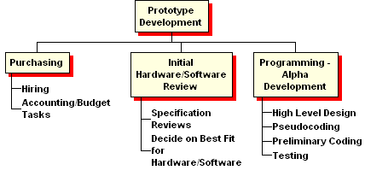
Phase 2 – Production Model Development

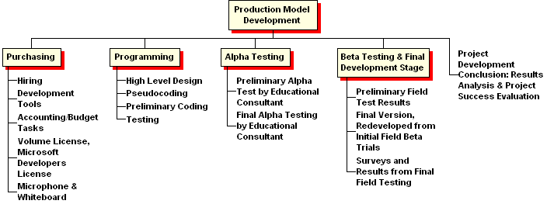

Phase 3 – Production Phase

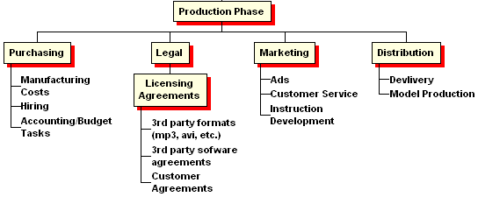
2.B Gantt Charts

2.B.i Phase 1
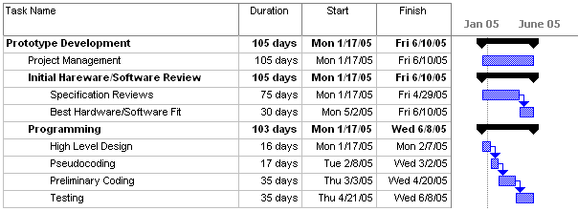

2.B.ii Phase 2
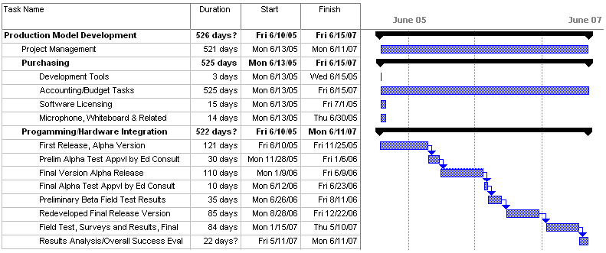

2.B.iii Phase 3
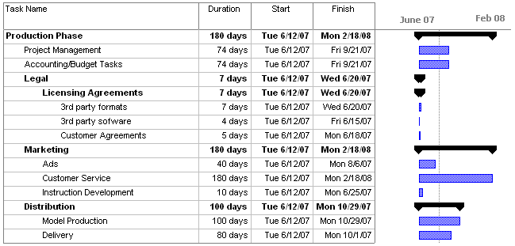

Evaluation Plan

Azul Business Corporation will evaluate each phase in the development of SAVE (Student Audio/Visual E-tool). Problems identified by consultants and field test groups will be evaluated for incorporation into the product specification.

Phase | Success Indicator(s)
Phase I | Prototype developed  Internal testing is complete
Phase II | Real world working model in a classroom  External testing and consultant evaluation complete
Phase III | Production begins

Phase 1 – Prototype Development
Duration: January 17, 2005 - June 10, 2005

We will evaluate the current state of technology, and make decisions on which technology upon which to base our project. We will identify necessary design features, and necessary software technology components to successfully complete the project. We will demonstrate the feasibility of the concepts and demonstrate that the necessary software solutions are possible.

Phase I
Phase I is divided into two sub-phases. In Phase IA we will place emphasis on research. This will include an evaluation of different digital whiteboards and wireless microphones.

In Phase IB, we will develop the lab prototype. This will include a pressure sensitive surface, a sound recording device, software to capture both the audio and visual, software to sync the audio and visual. Below is a selection of the test criteria.

Does the pressure sensitive surface capture what is written upon it?
Can the capture be saved as a file?
Can the capture be played back?
Can the audio from the mock presentation be recorded?
Can the audio be recorded as a file?
Can the audio be played back?
Can we synchronize the audio and visual capture files?
Can the synchronized file be played back?
Does the synchronized file match the mock presentation?

Phase II
We will use an education consultant to design and implement our final product evaluation criteria. The duties of the education consultant will be the following:

- Design real world field test
  - Create field test student survey
    - Evaluate playback usability, playback helpfulness, and additional playback qualities
    - Identify playback problems
  - Create teacher field test survey
    - Evaluate usability and durability of hardware
    - Evaluate usability of recording and distribution
    - Evaluate classroom role
    - Identify problems
    - Evaluate additional qualities
- Execute field tests, student surveys, and teacher surveys

We estimate that Phase II will last two years. In the first year, we will develop and conduct initial testing of the production model. In the second year, we will conduct the real world field test. We envision conducting this test during the summer session at a university. The model will be used in a classroom and tested for technical problems. The technical consultant will be on site for this test. Over the fall semester, we will correct and revise the model based on problems identified by students, professors, and the technical consultant. At the beginning of the spring semester, we will again use the model in a classroom and create a control group as well to test the performance of the model as it pertains to improvement of the learning process. Input for the evaluation of this phase will be provided by student and professor surveys, a comparison of the grades between the control group and the group using our solution and the education consultant.

Phase 2 – Production Model Development
Duration: June 10, 2005 – June 10, 2007

Section 2A
Duration: June 10, 2005 – November 25, 2005
During this time we will build the framework for the actual production software. At the end of this section, a rudimentary alpha version will be delivered. This alpha version will demonstrate the core functionality and uses of our software.

Section 2B
Duration: November 25, 2005 – December 10, 2005
Deliverable: Preliminary Alpha Test Approval by Educational Consultant

During this time, the Educational Consultant will be evaluating the software to determine its potential for successfully being deployed in a classroom environment. An early external testing phase will allow us to correct the direction of the product development before major faults are designed into the system.

Section 2C
Duration: December 10, 2005 – June 10, 2006
This section will continue the development started in 2A, with the factored in corrections generated during section 2B. The end of this section will result in an alpha release suitable for deployment in a classroom.

Section 2D
Duration: June 10, 2006 – June 25, 2006
Deliverable: Final Alpha Test Approval by Educational Consultant
The Educational Consultant will evaluate the developed version of the software and evaluate its potential use in the classroom environment. The approval of this will allow the software to move into the field testing sections.

Section 2E
Duration: June 25, 2006 – August 13, 2006
We will beta test this product in a classroom during the last half of the summer semester. This section is not oriented on determining the effectiveness of our product on learning rates, but on finding and evaluating all bug and failures in the program and receiving feedback from the teachers. No results on learning rates will be determined at this point, since the software will not be reliable or steady enough to depend on as a primary teaching tool.

Section 2F
Duration: August 27, 2006 – December 23, 2006
We will implement required improvements and make sure bugs discovered during the pervious section are fixed. This process will result in the final version of the software that will be the basis for judgments on the improvements in learning rates,

Section 2G
Duration: January 15, 2007 - May 10, 2007
Deliverable: Surveys and Results from Final Field Testing
The final version of the product will be deployed into multiple classrooms for the purposes of evaluation of the effect on learning rates. Results will be generated by surveys to the students and teachers along with grade analysis. These results will be used as evidence supporting our product for marketing. No changes will be made to the whiteboard technology during this phase to preserve the accuracy of the results.

Section 2H
Duration: May 10, 2007 – June 10, 2007
Deliverable: Results Analysis and Project Success Evaluation
The results from the previous section will be evaluated and analyzed. These will be used as a basis for confirming the effectiveness and usefulness of our product. From this section, we will have documents showing how big of an effect on learning our product provides.

Phase III – Production

In this phase, we begin production and the highest percentage of cost will be in personnel. We will consider the product successful when we have passed the break-even point. Our break-even point is based upon yearly operating costs and a first year sale of 20 systems. Our sales goals will be a 20% increase in sales each year. In the fifth year, when we have sold 27 systems total, we will begin to earn a profit. We will consider the product successful when we are covering our operating costs and earning a profit.

Marketing Plan

While there are many applications for our product, we still have a specific audience in mind. We would start with this specific audience and expand to a different or modified audience in the future.

Who is the Customer?
The target market for our product is university mathematics departments. Our target market includes the more than 2100 public and private four-year colleges in the United States.

A search for public or private four-year colleges in Virginia offering a degree in mathematics yielded 39 matches on Peterson’s Education Portal.

Averett University, Bluefield College, Bridgewater College, Christopher Newport University, Eastern Mennonite University, Emory & Henry College, Ferrum College, George Mason University, Hampden-Sydney College, Hampton University, Hollins University, James Madison University, Liberty University, Longwood University, Lynchburg College, Mary Baldwin College, Marymount University, Norfolk State University, Old Dominion University, Radford University, Randolph-Macon College, Randolph-Macon Woman's College, Roanoke College, Saint Paul's College, Shenandoah University, Sweet Briar College, University of Mary Washington, University of Richmond, University of Virginia, University of Virginia's College at Wise, Virginia Commonwealth University, Virginia Intermont College, Virginia Military Institute, Virginia Polytechnic Institute and State University, Virginia State University, Virginia Union University, Virginia Wesleyan College, Washington and Lee University, The College of William and Mary

Initial Customer
Our initial customer is the Old Dominion University (ODU) Mathematics Department. ODU offers a B.S. in mathematics, M.S. in computational and applied mathematics, M.S. in mathematics education, and a Ph.D. in computational and applied mathematics. All undergraduate students are required to complete at least three credit hours of mathematics:

- MATH 101M An introduction to mathematics for critical thinking
- MATH 102M College algebra
- MATH 162M Pre-calculus I
- STAT 130M Elementary statistics

Depending on a student’s major, (ex. computer science, engineering, physics, etc.) more mathematics may be required.

ODU has 20,802 total students. Among those 14,209 are undergraduate students and 6,593 are graduate students.

Return on Investment for Customer
This solution provides an easier and better way for students to see and hear the lecture again. It does not require one or more cameras. It will allow students to resize the presentation to their preferences.

Benefits to Instructors
Instructors can conceivably cover more examples of problems in the lectures. At Old Dominion University, MATH 102M (College Algebra), 162M (Pre-Calculus I), 163 (Pre-Calculus II), 211 (Calculus I), 212 (Calculus II), and 307U (Ordinary Differential Equations), administer common exams. These means that all instructors in each course are expected to cover the same material during the semester.

Benefits to University
An increase is success rates in mathematics and a possibility for lower attrition rates.

Price point

$15,000 for one board, one microphone, and the software

Return on investment for business
With the sale of 20 systems in the first year and a 15% increase in sales every year afterwards, we can expect to break even in the fifth year. We will break even with the sale of our 27th system.

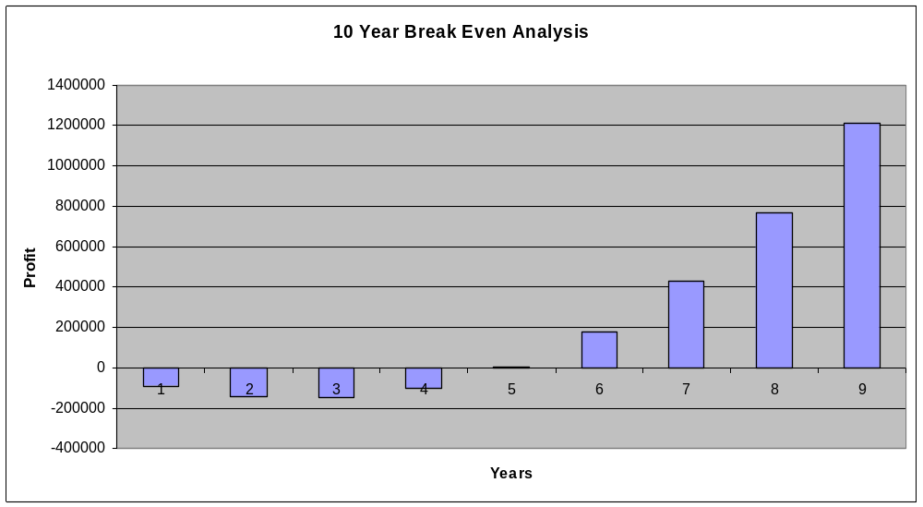

Competition Matrix

 | Does not require use of camera(s) | Does not require use of LCD | Does not require a full time operator | Does not require a change in teaching style | Records audio | Records visual | Scalable visual output
Student Audio Visual e-Tool | x | x | x | x | x | x | x
SmartBoard | x |  | x | x | x | x
Mimio | x | x | x | x |  | x
Quartet IdeaShare Board | x | x | x | x |  | x
Video camera/Teletechnet |  | x |  |  | x | x

There are several competing technologies, but each one has some detriments and/or missing components that our solution addresses.

Advertising
We can use direct marketing to university/college mathematics departments and consortiums.

Account representatives can attend several conferences aimed at teaching mathematics such as the following:

International Conference on Technology in Collegiate Mathematics
http://www.aw-bc.com/ictcm/index.shtml

National Council of Teachers of Mathematics
http://www.nctm.org/meetings/

Mathematics Association of America
http://www.maa.org/

American Mathematical Association of Two-Year Colleges
http://www.amatyc.org/

Funding Plan

With a focus on adding \technology that aims at increasing scholastic performance, SAVE will be the conduit to bring technology into the classroom. Key to success of this goal is the choice for the financier, and the National Science Foundation’s Small Business Innovative Research Program seeks to fund the development of innovative ideas such as ours for small businesses.
Success in Phase I, extending through the Spring semester of 2005 (1/17/05 through 6/10/05), will mostly require funding for salaries dedicated to research, prototype planning, programming, Management, and third party product reviews, will require $100,000 in grant funding by our chosen funding agency. Employees will include a Project Manager, 3 Hardware Developers, 3 Software Developers, and 2 expert consultants: an Educational Consultant and a Technical Consultant. Forty percent of the total funded sum will be allotted for overhead, which will be dedicated to personal salaries.
Phase II requires 2 years of intense development, and demands a much larger backing
of financial support than Phase I. Here, development and refining are the primary concerns. Lasting a full 2 years (6/10/05 through 6/11/05), it is split into major programming and test stages - Alpha/Beta Development & Testing and Final Development & Field Trials. The most financially demanding part of phase 2 will be the employment of a Project Manager, Software Developers, Hardware Developers, Web Developer, Testing Programmers, a Technical Staff (3), and the 2 Consultants. Also involved in the budget is the hardware (Development Server, Desktops (14),Whiteboard (3), & Microphone (3) ) and software (Flash (2), Microsoft Visual C# .NET (7), Photoshop CS or comparable photo editing program (1), and Microsoft Office (14) ) and miscellaneous overhead costs. The target sum for funding for the above items is $750,000.
As Phase II ends, the National Science Foundation will reward grantees by attempting to unite investors with our project, providing funding and support through a grounded, proven institution that meet a high standard of requirements set by the NSF. It is important that we are aligned with Universities and Colleges, in spirit and as a funding source. Our mission is to introduce a technologically advanced solution to the modern classroom that will be unobtrusive to the teacher, while aiding the student in necessary repetition. During Phase III, it will be our aim to seek financial solidarity through demonstrations and sample lectures throughout the country in various Secondary Educational Forums. As a supplement to this, we will also be taking a lesser (but important nonetheless) focus on high schools. This will help visibility of our product and potentially will open important alternate sources of revenue. In Phase III, we break even at Year 5 of production. Before that, we incur approximately $150,000 in debt by the end of Year 3 that will be covered by small business loans secured through the Small Business Administration and through local banks.
The most important funding decision is the use of a COTS solution for our main component - the whiteboard. This includes built-in Application Programming Interface (API) calls that will be easily interfaced with in the customized application set that we will be building for our project. The whiteboards that we have chosen have already gone through rigorous testing. All of this will inevitably lead to a savings in time, manpower, and ultimately money. Other factors that have been considered in our cost analysis are reduction of redundant software or hardware where they are unnecessary. This reduction will aid in our target of meeting financial goals in the 3rd phase. Profit and momentum are key in this phase, so even these small factors can be key to the project's success.

Funding source information:
http://www.nsf.gov/home/crssprgm/itr/
http://www.nsf.gov/mps/divisions/dms/about/dmsprograms.htm#itr
Resource Plan

Phase 1

The goals for Phase I include the development of the lab prototype for proof of concept and the research to begin production model development for Phase II.

We will need nine computer workstations. Seven of the nine computers will need to have Visual C#.NET. All nine computers will need to have office productivity software such as Microsoft Office and provide Internet access. One of the nine computers will need to have Microsoft Project.

- Project Manager – 1 desktop computer with MS Project, MS Office, and Visual C#.NET
  - The project manager will oversee software development and testing with Visual C#.NET, will monitor project’s process with MS Project, and will create various reports, proposals, presentations, etc. with Microsoft Office.
- Software/Hardware developers – 6 desktop computers with MS Office and Visual C#.NET
  - The developers will use Visual C#.NET for software development and will view and/or create documents with MS Office.
- Consultants – 2 desktop computers with MS Office
  - The consultants will view and/or create documents with MS Office.

We will need a pressure sensitive surface and sound recording device to create the lab prototype. Since this is the lab prototype, we do not need a full size digital whiteboard or a wireless sound recording device.

Phase II

The goals for Phase II include the development of the production model and the several testing phases.

In Phase II, we have 16 employees, of which, one is full time, five are half-time, and ten are less than half-time.

We will need fourteen desktops computers. Six of the desktops computers will be dedicated to the one full-time (project manager) and five half-time (developers) employees. The remaining eight computers will be shared by the 10 less than half-time employees as they will not all work at the same time.

For our software development and testing, we will need a development server. We will also need seven copies of Visual C#.NET for the testing programmers and the software developers. The two copies of Macromedia Flash will be used by the hardware developers. One copy of Adobe PhotoShop CS will be used by the web developer. Microsoft Office will be on all the desktop computers for creating and/or viewing documents.

For our hardware development, we will need three whiteboards and three wireless microphones. They will be used to test different whiteboards and microphones with our capture and synchronization software.

Phase III

The goal for Phase III is to begin production of our product and generate sufficient sales to break-even and start earning a profit.

Phase III will not include any Federal funding or use of a university’s resources. Therefore, we will need an office space, furniture, and supplies. We have a total of six employees and two contracted (attorney and accountant) employees. Therefore we will need six workspaces with four desktop computers and two laptop computers. The tech support employees work will include travel to universities for installation of new systems and user training and will therefore need the laptops for mobility. The remaining for employees will use desktop computers. All computers will have Microsoft Office to view and create documents or customer information databases. The software developer’s computer will have Microsoft Visual C#.NET.

Staffing Plan

Phase I

Title | Quantity | Hourly Rate | Hours Each | Total Cost
Project Manager | 1 | $40 | 200 | $8000
Plan and monitor the project’s process. Oversee all developers and consultants. Resolve all issues and conflicts. Maintain that the project meets schedule timelines and budget limits.

Title | Quantity | Hourly Rate | Hours | Total Cost
Software Developers | 3 | $25 | 300 | $22,500
Design and code the synchronization software for the lab prototype. Design and code the playback software for the synchronized output. Must consider the file format for the sound and video output. Will test synchronization and playback software developed.

Title | Quantity | Hourly Rate | Hours | Total Cost
Hardware Developers | 3 | $25 | 300 | $22,500
Test and choose the best sound capturing device and pressure sensitive surface to work for the lab prototype. Work with the API for the chosen sound and video devices. Translate whiteboard output into a vector format.

Title | Quantity | Hourly Rate | Hours | Total Cost
Education Consultant | 1 | $100 | 80 | $8000
Design real world field test. Create field test student survey. Create teacher test field survey. Acquire the classroom testing agreements.

Title | Quantity | Hourly Rate | Hours | Total Cost
Technical Consultant | 1 | $100 | 160 | $16,000
Will oversee and advise both hardware and software developers in choices, design, and testing.

Phase II

Title | Quantity | Hourly Rate | Hours | Total Cost
Project Manager | 1 | $40 | 3000 | $120,000
Plan and monitor the project’s process. Oversee all developers and consultants. Resolve all issues and conflicts. Maintain that the project meets schedule timelines and budget limits.

Title | Quantity | Hourly Rate | Hours | Total Cost
Software Developers | 3 | $25 | 2000 | $150,000
Design and code the synchronization software for the production prototype. Design and code the playback software for the synchronized output. Must consider the file format for the sound and video output. Design and develop the graphical user interface. Develop network communication interfaces for file transfers.

Title | Quantity | Hourly Rate | Hours | Total Cost
Hardware Developers | 2 | $25 | 2000 | $100,000
Work with the API for the chosen sound and video devices. Translate whiteboard output into a vector format. Encode the audio and graphics into our proprietary format.

Title | Quantity | Hourly Rate | Hours | Total Cost
Web Developer | 1 | $25 | 1500 | $37,500
Design the company web site and user interface for accessing the classroom content. Design authentication scheme for controlling access to content. Design database schema for storing users and content.

Title | Quantity | Hourly Rate | Hours | Total Cost
Testing Programmers | 4 | $25 | 500 | $50,000
Improve and enhance the software during the testing and evaluation phase.

Title | Quantity | Hourly Rate | Hours | Total Cost
Technical Staff | 2 | $25 | 500 | $25,000
Set up and maintain the hardware and software in the classroom environments during the testing and evaluation phase.

Phase II - continued

Title | Quantity | Hourly Rate | Hours | Total Cost
Education Consultant | 1 | $100 | 360 | $36,000
Execute field tests, student surveys, and teacher surveys. Evaluate playback usability, playback helpfulness, and additional playback qualities. Identify playback problems. Evaluate usability and durability of hardware. Evaluate usability of recording and distribution. Evaluate classroom role. Identify problems. Evaluate additional qualities.

Title | Quantity | Hourly Rate | Hours | Total Cost
Technical Consultant | 1 | $100 | 180 | $18,000
Will oversee and advise both hardware and software developers in choices, design, and testing. Responsible for critically evaluating all technical components.

Title | Quantity | Hourly Rate | Hours | Total Cost
Technical Writer | 1 | $25 | 500 | $12,500
Compose the product documentation and the training manuals.

Phase III

Title | Quantity | Hourly Rate | Hours | Total Cost
General Manager | 1 | $40 | 2000 | $80,000
Supervise all employees and contractors/consultants. Represent the company to all potential customers.

Title | Quantity | Hourly Rate | Hours | Total Cost
Attorney | 1 | $150 | 40 | $600
Prepares and examines contracts involving leases, licenses, purchases, sales, insurance, etc. Provides legal advice to an organization, prepares resolutions and forms, and participates in major legal actions. Responsible for foreseeing and protecting company against legal risks.

Title | Quantity | Hourly Rate | Hours | Total Cost
Software Developer | 1 | $25 | 1000 | $25,000
Develop upgrades and perform software maintenance.

Title | Quantity | Hourly Rate | Hours | Total Cost
Web Programmer | 1 | $25 | 1000 | $25,000
Maintain the company web site and make changes to web interface as needed due to software upgrades.

Title | Quantity | Hourly Rate | Hours | Total Cost
Accountant | 1 | $20 | 500 | $10,000
Prepares balance sheets, profit and loss statements, and other financial reports. Responsibilities also include analyzing trends, costs, revenues, financial commitments, and obligations incurred to predict future revenues and expenses. Reports organization's finances to management, and offers suggestions about resource utilization, tax strategies, and assumptions underlying budget forecasts.

Title | Quantity | Hourly Rate | Hours | Total Cost
Tech Support | 2 | $20 | 2000 | $80,000
Duties include help desk, installing systems for new customers and user training.

Title | Quantity | Hourly Rate | Hours | Total Cost
Account Representative | 1 | $15 | 2000 | $30,000
Maintains relationships and favorable contacts with current and potential accounts. Sets up new account information, and resolves customer issues/problems.

S.A.V.E Milestones

Phase 1 – Prototype Development
Duration: January 17, 2005 - June 10, 2005

Milestone 1-A -
Duration: January 17, 2005 – March 30, 2005
Deliverable: Preliminary Design Document

Milestone 1-B -
Duration: February 28, 2005 - June 10, 2005
Deliverable: Concept Prototype Demonstration

Phase 2 – Production Model Development
Duration: June 10, 2005 – June 10, 2007

Milestone 2-A –
Duration: June 10, 2005 – November 25, 2005
Deliverable: First Release Alpha Version

Milestone 2-B –
Duration: November 25, 2005 – December 10, 2005
Deliverable: Preliminary Alpha Test Approval by Educational Consultant

Milestone 2-C –
Duration: December 10, 2005 – June 10, 2006
Deliverable: Final Version Alpha Release

Milestone 2-D –
Duration: June 10, 2006 – June 25, 2006
Deliverable: Final Alpha Test Approval by Educational Consultant

Milestone 2-E –
Duration – June 25, 2006 – August 13, 2006
Deliverable: Preliminary Beta Field Test Results

Milestone 2-F –
Duration: August 27, 2006 – December 23, 2006
Deliverable: Redeveloped Final Release Version

Milestone 2-G –
Duration: January 15, 2007 - May 10, 2007
Deliverable: Surveys and Results from Final Field Testing

Milestone 2-H -
Duration: May 10, 2007 – June 10, 2007
Deliverable: Results Analysis and Project Success Evaluation

YEAR 2

TESTING SECTION
(4) Jan- May –Beta Testing
We test for bugs and receive feedback from teachers by putting the initial version of the product into a classroom environment. No results from learning rates are tabulated at this point.

(4) May-August – Redevelopment
Necessary Improvements and bug fixes discovered during Bug Testing are fixed and implemented during this portion, resulting in the final deliverable product.

(4) August-December – Evaluation Testing, Final Release
The final version of the product is deployed into multiple classrooms for the purposes of evaluation of the effect on learning rates. Results will be generated by surveys to the students and teachers along with grade analysis. These results will be used as evidence supporting our product for marketing. No changes will be made to the whiteboard during this phase to preserve the accuracy of the results.

SAVE Schedule

Phase 1 – Prototype Development
Duration: January 17, 2005 - June 10, 2005

We will evaluate the current state of technology, and make decisions on which technology to base our project off of. We will identify necessary design features, and necessary software technology components to successfully complete the project. We will demonstrate the feasibility of the concepts and demonstrate that the necessary software solutions are possible.

Phase 2 – Production Model Development
Duration: June 10, 2005 – June 10, 2007

Section 2A
Duration: June 10, 2005 – November 25, 2005
During this time we will build the framework for the actual production software. At the end of this section, a rudimentary alpha version will be delivered. This alpha version will demonstrate the core functionality and uses of our software.

Section 2B
Duration: November 25, 2005 – December 10, 2005
During this time, the Educational Consultant will be evaluating the software to determine its potential for successfully being deployed in a classroom environment. An early external testing phase will allow us to correct the direction of the product development before major faults are designed into the system.

Section 2C
Duration: December 10, 2005 – June 10, 2006
This section will continue the development started in 2A, with the factored in corrections generated during section 2B. The end of this section will result in an alpha release suitable for deployment in a classroom.

Section 2D
Duration: June 10, 2006 – June 25, 2006
The Educational Consultant will evaluate the developed version of the software and evaluate its potential use in the classroom environment. The approval of this will allow the software to move into the field testing sections.

Section 2E
Duration: June 25, 2006 – August 13, 2006
We will beta test this product in a classroom during the last half of the summer semester. This section is not oriented on determining the effectiveness of our product on learning rates, but on finding and evaluating all bug and failures in the program and receiving feedback from the teachers. No results on learning rates will be determined at this point, since the software will not be reliable or steady enough to depend on as a primary teaching tool.

Section 2F
Duration: August 27, 2006 – December 23, 2006
We will implement required improvements and make sure bugs discovered during the pervious section are fixed. This process will result in the final version of the software that will be the basis for judgments on the improvements in learning rates,

Section 2G
Duration: January 15, 2007 - May 10, 2007
The final version of the product will be deployed into multiple classrooms for the purposes of evaluation of the effect on learning rates. Results will be generated by surveys to the students and teachers along with grade analysis. These results will be used as evidence supporting our product for marketing. No changes will be made to the whiteboard technology during this phase to preserve the accuracy of the results.

Section 2H
Duration: May 10, 2007 – June 10, 2007
The results from the previous section will be evaluated and analyzed. These will be used as a basis for confirming the effectiveness and usefulness of our product. From this section, we will have documents showing how big of an effect on learning our product provides.

Phase 1
Time | 15 Weeks
Funding | $100,000
 | Total # | # of hours | hourly wage | cost
Employees
Project Manager | 1 | 200 | $40 | $8,000
Hardware Developer | 3 | 300 | $25 | $22,500
Software Developer | 3 | 300 | $25 | $22,500
Total for Employees |  |  |  | $53,000
Consultants
Educational Consultant | 1 | 80 | $100 | $8,000
Technical Consultant | 1 | 160 | $100 | $16,000
Total for Consultants |  |  |  | $24,000
Total Employees |  |  |  | $53,000
Total Overhead (40%) |  |  |  | $21,200
Employees |  |  |  | $53,000
Consultants |  |  |  | $24,000
Overhead |  |  |  | $21,200
Total |  |  |  | $98,200
Phase 2
Time | 2 Years
Funding | $750,000
 | Total # | # of hours | hourly wage | cost
Employees
Project Manager | 1 | 3000 | $40 | $120,000
Software Developers | 3 | 2000 | $25 | $150,000
Hardware Developers | 2 | 2000 | $25 | $100,000
Web Developer | 1 | 1500 | $25 | $37,500
Testing Programmers | 4 | 500 | $25 | $50,000
Technical Writer | 1 | 500 | $25 | $12,500
Technical Staff | 2 | 150 | $25 | $7,500
Total for Employees |  |  |  | $477,500
Consultants
Educational Consultant | 1 | 360 | $100 | $36,000
Technical Consultant | 1 | 180 | $100 | $18,000
Total for Consultants |  |  |  | $54,000
Software
Flash | 2 | 500 |  | $1,000
Microsoft Visual C# .NET | 7 | 109 |  | $763
Photoshop CS | 3 |  |  | $1,947
Microsoft Office | 9 |  |  | $630
Total for Software |  |  |  | $4,340
Hardware
Development Server | 1 |  |  | $6,000
Desktops | 9 |  |  | $10,800
Whiteboard | 3 |  |  | $6,000
Microphone | 3 |  |  | $300
Total for Hardware |  |  |  | $23,100
Total Employees |  |  |  | $477,500
Overhead (40%) |  |  |  | $191,000
Employees |  |  |  | $477,500
Consultants |  |  |  | $54,000
Software |  |  |  | $4,340
Hardware |  |  |  | $23,100
Overhead |  |  |  | $191,000
Total |  |  |  | $749,940
Phase 3
Time | Continual
 | Total # | # of hours | hourly wage | cost
Employees
General Manager | 1 | 2000 | $40 | $80,000
Software Developers | 1 | 1000 | $25 | $25,000
Web Programmer | 1 | 1000 | $25 | $25,000
Tech Support | 2 | 2000 | $20 | $80,000
Account Representative | 1 | 2000 | $15 | $30,000
Total for Employees |  |  |  | $240,000
Outside Staff
Contract Attorney | 1 | 40 | $150 | $6,000
Patent Attorney | 1 | 100 | $150 | $15,000
Accountant | 1 | 500 | $20 | $10,000
Total for Outside Staff |  |  |  | $31,000
Total Employees |  |  |  | $240,000
Overhead (40%) |  |  |  | $96,000
Employees |  |  |  | $240,000
Consultants |  |  |  | $31,000
Overhead |  |  |  | $96,000
Total |  |  |  | $367,000

Competition Matrix

 | Does not require use of camera(s) | Does not require use of LCD | Does not require a full time operator | Does not require a change in teaching style | Records audio | Records visual | Scalable visual output
Student Audio Visual e-Tool | x | x | x | x | x | x | x
SmartBoard | x |  | x | x | x | x
Mimio | x | x | x | x |  | x
Quartet IdeaShare Board | x | x | x | x |  | x
Video camera/Teletechnet |  | x |  |  | x | x

GANTT Charts

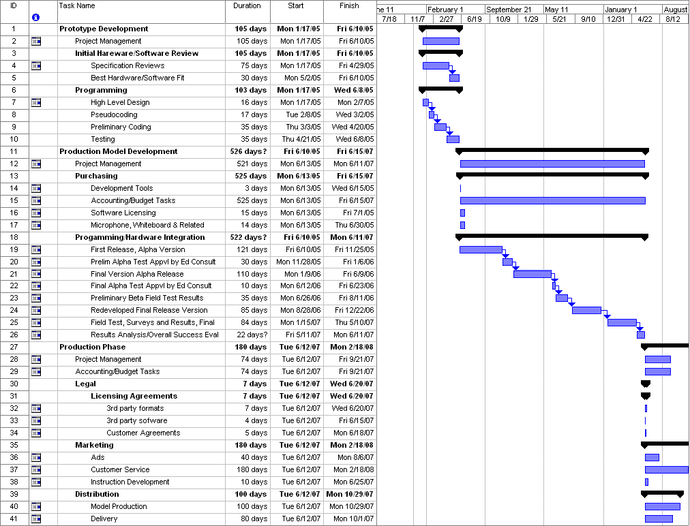

Work Breakdown Structure Chart

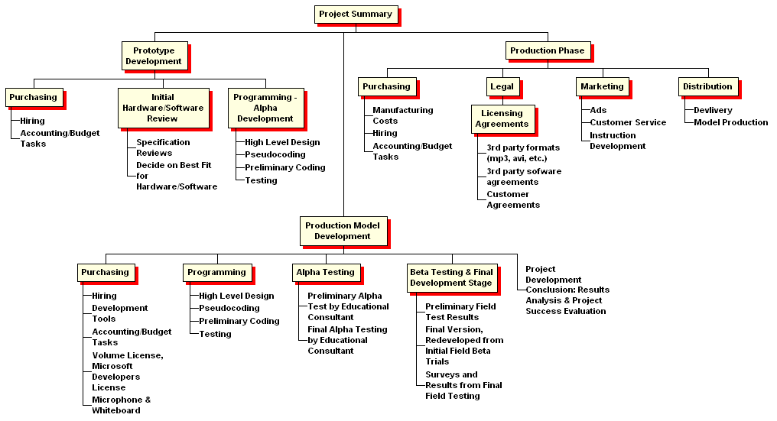

Organizational Charts

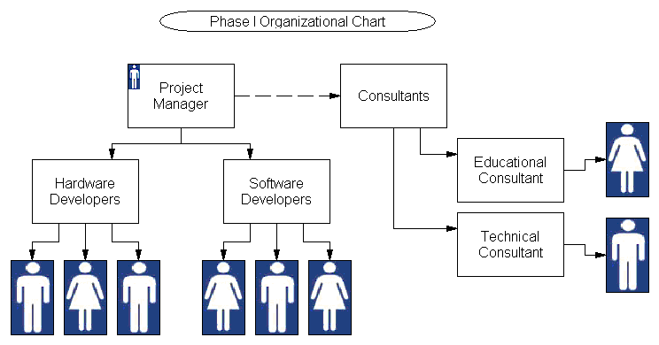

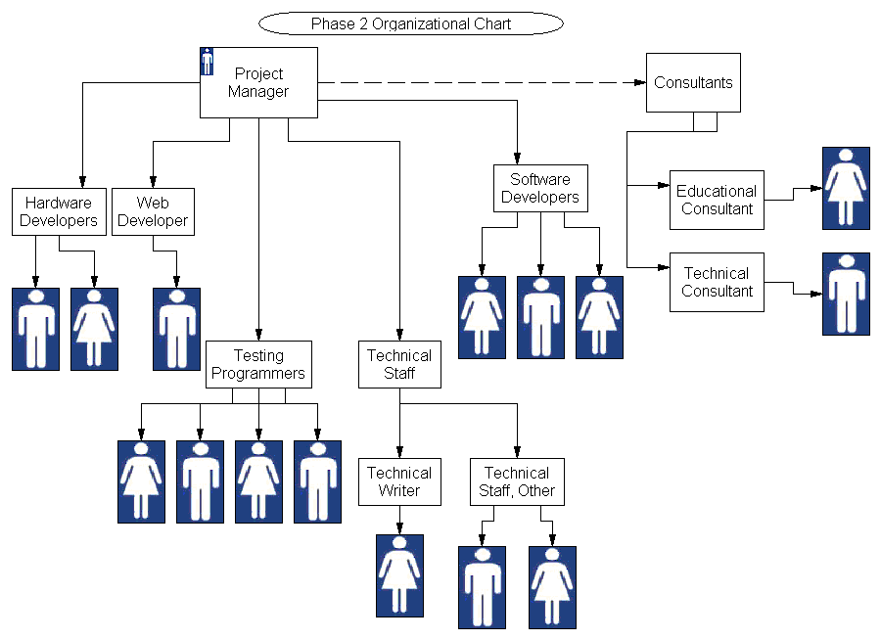
Data Flow Charts

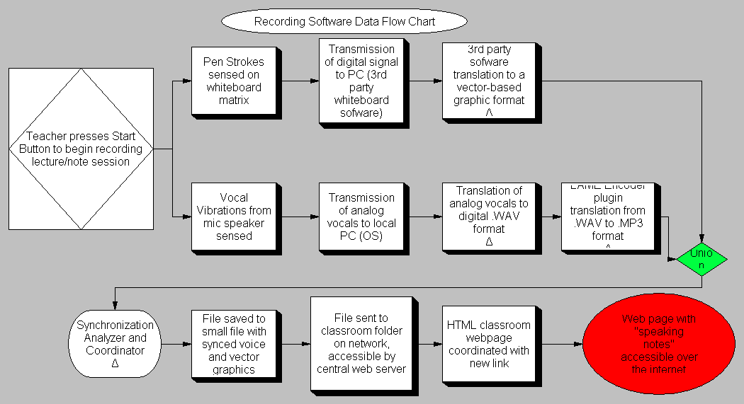
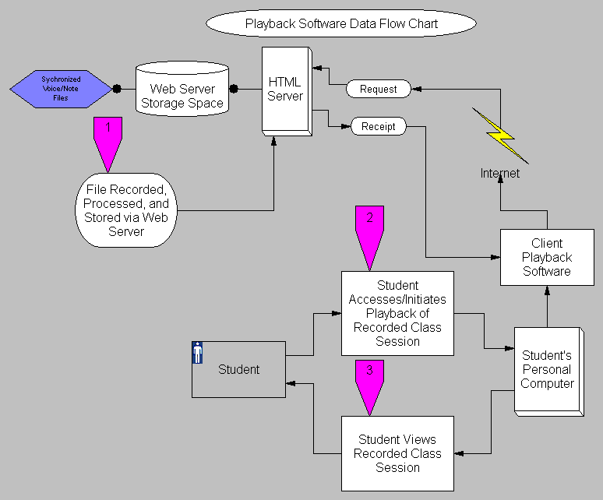

Miscellaneous Charts
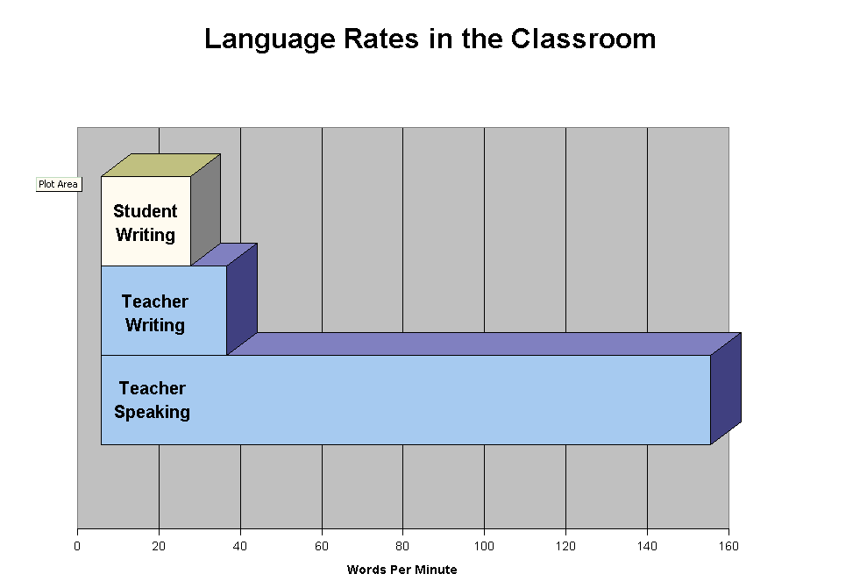
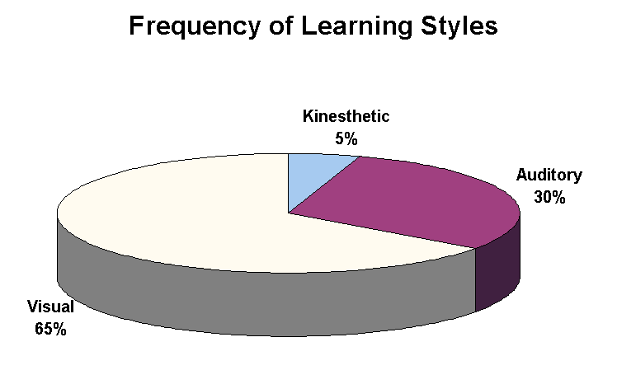

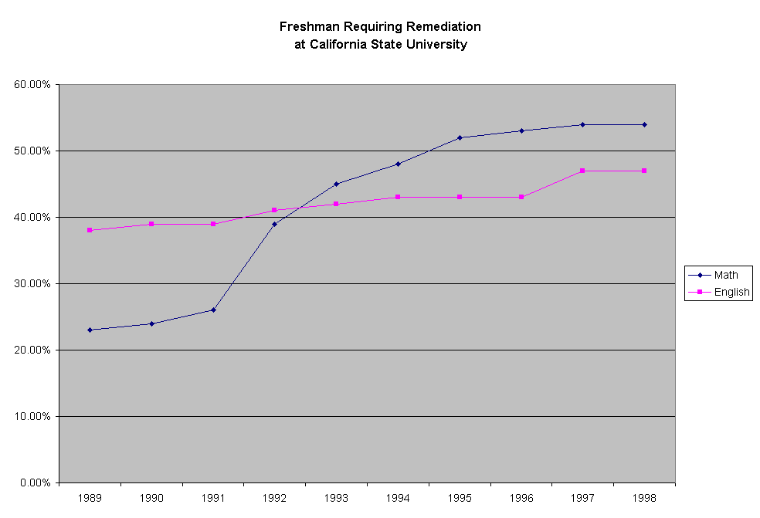

Playback Screenshots

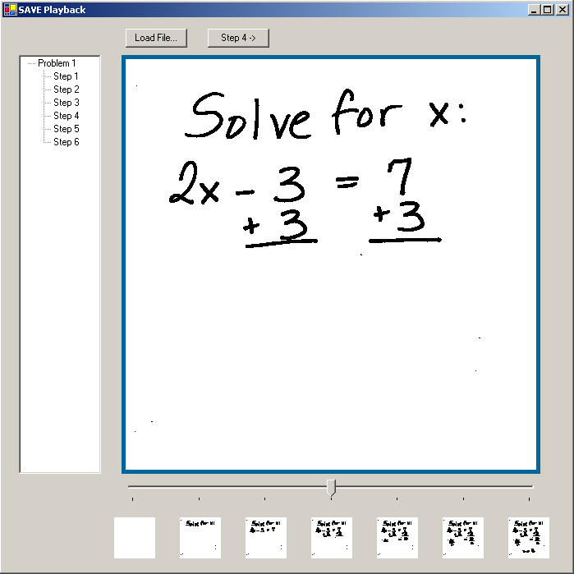

College Math Requirements
Old Dominion University (ODU) offers a B.S. in mathematics, M.S. in computational and applied mathematics, M.S. in mathematics education, and a Ph.D. in computational and applied mathematics. All undergraduate students are required to complete at least three credit hours of mathematics.
MATH 101M | An Introduction to Mathematics for Critical Thinking
 | An introduction to the ways in which modern mathematics can be used to analyze the modern world and make logical decisions. Topics include problem solving, sets, logic, consumer mathematics (loans, mortgages, annuities), and elementary statistics.
MATH 102M | College Algebra
 | A basic course in algebra which emphasizes applications and problem-solving skills. Topics include properties of the real numbers, graphing of equations and inequalities, the algebra of rational expressions, and properties of exponentials and logarithms.
MATH 162M | Pre-Calculus
 | The first course in a two course sequence designed to provide a strong preparation for calculus. Topics include algebraic operations, equations and inequalities, graphs and functions, polynomial functions, theory of equations, system of equations and Gaussian elimination.
STAT 130M | Elementary Statistics
 | An introduction to hypothesis testing, estimation, chi square tests, correlation, design of experiments, and data description. The concept of probability is introduced and its role in statistical inference is emphasized.
A student can choose three credits from one of the above to satisfy the general education mathematics requirement. He or she should choose the math course based upon further math requirements in his or her major, but will be placed in the appropriate level of math based upon results of the placement test. Depending on a student’s major, (ex. computer science, engineering, physics, etc.) more or different mathematics may be required.

ODU administers a common final exam for MATH 102M and MATH 162M among others. Therefore all instructors for these classes are required to cover a basic set of topics in the semester.

ODU has 20,802 total students. Among those 14,209 are undergraduate students and 6,593 are graduate students.

SAVE File Size Information

Because streaming media requires a representation of bit depth for every pixel captured in the original video, this requires much more space for file recording. This, in turn, requires more time to download and causes congestion at the source, and local congestion is of importance for our customer. Lower download speed equals a larger support system, and this means our customer will be able to reach out to more students.
By vector mathematics, curves, colors, etc. are simplified and require much less storage space because the computations are done in real-time at the site of the student, instead of at the server.

CNET News Headline, August 2004
"U.S. Broadband Connections Reach Critical Mass, Crossing 50 Percent Mark for Web
Surfers, According to Nielsen//NetRatings".

So even if we assume that college students make up a slightly larger portion of broadband users than the average person, we still have a little less than 50 percent of the market that's being discounted by assuming that streaming media is the standard.

Citation: The above CNET Article Headline quotation was taken from:
http://investor.news.com/Engine?Account=cnet&PageName=NEWSREAD&ID=1276668&Ticker=NTRT&SOURCE=SFW02718082004-1

Risk Analysis Chart

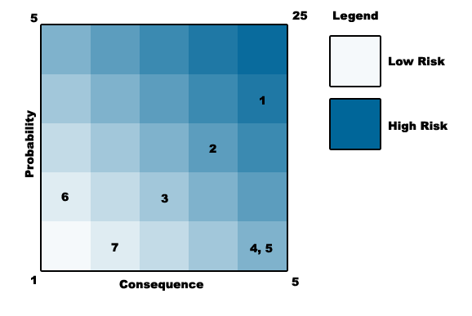

Ranking: 1
Probability / Consequence: 4 / 5
Risk Expected: 20
Risk Category: Technical
Description: The group will not be able to make the desired components of the project to work properly together. This will increase testing time and increase the cost of the phases.
Mitigation: The group researches enough to provide feasible components to the product that have the best chances of working together with minimal adjustments.

Ranking: 2
Probability / Consequence: 3 / 4
Risk Expected: 12
Risk Category: Cost
Description: Will the final product be cost effective enough that will promote purchases.
Mitigation: Create a Work Breakdown Structure (WBS) and plans that best suit to avoid this problem as well as research the components to determine more cost effective ways to solve the problem.

Ranking: 3
Probability / Consequence: 2 / 3
Risk Expected: 6
Risk Category: Technical
Description: Will the components be durable enough to last in a classroom setting and long enough to prevent user complaints and unnecessary future costs to the company and possible revision of product.
Mitigation: Provide components that allow the best results yet still maintain cost effectiveness stated in risk 2.

Ranking: 4
Probability / Consequence: 1 / 5
Risk Expected: 5
Risk Category: Customer
Description: Due to risks 1, 2, and 3 the customer will not be satisfied with the product and the product will not sell. The customer believes the product does not help solve the problem statement or improve current methodologies.
Mitigation: Prevent or reduce all risks that increase the described risk as well as provide enough research to prove our solution works. Provide a well designed product to the customer.

Ranking: 5
Probability / Consequence: 1 / 5
Risk Expected: 5
Risk Category: Customer / Technical
Description: The product, even though functional, does not provide the ease of use planned on incorporating. The hardware or software is not user friendly or requires too much technical knowledge for the average user to operate.
Mitigation: Provide a well designed product to the customer that includes most if not all the risks in the description.

Ranking: 6
Probability / Consequence: 2 / 1
Risk Expected: 2
Risk Category: Time Management
Description: The project will not be completed in the time frame allotted.
Mitigation: Allow plenty of time for time management. Make sure the project is on schedule or include enough extra time for any problems that may occur.

Ranking: 7
Probability / Consequence: 1 / 2
Risk Expected: 2
Risk Category: Customer
Description: The product is too advanced for users. Users resist the use of the technology for any reason.
Mitigation: Include advanced technology in the product but make the appearance simple and appear friendly to novice and expert users alike.

From Peterson’s Education Portal. Available at: http://www.petersons.com
From ODU Campus Facts. Available at: http://www.odu.edu/webroot/orgs/IA/university_news.nsf/campusfacts?OpenForm
From ODU Campus Facts. Available at: http://www.odu.edu/webroot/orgs/IA/university_news.nsf/campusfacts?OpenForm

