Customizable Credit Card Protection (C³P)

By: Green Team
Group Members: Justin Brunelle
Nigel Tierney, Jeremy Archey
Jason Benson, Lisa Ortiz

CS411W
Spring 2007
Table of Contents

Introduction (Nigel & Justin)………………………………………………………………….…2

Technical Approach………………………………………………………………………….3-14
Prototype Capabilities (Aaron)………………………………………………………..3-7
Prototype to Product Transition (Jason)……………………………………………...8-9
Key Personnel, Facilities, and Equipment (Lisa & Jason)………………………...10-14

Commercialization Strategy (Nigel)…………………………………………………………...15

Schedule, Milestones, and Deliverables (Justin)………………………………………………16

Proposal Costs (Lisa)……………………………………………………………………………17

Summary (Jeremy)……………………………………………………………………………...18

Appendix A: Lessons Learned (Aaron & Nigel)..…………………………………………19-20

Appendix B: Work Breakdown Structure (Justin)……………………………………...21-22

Appendix C: Glossary (Nigel & Lisa)………………………………..……………………23-27

Appendix D: Technical Tables (Justin)………………………………..…………………..28-32
(All sections reviewed and formatted by Jeremy, approved by Green Team as a whole)
Introduction
Under the current system of credit card use in industry, credit cards are issued by the company to employees. Normally, these cards are only to be used for expenses related to corporate functions. As the system currently stands, there are no immediate checks to prevent an employee from purchasing an item for personal use.
The Environmental Protection Agency (EPA) performed research showing that 11% of government employees given government credit cards could not produce receipts of purchases made using the issued cards. Of those that produced receipts, 9% had purchased prohibited items. 11% of these employees lent their card to unauthorized users. The EPA investigation also found that nearly $14 billion of government money entrusted to government employees was spent on private purchases and that small businesses lose, on average, $2,500 to $100,000 annually on unauthorized purchases (EPA, 1996).
The solution to company credit card misuse is Customizable Credit Card Protection (C³P). C³P is a solution developed by a group of computer science students at Old Dominion University (ODU) for the senior capstone course CS411W. The group of students is known as the Green Team. C³P will eliminate unauthorized purchases by government and private business employees. C³P will prevent employees from spending their company’s funds inappropriately by preventing purchases at certain types of commercial locations using Merchant Commercial Codes (MCCs) that distinguish a store by type (cheese shops, clothes shops, etc.). C³P will also limit spending by preventing purchases of specified items by Universal Product Code (UPC) that identify one product from another (Mrs. Fields cookies from Oreos). Spending will also be limited by a daily spending limit.
Technical Approach
Prototype Capabilities

Objectives
The purpose for the rigorous testing that we will be performing is to ensure that the prototype we have created is stable, functional and meets all of the requirements which we outlined in previous documents. In this section of the SBIR, we will be describing our plan of action to test the C³P software. We will outline the requirements for our testing plan and also our schedule of tests. Finally, we will describe in detail each of the intended test cases. We will be testing our software to make sure that it runs without errors and does not misinterpret data. We will also be testing the decision making mechanisms within the software to be sure that it adheres to the specifications that we decided on.

References
Fowler, Aaron (2-12-07). Lab 2 – Prototype specification. 3-18-07.
Fowler, Aaron (2-07-07). Lab 1 – Descriptive Paper. 3-18-07
Brunelle, Justin (2-12-07). Lab 2 – Prototype specification.
Benson, Jason (4-17-07). Lab 2 – Prototype specification. 4-17-07.

Test Plan
The test plan shall cover the testing approach, identifying test cases, and the testing schedule. For the entire process, fault reporting and data recording shall take place. The resource requirements shall be defined as well as the test environment.

Testing Approach
Compliance testing shall be performed on the component level to make sure all the units perform properly with no unplanned errors before integration. After integrating all the units, we shall test for compliance between the units to prove they have the ability to work together at the integration level. Finally, the entire system shall be tested for speed and compliance to make sure it will run smoothly.
Test methods shall be performed using several PCs and ODU Unix server. The software to be tested will be the Business Leader GUI, Simulated POST, and Purchase Verification Software. The testing data shall be a combination of real, simulated, and artificial. Everything for the Business Leader GUI except the UPC and MCC tables will be simulated. The UPC and MCC tables contain real and simulated data. All software modules input, output, and their ability to interface with the specified modules shall be tested.

Identification of Tests
For a detailed table that lists each test and its objective, please refer to Table 1 in Appendix D.

Test Schedule
For a detailed table showing a list of each test and the time allotted to it, please refer to Table 4 in Appendix D.

Fault Reporting and Data Recording
For each component of the overall prototype we will have different methods of recording faults and reporting errors. Each is as follows:
- Purchase Validation Software
  - Matrix of recorded behavior of the system will be compared to a matrix of expected outcomes (tautologies of each combination of inputs)
  - Any inconsistencies will be marked on the matrix and will be addressed in the code
- Database and data input
  - We will prepare a spreadsheet of records to be entered into the system. We will then attempt to insert these records into the system and view them.
  - If a printout of the records show inconsistencies with the intended values, the erred records will be marked and the structural problem will be addressed
  - Modification of the database will be handled the same way by making changes to records and comparing the resulting database to the intended outcome.
- Interface
  - We will create a structure chart of all vital components of the interface. This structure chart will show the methods by which each component is to be accessed. We will then navigate the interface and make sure that this chart matches the navigable components.
  - We will make a list of all the database fields, and we will mark the ones that should be editable and which ones should not. We will then navigate the interface to make sure that each element on the list is able to be edited if necessary.

Resource Requirements
Our hardware requirements include a web server and a database server to host the Business Leader GUI. Lastly we need at least one computer terminal to hook up the card reader to, access the GUI and run the Simulated POS Terminal. While multiple users are working on testing the system each will have a separate terminal, but the minimum will be only one.
There is a large amount of software required for the testing of our prototype. For the Web server, we will need a Web server application (Apache or Tomcat) and PHP 4 installed. On the database server we will need MySQL 4 installed. The Simulated POS Terminal will need a Windows workstation that can access the internet and run java applications. The Business Leader GUI can be accessed by internet from any computer that is running an internet browser (Mozilla Firefox, Internet Explorer, Netscape Navigator).
The database will be populated with simulated values in order to do testing. We will have a database of fake business leaders and a database of fake employees to test purchases on. We will then have a database that is populated with simulated UPCs of different kinds to demonstrate how they will be accessed and displayed. Finally, we will have a database of simulated MCCs that will allow us to show blocking by merchant type.
The only personnel that will be required in the testing of our prototype will be the Green Team. Our advisors may need to be contacted in case of a major problem with the software but the testing will be strictly done by Green Team members.

Test Environment
The test environment will be the meeting room in ODU's Engineering and Computer Science building. C³P shall use two projects and their screens to show the audience the Simulated POST from Aaron's laptop and the Business Leader GUI from one of ODU's laptops in that room.

Test Responsibilities
There will be two different types of testers in the development of our prototype. The first will be the developers themselves. Aaron will be responsible for testing the intricacies of the card reading software during its development because he has the knowledge of that system. Jason will be doing the testing on the Simulated POS Terminal operation and the Business Leader GUI because he has been coding them. The overall system, though, will be tested by each member of the team in a variety of ways in order to prove its robustness and ability to handle a wide range of inputs.

Test Procedures
In order for our test procedures to be affective, we made a couple assumptions. For all test cases the database must be set up to the specifications mentioned in previous documents and the software and interfaces are functioning. Each test case will be run for many trials and will be done with different sets of data as inputs.
Table 3 in Appendix D contains C³P's prototype requirements traceability, description of each test, test initialization, test inputs, test procedure, expected result, and special instructions where required for each test case. Data for section 6 is also included in this table.

Traceability to Requirements
For a detailed table tracing capabilities to requirements, please refer to Table 4 in Appendix D.

Prototype to Product Transition
For our prototype we chose to scale down our solution and cut out certain portions of the design that we intended to have in the product. By narrowing this scope we made the prototype more manageable to produce but also still allowed us to prove that our solution is functional and feasible. For each part of our prototype we will be doing design and development in order to create the final product.
Business Leader GUI
The business leader's interface will not get many changes. We will be implementing a reporting system that will work like an automated receipt tracking program. This will be written into the GUI and will interface with a database. Most of the work we will do on it will be to make it as reliable as possible. We will create redundancy with the databases and have a backup web server if anything goes down in order to provide 24-hour access to our software. The look and the operation of all the other parts will remain the same.
POS Terminal
In the final product we will be using real POS terminals, not the simulated POS that we created to test the prototype. This will involve us taking the POS software from different vendors and editing it to work with our system. What we will need to do is program the software to send the UPCs through the credit card transaction so that we will be able to check them. For this we will need to get a hold of a couple of different POS terminal software packages and find which we like the most and work with it.

Purchase Verification Software
The Purchase Verification Software was written in PHP in order to make it more easily integrate with our simulated POS terminal in testing the prototype. When we transition to the final product this package will be rewritten in another language with networking support. The logic is already complete it is just that the language it is written in now won't support what we need. This is because the software will have to receive incoming connections from POS terminals by phone line and then check if they are allowed or denied. Also we will have to implement the code for forwarding the credit card information, if the purchase is approved, to the credit card companies so that they can charge the card. These two functions will drive us to pick a language that is suitable for both and then we will code it.
Key Personnel, Facilities, and Equipment
Key Facilities
Computers, software, and facilities space will be provided by Old Dominion University. Costs for these materials are included in the 40% overhead calculated for the personnel resources.
Key Personnel
Project Manager & Risk Director
Name: Justin Brunelle
Annual Salary (Project Manager): $75,616
Annual Salary (Risk Director): $68,141
Background: Justin is a Virginia Beach local in his 3rd year as a Computer Science major at ODU. He works on the iSTART research project under Dr. Levinstein and plans on attending grad school at ODU. His research interests include web programming and modeling and simulation.
Responsibilities (Project Manager): The project manager’s responsibilities include making sure that all tasks are assigned and are performed with high quality. The project manager must also resolve difference between team members and facilitate team member communications. The project manager also must develop the WBS, assign resources, prioritize tasks, and define task dependencies.
Responsibilities (Risk Director): The risk director assesses and manages all risks associated with the project. He determines severity and probability of each risk. Mitigation methods are developed and documented to help eliminate each risk. The risks and mitigations are then documented and reported.
Technical Director
Name: Aaron Fowler
Annual Salary: $56,926
Background: Aaron is a senior at ODU majoring in Computer Science with a minor in Computer Engineering. He transferred from VWCC with associate’s degrees in Computer Science and Computer Engineering. He works as a consultant for the ODU systems group.
Responsibilities: The responsibilities include determining the technical requirements and managing the technical staff. The technical director must determine has the problem with be solved from a technical perspective.

Financial Director & Simulated POST Programmer
Name: Lisa Ortiz
Annual Salary: $108,901
Background: Lisa is from Northern Virginia and in her 4th year at ODU, majoring in Computer Science with a minor in Finance. During the summer and winter breaks, she interns with Northrop Grumman Mission Systems in Dahlgren, VA. She has been there since the summer of 2004. She is also currently a member of the Society of Hispanic Professional Engineers.
Responsibilities: The responsibilities include receiving funding, creating the budget, and determining the product cost. The financial director is responsible for the financial and funding plans.

Business Leader GUI Programmer
Name: Jason Benson
Annual Salary: $52,920
Background: Jason Benson is a senior in ODU’s computer science program. He enjoys break-dancing in his spare time.
Responsibilities: The responsibilities include determining the functionality of the project components. The co-technical director is responsible for defining the requirements from a user’s perspective. As webmaster, the responsibilities include creating the team and product websites, as well as managing the web developers in future phases.

Documentation Specialist/ Presenter
Name: Jeremy Archey
Annual Salary: $35,751
Background: Jeremy is a senior at ODU, majoring in Computer Science with a minor in Information Technology. He has an interest in sales and public speaking, and currently works full time at Kay Jewelers. After graduation, he hopes to enter a career that involves travel and personal interaction with clients.
Responsibilities: The responsibilities of the presenter are to make sure power points and presentations are of high quality and to present project information to board members. The responsibilities of the documentation specialist are to proof-read and assemble all team documentation.

GUI Programmer
Annual Salary: $46,282
Responsibilities: A GUI Programmer designs and develops business applications using a number of visual components. He may participate in the testing and enhancing of components. He may be required to have a bachelor's degree in a related area and 0-3 years of experience in the field or in a related area. He has knowledge of commonly-used concepts, practices, and procedures within a particular field (i.e., C, C++ language programming, XMotif programming interfaces and GUI API packages). A GUI Programmer relies on instructions and pre-established guidelines to perform the functions of the job.

Programmer II
Annual Salary: $45,368
Responsibilities: A Level II Programmer reviews, analyzes, and modifies programming systems including encoding, testing, debugging and documenting programs. He may be required to have an associate's degree in a related area and 2-5 years of experience in the field or in a related area. He needs to be familiar with standard concepts, practices, and procedures within a particular field. A Programmer II relies on limited experience and judgment to plan and accomplish goals. He performs a variety of tasks.

Database Administrator
Annual Salary: $73,252
Responsibilities: The DB Administrator administers, maintains, develops and implements policies and procedures for ensuring the security and integrity of the company database. He Implements data models and database designs, data access and table maintenance codes; resolves database performance issues, database capacity issues, replication, and other distributed data issues. He may be required to have a bachelor's degree in a related area and 2-4 years of experience in the field or in a related area. The administrator must be familiar with standard concepts, practices, and procedures within a particular field. A Database Administrator relies on limited experience and judgment to plan and accomplish goals. He performs a variety of tasks.

Key Equipment

RFID Cards, RFID Smart Card Reader/Writer, and domain name registration.
Commercialization Strategy
The initial target market that the Green Team chose for use of C³P will be the local, small to mid-size businesses within the Hampton Roads area that have a large employee base and that use corporate credit cards (Tierney, 2006). The reason that the Green Team chose this market is that they have already interviewed business managers at corporations such as Edo and Saic who, as a result, expressed a great need and interest in this product. These companies alone reflect a loss of either $250,000 per year or $100 per employee (Personal Communication, Nov 28, 2006). Market analysis could not find exact figures on the number of businesses in either the Hampton Roads area or even the United States; however, figures were located stating data that in 2006 Visa alone had $190 billion spent on corporate business credit cards (Tierney, 2006). However, C³P needs only to corner the local area alone to create a marketable success.
The Green Team chose SAIC and EDO corporation as their initial customer due to disturbing facts which were uncovered after interviewing business managers in both companies; one employee used the company credit card to put $14,000 down payment on a house, another employee bought several $1,500 airline tickets (and canceled the flight to collect the cash refund, which he used to finance his private company) (Personal Communication, 2006). This is just a minute look at the types of business credit card misuse that occurs today.
The Commercialization Strategy to be enacted:
- Meet with individual businesses who have large employee use of corporate credit cards
- Prove successful with single beta project
- Pursue a greater region of businesses
- Begin advertising campaign
- Receive vendor buy-in
- Companies such as Target, Wal-Mart, Home Depot, etc.
- Take on full scale nationwide implementation
- Initiate add campaign through all advertising mediums
- Business and technology sector of newspapers
- Television and Internet
- MarketPro Technology shows
Schedule, Milestones, and Deliverables
To complete the C³P Phase 1 prototype, the milestones listed in this section were achieved.
The C³P development team designed the prototype by designing each functional element and divided the prototype into modules. The tables and content of the database was designed. The look and feel and functionality of the Business Leader GUI was determined. The look and feel and functionality of the Simulated POST was determined. The algorithm of the Purchase Verification Software was determined.
The development of the prototype was completed by completing the creation of each module, starting with the creation of the database. The database was also populated with temporary data. The Business Leader GUI was created and interfaced with the database. The Simulated POST was created and interfaced with the database. The Purchase Verification Software was created and interfaced with the database and Simulated POST. Each module was unit tested individually before integration.
The modules were integrated to form one prototype after individual development and testing. The prototype completed an integration test successfully. The prototype functionality was demonstrated to the customer satisfactorily.
The following documents were created along with the milestones listed above: Requirements Document (specifies the functional elements of the prototype), Test Plan (listed the tests to be completed and passed during the integration and unit tests), and User’s Manual (includes detailed instruction on the functionality of and how to use the prototype).
See the attached Work Breakdown Structure (Appendix B) for further details of our schedule for C³P.
Proposal Costs
In Phase 2 of the project, creation of the actual prototype of C³P and setting up production operations will take place. The budget in the figure below first lists the hard resources needed to produce the actual prototype. This equipment includes RFID cards, card programmers, and card printers. The domain name registration is a required yearly fee for the C³P website. In order to complete Phase 2, C³P will need the following personnel resources to work at least part time on the project and bill their time accordingly. Personnel costs include both direct and indirect costs. Indirect costs are based on 40% overhead of direct personnel costs, which cover general administrative costs, facility costs, marketing and ongoing research and development. C3P hopes that with the large amount of programmers, automating administrative functions will prove to be useful during Phase 3 and its production out years.
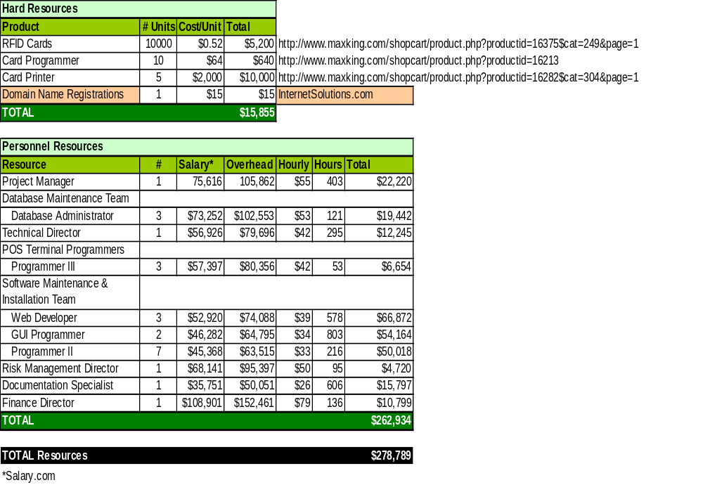
Summary
We have proven that our product is feasible by creating a well-designed prototype that incorporates the major functional components of our final product, albeit on a smaller scale than our company will actually need. The core ideas behind our product, C³P, are still accurately represented in the prototype, and they will remain our focus as we move to our end product. The additional funds that your organization will provide will help aide in this transition of scope from independent prototype to integrated product.
In addition to the commercial and technical viability of our product, as described throughout this document, the amount of time and money required for successful completion of product is well within the requirements of the SBIR guidelines. We have carefully documented the time and resources used for our prototype development phase, so that you can quantifiably see where your initial investment has gone. It is because of these detailed records that we are able to accurately predict our needs for the next phase of the project. We will be ready to roll out our completed product by the end of 2008, and our required funding falls well below the maximum of $750,000 your organization offers.
Perhaps most importantly, though, is that our project would improve society as a whole. It has been shown that the current means of protecting business leaders from credit card misuse are not sufficient, and that C³P would revolutionize the way that companies could monitor and control the use of their funds. Businesses will realize tremendous savings from our product, which will likely be passed on to the employees of the company. By eliminating misuse by a small minority of workers, the majority will reap the benefits, and that is an idea worth developing.
Appendix A: Lessons Learned

Items Purchased
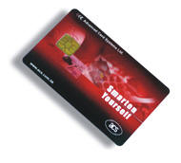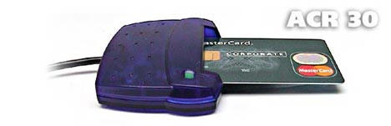
Figure 1 ACR30 and Contact ISO smart cards used for simulated POST
Name: ACR30 Smart Card Reader/Writer
Cost: $29.95
Quantity: 1
Name: Contact ISO Smart Cards
Cost: $1.65 per card
Quantity: 20
Reason to Purchase Items
The reason these items were purchased was for the use of the Green Team solution for C³P (Customizable Credit Card Protection). As part of this solution we were going to simulate a point of sale terminal. The simulated POST is a system that was initially planned to which the UPCs and MCC is inputted manually on a desktop machine and the user information is inputted by using a RFID card and reader to send the User ID information. The RFID card reader that we decided to purchase is a single chip card reader/writer and it is name the ACR-30. The RFID that will be used are contact ISO 7186 smart cards, as seen in Figure 1 above.
Reason Purchased Items Failed
The ACR-30 Smart Card reader purchased did not come with any documentation or software. We could have bought a development kit that would have included this card reader. Instead, we spent one week searching the internet for open source software that is compatible with our hardware. After failing to find a pre-existing solution, we spent two weeks searching the internet for libraries and APIs capable of implementing the ACR-30.
Now we only have 3 weeks to write the software required to read and write the smart cards along with all the other work that is also absolutely required for cs411.

Lessons Learned
We made several attempts where to program the reading/writing of the cards; however, the reading/writing to the card was an extremely tedious and time consuming task that was never solved and to spend any more time on trying to solve it was deemed a waste as it added nothing to the project other then a nifty feature. The main lesson learnt was that we should have evaluated the product in further detail prior to purchasing it. It was realized after the fact that there was a software development kit already available and should have been purchased along with the already purchased products. Finally, with regards to the innovativeness of the C³P prototype, nothing would have been gained!

Appendix B: Work Breakdown Structure
8/07
11/07
2/08+
Out Years
Out Years
10/31/07
Phase 3
151 days
10-31-07
5-3-07
Phase 2
5/07
Length
Finish
Start
Phase
Phase 2 Design:
6/07
30 days
7-31-07
7-1-07
Database
30 days
7-31-07
7-1-07
Purchase Verification Software
30 days
7-31-07
7-1-07
POST
7/07
8/07
30 days
7-31-07
7-1-07
Data Mining
30 days
7-31-07
7-1-07
Business Leader GUI
5/07
Length
Finish
Start
Module
Phase 2 Development:
8/07
43 days
9-11-07
7-31-07
Database
43 days
9-11-07
7-31-07
Purchase Verification Software
43 days
9-11-07
7-31-07
POST
9/07
10/07
43 days
9-11-07
7-31-07
Data Mining
43 days
9-11-07
7-31-07
Business Leader GUI
7/07
Length
Finish
Start
Module

Phase 2 Testing:
9/07
50 days
10-31-07
9-11-07
Purchase Verification Software
50 days
10-31-07
9-11-07
POST
10/07
11/07
50 days
10-31-07
9-11-07
Data Mining
50 days
10-31-07
9-11-07
Business Leader GUI
8/07
Length
Finish
Start
Module
Appendix C: Glossary
Audit - An official examination and verification of accounts and records, especially of financial accounts. (www.dictionary.com)
Business Leader – Term used to describe the main C³P customer that has full control over a company account. The Business Leader has access to the C³P Website and can add/delete/modify authorized card users on their specific company account.
Contact Card - Any card where information is transferred to a reader via a series of contact points located on the card. (www.vct.com)
Database - a collection of information stored in a computer in a systematic way, such that a computer program can consult it to answer questions. The software used to manage and query a database is known as a database management system (DBMS). The properties of database systems are studied in information science. (www.wikipedia.org)
Database Server - Any database application that follows the client/server architecture model, which divides the application into two parts: a front-end running on the user's workstation and a back-end running on a server or host computer. The front-end interacts with the user and collects and displays the data. The back-end performs all the computer-intensive tasks, including data analysis, storage, and manipulation. (www.labcompliance.com)
Data Mining - The process of automatically searching large volumes of data for patterns using tools such as classification, association rule mining, clustering, etc. Data mining is a complex topic and has links with multiple core fields such as computer science and adds value to rich seminal computational techniques from statistics, information retrieval, machine learning and pattern recognition. (www.wikipedia.org)
Employee Card Holder – The company employee who is given the C³P card by the Business Leader, and who uses the C³P to make corporate purchases.
Encryption - The scrambling of data in such a way that it can be unscrambled and read only by those for whom it is intended. In RFID systems, encryption is used to protect information store on a transponder's microchip or to prevent the interception of communications between the tag and reader. (www.RFIDjournal.com)
Fiscal Technician - Performs a variety of manual or automated fiscal record keeping tasks. Processes, balances and enters financial source documents which includes travel vouchers, field orders, invoice vouchers, and/or payroll documents. These functions involve calculating and applying simple cost allocations. (http://hr.dop.wa.gov/lib/hrdr/specs/10000/12030.htm)
Fraudulent Transaction - A transaction unauthorized by the cardholder of a bankcard. Such transactions are categorized as lost, stolen, not received, issued on a fraudulent application, counterfeit, fraudulent processing of transactions, account takeover or other fraudulent conditions as defined by the card company or the member company. (www.creditcards.com)
GUI (Graphical User Interface) - A program interface that takes advantage of the computer's graphics capabilities to make the program easier to use. (www.webopedia.com)
Library - In programming, a library is a collection of precompiled routines that a program can use. The routines, sometimes called modules, are stored in object format. Libraries are particularly useful for storing frequently used routines because you do not need to explicitly link them to every program that uses them. The linker automatically looks in libraries for routines that it does not find elsewhere. (www.webopedia.com)
Licensing - A business arrangement in which the manufacturer of a product (or a firm with proprietary rights over certain technology, trademarks, etc.) grants permission to some other group or individual to manufacture that product (or make use of that proprietary material) in return for specified royalties or other payment. (www.eaca.com)
MCC (Merchant Commercial Code) - A universal, four-digit merchant classification code that identifies the merchant by type of processing, authorization and settlement. (www.paymentech.com)
Modem - A device (modulator/demodulator) that allows computer information to be sent over a telephone line. (www.digitalhymnal.org)
Mutual Exclusion - (often abbreviated to mutex) Used in concurrent programming to avoid the simultaneous use of un-shareable resources by pieces of computer code called critical sections. (www.wikipedia.org)
MySQL - An open source relational database management system (RDBMS) that uses Structured Query Language (SQL), the most popular language for adding, accessing, and processing data in a database. Because it is open source, anyone can download MySQL and tailor it to their needs in accordance with the general public license. MySQL is noted mainly for its speed, reliability, and flexibility. (www.shop-script.com)
Network - A group of two or more computer systems linked together. (www.webopedia.com)
PHP (Hypertext Preprocessor) - Hypertext Preprocessor is a programming language that allows Web developers to create dynamic content that interacts with databases. PHP is basically used for developing web based software applications. (www.webasyst.net)
Point of Sale (POS) - Location in a merchant establishment at which the sale is consummated by payment for goods or services received. (www.creditcards.com)
POS Terminal (POST) - A device placed in a merchant location, connected to the bank's system or authorization service provider via telephone lines, and designed to authorize, record, and forward data for each sale by electronic means. (www.elotouch.com)
Purchase Verification Software – In house software created by the Green Team to determine whether a purchase is allowed or not. Follows a direct flow of logic and is housed on the C³P server.
Queue - To line up. In computer science, queuing refers to lining up jobs for a computer or device. The order in which a system executes jobs on a queue depends on the priority system being used. Most commonly, jobs are executed in the same order that they were placed on the queue, but in some schemes certain jobs are given higher priority. (www.webopedia.com)
RFID (Radio Frequency Identification) - A method of identifying unique items using radio waves. Typically, a reader communicates with a tag, which holds digital information in a microchip. But there are chipless forms of RFID tags that use material to reflect back a portion of the radio waves beamed at them. (www.RFIDjournal.com)
RFID Reader - A device that is used to interrogate an RFID tag. The reader has an antenna that emits radio waves; the tag responds by sending back its data. (www.technovelgy.com)
RFID Tag - A microchip attached to an antenna that is packaged in a way that it can be applied to an object. The tag picks up signals from and sends signals to a reader. The tag contains a unique serial number, but may have other information, such as a customers' account number. Tags come in many forms, such smart labels that can have a barcode printed on it, or the tag can simply be mounted inside a carton or embedded in plastic. RFID tags can be active, passive or semi-passive. (www.RFIDjournal.com)
Smart Card - A plastic card containing a computer chip with memory and CPU capabilities. Such a card may be used for identification or to store information, financial amounts or other forms of data. Also called an integrated circuit card or a chip card. (www.creditcards.com)
Table (Database) – A table is a set of data elements (values) that is organized using a model of horizontal rows and vertical columns
UPC (Universal Product Code) - A code consisting of a series of vertical bars of variable width that are scanned by a laser; printed on consumer product packages to identify the item for a computer that provides the price and registers inventory information (www.dictionary.com)
Venture Capital - Capital typically provided by outside investors for financing of new, growing or struggling businesses. Venture capital investments generally are high risk investments but offer the potential for above average returns and/or a percentage of ownership of the company. (www.wikipedia.org)
Appendix D: Technical Tables
Table 1. Table of test cases
Module | Functional Element | Test Case | Test Objective
Business Leader GUI | Login | 1. Enter a user ID that does not exist | Demonstrate the ability to recognize existing Business Leaders and user basic authentication to grant access to the Manage Account module
Business Leader GUI | Login | 2. Enter the Correct user ID and password
Business Leader GUI | Login | 3. Enter Correct user ID and incorrect password
Business Leader GUI | Manage Account - Add Employee | 4. Enter correct and complete information | Demonstrate the ability to add an employee to the database if all information is correct; else reject the attempt to add the employee.
Business Leader GUI | Manage Account - Add Employee | 5. Enter an existing user ID
Business Leader GUI | Manage Account - Add Employee | 6. Enter incomplete information, leaving fields blank
Business Leader GUI | Manage Account - Modify Purchase Restrictions - Choose Employee | 7. Choose employee from the drop-down | Demonstrate the ability to select the employee
Business Leader GUI | Manage Account - Modify Purchase Restrictions - Modify Allowed MCCs | 8. Select no MCCs | Demonstrate the ability to modify the allowed list of MCCs for a chosen employee
Business Leader GUI |  | 9. Select multiple MCCs from list
Business Leader GUI |  | 10. Select "All" from list
Business Leader GUI | Manage Account - Modify Purchase Restrictions - Modify Allowed UPCs | 11. Select no UPCs | Demonstrate the ability to modify the allowed list of UPCs for a chosen employee
Business Leader GUI |  | 12. Select multiple UPCs from list
Business Leader GUI |  | 13. Select "All" from list
Business Leader GUI | Manage Account - Modify Purchase Restrictions - Modify Spending Limit | 14. Set spending limit as 0 | Demonstrate the ability to set an employee's spending limit
Business Leader GUI |  | 15. Leave field blank | Demonstrate the ability to set an employee's spending limit
Business Leader GUI |  | 16. Enter a positive number | Demonstrate the ability to set an employee's spending limit
Business Leader GUI |  | 17. Enter a negative number | Demonstrate the ability to set an employee's spending limit
Business Leader GUI | Manage Account - Delete Employee | 18. Select an employee and click "Delete" button | Demonstrate the ability to delete en employee
Simulated POST | Enter MCC | 19. Enter existing and approved MCC | Demonstrate the ability to shop at stores with a variety of MCCs; all of approved, unapproved, and non-existent
Simulated POST | Enter MCC | 20. Enter Non-existent MCC
Simulated POST | Enter MCC | 21. Enter prohibited MCC
Simulated POST | Choose UPCs | 22. Select existing and approved UPCs | Demonstrate the ability to purchase UPCs; all of approved, unapproved, and non-existent
Simulated POST | Choose UPCs | 23. Select Non-existent UPC
Simulated POST | Choose UPCs | 24. Select prohibited UPC
Simulated POST | Get Purchase Confirmation | 25. Get confirmed purchase code | Demonstrate the ability of the module to handle a Purchase Confirmation code
Simulated POST | Get Purchase Confirmation | 26. Get rejected purchase code
Purchase Verification Software | Check MCC | 27. Enter existing and approved MCC | Demonstrate the ability to check the validity of the MCC of the store the employee is shopping at
Purchase Verification Software | Check MCC | 28. Enter Non-existent MCC
Purchase Verification Software | Check MCC | 29. Enter prohibited MCC
Purchase Verification Software | Check Spending Limit | 30. Cost of purchase is equal to limit remaining | Demonstrate the ability to reject a purchase if the employee has exceeded his spending limit
Purchase Verification Software | Check Spending Limit | 31. Cost of purchase is more than limit remaining
Purchase Verification Software | Check Spending Limit | 32. Cost of purchase is less than limit remaining
Purchase Verification Software | Check UPCs | 33. Select existing and approved UPCs | Demonstrate the ability to check the validity of the UPCs the employee is purchasing
Purchase Verification Software | Check UPCs | 34. Select Non-existent UPC
Purchase Verification Software | Check UPCs | 35. Select prohibited UPC
Purchase Verification Software | Send Confirmation Code | 36. Purchase is confirmed | Demonstrate the ability to send a purchase confirmation code
Purchase Verification Software | Send Confirmation Code | 37. Purchase is rejected | Demonstrate the ability to send a purchase confirmation code

(J. Brunelle, personal communications, March 18, 2006)

Table 2. Table of the test schedule
Module | Functional Element | Test Case | Test Duration
Business Leader GUI | Login | 1. Enter a user ID that does not exist | 4/2/2007-4/4/2007
Business Leader GUI | Login | 2. Enter the Correct user ID and password | 4/2/2007-4/4/2007
Business Leader GUI | Login | 3. Enter Correct user ID and incorrect password | 4/2/2007-4/4/2007
Business Leader GUI | Manage Account - Add Employee | 4. Enter correct and complete information | 4/4/2007-4/6/2007
Business Leader GUI | Manage Account - Add Employee | 5. Enter an existing user ID | 4/4/2007-4/6/2007
Business Leader GUI | Manage Account - Add Employee | 6. Enter incomplete information, leaving fields blank | 4/4/2007-4/6/2007
Business Leader GUI | Manage Account - Modify Purchase Restrictions - Choose Employee | 7. Choose employee from the drop-down | 4/4/2007-4/4/2007
Business Leader GUI | Manage Account - Modify Purchase Restrictions - Modify Allowed MCCs | 8. Select no MCCs | 4/6/2007-4/11/2007
Business Leader GUI |  | 9. Select multiple MCCs from list | 4/6/2007-4/11/2007
Business Leader GUI |  | 10. Select "All" from list | 4/6/2007-4/11/2007
Business Leader GUI | Manage Account - Modify Purchase Restrictions - Modify Allowed UPCs | 11. Select no UPCs | 4/6/2007-4/11/2007
Business Leader GUI |  | 12. Select multiple UPCs from list | 4/6/2007-4/11/2007
Business Leader GUI |  | 13. Select "All" from list | 4/6/2007-4/11/2007
Business Leader GUI | Manage Account - Modify Purchase Restrictions - Modify Spending Limit | 14. Set spending limit as 0 | 4/6/2007-4/11/2007
Business Leader GUI |  | 15. Leave field blank | 4/6/2007-4/11/2007
Business Leader GUI |  | 16. Enter a positive number | 4/6/2007-4/11/2007
Business Leader GUI |  | 17. Enter a negative number | 4/6/2007-4/11/2007
Business Leader GUI | Manage Account - Delete Employee | 18. Select an employee and click "Delete" button | 4/4/2007-4/4/2007
Simulated POST | Enter MCC | 19. Enter existing and approved MCC | 4/11/2007-4/11/2007
Simulated POST | Enter MCC | 20. Enter Non-existent MCC | 4/11/2007-4/11/2007
Simulated POST | Enter MCC | 21. Enter prohibited MCC | 4/11/2007-4/11/2007
Simulated POST | Choose UPCs | 22. Select existing and approved UPCs | 4/11/2007-4/16/2007
Simulated POST | Choose UPCs | 23. Select Non-existent UPC | 4/11/2007-4/16/2007
Simulated POST | Choose UPCs | 24. Select prohibited UPC | 4/11/2007-4/16/2007
Simulated POST | Get Purchase Confirmation | 25. Get confirmed purchase code | 4/11/2007-4/11/2007
Simulated POST | Get Purchase Confirmation | 26. Get rejected purchase code | 4/11/2007-4/11/2007
Purchase Verification Software | Check MCC | 27. Enter existing and approved MCC | 4/11/2007-4/16/2007
Purchase Verification Software | Check MCC | 28. Enter Non-existent MCC | 4/11/2007-4/16/2007
Purchase Verification Software | Check MCC | 29. Enter prohibited MCC | 4/11/2007-4/16/2007
Purchase Verification Software | Check Spending Limit | 30. Cost of purchase is equal to limit remaining | 4/11/2007-4/16/2007
Purchase Verification Software | Check Spending Limit | 31. Cost of purchase is more than limit remaining | 4/11/2007-4/16/2007
Purchase Verification Software | Check Spending Limit | 32. Cost of purchase is less than limit remaining | 4/11/2007-4/16/2007
Purchase Verification Software | Check UPCs | 33. Select existing and approved UPCs | 4/11/2007-4/16/2007
Purchase Verification Software | Check UPCs | 34. Select Non-existent UPC | 4/11/2007-4/16/2007
Purchase Verification Software | Check UPCs | 35. Select prohibited UPC | 4/11/2007-4/16/2007
Purchase Verification Software | Send Confirmation Code | 36. Purchase is confirmed | 4/11/2007-4/11/2007
Purchase Verification Software | Send Confirmation Code | 37. Purchase is rejected | 4/11/2007-4/11/2007

(J. Brunelle, personal communications, March 18, 2006)

Table 3. Table of test cases, their specifications, and traceability

Module | Functional Element | Test Case | Test Objective | Action | Error Message
Business Leader GUI | Login | 1. Enter a user ID that does not exist | Demonstrate the ability to recognize existing Business Leaders and user basic authentication to grant access to the Manage Account module | Deny access | "Incorrect ID or Password"
Business Leader GUI | Login | 2. Enter the Correct user ID and password |  | Allow access | N/A
Business Leader GUI | Login | 3. Enter Correct user ID and incorrect password |  | Deny access | "Incorrect ID or Password"
Business Leader GUI | Manage Account - Add Employee | 4. Enter correct and complete information | Demonstrate the ability to add an employee to the database if all information is correct; else reject the attempt to add the employee. | Update database | N/A
Business Leader GUI | Manage Account - Add Employee | 5. Enter an existing user ID |  | Do not update database | "This user already exists"
Business Leader GUI | Manage Account - Add Employee | 6. Enter incomplete information, leaving fields blank |  | Do not update database | "Please fill in all fields"
Business Leader GUI | Manage Account - Modify Purchase Restrictions - Choose Employee | 7. Choose employee from the drop-down | Demonstrate the ability to select the employee | Continue to next screen | N/A
Business Leader GUI | Manage Account - Modify Purchase Restrictions - Modify Allowed MCCs | 8. Select no MCCs | Demonstrate the ability to modify the allowed list of MCCs for a chosen employee | Update apMCC field in database for selected employee as NULL | N/A
Business Leader GUI |  | 9. Select multiple MCCs from list |  | Update apMCC field in database for selected user as selected MCCs | N/A
Business Leader GUI |  | 10. Select "All" from list |  | Update apMCC field in DB as "All" | N/A
Business Leader GUI | Manage Account - Modify Purchase Restrictions - Modify Allowed UPCs | 11. Select no UPCs | Demonstrate the ability to modify the allowed list of UPCs for a chosen employee | Update apUPC field in database for selected employee as NULL | N/A
Business Leader GUI |  | 12. Select multiple UPCs from list |  | Update apUPC field in database for selected employee as selected MCCs | N/A
Business Leader GUI |  | 13. Select "All" from list |  | Update apUPC field in DB as "All" | N/A
Business Leader GUI | Manage Account - Modify Purchase Restrictions - Modify Spending Limit | 14. Set spending limit as 0 | Demonstrate the ability to set an employee's spending limit | Set spending limit as 0 | N/A
Business Leader GUI |  | 15. Leave field blank | Demonstrate the ability to set an employee's spending limit | Do not update database | "Please fill in all fields"
Business Leader GUI |  | 16. Enter a positive number | Demonstrate the ability to set an employee's spending limit | Set spending limit as entered number | N/A
Business Leader GUI |  | 17. Enter a negative number | Demonstrate the ability to set an employee's spending limit | Do not update database | "Please enter a positive number
Business Leader GUI | Manage Account - Delete Employee | 18. Select an employee and click "Delete" button | Demonstrate the ability to delete en employee | Ask for confirmation, then if delete is confirmed, delete employee from database, else do not delete | N/A
Simulated POST | Enter MCC | 19. Enter existing and approved MCC | Demonstrate the ability to shop at stores with a variety of MCCs; all of approved, unapproved, and nonexistent | Send MCC to Purchase Verification Software | N/A
Simulated POST | Enter MCC | 20. Enter Non-existent MCC |  | Send MCC to Purchase Verification Software | N/A
Simulated POST | Enter MCC | 21. Enter prohibited MCC |  | Send MCC to Purchase Verification Software | N/A
Simulated POST | Choose UPCs | 22. Select existing and approved UPCs | Demonstrate the ability to purchase UPCs; all of approved, unapproved, and nonexistent | Send UPC to Purchase Verification Software | N/A
Simulated POST | Choose UPCs | 23. Select Non-existent UPC |  | Send UPC to Purchase Verification Software | N/A
Simulated POST | Choose UPCs | 24. Select prohibited UPC |  | Send UPC to Purchase Verification Software | N/A
Simulated POST | Get Purchase Confirmation | 25. Get confirmed purchase code | Demonstrate the ability of the module to handle a Purchase Confirmation code | Display acceptance message to employee | N/A
Simulated POST | Get Purchase Confirmation | 26. Get rejected purchase code |  | Display reject message and reason to employee | N/A
Purchase Verification Software | Check MCC | 27. Enter existing and approved MCC | Demonstrate the ability to check the validity of the MCC of the store the employee is shopping at | Move to next checking algorithm | N/A
Purchase Verification Software | Check MCC | 28. Enter Non-existent MCC |  | Send rejection code for non-accepted MCC | N/A
Purchase Verification Software | Check MCC | 29. Enter prohibited MCC |  | Send rejection code for non-accepted MCC | N/A
Purchase Verification Software | Check Spending Limit | 30. Cost of purchase is equal to limit remaining | Demonstrate the ability to reject a purchase if the employee has exceeded his spending limit | Move to next checking algorithm | N/A
Purchase Verification Software | Check Spending Limit | 31. Cost of purchase is more than limit remaining |  | Send rejection code for exceeded spending limit | N/A
Purchase Verification Software | Check Spending Limit | 32. Cost of purchase is less than limit remaining |  | Move to next checking algorithm | N/A
Purchase Verification Software | Check UPCs | 33. Select existing and approved UPCs | Demonstrate the ability to check the validity of the UPCs the employee is purchasing | Purchase is confirmed code | N/A
Purchase Verification Software | Check UPCs | 34. Select Non-existent UPC |  | Send rejection code for non-accepted UPC | N/A
Purchase Verification Software | Check UPCs | 35. Select prohibited UPC |  | Send rejection code for non-accepted UPC | N/A
Purchase Verification Software | Send Confirmation Code | 36. Purchase is confirmed | Demonstrate the ability to send a purchase confirmation code | Send confirmation code | N/A
Purchase Verification Software | Send Confirmation Code | 37. Purchase is rejected | Demonstrate the ability to send a purchase confirmation code | Send rejection code and code giving reason of rejection | N/A

(J. Brunelle, personal communications, March 18, 2006)

Table 4. Traceability and requirements for the C3P Prototype

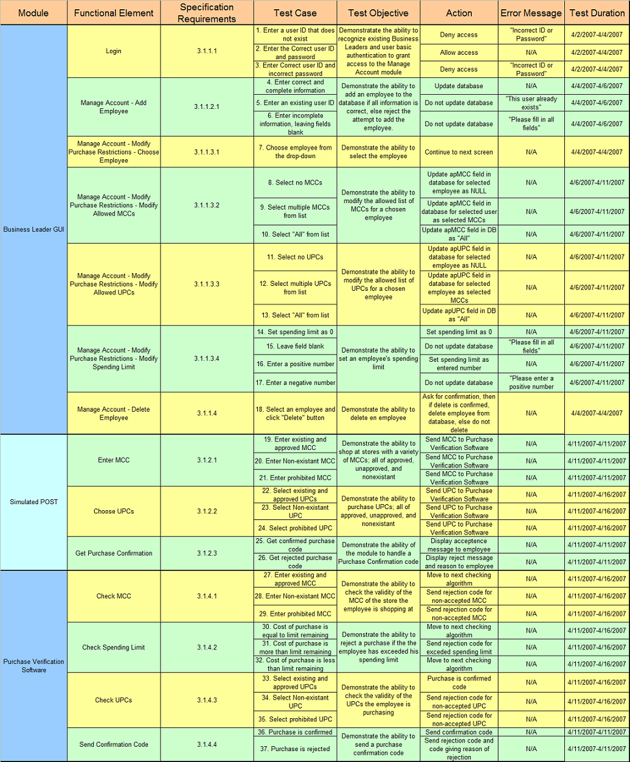
(J. Brunelle, personal communications, March 18, 2006)

