- RESEARCH PLAN

2.1 Introduction
2.1.1 Specific Aims and Goals
Individuals with cardiovascular diseases that do not continue in a proactive approach to improving their well-being are more susceptible to future cardiovascular problems. Our team plans to solve this problem by providing A software application designed to track specific characteristics of physical fitness in cardiac rehabilitation patients and facilitate continued communication with healthcare providers.

2.1.2 Background and Significance
Currently, coronary atherosclerosis disease (CAD) and cardiovascular disease (CVD) are the leading causes of death in industrialized countries. CAD and CVD are precursors to syndromes such as myocardial infarctions (MI), angina pectoralis, sudden cardiac death syndrome, and heart failure. In America alone, over 60 million people are currently diagnosed with some form of CAD and almost a million died last year as a result of CAD.

The human body is made up of hundreds of miles of blood vessels. These are broken down into two groups, arteries and veins. In general, arteries carry oxygenated blood away from the heart to the rest of the body, and veins carry deoxygenated blood back to the heart and lungs. The whole loop can be visualized as tree. At the trunk of the tree are the largest blood vessels called arteries. As the trunk branches, smaller vessels called arterioles are found. Finally, at the smallest branches, capillaries can be found. Capillaries then rejoin for the bloods return trip to the heart to form venules. These, in turn, join to form veins (Figure 1.)

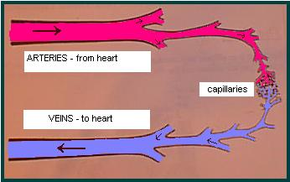
Figure 1
(Picture Courtesy of: http://users.tpg.com.au/amegann/body/circulatory.html)

Atherosclerosis is the process by which the lining of the arteries hardens. While, this process takes place throughout the human body over the course of a person’s lifetime, the hardening of the coronary arteries is by far the most dangerous. During the process, plaque builds up on the artery walls, constricting the amount of blood flow through these arteries. Since a smaller amount of blood flows through this artery, tissues that are fed by the artery are generally lacking oxygen. This can result in pain localized around the check called angina pectoralis. Once the blockage has occluded a large percentage of the artery, it is possible for artifacts in the person’s blood stream, such as other dislodged pieces of plaque or scar tissue, to effectively plug up the rest of the occluded artery. The resulting lack of blood to areas of the heart causes a MI or heart attack. The results of the MI depend largely on what artery was occluded. If the blockage occurs closer to the capillaries, only a small amount of tissue is affected and the MI is generally minor. The closer to the trunk, or main arteries the occlusion is, the more life threatening the resulting MI becomes.

The American Heart Association has identified a number of risk factors for developing CVD. The major factors include: age, family history, smoking, hypertension, hypercholesterolemia, diabetes mellitus, and sedentary lifestyle.

Unfortunately, as a society, we still wait for something bad to happen and then attempt to treat it as opposed to prevent the problem in the first place. After a person has been diagnosed with a CVD, there are a number of ways to treat the disease. Varying success has been had with such methods as: lifestyle changes, cholesterol medication, blood pressure medication, heart rhythm regulating medication, smoking cessation, coronary artery bypass grafts (CABG), and counseling.

Prevention is the best medicine. Whether or not a person has been diagnosed with a CVD or CAD, it is possible to prevent further development of the disease by making lifestyle specific changes. A controlled diet in conjunction with regular exercise can result in regression of the blockage of arteries. Regular exercise is also important for coaxial arterial growth. As a person becomes more physically fit, the amount of oxygen that their muscles demands increase. Eventually, the amount of oxygen that a single artery carries is not enough to supply an entire area. The body will grow additional arteries to compensate for the lack of oxygen. These additional arteries greatly improve a person’s chances of survival during a heart attack. While one blood vessel becomes occluded, the other vessels can still feed the oxygen starved area. Interestingly, a similar process occurs in people with a medium to high percentage of occlusion in their arteries. The occlusion reduces the amount of blood flow, signaling the same response where by new arteries are developed.

Once a person has experienced a cardiac event, or been diagnosed with cardiovascular disease, they will often be prescribed to begin cardiac rehabilitation. Cardiac rehabilitation is generally broken down into three phases.

Phase I is an inpatient program. After a person has experienced a cardiac event or undergone surgery, they will generally have a short stay in the hospital. During this stay, hospital staff will assist the patient in getting out of bed and going for short walks to begin building cardiovascular endurance. These walks get progressively longer until the person is discharged from hospital care.

Once released from the hospital, the patient is usually prescribed phase II rehabilitation. Phase II is generally covered by a patients insurance and lasts about 12 weeks. During phase II, a patient will exercise approximately three times a week, starting at a low intensity and building over the course of their 12 week stay. They will also undergo a small amount of nutritional counseling. At this point, for the safety of the patients, all exercise happen while the person is attached to a 3-lead ECG (encephalocardiogram) that tracks electrical impulses across a person’s heart. They also have resting, exercise, and post exercise blood pressures take at every visit. Unfortunately, at the end of 12 weeks, most insurance plans will no longer provide assistance to patients in cardiac rehabilitation. It is at this point that patients graduate to phase III rehabilitation.

Phase III cardiac rehabilitation is perhaps the most important phase. For all intents and purposes, it is maintenance. It is relatively unsupervised exercise where a patient puts into practice what they learned in phase II. In general, people who graduate from phase II rehabilitation are healthier than they were prior to their cardiac event. During phase III it is their responsibility to maintain this healthiness. There are cardiac rehabilitation facilities that provide phase III support, but they often operate as gyms, where memberships require a prescription from a doctor and a large monthly fee. More often though, patients will join local recreation centers or cheaper gyms to gain access to some form of exercise expertise.

It is estimated that between 10-30% of all graduates of phase II rehabilitation start and continue with phase III rehabilitation. There are many barriers to continued participation in phase III rehabilitation, often cited on the patient’s side are: lack of motivation to exercise, lack of communication with their physicians, and lack of understanding of the importance of exercise. Healthcare providers are often held responsible for: not stressing the importance of exercise, lack of communication with patients, and lack of communication between primary care physicians and specialists.

The Phase 3 Communicator is expected to mitigate many of the patient’s reasons for lack of participation. It will provide communication between a cardiac rehabilitation specialist and the patients. That path of communication is expected to provide motivation. Additional motivation will come from peers that are met on the Phase 3 Communicator’s chat rooms that are designed to work as support groups or a place to openly ask questions. The Phase 3 Communicator will provide graphs that show a patient’s progress so the patient can give their physician more detailed medical information on what they have accomplished.

2.2 Proposed Solution

    - Proposed Technical Solution
Studies have shown that remote supervision along with continued
communication with a health care professional helps increase patient participation in Phase III of cardiac rehabilitation, and as a result decrease the incidences of recurrent cardiac complications. Support for a solution of this type was demonstrated in a study conducted at Stanford University, where patients were monitored remotely via telephone contact with a nurse case manager. The study revealed that communication was key in keeping 85% of the patients motivated in maintaining their health, compared to an 80% drop out rate for patients not participating in the program (American Journal of Cardiology.) P3C can facilitate the success of such a program by utilizing technology as a means of communication, tracking and education.

      - Characteristics of the Solution
To address the problem of recurrent cardiac incidences due to patients lack of participation in Phase III cardiac rehabilitation, we propose a solution that is designed to track specific characteristics of physical fitness and facilitate continued communication between cardiac patients and health care providers. The characteristics of this solution are as follows:
- Foster communication between health care professionals and Phase III patients
- Provide a forum for patients to communicate and collaborate together
- Incorporate into hospitals for health care professionals' supervision
- Provide an easy to use web-based graphical user interface
- Provide exercise tracking along with certain vital statistics
- Provide a mechanism for monitoring patient health progress
- Supply health care providers with an administration tool designed to help monitor and motivate a large number of patients with minimal staff
- Provide a framework for gathering statistical data related to patient participation in Phase III cardiac rehabilitation
- Reduce financial costs associated with recurrent cardiac incidences

      - Feasibility
Since “nearly one million Americans die of CVDs every year (American Heart Association,)” and “persons with established CHD are five to seven times more likely to experience a heart attack than the general population (Center for Disease Control,)” P3C will be designed to help alleviate the rate of recurrence of cardiac issues by providing a mechanism for health care providers to facilitate and encourage patients to continue participation in Phase III cardiac rehabilitation. The Phase III Communicator (P3C) portal will provide health care professionals and patients with a comprehensive technological solution to directly address the issues associated with Phase III cardiac rehab participation, and indirectly effect the number of occurrences of repeat cardiac complications.

The decision to use a portal as the framework of the solution for this particular societal problem stemmed from the type of characteristics of the solution, that require remote supervision and interaction, along with the fact that portals are inherently suitable for solving problems requiring secure remote access to multiple, closely-related web services. In addition, the fact that “The likelihood of a hospital having a web site grew from roughly six in 10 in 2000 to seven in 10 during 2001 (Hospital Access Management,)” indicates the availability of supporting infrastructure already present in the facilities where the P3C portal will reside. Hospitals currently with the infrastructure in place to support a web-based application will provide a customer-base that has to incur minimal additional expense to implement the P3C solution.

      - Phase II: Functional Prototype and Development
The technical feasibility of the P3C solution will be proven during Phase I of the project, which will include the preliminary development of the software components that make up the P3C solution. The application software and database layout and functionality will be developed during Phase I and used as a baseline to begin fully implementing a functional P3C prototype in Phase II. In Phase II the P3C prototype will consist of two major functional components: an application server and a database server. The major functional component diagram depicted in Figure 2 illustrates the two tier architecture to be utilized by P3C for improved scalability and flexibility. Each server will be an Intel-based multiprocessor platform, with multiple Ethernet network interface cards (NICs), running RedHat's Enterprise Linux AS operating system. The database server will run MySQL as its database software.



Database Server
P3C App Server
Internet

Figure 2: Major Functional Component Diagram

The functionality the application server will provide includes:

- Accept new exercise data
- Display patient progress diagrams
- Send automatic email notifications
- Provide messaging service
- Provide Chat service
- Coordinate with the database server for data storage and retrieval
- Process statistics

And the database server will:

- Process requests from P3C application server
- Store patient exercise data
- Store patient communication data
- Store internal messaging data
- Store statistical data

Both servers will be located within the health care provider’s facility. The P3C portal will provide secure access for patients and health care providers to do the following:

- Update exercise data and required vital statistics
- View health progress via dynamic graphs extrapolated from collected data
- Send and receive secure internal messages
- Chat with fellow Phase III cardiac patients via an easy to use web-based user interface.

Figure 3 depicts the functional overview of the P3C solution and demonstrates the interaction between external entities, in this case the web browser on the patients home personal computer, and the internal components which represent the application server and the database server located on the health care provider's network.












Hospital Network
Internet
Hospital
Phase III Patients

Figure 3: P3C Functional Overview

The functional overview diagram (Fig 1.1) also illustrates the human requirement necessary for the P3C solution. The nurse located at the health care provider's facility will utilize the P3C application in two major categories: first, to track patients exercise data and health progress, and second to track the communication frequency between patients and their health care provider. When warning thresholds are reached in either category, alerts will be generated so that the nurse can intervene quickly with messages along with external notification emails, or phone calls necessary to keep patients motivated in maintaining their health.

      - The P3C Communication Model
Figure 4 illustrates the communication model that will be implemented by the P3C solution. The communication diagram demonstrates the importance of regular communication between patients who are active members, as well as patients who require extra motivation because of lack of participation. Those patients desiring to collaborate and communicate with each other will be able to do so using the chat service offered by the P3C portal.



Active Participant
Slacker

Periodic Phone Call
Email Notifications
Messaging
Alert Phone

Call

Chat
Alerts
Extra Motivation
Q&A
Exercise Updates

Phase III Patients
Collaboration
Friendship
Motivation
Information Sharing
Figure 4: P3C Communication Model

      - The P3C Application Logical Design
Figure 5 illustrates the overall logical design of the application components required for P3C. The application server will serve the P3C application to users connecting from the Internet. This layer will be implemented using JSP pages and servlets that make up the P3C server application. Also depicted in the diagram are data access objects which represent application software objects that will use JDBC to communicate with the backend database server. Representing the internal messaging service that will be used by patients and health care providers for general communication is the Java mail service shown. When internal mail is received by a patient's account, an automatic, preformatted external email notification will be sent to the patient's external email address. This method of using email notifications instead of direct external emails was chosen to eliminate the need for secure remote email communication between the health care provider and the patient, and ease administration requirements for the mail service.

The application server will also provide a separate application for the chat service Phase III patients will use to communicate and collaborate with each other. To save money and speed to production, a COTS application will be used for this functionality. One application currently being considered is RealChat ^{(TM),} a java-based chat software application used for server-side chat sessions.

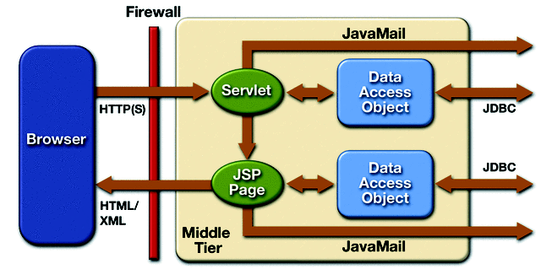
Figure 5: Logical Application Design for the P3C application portal http://java.sun.com/blueprints/guidelines/designing_enterprise_applications/introduction/application_scenarios/

      - The P3C Application Overview
Figure 1.4 depicts the P3C application overview and characterizes examples of the flow of data that will result from use of the P3C application by patients and health care professionals. This diagram demonstrates how use of the portal will provide patients the ability to provide regular updates about their exercise activity, view health progress in graphical format, view messages received from the health care professional, and how the patient will receive external email notifications when either of these attributes changes on his/her account. The nurse or health care professional will be able to view and update the patient's exercise prescription, view patient progress graphs, and keep track of communication frequency via call lists using P3C. In addition, the health care professional will receive alerts via an alert list that will categorize patients based on the alert status they have reached, such as lack of participation, slow health progress, exceeded threshold values, or communication frequency.
Nurse
Phase III Patients
Exercise Data
Email notifications
Exercise Updates
Phone calls
Display
Call / Alert Lists
Internal messages
Progress Graphs
P3C App Server
Database Server

Figure 6: P3C Application Overview

All aspects of the P3C solution work synergistically to provide a comprehensive solution to the problem of non-participation in Phase III cardiac rehabilitation. Since Phase III cardiac rehabilitation is essentially a maintenance phase for continued health, the primary goal of P3C is to provide a mechanism to keep patients motivated and persistent in maintaining their health after having experienced a cardiac condition. Utilizing current technology, P3C aims to keep patients connected to the main force of encouragement capable of ensuring that they are taking the proper steps necessary to stay healthy and live as long as possible. That force of encouragement consists of the health care provider and the invaluable communication they can provide to patients who may be inclined to drop out of the program to their own detriment. P3C facilitates the communication and motivation that has been shown in studies to decrease a patient's chances of experiencing recurrent cardiac complications due to poor health maintenance.

2.2.2 Research Designs and Methods
After a Preliminary Research Phase, Phase Zero, Phase I begins. The beginning of Phase I will be a detailed analysis of the software and components necessary for this product. This will be followed by the creation of a product user’s manual.

The second part of Phase I will be dedicated to development of a prototype. This prototype will demonstrate the total feasibility of the product. The prototype will undergo extensive testing and analysis. If no changes are deemed necessary, preparations for final design will begin.

Once the prototype has been approved by the team, advanced testing will occur with the targeted customer base. A test group of potential customers will then use the system and test for any fallibility. After the tests are complete changes will be made, if necessary, to meet the customer’s demands.

The conclusion of creating and testing the prototype will start Phase II, the development and preliminary production of the product. First, the product specifications will be reviewed and finalized. A detailed market plan and management plan will be implemented. Then, software development will begin and take approximately one year. Software development includes systems, unit, and integration testing. The end of Phase II will comprise of full systems test in a hospital setting. Upon completion of installation testing the project will shift to the production Phase III.

Phase III will start with putting the product into full production. The marketing plan will continue to be implemented and expanded as customer base grows. Next, an initial indoctrination course will be developed and taught to all customers. All employees will be fully trained on the use of the product. The Phase will end with a shift to out years where technical support and help lines will be implemented and continued production and upgrading.

*please refer to appendix for a full project plan, yearly Gantt charts and monthly Gantt charts.

2.2.3 Management Plan

Execution of the Project will be performed in accordance with the plans set forth in this SBIR document including the Management Plan (2.2.3), the Evaluation Plan (2.2.4), the Test Plan (3.5.2), the Marketing Plan (3.4), and with regard to our Risk Assessment (3.6). The responsibilities of the Project Team, the capabilities of the system, and the Project deliverables are detailed in this SBIR document.
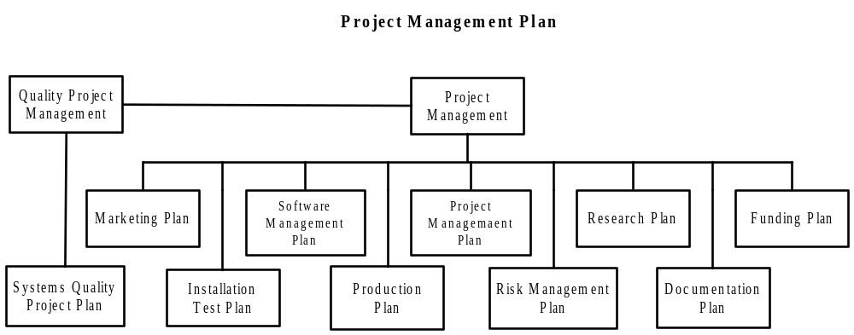

Figure 7: Management Plan
The Project Management Plan (Figure 7) describes the management philosophy, project organization, schedule, and major milestones that serve as the guide for execution of the Project. The PMP also provides the customer and the quality team with the information they need to monitor and evaluate the progress of the effort. This plan provides the following pertinent information:

Management Approach
Phase III Communicator’s management goal is to work closely with the customer to fully understand the system requirements and field a system that meets those requirements. The management approach to executing contracts at ODU is based on the philosophy that successful projects are delivered by goal-oriented teams. A Project Manager (PM) will lead the Phase III Communicator team. The PM is responsible for all planning, programmatic, technical, and financial aspects of the Project. The PM is the primary Point of Contact (POC) for the customer. The primary duties include supervision of all planning, scheduling, financial and technical activities, and customer liaison. The PM is responsible for all Project-related decisions and commitments with approval, as required, from the Corporate Management Team.

A key element of ODU’s Project management approach is customer involvement. ODU encourages the customer to retain an active role in monitoring the progress of all aspects of the Project. The customer is encouraged to discuss technical details directly with members of the Project team, provide planning and schedule recommendations, and assist in resolution of technical and programmatic issues. In order to facilitate customer involvement, Phase III Communicator Project will provide access to project information as it is requested by the customer.

The Phase III Communicator Team
The Project Team is committed to provide the best value by delivering COTS, open architecture, and low-risk systems at the lowest cost. This commitment is attainable because it is based on the re-use of existing technology that is field-proven. Through strategic teaming and an extensive system selection process, ODU has assembled a cohesive Project Team that is experienced with the implementation of each component that will comprise the Phase III Communicator system.
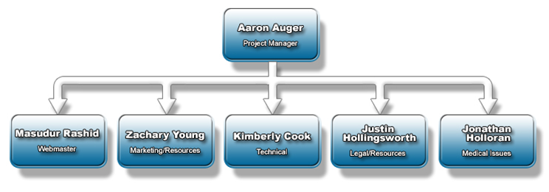
Figure 8: The P3C Team

Aaron Auger is currently a senior at Old Dominion University College of Sciences, seeking a Bachelors of Science in Computer Science and a Minor in Spanish. Aaron is an officer in the United States Navy. He is currently completing his degree under a scholarship from the U.S. Navy. Aaron serves as the Project Manager on the team.
Kimberly Cook is senior at Old Dominion University and expects to earn a BS in Computer Science in May 2004. Kim has seven years of IT work experience in Systems Administration and Management. After graduation she plans to pursue an MBA. Kimberly’s role on the P3C team is the Technical Solution Manager.
Justin Hollingsworth is the Legal and Resources Manager for the Phase III
Communicator. Justin is a senior undergraduate student at Old Dominion University working towards a degree in Computer Science with a minor in Business Administration. Currently, he is employed at Walldingers Inc. working part-time as a Network Administrator, where he hopes to gain the experience necessary to begin a career in I.T. upon graduation.
Jonathan Holloran is the Medical Issues Manager for the Phase III Communicator
project. He is currently working towards a degree in Computer Science at Old Dominion University. Jonathan works part time for CCG Systems Inc., a fleet management company. He obtained a B.S. in Exercise Science and minor in Chemistry in 2000. During the completion of his first degree, Jonathan interned with Sentara Virginia Beach Cardiac Rehabilitation Center for four months.
Masudur Rashid, preferred to be called Jitu for your sake, is diligently working his way toward achieving his BS in Computer Science with a minor in Information Technology. Masudur’s favorite field of study is computer graphics and design. His interests, therefore, lend himself to the position of webmaster for P3C. He will graduate in May 2004.
Zachary Young is a junior at Old Dominion University pursuing a B.S. in Computer Science and a minor in Philosophy. Graduating in May of 2005, Zachary is currently looking towards job opportunities in Western Europe. Currently, Zachary serves as the Marketing Analyst for the Phase III Communicator team.

The following is an overview of each of the team’s positions.
Project Manager. Overall management responsibility for Phase III Communicator Project is assigned to a Project Manager who is responsible for planning and coordination of the day-to-day technical, contractual, and financial aspects of the project. He is responsible for the generation and management of all project schedules, for the coordination of project staff assignments, and for coordinating all project activities. His principal assistants are:
Technical Solutions Manager. The TD provides overall technical direction for the Project Team. She is the senior software engineer and will directly oversee the development and production of P3C to ensure that the software is being created according to the proposed solution.
Medical Issues Manager. The Medical Issues Manager is responsible for providing the team with background and possible feasibility issues that may occur in the medical field. He will also be primary spokesperson of the group behind the Project Manager, as the MIM has a larger background in the topic and is possibly more qualified to answer questions.
Legal / Resource Analyst. The Legal / Resource Analyst is responsible for seeing to it that any necessary waivers or disclaimers are made, and that contractual agreements are fulfilled. He is also responsible for determining the resources needed for the project.
Marketing Analyst. The Marketing Analyst provides the team with the resources necessary to successfully sell the product. He is responsible for monitoring competition, monitoring the currently targeted demographic, and the test market and test plan.
Webmaster. The webmaster is responsible for maintaining the website, as well as providing the Graphical User Interfaces for prototypes and eventually the final product.

Project Duration
The Phase III Communicator Project totals four years. The Phase 0 schedule consists of a preliminary design, research, and SBIR funding approval. Phase I will entail creating the prototype development, completing a manual, and applying SBIR Phase II funding approval. Phase II will include the preliminary production and software development. Phase III will involve full-scale production. At this point, the project will switch to out years, where technical support and phone lines are in place.

Work Breakdown Structure
The project Work Breakdown Structure (WBS) reflects the budgeted cost versus resources required to complete each task. The WBS phase numbers are integrated as part of the master project schedule. Budgets for work planned are entered into ODU’s financial tracking system for each WBS element, actual costs and estimates to complete are managed by the Project Manager. The WBS element numbers will be used to track project costs, progress, earned value and progress relative to the master project schedule. The WBS management tools that ODU will use are SmartDraw and Microsoft Project
Phase III Com.
Integration
H/W
S/W
Gui
Data Base
Communication
Testing
Documentation
Milestone pres
Presentations IV
Grant paper
website
H/W WITH S/W
COMPATIABILATY
S/W
H/W
Marketing
ID customer
Budget
Cost
Management
Project Plan
Marketing Plan
Risk Mgt.
Project Management
Plan
Legal
integration
Client S/W
Phase III Com.
Integration
H/W
S/W
GUI
Data Base
Communication
Testing
Documentation
Milestone pres
Presentations IV
Grant paper
Website
H/W WITH S/W
COMPATABILATY
S/W
H/W
Marketing
ID customer
Budget
Cost
Management
Project Plan
Marketing Plan
Risk Mgt.
Project Management
Plan
Legal
Integration
Client S/W
Figure 9: Work Breakdown Structure

Project Planning
The Phase III Communicator Project team office will maintain the project master schedule. The master schedule contains a line item for each WBS element and will be used to track the progress of each element. All deviations from the master schedule must be coordinated with the project office. It is the responsibility of each team member to call attention to possible schedule deviations at the earliest opportunity. The project office will coordinate the project schedule with ODU. The project will be developed in phases; within each phase, formal reviews will play an integral part in monitoring project progress. All formal reviews will be announced four weeks in advance of the starting date.

Phase III Communicator Project will take a “top down approach” to the Project Schedule, meaning that we will pace our workload to fit the overall Project requirements. Particular attention will be given to timely milestone completions. It is recognized that the schedule is particularly tight, containing critical project milestones during the first year, and adequate personnel will be available in order to keep the project moving forward.

Progress PERFORMANCE ASSESSMENT
All Phase III Communicator team members will participate in progress reporting and team management. ODU will track technical and financial progress of the project. Reviews will be held monthly or as mutually agreeable between the Phase III Communicator team and Professor Brunelle.
- Report on progress to date
- Present work to be performed during the next month
- Present status of all deliverables and review planned delivery dates
- Present status of all received GFX/PFX items
- Plan and coordinate activities
- Discuss technical or programmatic issues as necessary.
In preparation for the meetings the Phase III Communicator Project Manager will collect the current status data on relevant on-going activities, progress against schedule and budget, and planned activity for the next reporting period. Quality reviews of all project documentation and procedures will be held periodically. In particular, the quality project will be involved with project deliveries and milestones and will work off of the master project schedule to plan project audits. Technical, financial and quality progress and status reporting will be conducted according to the following general guidelines.

Technical Progress and Reporting
The schedule for the project is established during the planning phase and monitored throughout the performance period. The schedule contains an entry for each WBS element. The percentage of completion for each WBS element is determined as necessary to manage project progress and is reviewed at least quarterly during Professor Bunelle’s review.

Financial Management and Reporting
The financial profile for the Project is established during the planning phase and monitored throughout the performance period. This profile is generated by assigning accounting phase numbers to every Project activity that has been identified as a scheduled event. A budget representing labor costs, materials purchase, and other expenditures (such as travel expenses) is then prepared for every phase. The schedule and budgets are then integrated to provide a spending profile for the phase. The Project spending profile represents a summary of phase spending profiles.

The PM provides an information package that identifies the phase numbers assigned to each activity, the corresponding budgets and schedules, the overall spending profile for the project, and a synopsis of all major deliverables and milestones specified in the contract. The PM uses this information, combined with an on-line financial summary of the Project to track its financial status on a weekly basis. An updated spending profile is provided automatically by the Contracts Administrator on a monthly basis, or upon request from the PM. The PM uses the financial summary in conjunction with his assessments of technical progress to track the overall status of the efforts.

Earned Value
Earned Value Ratios will be reported as required. At a minimum, Phase III Communicator Project team will determine earned value quarterly at the overall Project level and will report at the 2nd level of WBS indenture in order to provide additional information.
Ratios will be reported in the form of the Schedule Performance Index (SPI) and the Cost Performance Index (CPI). Ratios below 0.90 will be explained in further detail.
SPI is to be calculated as follows:
SPI = BCWP (Budgeted Cost of Work Performed)
BCWS (Budgeted Cost of Work Scheduled)
CPI is to be calculated as follows:
CPI = BCWP (Budgeted Cost of Work Performed)
ACWP (Actual Cost of Work Performed)
ODU will use Microsoft Project in order to calculate the ratios. On a monthly basis, actual costs will be downloaded into Project. A baseline of work to be performed will be established in Project and will provide the BCWS. Milestones will be applied against the various WBS elements, and % complete status of the milestones will be updated on a monthly basis. Based upon % complete, Project will calculate BCWP, or earned value, at the individual WBS level and determine the earned value at the overall project level.

Quality Process and Reporting
Quality management on the project will be a team effort. The Quality System Manager will coordinate conduct, quality reviews, and audits. The PM is ultimately responsible for the development and implementation of the System Quality Project Plan. The SQPP is an umbrella plan which incorporates the quality projects of the project team members. The SQPP describes a team quality concept, including Process Coordination and Quality Evaluators. Team members are responsible for performing the processes required to complete Project tasks. Quality Evaluators are responsible for verifying that the development, production, and handling of all documentation, software, and hardware are performed in accordance with the SQPP and its component processes. The team is also responsible for conducting periodic reviews and evaluations of work-in-process; attending in-house test events, and supporting in-house Project reviews. All planned quality project activities and quality evaluations (internal audits) are submitted to the PM for review.

Monthly Progress Report
Phase III Communicator Project will submit a monthly progress reports. The report shall cover, at a minimum, the following:
- Progress Summary;
- The Variance Statement;
- Critical Path Analysis;
- Milestone Deliverables, planned actual and forecast;
- Earned Value Schedule and Cost Performance Indices;
- Dependencies: a ‘critical items list’ of all items, whether or not the Contractor’s direct responsibility, which could jeopardize timely completion of the work or any significant parts of the project;
- Risk Status: update of risk register;
- Look Ahead (Future action and Forecast);
- Resource Profile;
- Work Package/Activities planned, actual & forecast status;
- Milestone/Deliverables planned, actual & forecast status;
- Configuration Change Control issues;
- Quality Actions (Reviews, audits);
- One Page Plans and Reports summarising the above for inclusion in the Purchaser’s monthly report; and
- Commercial: amendments to Contract status report; No later than meeting + 10 working days.

REVIEWS
Reviews will play an integral part in the management and monitoring of all phases of the Phase III Communicator Project. Informal reviews with the Project team members will be held at all levels on a weekly basis to ensure that the project stays on track. Formal technical reviews will be held to ensure that the project is proceeding as planned. The types of reviews, their purpose and presented information are addressed in the following paragraphs.

Project Management Reviews
Project Management Reviews (PMRs) will be conducted with ODU and subcontract representatives. The first PMR will be conducted in July 2004; thereafter PMRs will be conducted approximately every six months (immediately preceding each technical review). The PMRs are scheduled to discuss programmatic issues related to the development and implementation of the Project. The reviews will provide the opportunity to review the progress of the effort; as well as to conduct milestone reviews of deliverables, and identifies and resolves any issues that may arise during the execution of the tasking.

The PM will ensure that all project-related information required to meet the objectives of the review are prepared and delivered not later than two weeks prior to the scheduled review date. The PM will also be responsible for identifying the Phase III Communicator Project team personnel who will attend the review. The PM will attend all Project Management Reviews. The following information will be prepared in support of each PMR. Recorded during the review and delivered before the completion of the review.

Technical Reviews
Formal technical reviews will be conducted on the dates specified in the master schedule. The reviews will be held jointly with ODU, Phase III Communicator Project team members and sub-suppliers as necessary. An agenda and review material will be submitted to ODU two weeks prior to the scheduled meeting. Review meeting minutes will be delivered before the completion of the review. The objectives for each review are outlined below.

Reviews will be held to validate the direction taken for the design, development, and test of the system. The System Requirements Review (SRR), Preliminary Design Review (PDR), and Critical Design Review (CDR) will be formal reviews held at ODU. The Test Readiness Reviews (TRR) will be formal reviews held prior to HAT & SAT.

System Requirements Review is conducted to ensure that the Project team fully understands the system performance requirements specified in the System/Segment Specification. A detailed review of requirements for the system and each subsystem will be reviewed. The System/Segment Specification (Technical Specification) will be used in the review.
System Design Review is conducted to present and review the system design. System requirement allocation to each system component will be discussed. The general approach to be taken for the integration of each system component will be presented. The documents listed below will be used in the review. This will be an informal review. The data will be included in the PDR.
- System/Segment Design Document
- System Interface Design Document
Software Requirements Review is conducted to review the software specification and interface requirement specifications. This review will be conducted as part of the PDR.
Preliminary Design Review is conducted to present the preliminary design of the Project System. The functional requirements of each subsystem will be discussed in detail. The following documents will be used in the review.
Critical Design Review is conducted to review system integration issues. In particular the review will focus on system interfaces in preparation for Subsystem FAT.
Test Readiness Reviews are held to determine if the system is ready to proceed to the next level of test. Test configurations and results from the previous test efforts will be presented. The test report from the previous test will be used in the review. The following TRRs will be performed:
- Prior to FAT
- Prior to HAT
- Prior to SAT

Quality Reviews
The PM supported by the quality system manager (QSM) will establish the time and identify attendees for all formal reviews. He will also coordinate with the appropriate managers to conduct quality reviews at key project milestones, and in preparation for formal reviews with the customer. Informal peer review and engineering planning meetings will also be held at the discretion of each subsystem manager to discuss technical issues, conduct internal comment reviews, and provide technical guidance to members of the Project team. As part of the quality activities for the project, the quality team will conduct informal reviews to:
- Evaluate the processes used by the Project team members to perform project tasks;
- Evaluate deliverable products for compliance with contract requirements;
- Evaluate work-in-process during engineering reviews;
- Document results of each evaluation; and
- Recommend corrective and preventive actions if necessary.

2.2.4 Evaluation Plan
The product will continually be monitored for progress by the project manager. Phase I will be deemed a success if the prototype is fully functional and passes testing. There must also be a preliminary product manual.

Phase II will be deemed a success when software development is complete and installation testing is complete with no defects.

Phase III will be deemed a success if product reaches full production and a break even number of products are sold.

The evaluation plan is as follows:

    - Per Milestones
      - Review progress
      - Review specifications
      - Implement next phase
      - Thorough unit and integration testing

2.3 Conclusion
Cardiac rehabilitation is a very important aspect to continued heath in patients who have had a cardiac event. The benefits of exercise can prove the difference in maintaining a long and healthy life. While the first two phases of cardiac rehabilitation are important on getting a person started on the road to healthiness, the third phase lasts the rest of that person’s life. The Phase 3 Communicator can assist in the longest part of this journey by providing ways to communicate and motivate patient’s to continue being proactive in maintaining their health.

2.3.1 Literature Cited
ACSM's Resource Manual for Guidelines for Exercise Testing and Prescription, Third
Edition, 2003.
American Heart Association. http://www.americanheart.org.

American Journal of Cardiology, The . Volume 79, Issue 1 , 1 January 1997, Pages 58-
63.

“Heart Disease and Stroke Statistics – 2003 Update.” American Heart Association, 2003.

“Heart Disease and Stroke”. http://www.cdc.gov/cvh/hp2010/pdf/HP2010.pdf. P12

“Healthy People 2010. 12 - Heart Disease and Stroke.” Center for Disease Control,
2000.

Hospital Access Management, Dec 2002 v21 i12 p144

Sentara Hospitals. http://www.sentara.com

U.S. News and World Report, 2003

- APPENDICES
3.1 Project Management
3.1.1 Gantt Chart
3.1.1.1 Phase 0 and I Gantt Chart
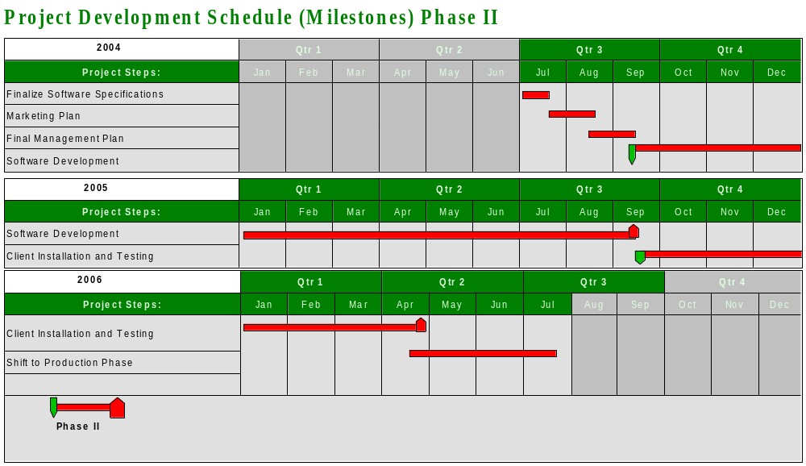

3.1.1.2 Phase II Gantt Chart

3.1.1.3 Phase III Gantt Chart
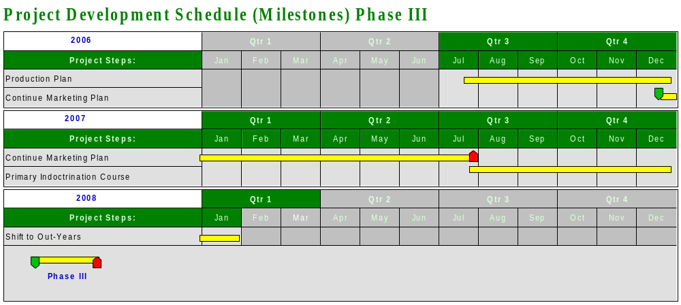

3.1.1.4 Monthly Gantt Charts
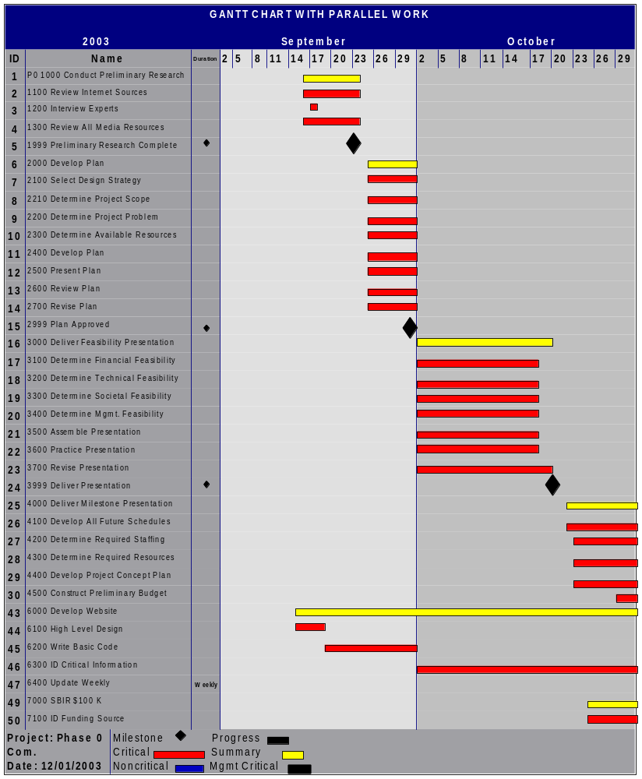
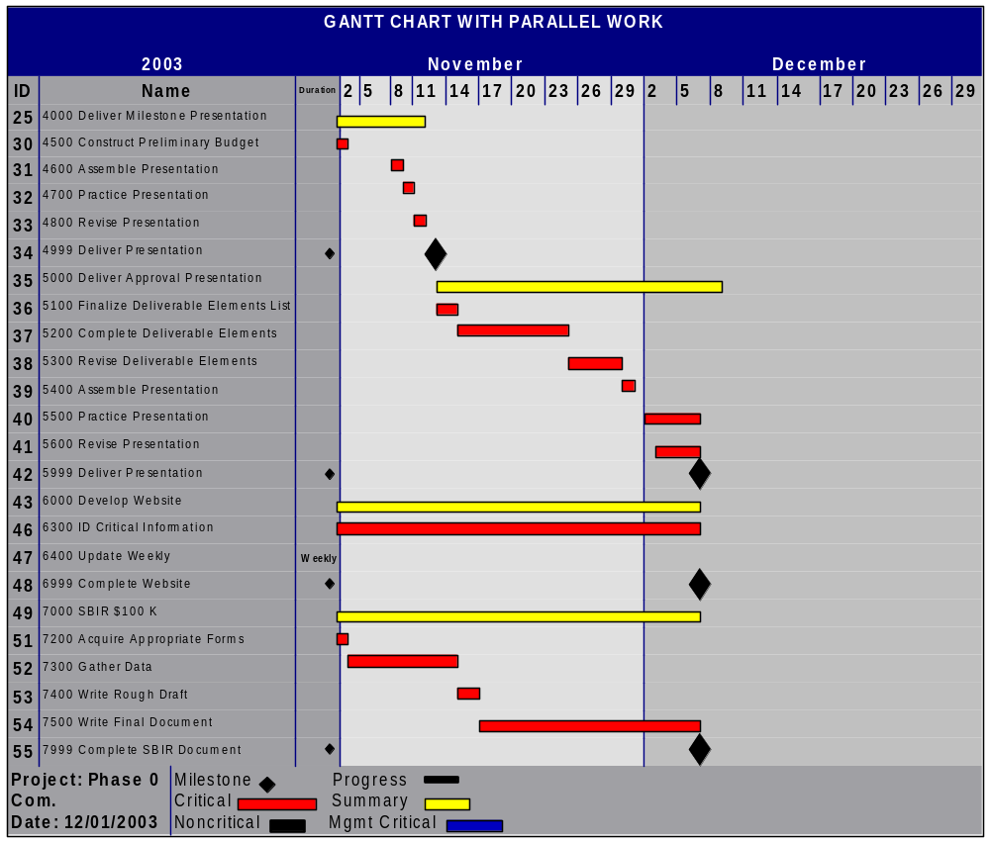
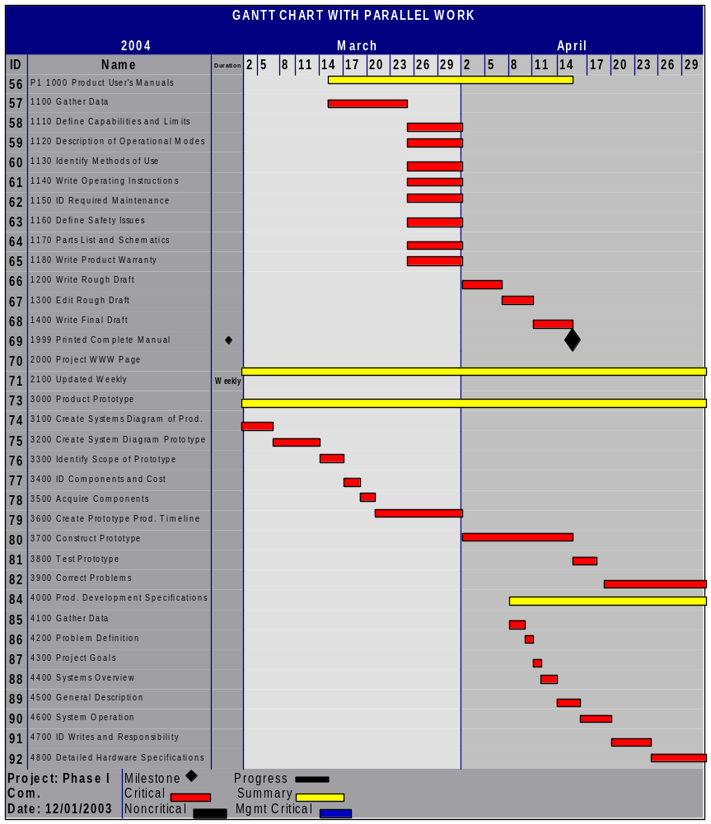
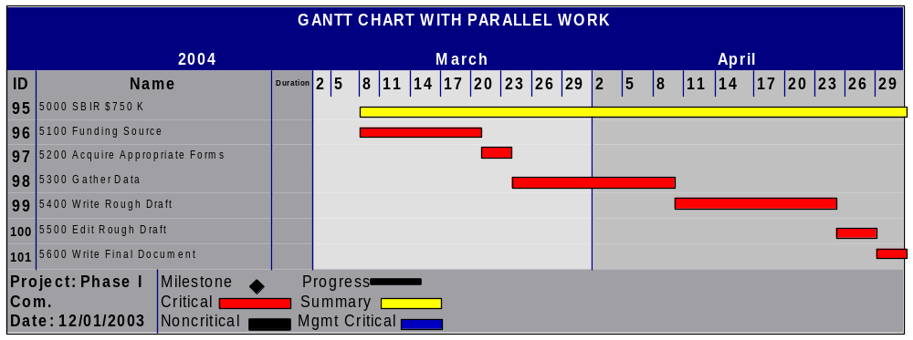
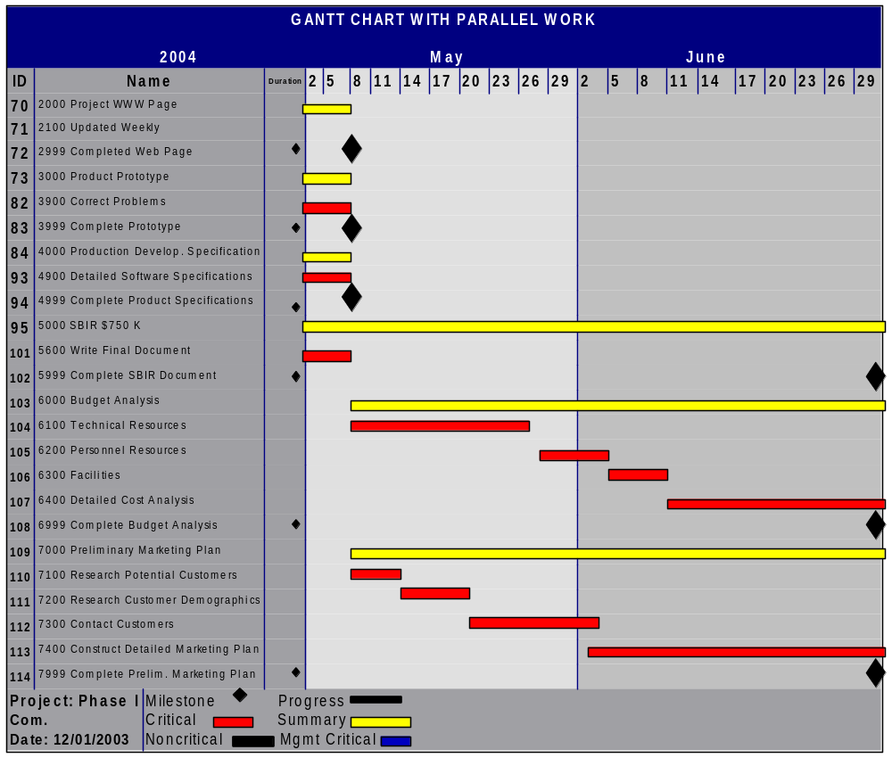
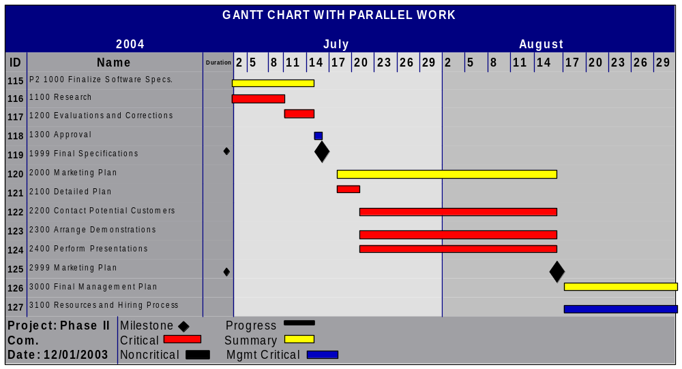
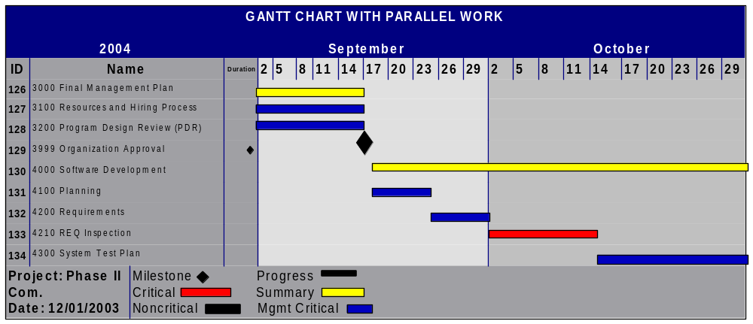
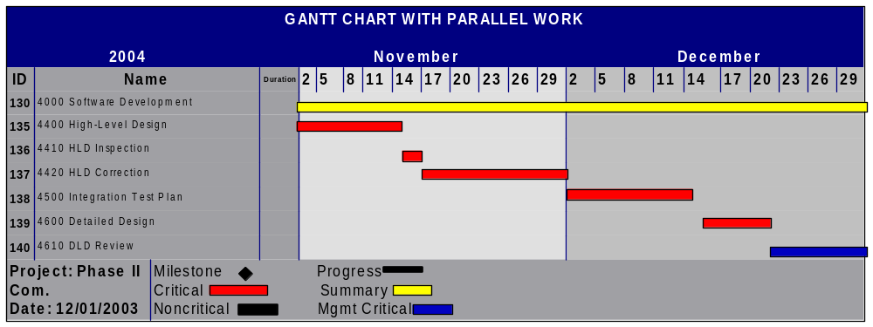
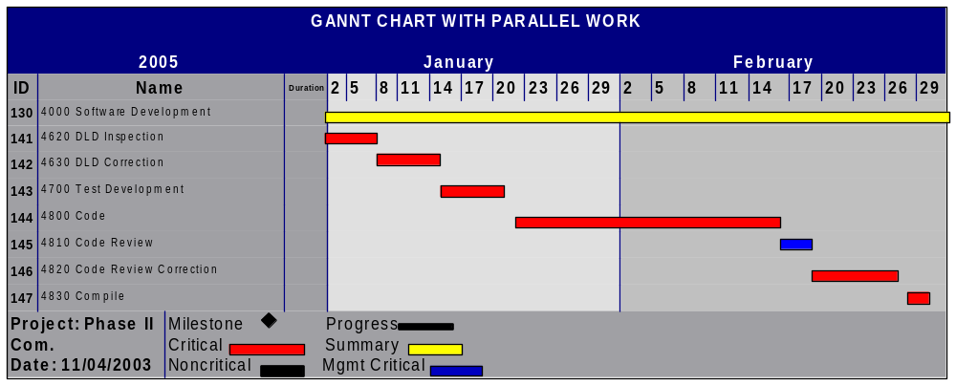
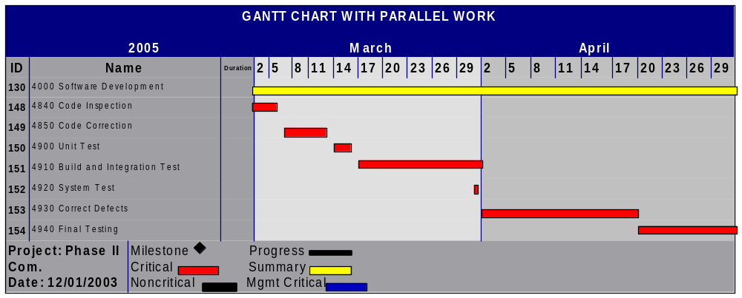
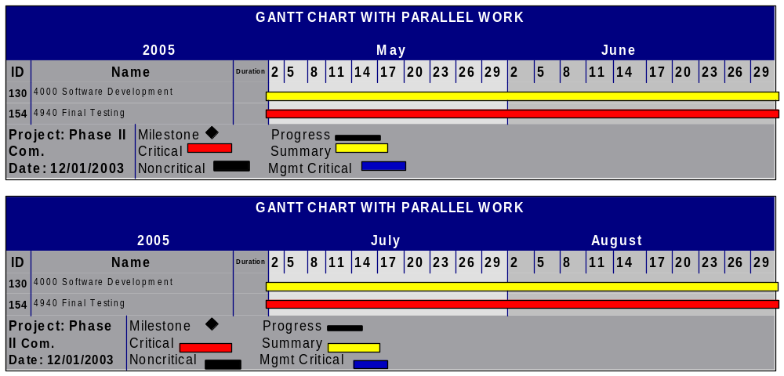
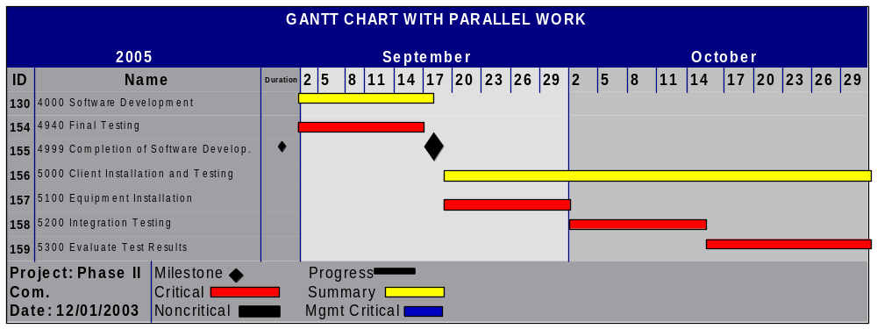
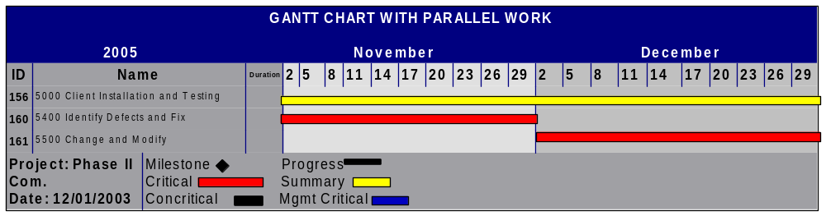
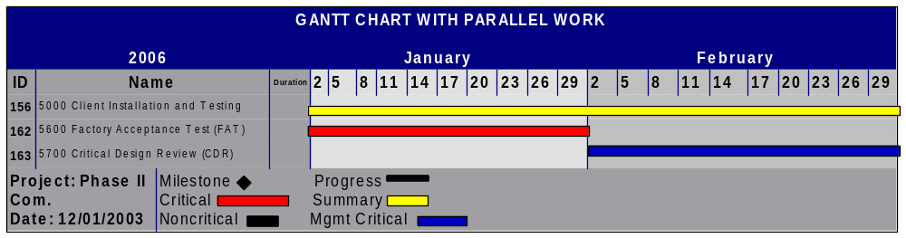
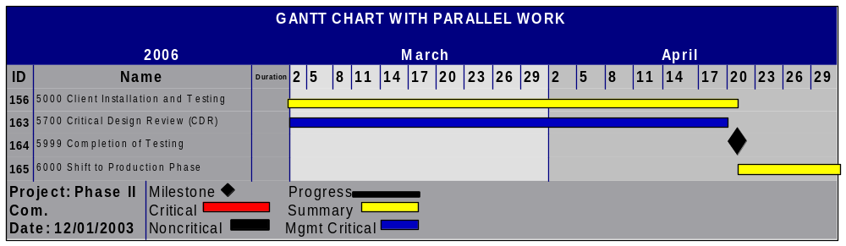
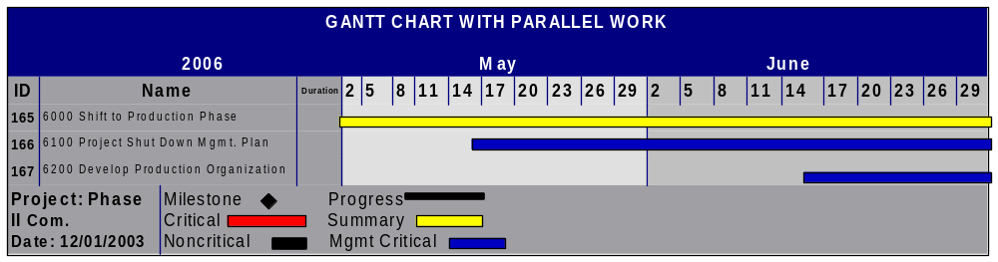
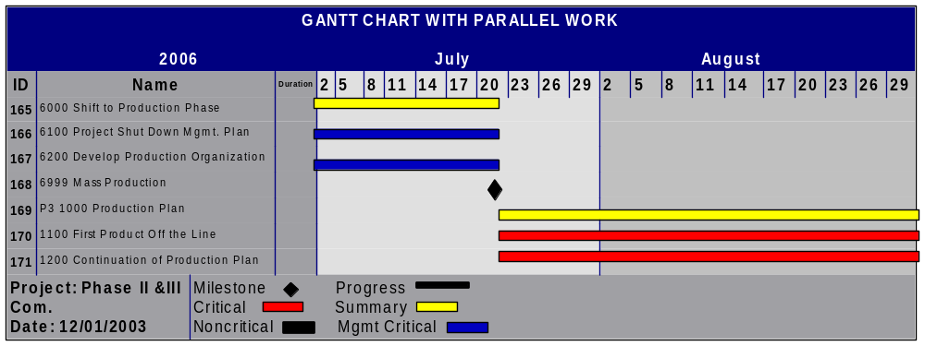
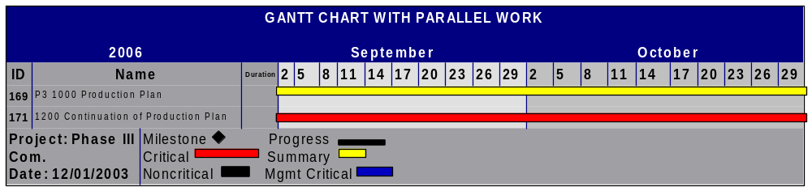
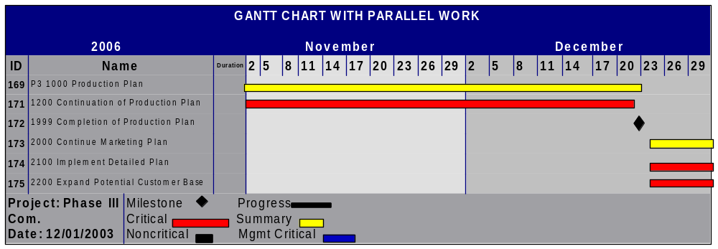
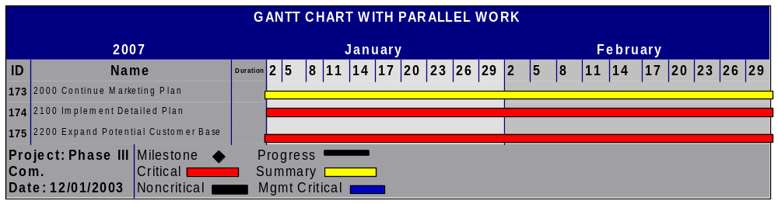
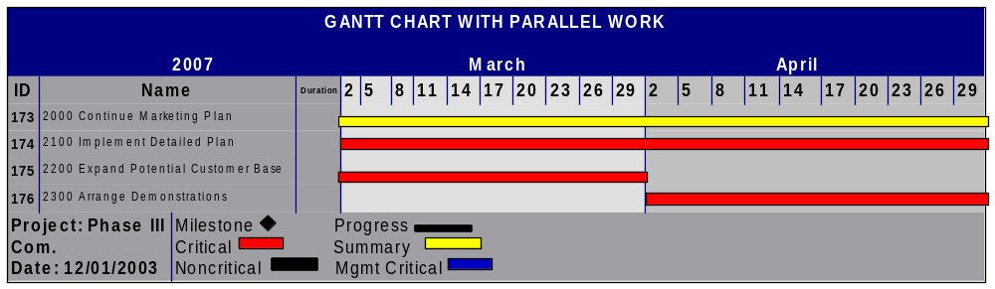
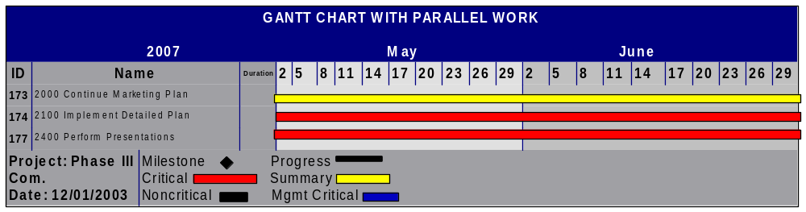
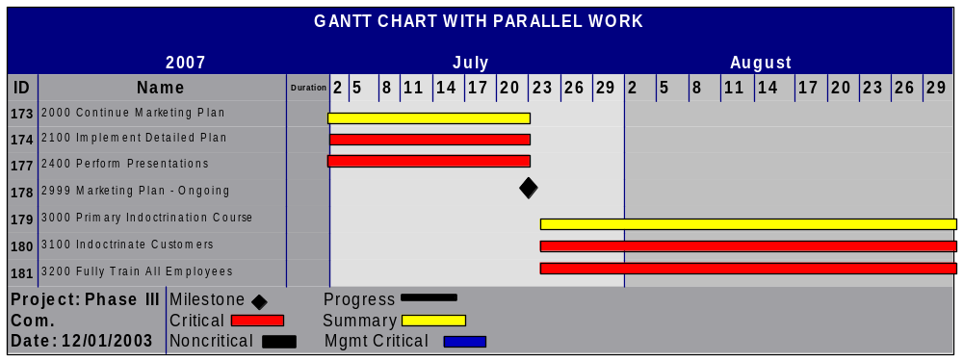
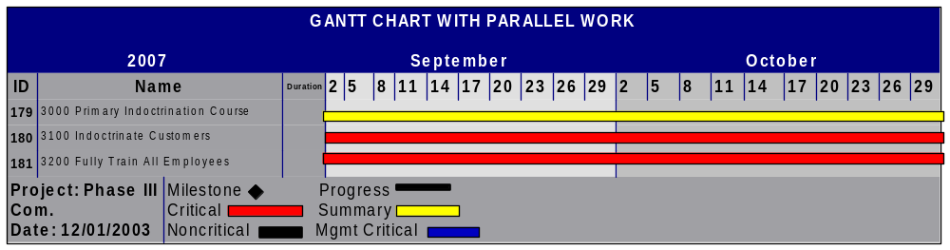
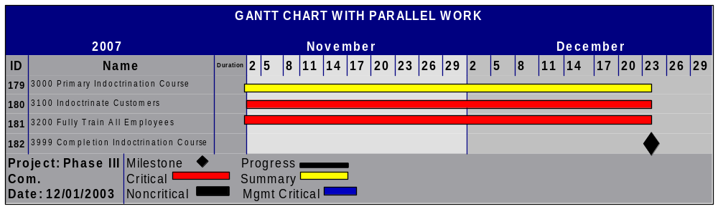
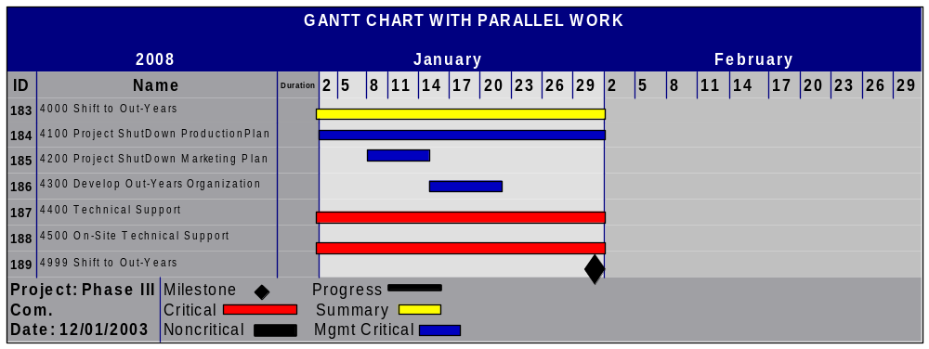

3.1.2 Product Plan
ID | Name | Predecessors | Resource Names | Start Date | Finish Date
1 | P0 1000 Conduct Preliminary Research |  | Group | 09.15.03 | 09.23.03
2 | 1100 Review Internet Sources |  | Group | 09.15.03 | 09.23.03
3 | 1200 Interview Experts |  | Group | 09.17.03 | 09.17.03
4 | 1300 Review All Media Resources |  | Group | 09.15.03 | 09.23.03
5 | 1999 M:Preliminary Research Complete |  | Milestone | 09.23.03 | 09.23.03
6 | P0 2000 Develop Plan |  | Group | 09.24.03 | 10.01.03
7 | 2100 Select Design Strategy |  | Group | 09.24.03 | 09.29.03
8 | 2200 Determine Project Problem |  | Group | 09.24.03 | 09.29.03
9 | 2210 Determine Project Scope | 8 | Group | 09.24.03 | 09.29.03
10 | 2300 Determine Available Resources |  | Group | 09.24.03 | 09.29.03
11 | 2400 Develop Plan |  | Group | 09.24.03 | 09.29.03
12 | 2500 Present Plan |  | Group | 09.24.03 | 09.29.03
13 | 2600 Review Plan |  | Group | 09.24.03 | 09.29.03
14 | 2700 Revise Plan |  | Group | 09.24.03 | 09.29.03
15 | 2999 M: Plan Approved |  | Milestone | 10.01.03 | 10.01.03
16 | P0 3000 Deliver Feasibility Presentation |  | Group | 10.01.03 | 10.20.03
17 | 3100 Determine Financial Feasibility |  | Zach | 10.01.03 | 10.18.03
18 | 3200 Determine Technical Feasibility |  | Kim | 10.01.03 | 10.18.03
19 | 3300 Determine Societal Feasibility |  | Jonathan | 10.01.03 | 10.18.03
20 | 3400 Determine Management Feasibility |  | Aaron | 10.01.03 | 10.18.03
21 | 3500 Assemble Presentation |  | Group | 10.01.03 | 10.18.03
22 | 3600 Practice Presentation |  | Aaron, Jonathan, Zach | 10.01.03 | 10.18.03
23 | 3700 Revise Presentation |  | Group | 10.01.03 | 10.19.03
24 | 3999 M: Deliver Presentation |  | Milestone | 10.20.03 | 10.20.03
25 | P0 4000 Deliver Milestone Presentation |  | Group | 10.21.03 | 11.12.03
26 | 4100 Develop All Future Schedules |  | Aaron | 10.21.03 | 10.31.03
27 | 4200 Determine Required Staffing | 26 | Justin, Zach | 10.22.03 | 10.31.03
28 | 4300 Determine Required Resources | 26 | Justin | 10.22.03 | 10.31.03
29 | 4400 Develop Project Concept Plan |  | Group | 10.22.03 | 10.31.03
30 | 4500 Construct Preliminary Budget |  | Justin | 10.27.03 | 11.03.03
31 | 4600 Assemble Presentation |  | Group | 11.08.03 | 11.09.03
32 | 4700 Practice Presentation |  | Group | 11.10.03 | 11.10.03
33 | 4800 Revise Presentation |  | Group | 11.10.03 | 11.10.03
34 | 4999 M: Deliver Presentation |  | Milestone | 11.12.03 | 11.12.03
35 | P0 5000 Deliver Approval Presentation |  | Group | 11.12.03 | 12.08.03
36 | 5100 Finalize Deliverable Elements List |  | Group | 11.12.03 | 11.14.03
37 | 5200 Complete Deliverable Elements |  | Group | 11.14.03 | 11.24.03
38 | 5300 Revise Deliverable Elements |  | Group | 11.24.03 | 11.28.03
39 | 5400 Assemble Presentation |  | Group | 11.29.03 | 11.29.03
40 | 5500 Practice Presentation |  | Group | 12.01.03 | 12.07.03
41 | 5600 Revise Presentation |  | Group | 12.03.03 | 12.07.03
42 | 5999 M: Deliver Presentation |  | Milestone | 12.08.03 | 12.08.03
43 | P0 6000 Develop Website |  | Group | 09.15.03 | 12.08.03
44 | 6100 High Level Design |  | Jitu, Zach | 09.15.03 | 09.18.03
45 | 6200 Write Basic Code | 44 | Jitu | 09.18.03 | 10.01.03
46 | 6300 ID Critical Information |  | Group | 10.01.03 | 12.08.03
47 | 6400 Update Weekly |  | Jitu | Weekly | Weekly
48 | 6999 M:Complete Website |  | Milestone | 12.08.03 | 12.08.03
49 | P0 7000 SBIR $100 K |  | Group | 10.25.03 | 12.08.03
50 | 7100 ID Funding Source |  | Zach | 10.25.03 | 10.31.03
51 | 7200 Acquire Appropriate Forms | 50 | Zach | 11.01.03 | 11.02.03
52 | 7300 Gather Data |  | Group | 11.02.03 | 11.15.03
53 | 7400 Write Rough Draft |  | Group | 11.15.03 | 11.17.03
54 | 7500 Write Final Document |  | Group | 11.17.03 | 12.08.03
55 | 7999 M: Complete SBIR Document |  | Milestone | 12.08.03 | 12.08.03
56 | P1 1000 Product User's Manuals |  | Group | 03.15.04 | 04.15.04
57 | 1100 Gather Data |  | Group | 03.15.04 | 03.25.04
58 | 1110 Define Capabilities and Limitations |  | Group | 03.25.04 | 04.01.04
59 | 1120 Description of Operational Modes |  | Group | 03.25.04 | 04.01.04
60 | 1130 Identify Methods of Use |  | Group | 03.25.04 | 04.01.04
61 | 1140 Write Operating Instructions |  | Group | 03.25.04 | 04.01.04
62 | 1150 ID Required Maintenance |  | Group | 03.25.04 | 04.01.04
63 | 1160 Define Safety Issues |  | Group | 03.25.04 | 04.01.04
64 | 1170 Parts List and Schematics |  | Group | 03.25.04 | 04.01.04
65 | 1180 Write Product Warranty |  | Group | 03.25.04 | 04.01.04
66 | 1200 Write Rough Draft | 57-65 | Group | 04.01.04 | 04.07.04
67 | 1300 Edit Rough Draft |  | Group | 04.07.04 | 04.09.04
68 | 1400 Write Final Draft |  | Group | 04.09.04 | 04.15.04
69 | 1999 M: Printed Complete Manual |  | Milestone | 04.15.04 | 04.15.04
70 | P1 2000 Project WWW Page |  | Web Manager | 01.08.04 | 05.08.04
71 | 2100 Updated Weekly |  | Web Manager | Weekly | Weekly
72 | 2999 M: Completed Web Page |  | Milestone | 05.08.04 | 05.08.04
73 | P1 3000 Product Prototype |  | Group | 03.01.04 | 05.08.04
74 | 3100 Create Systems Diagram of Product |  | Group | 03.01.04 | 03.07.04
75 | 3200 Create Systems Diagram of Prototype | 74 | Group | 03.07.04 | 03.14.04
76 | 3300 Identify Scope of Prototype |  | Group | 03.14.04 | 03.16.04
77 | 3400 ID Components and Cost |  | Group | 03.16.04 | 03.18.04
78 | 3500 Acquire Components |  | Group | 03.18.04 | 03.20.04
79 | 3600 Create Prototype Production Timeline |  | Group | 03.20.04 | 03.30.04
80 | 3700 Construct Prototype |  | Group | 03.30.04 | 04.15.04
81 | 3800 Test Prototype |  | Group | 04.15.04 | 04.19.04
82 | 3900 Correct Problems |  | Group | 04.19.04 | 05.08.04
83 | 3999 M: Complete Prototype |  | Milestone | 05.08.04 | 05.08.04
84 | P1 4000 Production Development Specifications |  | Group | 04.08.04 | 05.08.04
85 | 4100 Gather Data |  | Group | 04.08.04 | 04.10.04
86 | 4200 Problem Definition |  | Group | 04.10.04 | 04.11.04
87 | 4300 Project Goals |  | Group | 04.11.04 | 04.12.04
88 | 4400 Systems Overview |  | Group | 04.12.04 | 04.14.04
89 | 4500 General Description |  | Group | 04.14.04 | 04.16.04
90 | 4600 System Operation |  | Group | 04.16.04 | 04.20.04
91 | 4700 ID Writes and Responsibility |  | Group | 04.20.04 | 04.25.04
92 | 4800 Detailed Hardware Specifications |  | Group | 04.25.04 | 04.30.04
93 | 4900 Detailed Software Specifications |  | Group | 05.01.04 | 05.08.04
94 | 4999 M: Complete Product Specifications |  | Milestone | 05.08.04 | 05.08.04
95 | P1 5000 SBIR $750 K |  | Group | 03.08.04 | 06.30.04
96 | 5100 Funding Source |  | Budget Manager | 03.08.04 | 03.20.04
97 | 5200 Acquire Appropriate Forms |  | Budget Manager | 03.20.04 | 03.24.04
98 | 5300 Gather Data |  | Group | 03.24.04 | 04.10.04
99 | 5400 Write Rough Draft |  | Group | 04.10.04 | 04.25.04
100 | 5500 Edit Rough Draft |  | Group | 04.25.04 | 04.28.04
101 | 5600 Write Final Document |  | Group | 04.28.04 | 05.08.04
102 | 5999 M: Complete SBIR Document |  | Milestone | 06.30.04 | 06.30.04
103 | P1 6000 Budget Analysis |  | Budget Manager | 05.09.04 | 06.30.04
104 | 6100 Technical Resources |  | Team | 05.09.04 | 05.24.04
105 | 6200 Personnel Resources |  | Team | 05.24.04 | 06.04.04
106 | 6300 Facilities |  | Team | 06.04.04 | 06.11.04
107 | 6400 Detailed Cost Analysis |  | Team | 06.11.04 | 06.30.04
108 | 6999 M: Complete Budget Analysis |  | Team | 06.30.04 | 06.30.04
109 | P1 7000 Preliminary Marketing Plan |  | Marketing Manager | 05.09.04 | 06.30.04
110 | 7100 Research Potential Customers |  | Team | 05.09.04 | 05.14.04
111 | 7200 Research Customer Demographics |  | Team | 05.14.04 | 05.21.04
112 | 7300 Contact Customers |  | Team | 05.21.04 | 06.04.04
113 | 7400 Construct Detailed Marketing Plan |  | Team | 06.04.04 | 06.30.04
114 | 7999 M: Complete Preliminary Marketing Plan |  | Team | 06.30.04 | 06.30.04
115 | P2 1000 Finalize Software Specifications |  | Project Manager | 07.01.04 | 07.15.04
116 | 1100 Research |  | Team | 07.01.04 | 07.10.04
117 | 1200 Evaluations and Corrections |  | Team | 07.10.04 | 07.14.04
118 | 1300 Approval |  | Team | 07.14.04 | 07.15.04
119 | 1999 M: Final Specifications |  | Milestone | 07.15.04 | 07.15.04
120 | P2 2000 Marketing Plan |  | Marketing Manager | 07.16.04 | 08.16.04
121 | 2100 Detailed Plan |  | Marketing Manager | 07.16.04 | 07.19.04
122 | 2200 Contact Potential Customers |  | Marketing Manager | 07.19.04 | 08.16.04
123 | 2300 Arrange Demonstrations |  | Marketing Manager | 07.19.04 | 08.16.04
124 | 2400 Perform Presentations |  | Marketing Manager | 07.19.04 | 08.16.04
125 | 2999 M: Marketing Plan Complete |  | Milestone | 08.16.04 | 08.16.04
126 | P2 3000 Final Management Plan |  | Project Manager | 08.17.04 | 09.17.04
127 | 3100 Resources and Hiring Process |  | Project Manager | 08.17.04 | 09.17.04
128 | 3200 Program Design Review (PDR) |  | Project Manager | 09.01.04 | 09.17.04
129 | 3999 M: Organization Approval |  | Milestone | 09.17.04 | 09.17.04
130 | P2 4000 Software Development |  | Software Engineers | 09.18.04 | 09.18.05
131 | 4100 Planning |  | Project Manager | 09.18.04 | 09.25.04
132 | 4200 Requirements |  | Project Manager | 09.25.04 | 10.01.04
133 | 4210 REQ Inspection |  | Team | 10.02.04 | 10.14.04
134 | 4300 System Test Plan |  | Project Manager | 10.15.04 | 10.30.04
135 | 4400 High-Level Design |  | Team | 11.01.04 | 11.14.04
136 | 4410 HLD Inspection |  | Team | 11.15.04 | 11.17.04
137 | 4420 HLD Correction |  | Team | 11.18.04 | 11.30.04
138 | 4500 Integration Test Plan |  | Team | 12.01.04 | 12.15.04
139 | 4600 Detailed Design |  | Team | 12.16.04 | 12.22.04
140 | 4610 DLD Review |  | Project Manager | 12.23.04 | 12.31.04
141 | 4620 DLD Inspection |  | Team | 01.01.05 | 01.07.05
142 | 4630 DLD Correction |  | Team | 01.08.05 | 01.15.05
143 | 4700 Test Development |  | Team | 01.16.05 | 01.21.05
144 | 4800 Code |  | Team | 01.22.05 | 02.16.05
145 | 4810 Code Review |  | Project Manager | 02.17.05 | 02.19.05
146 | 4820 Code Review Correction |  | Team | 02.20.05 | 02.27.05
147 | 4830 Compile |  | Team | 02.28.05 | 02.28.05
148 | 4840 Code Inspection |  | Team | 03.01.05 | 03.06.05
149 | 4850 Code Correction |  | Team | 03.07.05 | 03.13.05
150 | 4900 Unit Test |  | Team | 03.14.05 | 03.15.05
151 | 4910 Build and Integration Test |  | Team | 03.16.05 | 03.30.05
152 | 4920 System Test |  | Team | 03.31.05 | 03.31.05
153 | 4930 Correct Defects |  | Team | 04.01.05 | 04.20.05
154 | 4940 Final Testing |  | Team | 04.20.05 | 09.17.05
155 | 4999 M: Completion of Software Development |  | Team | 09.18.05 | 09.18.05
156 | P2 5000 Client Installation and Testing |  | Software Engineers | 09.19.05 | 04.20.06
157 | 5100 Equipment Installation |  | Technicians | 09.19.05 | 09.30.05
158 | 5200 Integration Testing |  | Software Engineers | 10.01.05 | 10.15.05
159 | 5300 Evaluate Test Results |  | Software Engineers | 10.16.05 | 10.31.05
160 | 5400 Identify Defects and Fix |  | Software Engineers | 11.01.05 | 11.30.05
161 | 5500 Change and Modify |  | Software Engineers | 12.01.05 | 12.30.05
162 | 5600 Factory Acceptance Test (FAT) |  | Software Engineers | 01.01.06 | 01.31.06
163 | 5700 Critical Design Review (CDR) |  | Project Manager | 02.01.06 | 04.19.06
164 | 5999 M: Completion of Testing |  | Milestone | 04.20.06 | 04.20.06
165 | P2 6000 Shift to Production Phase |  | Project Manager | 04.21.06 | 07.21.06
166 | 6100 Project ShutDown Management Plan |  | Project Manager | 05.15.06 | 07.21.06
167 | 6200 Develop Production Organization |  | Production Manager | 06.15.06 | 07.21.06
168 | 6999 M: Mass Production |  | Milestone | 07.21.06 | 07.21.06
169 | P3 1000 Production Plan |  | Production Manager | 07.22.06 | 12.22.06
170 | 1100 First Product Off the Line |  | Factory | 07.22.06 | 09.01.06
171 | 1200 Continuation of Production Plan |  | Production Manager | 07.22.06 | 12.21.06
172 | 1999 M: Completion of Production Plan |  | Milestone | 12.22.06 | 12.22.06
173 | P3 2000 Continue Marketing Plan |  | Marketing Manager | 12.23.06 | 07.23.07
174 | 2100 Implement Detailed Plan |  | Marketing Manager | 12.23.06 | 07.23.07
175 | 2200 Expand Potential Customer Base |  | Marketing Manager | 12.23.06 | 03.30.07
176 | 2300 Arrange Demonstrations |  | Marketing Manager | 04.01.07 | 04.30.07
177 | 2400 Perform Presentations |  | Budget Manager | 05.01.07 | 07.23.07
178 | 2999 M: Marketing Plan- Ongoing |  | Milestone | 07.23.07 | 07.23.07
179 | P3 3000 Primary Indoctrination Course |  | Documentation Dept. | 07.24.07 | 12.24.07
180 | 3100 Indoctrinate Customers |  | Documentation Dept. | 07.24.07 | 12.24.07
181 | 3200 Fully Train all employee's |  | Documentation Dept. | 07.24.07 | 12.24.07
182 | 3999 M: Completion Indoctrination Course |  | Milestone | 12.24.07 | 12.24.07
183 | P3 4000 Shift to Out-Years |  | Production Manager | 01.01.08 | 02.01.08
184 | 4100 Project Shut Down Production Plan |  | Production Manager | 01.01.08 | 01.07.08
185 | 4200 Project Shut Down Marketing Plan |  | Production Manager | 01.08.08 | 01.15.08
186 | 4300 Develop Out-Years Organization |  | Production Manager | 01.16.08 | 01.21.08
187 | 4400 Technical Support |  | Technician | 01.01.08 | 02.01.08
188 | 4500 On-Site Technical Support |  | Technician | 01.01.08 | 02.01.08
189 | 4999 M: Shift to Out-Years |  | Milestone | 02.01.08 | 02.01.08

3.2 Resources

3.2.1 Phase I Resources

3.2.2 Phase II Resources

3.2.3 Phase III Resources

3.2.4 Resource Overview

3.2.5 Personnel Overview

3.2.5.1 Project Manager
The project manager will lead all aspects of the project, managing the product development process from concept to commercialization. He will monitor workflow and deadlines, while providing leadership, coaching, and mentoring for the development staff.

3.2.5.2 Software Manager
The software manager will lead the team of software engineers to design and develop the software. He will lead a team consisting of a level 3 software engineer III, 3 level 2 software engineers, a software quality assurance person, and a database architect. Additional responsibilities include writing product requirement documents, and implementing and tracking development timelines.

3.2.5.3 Software Engineer III
This software engineer will be the main programmer, working on the most critical parts of the project. He will report to the software manager, while providing assistance to the other software engineers.

3.2.5.4 Software Engineer II
Three level 2 software engineers will be part of the team. These engineers will report to the software manager, working on the less critical aspects of the software.

3.2.5.5 Software Quality Assurance
The function of this position is to ensure the quality of the software. Some of the responsibilities of this position are developing, publishing, and implementing test plans, writing and maintaining test automation, developing quality assurance standards, and defining and tracking quality assurance metrics such as defect densities and open defect counts.

3.5.5.6 Data Architect
The Data Architect is responsible for designing and developing the patient database that will be part of the server side software run at the cardiac rehab centers. The Data Architect will report to the software manager.

3.5.5.7 Financial Analyst
The Financial Analyst is responsible for developing the project’s budget, as well as finding sources for funding.

3.5.5.8 Product Marketing Analyst III
The Product Marketing Analyst III will be responsible for developing the marketing plan for our project, overseeing its implementation, determining potential customers for our system, and convincing those potential customers why they should purchase our software.

3.5.5.9 Web Developer
The web developer will be responsible for designing, creating, and maintaining the product’s website.

3.5.5.10 Sr. Documentation Specialist
The Sr. Documentation Specialist will be responsible for creating precise, and thoroughly detailed user manuals, technical specifications, and other product documents as necessary.

3.5.5.11 Medical Advisor
The medical advisor will assist the software engineers during the design phase to ensure that the software doesn’t include any incorrect medical advice or information, that could lead to undesired consequences.

3.5.5.12 Legal Advisor
The legal advisor will be responsible for creating unambiguous the disclaimer and terms of use agreement for our product, assuring that our product adheres to HIPAA, and the FDA software policy.

3.3 Budget

3.3.1 Phase I Budget



3.3.2 Phase II Budget



3.3.3 Phase III Budget

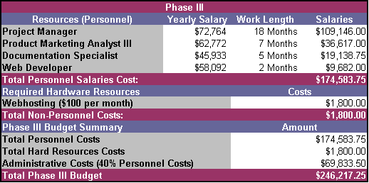

3.3.4 Production Budget Overview
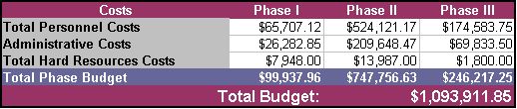

3.3.5 Post-Production Out-Years Budget
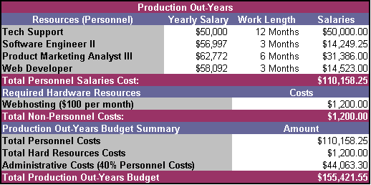

3.4 Marketing Plan
3.4.1 Customer
The customer base of the Phase III Communicator would have two primary layers. The first and topmost layer would be cardiac rehabilitation facilities. These facilities would provide their patients with the software in order to keep them enrolled in programs at the facility. The second layer of the customer base would be insurance companies. Insurance companies would support P3C by paying the monthly service charges charged by the cardiac care center to the patient. The insurance companies would also cover the licensing charge.

The primary customers of the Phase III Communicator are hospitals and cardiac rehabilitation facilities. There are over 1,500 trauma centers in the United States. Of these, there is at least one level I trauma center in most every large metropolitan area in America. P3C intends to target these institutions. Specifically, P3C will target those facilities with highly competitive cardiac programs wanting an edge in the market. The hospitals expenses in the program would be a server and necessary software, additional personnel needed to run the program, and licenses for the client version (which can be reimbursed by the patient or his or her insurance company.

The secondary customers are insurance companies. To make the program feasible, P3C will need insurance companies to be willing to pay for the software as well as for the hospital’s monthly service fee. We plan to market to insurance companies by showing that using our program will decrease the amount of money they spend on cardiac patients. Currently 351.8 billion dollars is spent yearly on cardiovascular diseases (American Heart Association, 2003.) The average cost of a hospital visit for a cardiovascular disease is 7,883 dollars (American Heart Association, 2003.) Those who display a high risk for a cardiovascular disease account for 50 to 70 percent of all cardiovascular diseases patients (Center for Disease Control, 2000.).

The users of the Phase III Communicator would be cardiovascular disease patients. Our main focus is on the patients between the ages of 35 and 60. Over 21 million of these individuals have a cardiovascular disease (Figure 10.) Of those 21 million, an estimated 11 million use the internet (Figure 11.) If one percent of the individuals within the above ranges participate in our program, we could expect to see a user base of approximately 112,660 people.
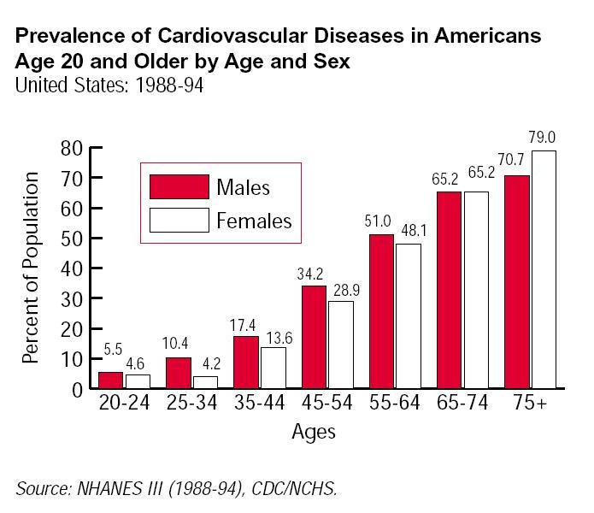
Figure 10: CVD Percentages by Age

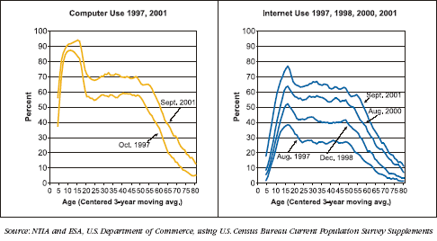
Figure 11: Computer and Internet Usage by Age

3.4.2 Competition Matrix
The competition for the Phase III Communicator (P3C) falls into two categories: software and existing cardiovascular rehabilitation programs. Of the former, the two most potent competitors are Fitlynxx and UltraCoach. The cardiovascular rehabilitation programs surveyed included the California Pacific Medical Center, the Rochester Heart Institute, and the Tidewater Cardiovascular Institute.

Fitlynxx provides support beyond Phase II of rehabilitation and is useable at home via the internet. It does provide contact with a personal trainer who can give feedback and answer the patient’s questions. What Fitlynxx does not provide is measurement and tracking of the user’s blood pressure and pulse. It also does not provide the user with a phone call from the rehabilitation facility that was shown to increase patient participation in the Stanford Study.

UltraCoach does not specifically target cardiovascular patients, but has been used by cardiovascular patients with some success. It provides exercise feedback based upon historical input. It does not provide any form of communication between a rehabilitation facility and the patient. Both software programs’ major feature for cardiovascular patients is their usability at home.

The three cardiovascular rehabilitation facilities provided roughly the same features. They provided support through Phase I, II, and III (with the exception of the Tidewater Cardiovascular Institute.) The key selling point for these programs is their ability to provide professional monitoring and feedback to the patients. The disadvantages are that these programs are not usable at home and are expensive, as the patient must use the existing facilities.

The Phase III Communicator bridges the gap between the two types of programs by providing professional monitoring and feedback at home, while also storing input data from the user and providing the user with an exercise database with equivalencies and other information. P3C will not provide exercise prescription that has not been approved by the medical professional monitoring the patient.

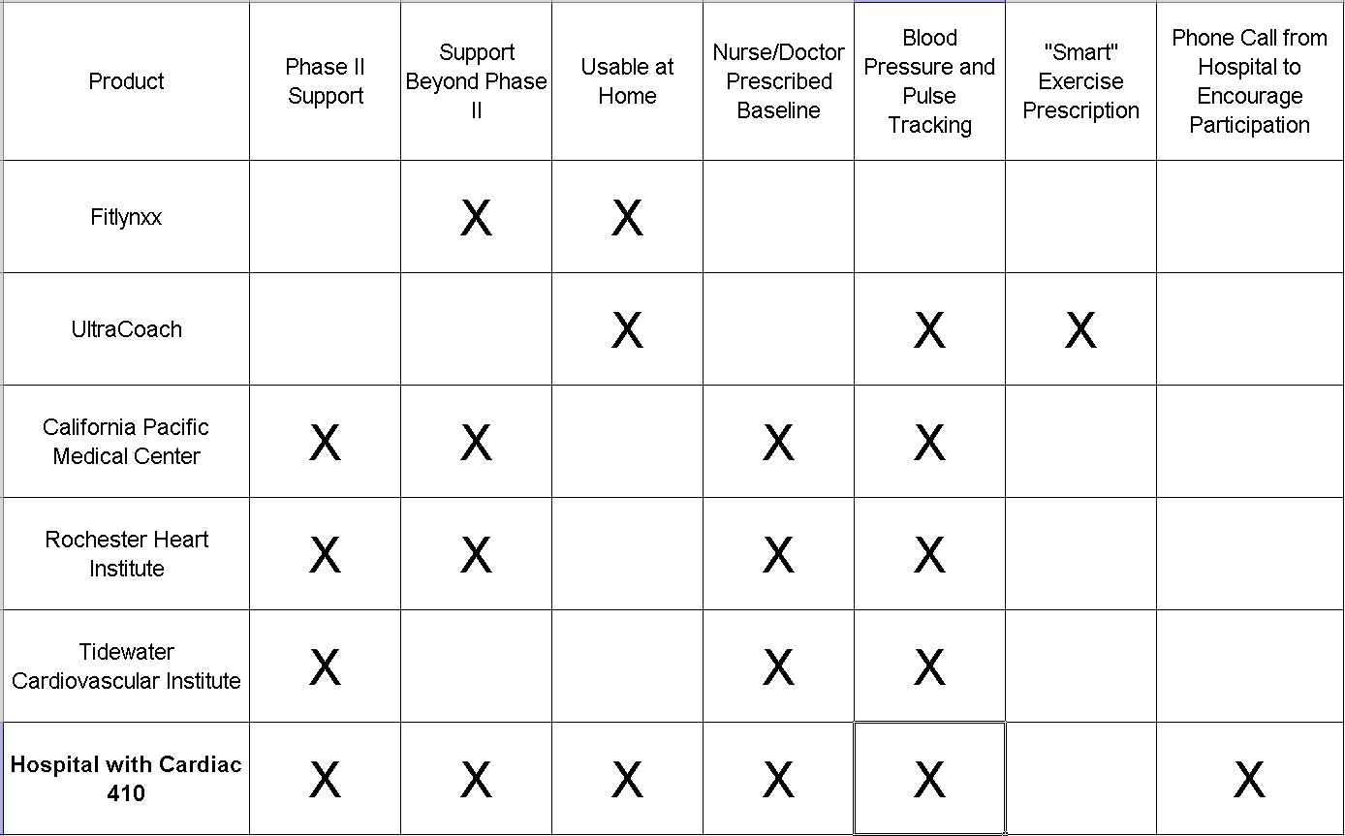
Figure 12: Competition Matrix

3.5 Testing and Prototyping
3.5.0 Test Market
Our test market will be Sentara Norfolk General Hospital. Their cardiac program is ranked 21st in the nation³. Recently, Sentara announced plans to open a dedicated heart hospital on the campus of Norfolk General⁴. We will provide a server, the software, and funds for any additional staff that the hospital may require.

3.5.1 Test Plan
The test will involve a control group and experimental group of 300 individuals each. The control group will participate in the standard rehabilitation process. The experimental group will be introduced to the software in Phase II of their rehabilitation. We will test to see how many individuals in each group remain in some sort of rehabilitation past Phase II. Provided that the test results prove promising, we will proceed to market the software to other hospitals and cardiovascular rehabilitation centers.

3.5.2 Prototype Plan
Phase III Communicator’s prototype will involve a small-scale simulation of the actual P3C system. The team will use three personal computers: the first to simulate the patient’s computer, the second to simulate the nurse’s computer, and the third to simulate the P3C server. A scaled down model of the actual P3C web software will be stored on the server computer. Both the patient and nurse will access their respective portals via the server computer.

The patient side web portal will feature the basic input fields for reporting exercise, as well as display the nurses feedback. The nurse’s portal will allow him or her to view patient’s records and display a list of patients who need to a motivational phone call.

3.6 Risk Assessment

3.6.1 Customer Risks

3.6.1.1 Reluctance to exercise and/or use our software

Probability: Moderate
Consequences: Severe
Solution: We will emphasize a strong marketing campaign designed to enlighten cardiac rehab patients about the importance of exercising in order to increase their well-being and to decrease the risk of repeat cardiac issues.

3.6.1.2 Users incorrectly using our software

Probability: Moderate
Consequences: Moderate
Solution: Our system will include functionality allowing the
transmission of measured vital stats from external
measuring devices connected to the user’s computer
through a USB cable. This will limit the possibility of
user’s incorrectly manually entering in their vital stats.
Furthermore, we will keep the GUI simple and intuitive to
use, enabling even those with limited computer knowledge
to be able to successfully use our system. We will be
explicit as possible with easy-to-follow on screen exercise
instructions and directions. We will also be hiring a
Documentation Specialist to ensure that the user manual
that we include with our software is thorough and precisely
detailed.

3.6.1.3 Hospitals and Clinics reluctant to use our system

Probability: Moderate
Consequences: Severe
Solution: Through our marketing campaign we will convince
hospitals and cardiac rehabilitation centers that our system
is an ideal way to distinguish themselves from other cardiac
centers and a means to attract new patients to their center
thus bringing additional business and revenue.

3.6.2 Legal Risks

3.6.2.1 Lawsuits resulting from user being injured/dying

Probability: Moderate
Consequences: Severe
Solution: Clear and unambiguous terms of use agreements
that the user must read and agree to before installing the
software. Included in the terms of use will be statements
absolving C Group from any liability and/or responsibility
to any possible bodily injury that the user might incur. A
legal advisor will also be hired in order to handle all the
cases that might be filed against our company, and to
ensure that we are adequately protected from lawsuits.

3.6.2.2 Lawsuits resulting from users’ health not improving

Probability: Moderate
Consequences: Severe
Solution: Clear and unambiguous disclaimer, that makes it
clear that our company makes no guarantees concerning the
results and outcomes of using our product. Again, our
lawyer will take care of any lawsuits that might be filed
against our company.

3.6.2.3 Lawsuits accusing us of violating patient’s privacy

Probability: Moderate
Consequences: Severe
Solution: To govern how we collect data from the hospitals
and clinics running our software, we will closely adhere to
the rules set forth by the HIPAA (Health Information
Portability and Accounting Act of 1996), and its Privacy
Rule put in effect in April 2003

3.6.3 Technical Risks

3.6.3.1 Data sent between nurse and patient prone to hackers

Probability: Moderate
Consequences: Severe
Solution: While the information sent back and forth between
the user and the nurse/exercise specialist is not especially
useful if a third-party gets ahold of it, it does violate
privacy rules detailed in the HIPAA. Thus, our software
will use PGP encryption technology to protect the data sent
and received by our software system.

3.6.3.2 Scope of product considered too limited

Probability: Moderate
Consequences: Moderate
Solution: The scope is intentionally limited in the beginning.
Once our product starts being used, and we begin to see a
steady revenue flow, we will obviously update our product
to add more functionality to it. Not only does this
allow our company to roll out a product earlier, albeit a
somewhat limited scope version, it also allows for new
streams of revenue. Included in future phases of the
product will be a heart rate/blood pressure wrist monitor
that works directly with our software, and nutritional
advice and feedback.

3.6.3.3 Software bugs causing software to not function as intended

Probability: Low/Moderate
Consequences: Moderate
Solution: Design phase to minimize the possibility of design
errors, and a lengthy testing phase to ensure that the critical
and addressable software bugs are found and fixed.

3.7 Glossary
Aerobic activities – Activities of sub-maximal intensity that use large muscle groups with energy
supplied aerobically.

Angina – Severe cardiac pain that may radiate to the jaw or arms. Angina is caused by
myocardial ischemia, which can be induced by exercise in susceptible individuals.

Arteriosclerosis – An arterial disease characterized by the hardening and the thickening of the
vessel walls.

Atherosclerosis – A form of arteriosclerosis in which fatty substances are deposited in the inner
walls of the arteries.

Blood pressure – The pressure exerted by the blood on the vessel walls measured in millimeters
of mercury by the sphygmomanometer. The systolic pressure is the first sound, followed by the diastolic pressure, which is recorded when there is a change of tone of the sound or disappearance of the sound.

Blood vessel – Any vessel through which blood circulates.

Cardiac rehabilitation – A program designed to help cardiac patients return to normal lives with
reduced risk of additional health problems.

Circulation – The continuous movement of blood though the heart, lungs, and tissue via blood
vessels.

Coronary arteries – Blood vessels that supply the heart muscle.\

Coronary artery bypass graft (CABG) – Surgery to bypass one or more blocked coronary arteries
in which a blood vessel is sewn into existing coronary arteries above and below the blockage.

Electrocardiogram (ECG) – The graphical recording of the electrical activity of the heart,
obtained with the electrocardiograph.

Exercise – Structured physical activity whose purpose is to improve come component of physical
fitness.

Heart Attack – A general term used to describe an acute episode of heart disease; common name
for myocardial infarction.

Heart rate – Number of beats of the heart per minute.

Infarction – Death of a section of tissue due to lack of blood flow, as in myocardial infarction.

Myocardial infarction (MI) – Death to a section of heart tissue in which the blood supply has
been cut off.

Myocardial ischemia – A lack of oxygen for heart function due to a decrease in blood flow.

Prescribed exercise – A recommendation of type, intensity, frequency, duration, and total work
needed to accomplish fitness objectives.

Risk factor – A characteristic, sign, symptom, or test score that is associated with increased
probability of developing a health problem.

