COVER SHEET FOR PROPOSAL TO THE NATIONAL SCIENCE FOUNDATION
PROGRAM ANNOUNCEMENT/SOLICITATION NO./CLOSING DATE/If not in response to a program announcement/solicitation enter NSF 00-2 |  |  |  |  |  |  |  |  |  |  |  |  |  |  |  |  |  |  |  |  |  |  |  |  | FOR NSF USE ONLY
Azul Business Corporation / December 8, 2004 |  |  |  |  |  |  |  |  |  |  |  |  |  |  |  |  |  |  |  |  |  |  |  |  | NSF PROPOSAL NUMBER
FOR CONSIDERATION BY NSF ORGANIZATIONAL UNIT(S) (Indicate the most specific unit known, i.e., program, division, etc.)

Education
DATE RECEIVED |  | NUMBER OF COPIES |  |  |  |  | DIVISION ASSIGNED |  |  |  |  | FUND CODE |  |  |  |  |  |  |  | DUNS # (Data Universal Numbering System) |  |  |  |  |  | FILE LOCATION
EMPLOYER IDENTIFICATION NUMBER (EIN) OR |  |  |  |  |  |  |  | SHOW PREVIOUS AWARD NO. IF THIS IS |  |  |  |  |  |  |  |  |  |  |  |  |  | IS THIS PROPOSAL BEING SUBMITTED TO ANOTHER FEDERAL
TAXPAYER IDENTIFICATION NUMBER (TIN) |  |  |  |  |  |  |  | A RENEWAL |  |  |  |  |  |  |  |  |  |  |  |  |  | AGENCY? YES NO IF YES, LIST ACRONYM(S)
xxx-xx-xxxx |  |  |  |  |  |  |  | AN ACCOMPLISHMENT-BASED RENEWAL
NAME OF ORGANIZATION TO WHICH AWARD SHOULD BE MADE |  |  |  |  |  |  |  |  |  |  |  |  | ADDRESS OF AWARDEE ORGANIZATION, INCLUDING 9 DIGIT ZIP CODE
Old Dominion University |  |  |  |  |  |  |  |  |  |  |  |  | P.O. Box 6369
AWARDEE ORGANIZATION CODE (IF KNOWN) |  |  |  |  |  |  |  |  |  |  |  |  | 800 West ⁴⁶th Street
 |  |  |  |  |  |  |  |  |  |  |  |  | Norfolk, VA 23508
NAME OF PERFORMING ORGANIZATION, IF DIFFERENT FROM ABOVE |  |  |  |  |  |  |  |  |  |  |  |  | ADDRESS OF PERFORMING ORGANIZATION, IF DIFFERENT, INCLUDING 9 DIGIT ZIP CODE
ODU Computer Science Department |  |  |  |  |  |  |  |  |  |  |  |  | Computer Science Department
PERFORMING ORGANIZATION CODE (IF KNOWN) |  |  |  |  |  |  |  |  |  |  |  |  | Old Dominion University
 |  |  |  |  |  |  |  |  |  |  |  |  | Norfolk, VA 23529-0162
IS AWARDEE ORGANIZATION (Check All That Apply)
(See GPG II.D.1 For Definitions) FOR-PROFIT ORGANIZATION SMALL BUSINESS MINORITY BUSINESS WOMAN-OWNED BUSINESS

TITLE OF PROPOSED PROJECT S.A.V.E. The Student Audio Visual e-Tool

REQUESTED AMOUNT  $98,200  $ |  |  |  |  |  | PROPOSED DURATION (1-60 MONTHS)  6  months |  |  |  |  |  |  |  |  |  |  | REQUESTED STARTING DATE  January 1, 2005 |  |  |  |  |  |  |  | SHOW RELATED PREPROPOSAL NO.,  IF APPLICABLE
CHECK APPROPRIATE BOX(ES) IF THIS PROPOSAL INCLUDES ANY OF THE ITEMS LISTED BELOW
BEGINNING INVESTIGATOR (GPG I.A.3) |  |  |  |  |  |  |  |  |  |  |  |  |  |  |  | VERTEBRATE ANIMALS (GPG II.D.12) IACUC App. Date
DISCLOSURE OF LOBBYING ACTIVITIES (GPG II.D.1) |  |  |  |  |  |  |  |  |  |  |  |  |  |  |  | HUMAN SUBJECTS (GPG II.D.12)
PROPRIETARY & PRIVILEGED INFORMATION (GPG I.B, II.D.7) |  |  |  |  |  |  |  |  |  |  |  |  |  |  |  | Exemption Subsection or IRB App. Date
NATIONAL ENVIRONMENTAL POLICY ACT (GPG II.D.10) |  |  |  |  |  |  |  |  |  |  |  |  |  |  |  | INTERNATIONAL COOPERATIVE ACTIVITIES: COUNTRY/COUNTRIES
HISTORIC PLACES (GPG II.D.10)

SMALL GRANT FOR EXPLOR. RESEARCH (SGER) (GPG II.D.12) |  |  |  |  |  |  |  |  |  |  |  |  |  |  |  | FACILITATION FOR SCIENTISTS/ENGINEERS WITH DISABILITIES (GPG V.G.)
 |  |  |  |  |  |  |  |  |  |  |  |  |  |  |  | RESEARCH OPPORTUNITY AWARD (GPG V.H)
PI/PD DEPARTMENT |  |  |  |  |  |  |  |  |  | PI/PD POSTAL ADDRESS
Computer Science |  |  |  |  |  |  |  |  |  | Old Dominion University
PI/PD FAX NUMBER |  |  |  |  |  |  |  |  |  | Computer Science Department
 |  |  |  |  |  |  |  |  |  | Norfolk, VA 23529-0162
NAMES (TYPED) |  |  |  |  |  |  |  |  |  | High Degree |  |  |  | Yr of Degree |  |  |  |  |  |  | Telephone Number |  |  | Electronic Mail Address
PI/PD NAME
Dennis Ray |  |  |  |  |  |  |  |  |  |  |  |  |  |  |  |  |  |  |  |  |  |  |  | ray@cs.odu.edu
CO-PI/PD
CO-PI/PD
CO-PI/PD
CO-PI/PD

NSF Form 1207 (10/99) Page 1 of 2

CERTIFICATION PAGE
Certification for Principal Investigators and Co-Principal Investigators
I certify to the best of my knowledge that:
(1) the statements herein (excluding scientific hypotheses and scientific opinions) are true and complete, and
(2) the text and graphics herein as well as any accompanying publications or other documents, unless otherwise indicated, are the original work of the
signatories or individuals working under their supervision. I agree to accept responsibility for the scientific conduct of the project and to provide the
required project reports if an award is made as a result of this proposal.
I understand that the willful provision of false information or concealing a material fact in this proposal or any other communication submitted to NSF is a
criminal offense (U.S.Code, Title 18, Section 1001).
Name (Typed) | Signature |  |  | Social Security No.* |  |  | Date
PI/PD
Dennis Ray
Co-PI/PD
Co-PI/PD
Co-PI/PD
Co-PI/PD
Certification for Authorized Organizational Representative or Individual Applicant
By signing and submitting this proposal, the individual applicant or the authorized official of the applicant institution is: (1) certifying that statements made herein
are true and complete to the best of his/her knowledge; and (2) agreeing to accept the obligation to comply with NSF award terms and conditions if an award is
made as a result of this application. Further, the applicant is hereby providing certifications regarding Federal debt status, debarment and suspension, drug-free
workplace, and lobbying activities (see below), as set forth in the Grant Proposal Guide (GPG), NSF 00-2. Willful provision of false information in this application
and its supporting documents or in reports required under an ensuing award is a criminal offense (U.S. Code, Title 18, Section 1001).
In addition, if the applicant institution employs more than fifty persons, the authorized official of the applicant institution is certifying that the institution has
implemented a written and enforced conflict of interest policy that is consistent with the provisions of Grant Policy Manual Section 510; that to the best of his/her
knowledge, all financial disclosures required by that conflict of interest policy have been made; and that all identified conflicts of interest will have been
satisfactorily managed, reduced or eliminated prior to the institution’s expenditure of any funds under the award, in accordance with the institution’s conflict of
interest policy. Conflicts that cannot be satisfactorily managed, reduced or eliminated must be disclosed to NSF.
Debt and Debartment Certifications (If answer “yes” to either, please provide explanation.)

Is the organization delinquent on any Federal debt? |  |  |  |  |  | Yes |  |  | No
Is the organization or its principals presently debarred, suspended, proposed for debarment, declared ineligible,

or voluntarily excluded from covered transactions by any Federal Department or agency? |  |  |  |  |  | Yes |  |  | No
Certification Regarding Lobbying
This certification is required for an award of a Federal contract, grant or cooperative agreement exceeding $100,000 and for an award of a Federal loan or
a commitment providing for the United States to insure or guarantee a loan exceeding $150,000.
Certification for Contracts, Grants, Loans and Cooperative Agreements
The undersigned certifies, to the best of his or her knowledge and belief, that:
(1) No Federal appropriated funds have been paid or will be paid, by or on behalf of the undersigned, to any person for influencing or attempting to
influence an officer or employee of any agency, a Member of Congress, an officer or employee of Congress, or an employee of a Member of Congress in
connection with the awarding of any federal contract, the making of any Federal grant, the making of any Federal loan, the entering into of any cooperative
agreement, and the extension, continuation, renewal, amendment, or modification of any Federal contract, grant, loan, or cooperative agreement.
(2) If any funds other than Federal appropriated funds have been paid or will be paid to any person for influencing or attempting to influence an officer or
employee of any agency, a Member of Congress, and officer or employee of Congress, or an employee of a Member of Congress in connection with this
Federal contract, grant, loan, or cooperative agreement, the undersigned shall complete and submit Standard Form LLL, “Disclosure of Lobbying
Activities,” in accordance with its instructions.

(3) The undersigned shall require that the language of this certification be included in the award documents for all subawards at all tiers including

subcontracts, subgrants, and contracts under grants, loans, and cooperative agreements and that all subrecipients shall certify and disclose accordingly.
This certification is a material representation of fact upon which reliance was placed when this transaction was made or entered into. Submission of this
certification is a prerequisite for making or entering into this transaction imposed by Section 1352, Title 31, U.S. Code. Any person who fails to file the

required certification shall be subject to a civil penalty of not less than $10,000 and not more than $100,000 for each such failure.
AUTHORIZED ORGANIZATIONAL REPRESENTATIVE |  |  | SIGNATURE |  |  |  |  | DATE
NAME/TITLE (TYPED)
Dennis Ray / Professor of Computer Science |  |  |  |  |  |  |  | 12 / 14 / 05
TELEPHONE NUMBER |  | ELECTRONIC MAIL ADDRESS |  |  | FAX NUMBER
 |  | ray@cs.odu.edu
*SUBMISSION OF SOCIAL SECURITY NUMBERS IS VOLUNTARY AND WILL NOT AFFECT THE ORGANIZATION’S ELIGIBILITY FOR AN AWARD. HOWEVER, THEY ARE AN INTEGRAL PART OF THE NSF INFORMATION SYSTEM AND ASSIST IN PROCESSING THE PROPOSAL. SSN SOLICITED UNDER NSF ACT OF 1950, AS AMENDED.

Page 2 of 2

Project Summary

Intellectual Merits

This Small Business Innovation Research Phase I project chooses to aid learning at the higher education level. This project specifically targets the problem modern colleges have with successfully educating students in entry level mathematics. In a sampling of colleges, more than half of the students attempting College Algebra failed to pass it (Miami-Dade Community College)(Austin Community#). This project will improve the learning process by specifically improving the students personal study time.. It was determined that teachers communicate at over 180 words per minute, whereas students are able to record notes only at approximately 20 words per minute (##). Furthermore, these incomplete notes suffer from their static nature, and cannot repeat the step-by-step processes fundamental to mathematics. The objective of this project is to develop an integrated multimedia recording and distribution system based around COTS digital whiteboard technology. The entirety of the instructor’s oral lecture and written notes will be stored in a compact, real-time format that will be distributed to students. Phase I of this project seeks to prove the viability of recording and synchronizing the audio and graphical data. It is anticipated this exploratory research will prove the feasibility of gathering the data, synchronizing it, and storing it in a readily distributable format.

Broader Impacts

This project will offer several broad advancements to modern digital presentation technology. Foremost, this project will offer distribution methodology for presentations superior to current options. This will be achieved by storing all graphical information in a vector-based format which is much smaller and much more accurate than bitmap or raster graphics. Additionally, storing graphics as vector-based strokes with timestamps will allow the real-time replay of the presenter’s written notation in such a way that it directly replicates the timing and order of the original writing. This will give a lossless repeat of the presenter’s performance in a visual style equivalent to a movie, but with file sizes several orders of magnitude less, while also escaping the compression and lossy data storage that plague modern digital movie formats. This projects achievements can not only be used in university mathematics instruction but also across all subjects in a university setting, especially ones featuring step-by-step processes such as physics, chemistry, and other technical subjects. Beyond the university level, this project would be a superior solution to most applications used by digital whiteboards in the business world. The ease of recording and distribution would allow businesses to integrate the product into their daily communication.

Keywords
Digital presentations, vector graphics, digital communication, multimedia, mathematics instruction, educational, media synchronization

Topic
Information-Based Technologies (IT)
F. Education Applications
2. Applications in Support of Learning
c. Content authoring systems

TABLE OF CONTENTS
For font-size and page-formatting specifications, see GPG Section II.C.

 |  |  | Total No. of |  |  |  | Page No.*
Section |  |  | Pages in Section |  |  |  | (Optional)*
Cover Sheet (NSF Form 1207) (Submit Page 2 with original proposal only)

A | Project Summary (not to exceed 1 page) |  | 2 |  |  |  |  | 3
B | Table of Contents (NSF Form 1359) |  | 1 |  |  |  |  | 5
C |  | Project Description (including Results from Prior NSF Support) |  | 15 |  |  |  |  | 6
 | (not to exceed 15 pages) (Exceed only if allowed by a specific
 | program announcement/solicitation or if approved in advance by the
 | appropriate NSF Assistant Director or designee)
D | References Cited |  | 3 |  |  |  |  | 21
E | Biographical Sketches (Not to exceed 2 pages each) |  | 7 |  |  |  |  | 24
F | Budget |  | 3 |  |  |  |  | 31
 |  | (NSF Form 1030, plus up to 3 pages of budget justification)
G | Current and Pending Support (NSF Form 1239) |  | 1 |  |  |  |  | 34
H | Facilities, Equipment and Other Resources (NSF Form 1363) |  | 1 |  |  |  |  | 35
I | Special Information/Supplementary Documentation |  | 2 |  |  |  |  | 36
J | Appendix (List below)
 | Include only if allowed by a specific program announcement/
 | solicitation or if approved in advance by the appropriate NSF
 | Assistant Director or designee)
 | Appendix Items:
Please See Proposal Main Table of Contents for Appendix Items
*Proposers may select any numbering mechanism for the proposal. The entire proposal, however, must be paginated. Complete
both columns only if the proposal is numbered consecutively.
NSF Form 1359 (10/99)

Project Description

1. Identification and Significant of the Innovation

Azul Business Corporation proposes to develop a multimedia system for the aggregation, synchronization, and distribution of an educational instructor’s classroom presentation for the purposes of providing a student with an easily accessible instructional replica of the instructor’s performance. This presentation will encompass both the content written by the instructor, and the content spoken by the instructor. The innovation occurs in how the content is stored and presented. Vector-based graphics will be utilized to create a presentation that is scalable and compact. Gesture recognition will be utilized to allow the teacher to command the software remotely from the digital whiteboard. Time encoding will be utilized to synchronize the graphical and audio content. This tool allows the teacher to seamlessly author content for their students by recording the in-class presentation. There is minimal additional effort on the instructor’s part to distribute this content to the students and minimal impact on the instructor’s previous teaching style, ensuring a higher rate of utilization across the board.

2. Background and Phase I Technical Objectives

In conventional wisdom, a college student should spend three hours reviewing and studying for ever one hour spent in class to succeed in that class. For all learners, repeating and reinforcing the material is essential to fully grasping the topic. Without multiple exposures to the information, the student will not be able to maintain a long term memory of the topic material. Current instruction techniques offer little help for a student trying to study outside of the teacher’s direction. Either the students are forced to teach themselves from textbooks, forced to go to the teacher for additional tutoring, or forced to work from their personal lecture notes.

All of these current options are insufficient for the needs of the student. Textbooks offer only one perspective on the material being learned, and fail to account for the specific background of the student, and the specific goals of the course. Effective instructors will use textbooks as reference materials, and specifically tailor their instruction to meet the needs of the specific topics being discussed as well as customizing the methodologies to concur with their own teaching styles. Tutoring is expensive in terms of man-hours due to an instructor having limited time outside of regularly scheduled classes to spend with their students, especially considering the trend towards larger class sizes in the introductory levels of college education. Furthermore, personal tutoring fails to help any other student in the class besides the one being tutored.

Studying from lecture notes taken personally by the student is the most prevalent method used by students to reinforce the professor’s lesson. While these are taken directly from the professor’s direct instruction, it is impossible for a student to be able to transcribe all content given by the professor. According to studies, the average rate for effective speaking is 150 words per minute (Williams, 1998), and the average rate for writing from memory is 31 words per minute (Brown, 1988). This means that an instructor that is both lecturing and utilizing a chalkboard or whiteboard would be delivering information at an approximate rate of 180 words per minute. Unfortunately, a student will only be able to record unfamiliar material at a rate of 22 words per minute (Brown, 1988), leaving a huge gap between what is taught and what is preserved for study outside of the classroom.

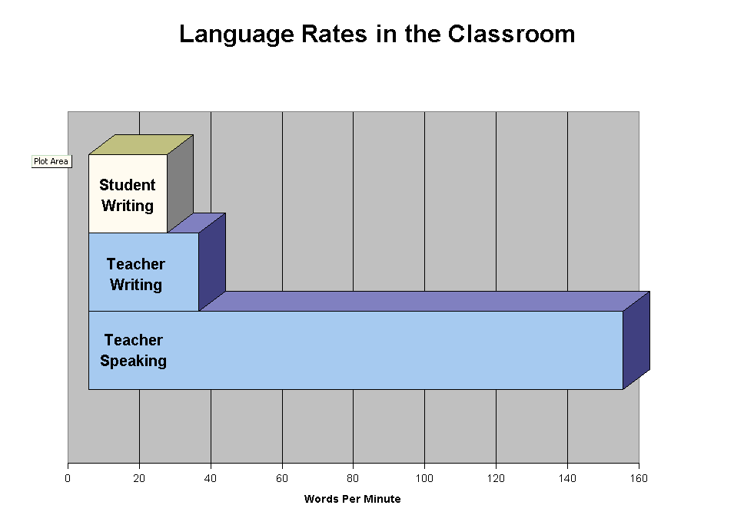

Additionally, lecture notes offer only a static view of the content. In curriculums such as history, this may be acceptable since the majority of the facts can be understood independent of each other. In curriculums such as mathematics, this is not the case since techniques are based around several related steps that can not be comprehended without comprehending how they relate to each other. It is necessary to grasp each of the progressive and iterative steps of a given problem solving technique. Common sets of problems have common sets of techniques to solve them, but if the students sees only a fixed picture of the problem, the steps, and the answer to the problem they will not be able to understand the critical decisions made to achieve the final solution. To parallel this with everyday driving, this is akin to being shown photographs of street signs without being told where or why you’re turning or how this helps you get where you’re going. While mathematics students may be able to record the work the professor does in class, they lack the professor’s narrative and pacing that provides guidance, instructions, and detailed explanations of what and why they are doing what they are doing.

The static nature of notes impedes many different types of learners. Sixty five percent of learners are classified as Visual learners, where they learn best by watching. Although notes serve this portion of learners the best, they still are impeding by the lack of demonstration of the step-by-step processes during their study time. Thirty percent of learners are classified as auditory learners who learn best by hearing the material spoken to them. Nothing about notes will help these learns, and they have a considerable amount of difficulty learning without hearing the professor’s lecture. The remaining five percent can best be described as tactile learners who learn through the use of hands on activities. They are difficult in any situation to teach, and learn math best by hands-on demonstrations of the material. (Mindtools, 2004)

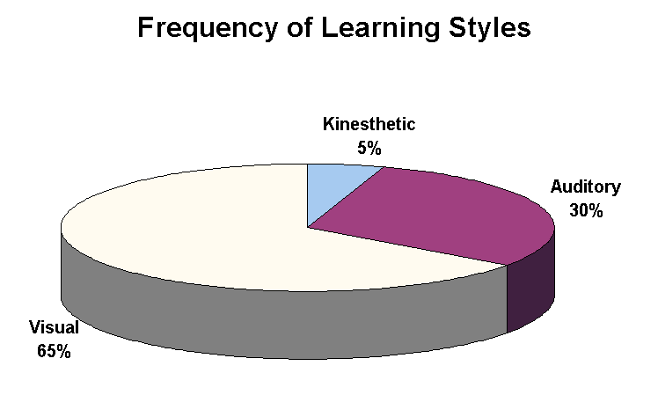

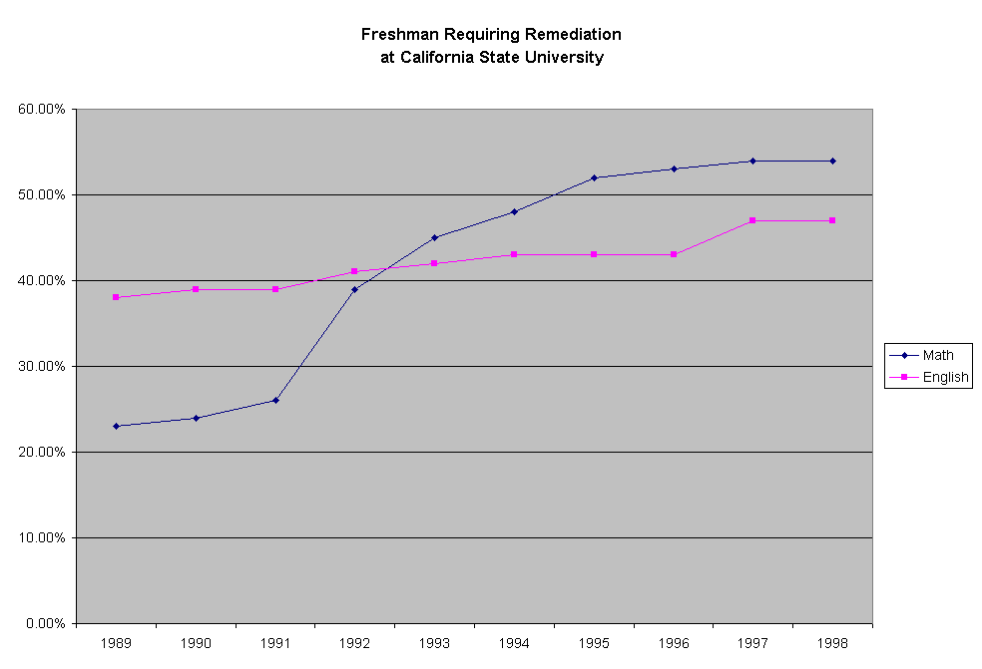
We specifically target the mathematics curriculum both because of the aforementioned step-by-step problem solving nature, and because of the severe need for improvement in the success of mathematics students. Introductory college level math courses have become an increasingly difficult hurdle for incoming students to get over. In many colleges surveyed, the failure rates for college algebra were over 50% (Austin Community College, 1998)(CSU, 1998). Worse than that, the trend has only gotten worse. At California State University, the number of students needing remedial math help, that is needing to take math courses below the minimum expected skill set of an entering freshman, has taken a sharp rise over the last decade. In just ten years, the number has more than doubled from 23% to 54% needing remediation. Comparatively, English remediation has only had a small rise from 38% to 47% over the corresponding time frame. (CSU, 1998)

Current solutions for classroom technology are insufficient to properly meet these needs. The widespread use of digital projectors and slide show presentations across most academic subjects only offer static, inflexible views of information. This allows no iterative explanations of problems, no dynamic changes done by the professor, and no interaction with the class. This is completely insufficient for problem solving and is why this solution is rarely used for algebra, calculus, and other beginning college level math courses.

Video cameras have been around for decades, but have yet to find a place in the math classroom. Video cameras have to be operated by a technician, which is an expensive overhead to incur. Worse yet, the video recordings frequently poorly reproduce what has been written on the board due to lighting conditions, resolution, angle and a myriad of other factors. Also, placing a video camera in the classroom will negatively effect the involvement of the students in the discussion due to issues of stage fright and nervousness. Finally, it is difficult if not impossible to distribute a video tape to dozens of students in time for them to study the classes lecture within a reasonable time frame.

A recent advancement in education has been the use of satellite and internet-based courses to record and distribute the content to students over multiple locations. Old Dominion University has developed a program called TELETECHNET to do just this. As implemented, TELETECHNET requires a specially constructed $50,000 classroom complete with multiple videos cameras, a full-time technician, dozens of microphones, specialized lighting, and half a dozen high-end computer servers to encode the video and audio and to stream it over the internet and through the satellite dish uplinks. This is all required on a per classroom basis. As a result, ODU has needed half a dozen of these specially developed classrooms, and had to construct a specialized building to house them. TELETECHNET is a fantastic program for what it is, but it requires a multi-million dollar commitment to build and operate. Furthermore, it imposes difficult restrictions on the teacher’s methodologies, since not every technique can be recorded by the cameras, and in fact the teacher is not allowed to leave his chair for the entirety of the lesson. Even after all these advances, the output for students repeating the lectures outside of class still remains a small, grainy video stream over the internet that is over 275 megabytes for three hours worth of class.

We choose to solve this problem by recording the professor’s narrative lecture using a wireless microphone and the professor’s written notation using a digital pressure sensitive whiteboard. This content will then be synchronized together, stored in an efficient format, and distributed via the internet to students for playback on their own computer of use. We term this solution Student Audio/Visual E-tool or SAVE.

The key topics that need to be addressed in our Phase I research involve the technical feasibility of the project. We need to determine and demonstrate the best ways to handle vector-based interpretation of the whiteboard input, to synchronize the whiteboard input with the audio input, to interpret drawn gestures on the whiteboard as command input, and the ability to store the entirety of this data in a compact format for distribution.

Vector-based recording will allow us to have a high quality graphical reproduction and also be able to store the graphical data in a format that will be one hundredth to one fifth the size of other graphical storage formats. Synchronization is integral to being able to replicate the presentation in a coherent format on the students own home computer. Drawn gestures are a very significant innovation and will allow the teacher to send commands and instructions to the recording software for purposes of content control and authoring without interrupting the flow of their instruction. Developing gesture recognition technology will allow us to seamlessly integrate this with our product. Storing all this data in an appropriate format is necessary to be able to distribute this file over the internet to the students for their own personal study time.

3. Phase I Research Plan

The core of the SAVE project is being able to deliver the instructor’s presentation from the classroom to the student. As such, the project can be broken down into three major conceptual areas. First, there is the software and hardware architecture necessary for recording the instructor’s presentation. Secondly, there is the distribution mechanism to deliver the data to the student. Thirdly, there is the playback software on the machine the student is using.

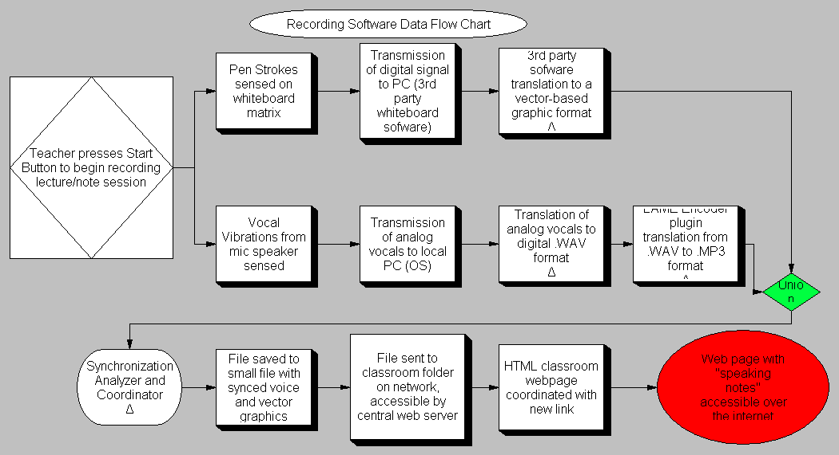

The recording functionality needs to interpret both the graphical and audio portion of the presentation. The graphical portion is captured by the use of a digital whiteboard. This whiteboard is connected to the classroom computer which has our recording software running on it. All pen strokes on the digital whiteboard are translated from the whiteboards native format into our proprietary vector-based format. The audio will be transmitted from a wireless microphone worn by the professor to the classroom computer’s sound input. This will be encoded into a compressed mp3 format at a constant bit rate suitable for spoken word recordings.

We will have on the whiteboard a specially designated “Command Square.” Anything drawn by the instructor in this special portion of the whiteboard will be interpreted by our software. Certain shapes or lines will be interpreted as commands from the instructor to our software. A specific sequence of lines, such as three lines forming a triangle, will be interpreted by our software to mean it should divide the playback into a new problem. Another sequence of lines, such as circle, would mean the software should further segment this problem unit into an individual step sub-unit. Another sequence could be used to pause the recording, and another could be used to restart the recording. By use of such gesture recognition technology, we allow the instructor to control the content flow of their presentation without interrupting the lesson by leaving the whiteboard. No interaction with the computer will be required after the initial software is setup. We feel this is an important innovation, and allows a considerable degree of simplification of the content authoring process.

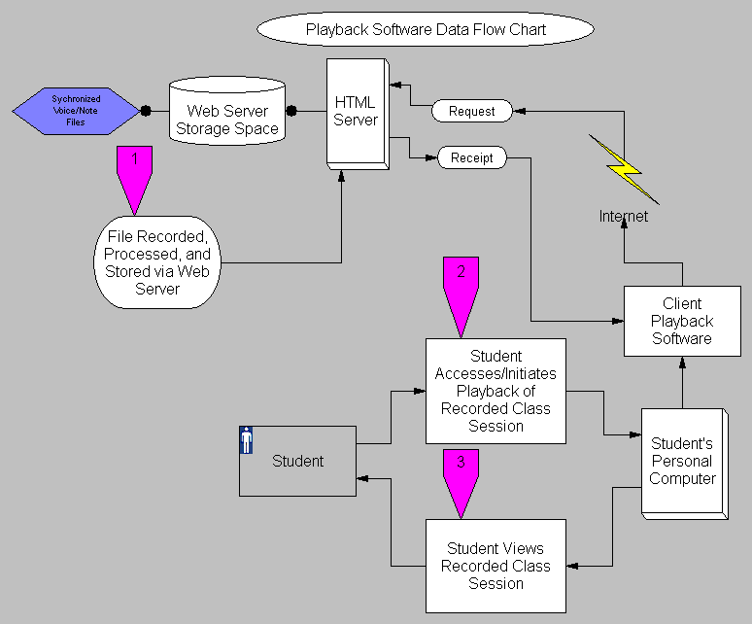

In the distribution chain of events, we start when the instructor completes the lesson. The recording software will finalize the encoding, and offer the instructor additional customization options for the file, such as naming it and providing a short description. After the file is complete, the software will ask the instructor where to upload it. The software will then upload the file to the designated server. This server will be running software designed as part of the SAVE project designed to handle these presentation files. This server software handles uploads from instructors remote machines, and stores it for future retrieval. Students will access the presentation files by logging into the server and accessing the specific class they want notes from. Control of content distribution will occur by this software to allow only authorized students to access the content. Once logged in, the students will be able to either download the file to their local computer, or play it back on the website itself.

The playback software will either be a standalone program installable on the students machine, or a web-based application based off of languages such as Java or Macromedia flash that are capable of operating within a users internet browser. Both types of software will be developed to ensure maximum interoperability. The software will open up the file, and decode it and play it back

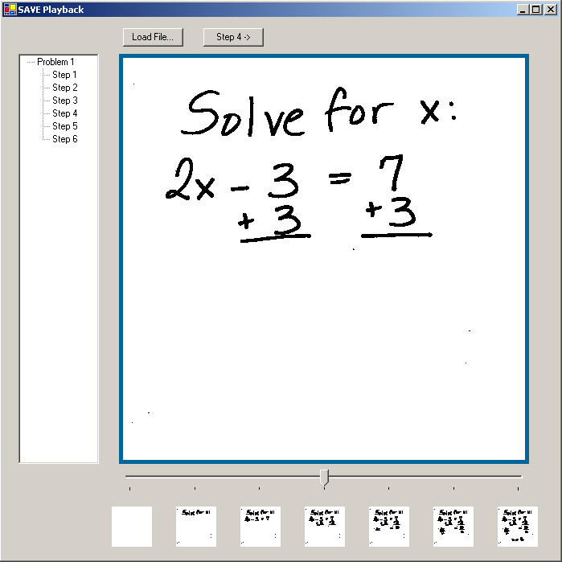

Initially, we need to demonstrate the practicality of taking the pressure sensitive input from the digital whiteboard and converting it to vector format. The majority of digital whiteboards on the market employ raster-based graphics. This stores and transmits the image on a pixel by pixel basis. The problems with this format are that it does not scale well to show fine detail, and that it is difficult to store this information in an efficient manner since the end output would take the form of a full motion video. This would quickly grow to an unmanageable size. Each unit of vector-based data stored in our proposed solution would describe an individual pen stroke, including start point, end point, color, start time, and end time. This information would allow us to redraw in real-time the exact writings of the instructor.

Next, we need to take the coded graphical input and the audio input and ensure that it is possible to synchronize the two streams. To ensure this, every vector stroke recorded being drawn will have a time stamp attached to it signifying at what specific point in time in the presentation this stroke was drawn, and the duration of time until the stroke was completed. This will allow us to know when every single pen stroke was drawn precisely. Furthermore, since we are using a constant bit rate audio stream, we will be able to match the sequence of event to the audio being played simply by determining the time into the presentation the audio was recorded.

Now, we need to develop a gesture recognition technology to enable the teacher to be able to control the recording software. Since at this point we have already decoded the graphics into vector strokes, we can match these strokes against a library of recognized commands. Each command drawing will have very characteristic vector strokes associated with it. For instance, a square has four connected vectors, two vertical lines, and two horizontal lines. A robust implementation of this technology will account for variances in drawing styles without misinterpreting what is drawn. Since we have only a few commands that need to be recognized, and a pre-defined Command Area, there should be a very low false-positive rate.

Finally, we need to store the audio and graphical data into a compact file format. This will be accomplished by encoding both the audio and graphical data on the fly during the presentation. The audio will be encoded as a series of small mp3 snippets, each one corresponding and identified as belonging to a specific step or problem within the presentation. The graphical data will be stored as a list of vector pen strokes with associated time stamps and other information. Each segment of the presentation, whether it be a problem or a step within a problem, will have an associated list of vector pen strokes.

Phase I has several critical steps that will be shown to have been achieved at the end of Phase I. Each individual objective, once accomplished, should be demonstrable. Obtaining the graphical data in a vector format will be proven by displaying the whiteboard output in a vector output on the connected computer screen. The synchronization will be proven by not only displaying the vector data, but correctly having the recorded audio match up with and playback with the graphics. The gesture recognition technology will be demonstrated by having software that takes in the vector strokes drawn, matches the pattern against a library of known gesture commands, and alerting the computer user as to which gesture was drawn. Accuracy of the gesture interpretation software can be determined at this point. Finally, once all of this data can be written to file, and successfully have all of its information retrieved from, we should be able to see the results on-screen in the same ways as the previous objectives.

4. Company Information

Azul Business Corporation

"Our mission at Azul Business Corporation is to improve the quality of education by implementing technology into schools particularly those technologies that help the many different styles of learning. Our products are built to integrate easily into current systems and be used without excessive training. Students and Professors that take advantage of our products will see an increase in the student’s ability to learn material by emphasizing repetition and allowing access to classroom lectures."

Azul Business Corporation was founded in 2004 when six Old Dominion University Computer Science students formed a group in their CPI (see below) class. The company's first product was initially called The Invisible Blackboard. After conception the group decided that the name was misleading to what the product will accomplish thus, our product found a new name in an acronym,

SAVE, The Student Audio Visual e-Tool.

We plan on incorporating this tool into many classrooms to encourage students to study and review more, improving education. Technology is become more and more dominant in schools today. We are striving to be the best and first choice of schools across the nation when upgrading their technology needs in the classroom. We believe that with the introduction of our product into a school students will be more inclined to review material taught. We provide a clear investment for education. By decreasing failure rates the school may see an increase in enrollment due to the quality of the resources and education they will be providing with our products.

Computer Product Initiative (CPI):

The Computer Productivity Initiative (CPI) began as a research project that was supported by the National Science Foundation as the first attempt of tying together a Computer Science set of curricula courses by providing a project based course sequence that required the knowledge and skills previously learned. Since the completion and reporting of the research success, several courses of a similar nature have been developed and placed in use as part of the curricula of other universities. All information on this site pertains to CS410 projects at Old Dominion University. If any questions arise, please contact our Professor Dennis Ray.

5. Commercial Potential

While there are many applications for our product, we still have a specific audience in mind. We would start with this specific audience and expand to a different or modified audience in the future.

Who is the Customer?
The target market for our product is university mathematics departments. Our target market includes the more than 2100 public and private four-year colleges in the United States.

A search for public or private four-year colleges in Virginia offering a degree in mathematics yielded 39 matches on Peterson’s Education Portal.

Averett University, Bluefield College, Bridgewater College, Christopher Newport University, Eastern Mennonite University, Emory & Henry College, Ferrum College, George Mason University, Hampden-Sydney College, Hampton University, Hollins University, James Madison University, Liberty University, Longwood University, Lynchburg College, Mary Baldwin College, Marymount University, Norfolk State University, Old Dominion University, Radford University, Randolph-Macon College, Randolph-Macon Woman's College, Roanoke College, Saint Paul's College, Shenandoah University, Sweet Briar College, University of Mary Washington, University of Richmond, University of Virginia, University of Virginia's College at Wise, Virginia Commonwealth University, Virginia Intermont College, Virginia Military Institute, Virginia Polytechnic Institute and State University, Virginia State University, Virginia Union University, Virginia Wesleyan College, Washington and Lee University, The College of William and Mary

Initial Customer
Our initial customer is the Old Dominion University (ODU) Mathematics Department. ODU offers a B.S. in mathematics, M.S. in computational and applied mathematics, M.S. in mathematics education, and a Ph.D. in computational and applied mathematics. All undergraduate students are required to complete at least three credit hours of mathematics:

- MATH 101M An introduction to mathematics for critical thinking
- MATH 102M College algebra
- MATH 162M Pre-calculus I
- STAT 130M Elementary statistics

Depending on a student’s major, (ex. computer science, engineering, physics, etc.) more mathematics may be required.

ODU has 20,802 total students. Among those 14,209 are undergraduate students and 6,593 are graduate students.

Return on Investment for Customer
This solution provides an easier and better way for students to see and hear the lecture again. It does not require one or more cameras. It will allow students to resize the presentation to their preferences.

Benefits to Instructors
Instructors can conceivably cover more examples of problems in the lectures. At Old Dominion University, MATH 102M (College Algebra), 162M (Pre-Calculus I), 163 (Pre-Calculus II), 211 (Calculus I), 212 (Calculus II), and 307U (Ordinary Differential Equations), administer common exams. These means that all instructors in each course are expected to cover the same material during the semester.

Benefits to University
An increase is success rates in mathematics and a possibility for lower attrition rates.

Price point

$15,000 for one board, one microphone, and the software

Return on investment for business
With the sale of 20 systems in the first year and a 15% increase in sales every year afterwards, we can expect to break even in the fifth year. We will break even with the sale of our 27th system per year.

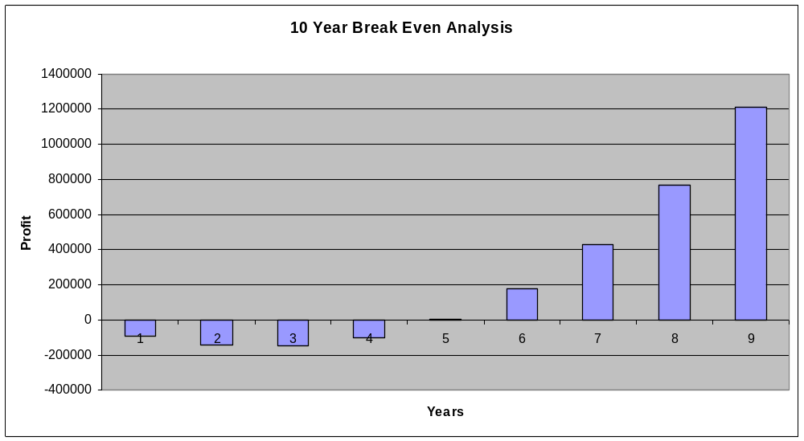

Competition Matrix

 | Does not require use of camera(s) | Does not require use of LCD | Does not require a full time operator | Does not require a change in teaching style | Records audio | Records visual | Scalable visual output
Student Audio Visual e-Tool | x | x | x | x | x | x | x
SmartBoard | x |  | x | x | x | x
Mimio | x | x | x | x |  | x
Quartet IdeaShare Board | x | x | x | x |  | x
Video camera/Teletechnet |  | x |  |  | x | x

There are several competing technologies, but each one has some detriments and/or missing components that our solution addresses.

Advertising
We can use direct marketing to university/college mathematics departments and consortiums.

Account representatives can attend several conferences aimed at teaching mathematics such as the following:

International Conference on Technology in Collegiate Mathematics
http://www.aw-bc.com/ictcm/index.shtml

National Council of Teachers of Mathematics
http://www.nctm.org/meetings/

Mathematics Association of America
http://www.maa.org/

American Mathematical Association of Two-Year Colleges
http://www.amatyc.org/

Funding
With a focus on adding \technology that aims at increasing scholastic performance, SAVE will be the conduit to bring technology into the classroom. Key to success of this goal is the choice for the financier, and the National Science Foundation’s Small Business Innovative Research Program seeks to fund the development of innovative ideas such as ours for small businesses.

Success in Phase I, extending through the Spring semester of 2005 (1/17/05 through 6/10/05), will mostly require funding for salaries dedicated to research, prototype planning, programming, Management, and third party product reviews, will require $100,000 in grant funding by our chosen funding agency. Employees will include a Project Manager, 3 Hardware Developers, 3 Software Developers, and 2 expert consultants: an Educational Consultant and a Technical Consultant. Forty percent of the total funded sum will be allotted for overhead, which will be dedicated to personal salaries.

Phase II requires 2 years of intense development, and demands a much larger backing of financial support than Phase I. Here, development and refining are the primary concerns. Lasting a full 2 years (6/10/05 through 6/11/05), it is split into major programming and test stages - Alpha/Beta Development & Testing and Final Development & Field Trials. The most financially demanding part of phase 2 will be the employment of a Project Manager, Software Developers, Hardware Developers, Web Developer, Testing Programmers, a Technical Staff (3), and the 2 Consultants. Also involved in the budget is the hardware (Development Server, Desktops (14),Whiteboard (3), & Microphone (3) ) and software (Flash (2), Microsoft Visual C# .NET (7), Photoshop CS or comparable photo editing program (1), and Microsoft Office (14) ) and miscellaneous overhead costs. The target sum for funding for the above items is $750,000.

As Phase II ends, the National Science Foundation will reward grantees by attempting to unite investors with our project, providing funding and support through a grounded, proven institution that meet a high standard of requirements set by the NSF. It is important that we are aligned with Universities and Colleges, in spirit and as a funding source. Our mission is to introduce a technologically advanced solution to the modern classroom that will be unobtrusive to the teacher, while aiding the student in necessary repetition. During Phase III, it will be our aim to seek financial solidarity through demonstrations and sample lectures throughout the country in various Secondary Educational Forums. As a supplement to this, we will also be taking a lesser (but important nonetheless) focus on high schools. This will help visibility of our product and potentially will open important alternate sources of revenue. In Phase III, we break even at Year 5 of production. Before that, we incur approximately $150,000 in debt by the end of Year 3 that will be covered by small business loans secured through the Small Business Administration and through local banks.

The most important funding decision is the use of a COTS solution for our main component - the whiteboard. This includes built-in Application Programming Interface (API) calls that will be easily interfaced with in the customized application set that we will be building for our project. The whiteboards that we have chosen have already gone through rigorous testing. All of this will inevitably lead to a savings in time, manpower, and ultimately money. Other factors that have been considered in our cost analysis are reduction of redundant software or hardware where they are unnecessary. This reduction will aid in our target of meeting financial goals in the 3rd phase. Profit and momentum are key in this phase, so even these small factors can be key to the project's success.

6. Consultants and Subawards/Subcontracts
Educational Consultant

The educational consultant is utilized in the understanding of educational methodologies that will support the development of the project. The consultant will assist in the development of a product that will positively affect student’s learning ability by emphasizing repetition of step by step problems. By attaining an outside source with explicit studies involving educational methods, the hope is to clearly determine areas of teaching that can make the most of technology to improve educational practices.

During phase one of the intended grant proposal the educational consultant will be acquired as a resource in analyzing the problematic areas of study. Advice on these problematic areas will aid in the design of the product as well as suggestion and critiquing of features and components of the product.

The educational consultant will be on hand for a limited period of time during each of the four parts of phase two which is comprised of two development phases and two testing phases. The consultant will be representing the opinions of the consensus in the locations (universities, schools, etc.) that will be used during this phase. The consensus will include evaluations from teachers and students that will be presented in the way desired by the consultant (survey, poll, etc.). Being present in the classrooms during testing phases will assure accurate data and reactions for and against the product. The consultant will have sole responsibility of these forms and will provide a complete analysis of the results in a useful and understanding fashion.

Desired Educational Consultant

Richard C. Overbaugh, Ed.D.
Darden College of Education
Department of Education Curriculum & Instruction
Old Dominion University
Norfolk, VA 23529-0161
roverbau@odu.edu
http://www.odu.edu/educ/roverbau/vita/vitae.htm as of December 15, 2004

Mr. Overbaugh is a program coordinator and professor for instructional design and technology. He has implemented technology into the classroom and curricula in order to promote learning.

Technical Consultant

The technical consultant desired will be projected as an expert in the field of audio and visual elements. The consultant will collaborate primarily on the hardware aspects of the product as well as make suggestions towards the interaction between these components and the software used to capture the data of the components. The expert attained will have experience in developing new hardware and possibly experience in the audio or visual components suggested.

For the duration of phases one and two the technical consultant will be scheduled to provide guidance during the development sub phases of the product. The consultant will have knowledge of the latest technologies to be employed in the development and provide options in hardware alongside each advantage and disadvantage to the technology. Researching and approving the best and most cost efficient solution to the businesses hardware and software needs will be a prime responsibility of the technical consultant. Assistance in the design of the hardware’s operation will relieve possible time constraints due to any lack of unspecialized operational employees of the business.

Desired Technical Consultant

Garry Musgrave
Conceptron Associates: Independent Audio-Visual Design Consultants
1195 Durant Dr.
Coquitlam, BC Canada V3B 6R3
gmusgrave@conceptron.com
http://www.conceptron.com/profile/tech_resume.html as of December 15, 2004

Mr. Musgrave is an independent audio and visual consultant with over 20 years of experience. He is a member of many authorized professional associations as well as a certified technology specialist – design (CTS-D).

7. Equivalent or Overlapping Proposals to other Federal Agencies

NONE

References

Mathematic Resources
Baumslag, B. Fundamentals of Teaching Mathematics at University Level. London: Imperial College Press, 2000.
Mitchell, Richard. College Algebra: Traditional Instruction Versus Instruction via Video Tape. Ed. Mohammed H. Ahmadi. Lanham: University Press of America, 2002
Owens, Philip. (February 10, 2003). "Managing Attrition and Improving Instruction in College Algebra: A Radical (?) Approach" Online. Available: http://www.austincc.edu/powens/attrition/attrition.htm 2004, October 16.
National Council of Teachers of Mathematics. http://www.nctm.org/about/met/index.htm
Simon, Beth Five Questions Online. Available: http://www.signonsandiego.com/news/computing/personaltech/20041115-9999-lz1b15five.html 2004, November 15.

Equipment Resources
"Digital Whiteboards Buyer's Guide". 3M Meeting Network Product Solutions Product Buyer's Guide. http://www.3m.com/meetingnetwork/products/product_guide_digital.html
eBeam - Interactive Whiteboard Technology http://www.e-beam.com
MicroTouch Ibid Systems, Inc. Review by American Institutes for Research: Human Factors and Design. http://www.air.org/usability/case_studies/microtouch.html
Mimio by Virtual Ink. http://www.mimio.com
SmartTech www.smarttech.com
System Requirements http://www.new-technologies.org/ECT/Internet/mimio.htm
How to Build a Whiteboard. http://www.ebibleteacher.com/howtomarkm.html
PC Whiteboards FAQ http://www.gbcoffice.com/register_support/ibid/faq.htm

Educational Resources
Hodgdon, Linda A. Visual Strategies for Improving Communication: Practical Supports for School and Home. Troy: QuirkRoberts Publishing, 1998.
Kaplan, Howard. (1992). "Multimedia in Lecture Halls: Science & Math Visualizations". THE Journal (Technological Horizons in Education) Online. (3pp.). Available: InfoTrac OneFile. 2004, October 14.
Kiplinger.com. (no date). "How to Use the College Survey Data." Online. Available: www.kiplinger.com/tools/colleges/glossary.html 2004, October 18.
Miller, David and Derek Glover. (2002) "The Interactive Whiteboard as a Force for Pedagogic Change: The Experience of Five Elementary Schools in an English Education Authority." Information Technology in Childhood Education Annual Online. Available: http://www.aace.org/dl/files/ITCE/ITCE200215.pdf 2004, October 18.
National Center for Education Statistics. (2002) "Number of degree-granting institutions that enrolled freshmen, and the percentage of those institutions that offered remedial reading, writing, or mathematics cources, by institution type: Fall 1995 and 2000" Quick Table and Figures (2000) Online. Available: http://nces.ed.gov/quicktables/Detail.asp?Key=1123 2004, October 18.

"Visual & Auditory Learners." (no date). ReadingInstructions.com: Superlinks Accelerated Learning & Reading Instruction Center. Online. Available: http://www.readinginstruction.com/readinginstruction/visuallearners.html 2004, October 17.
"Will Changes in This Course Have a High Impact on the Curriculum?" (no date) Center for Academic Transformations. Online. Available: http://www.center.rpi.edu/PewGrRdi/CRC1.html 2004, October 16.
Blackboard http://www.blackboard.com
Lotus Learning Space http://www.lotus.com/lotus/offering3.nsf/wdocs/learningspacehome
Anderson, Richard "Beyond PowerPoint: Building a New Classroom Presenter" Campus Technology, (2004) Online. Available: http://www.campus-technology.com/article.asp?id=9537 2004, November 6.

Miscellaneous Resources
National Science Foundation http://www.eng.nsf.gov/sbirspecs/IT/it.htm
Nation Science Foundation Proposal Guidelines http://www.nsf.gov/pubs/gpg/nsf04_23/nsf04_23.pdf

How Your Learning Style Affects Your Use of Mnemonics http://www.mindtools.com/mnemlsty.html

Williams, J. R. (1998). Guidelines for the use of multimedia in instruction, Proceedings of the Human Factors and Ergonomics Society 42nd Annual Meeting, 1447-1451.

Brown, Bettina Lankard. “Learning Styles and Vocational Education Practice.” 1998. http://www.cete.org/acve/docs/pab00007.pdf

INFORMATION ABOUT PRINCIPAL INVESTIGATORS/PROJECT DIRECTORS (PI/PD) and
co-PRINCIPAL INVESTIGATORS/co-PROJECT DIRECTORS

Submit ONE copy of this form for each PI/PD and co-PI/PD identified on the proposal. The form(s) should be attached to the original proposal as specified in GPG Section II.B. Submission of this information is voluntary and is not a precondition of award. The information will not be disclosed to external peer reviewers. DO NOT INCLUDE THIS FORM WITH ANY OF THE OTHER COPIES OF YOUR PROPOSAL AS THIS MAY COMPROMISE THE CONFIDENTIALITY OF THE INFORMATION.

PI/PD Name: Dennis Ray

Gender: Male Female

Ethnicity: (Choose one response) Hispanic or Latino Not Hispanic or Latino

Race: American Indian or Alaska Native
(Select one or more) Asian
Black or African American
Native Hawaiian or Other Pacific Islander
White
Disability Status: Hearing Impairment
(Select one or more) Visual Impairment
Mobility/Orthopedic Impairment
Other
None
Citizenship: (Choose one) U.S. Citizen Permanent Resident Other non-U.S. Citizen
Check here if you do not wish to provide any or all of the above information (excluding PI/PD name):
REQUIRED: Check here if you are currently serving (or have previously served) as a PI, co-PI or PD
on any federally funded project.

Ethnicity Definition:
Hispanic or Latino. A person of Mexican, Puerto Rican, Cuban, South or Central American, or other Spanish culture or origin, regardless of race.
Race Definitions:
American Indian or Alaska Native. A person having origins in any of the original peoples of North and South America (including Central America), and who maintains tribal affiliation or community attachment.
Asian. A person having origins in any of the original peoples of the Far East, Southeast Asia, or the Indian subcontinent including, for example, Cambodia, China, India, Japan, Korea, Malaysia, Pakistan, the Philippine Islands, Thailand, and Vietnam.
Black or African American. A person having origins in any of the black racial groups of Africa.
Native Hawaiian or Other Pacific Islander. A person having origins in any of the original peoples of Hawaii, Guam, Samoa, or other Pacific Islands.
White. A person having origins in any of the original peoples of Europe, the Middle East, or North Africa.

WHY THIS INFORMATION IS BEING REQUESTED:

The Federal Government has a continuing commitment to monitor the operation of its review and award processes to identify
and address any inequities based on gender, race, ethnicity, or disability of its proposed PIs/PDs. To gather information
needed for this important task, the proposer should submit a single copy of this form for each identified PI/PD with each proposal. Submission of the requested information is voluntary and will not affect the organization’s eligibility for an award. However, information not submitted will seriously undermine the statistical validity, and therefore the usefulness, of information received from others. Any individual not wishing to submit some or all the information should check the box provided for this purpose. (The exceptions are the PI/PD name and the information about prior Federal support, the last question above.)

Collection of this information is authorized by the NSF Act of 1950, as amended, 42 U.S.C. 1861, et seq. Demographic data allows NSF to gauge whether our programs and other opportunities in science and technology are fairly reaching and benefiting everyone regardless of demographic category; to ensure that those in under-represented groups have the same knowledge of and access to programs and other research and educational opportunities; and to assess involvement of international investigators in work supported by NSF. The information may be disclosed to government contractors, experts, volunteers and researchers to complete assigned work; and to other government agencies in order to coordinate and assess programs. The information may be added to the Reviewer file and used to select potential candidates to serve as peer reviewers or advisory committee members. See Systems of Records, NSF-50, “Principal Investigator/Proposal File and Associated Records,” 63 Federal Register 267 (January 5, 1998), and NSF-51, “Reviewer/Proposal File and Associated Records,” 63 Federal Register 268 (January 5, 1998).


NSF Form 1225 (10/99)
Dennis Ray Principle Investigator
Old Dominion University
Department of Computer Science
Norfolk, VA 23529-0162

Grants Awarded
1992 – 1994 Computer Productivity Initiative
Co-Principle Investigator
Educational System Development
NSF $215,522 with ODU match $279,137

1988-1990 An Integrated Research / Instructional Facility to Evaluate and Transfer Software Production Technologies
Co-Principle Investigator
Equipment grant from AT&T Information $728,000

1988-1989 Software Development for the Two-Axis Angle Calibration System
Principle Investigator
Software System Development NASA $1,666

Education

Dennis Ray is a professor in the Computer Science Department at Old Dominion University. He has earned a B.S. in Marine Engineering from the United States Naval Academy as well as a M.S. in Computer Science from the United States Naval Postgraduate School.

Teaching Experience

ODU Computer Science Department Norfolk, VA
Instructor 1984 – 1987
Teach Undergraduate, Graduate CS courses

ODU Computer Science Department Norfolk, VA
Lecturer 1987 – present
Teach Undergraduate, Graduate, and Distance Learning CS courses

Thomas Nelson Community College CS Department Hampton, VA
Adjunct Instructor 1999 – 2000
Teach Undergraduate courses

Relevant Experience

Dennis Ray has developed many of the curricula used in Computer Science Department at Old Dominion University. Many of these include transitions from old, obsolete programming languages and methodologies to prominently used standards such as C++ and Object Oriented Design. His involvement in the Computer Productivity Initiative Grant (stated above) formed the basis for senior improvement in the workplace after graduation due to the developed courses CS410 and CS411. His interest in research involves using technology to effectively teach as well as many aspects of expert systems and robotics artificial intelligence.

Co-Principle Investigators Listed Beyond This Point

Brian Blain
bblain@cs.odu.edu

Objective My professional objectives are to obtain experience in a computer field that will allow me to demonstrate my knowledge, work ethic, communication and leadership skills, and attention to detail while continuing to improve my talents.

Education I am a senior currently enrolled at Old Dominion University studying Computer Science with a minor in Information Technology. I will graduate in the spring of 2005.

Experience Kmart June 2003 – February 2004
Electronics Associate Virginia Beach, VA

My responsibilities as an Electronics Associate were to answer customer questions, stock shelves, create shelf layouts, checkout customers, and maintain the electronics department as a clean and welcoming place for customers to shop.

NetTek October 2004 – current
Programmer Virginia Beach, VA

My responsibilities as a programmer is to create and update web applications and pages using dynamic languages and utilizing databases.

In the spring of 2004 I lead a team project of five students in creating software that could be used for scheduling students in high school classes using PSP and TSP protocols.

Computer Operating Systems/environments: Windows, Unix, MSDOS
Skills and Languages: C, C++, Java, html, XML, VB, CSS, ASP
Languages Software: Excel, Word, Adobe Photoshop, Acrobat, PowerPoint, FrontPage, Visual Studio, Borland, Maya 5
Basic Skills: Format/Reinstalling software/operating systems, installing wireless networks, leadership, grasp concepts and learn software, problem solving, and artistic talents.

Additional
Information The type of position I am seeking is one involving designing, drawing, creating, programming, and/or graphic design.

I have an open personality and the ability to communicate ideas through constructive criticism.

My hobbies include cars, surfing, drawing, video games, and learning software such as Maya and Photoshop.

My portfolio is on my personal webpage which can be found here.
http://www.cs.odu.edu/~bblain/

Ryan Florin
Quality / Process Manager
Objective
To further my education by using the Computer Science skills learned from Old Dominion University in a real world setting.
Education
I am currently a senoir at Old Dominion University. I'm working on a Computer Science major with a minor in Physics and Math. I plan on graduating in May of 2005.
Experience
Virginia Beach Parks and Recreation  Swim Instructor | Spring 2003 to current  Virginia Beach, VA
Virginia Beach Parks and Recreation  Surfing Instructor | Summer 2002, 03, 04  Virginia Beach, VA
Virginia Beach Parks and Recreation  Lifeguard | Spring 2001 to current  Virginia Beach, VA

John Gedville
Old Dominion University, Norfolk, VA 23529
jgedvill@.cs.odu.edu

objective
Seeking a position in Information Technology, utilizing my advanced computer skills.
Experience
2001–present Northrop Grumman Newport News Newport News, VA
Associate Designer
- Supported design by maintaining and updating the structural CATIA catalog in accordance with design requirements.
- Assisted in developing and maintaining a CATIA database as required by design.
- Ensured that setup data is produced in accordance with the Catalog and Setup Procedures.
- Developed the setup data and catalogs in accordance with design schedule.
- Support the development of the Structural Manufacturing Prototype by establishing the catalogs and setup data to facilitate implementation.
- Ensured all classified documents were properly marked and safeguarded. Followed rules regarding confidential CATIA, cabinets, and conference rooms. Maintained zero infractions.
- Practiced teamwork within and across functional boundaries. Worked with assigned back-up team member to ensure assignments could be continued in the event of absence.
2000-2001 Newport News Shipyard Newport News, VA
Co-op Designer
- Worked with minmal supervision and in accordance with Design standards to produce clear and accurate drawings.
Education
2002-2005 Old Dominion University Norfolk, VA
- B.S., Computer Science.
2001-2002 Thomas Nelson Community College Hampton, VA
- A.S., Computer Science.
1998-2001 Thomas Nelson Community College Hampton, VA
- A.A.S., Computer Aided Drafting and Design.
Certifications
Oracle Certified Associate (OCA), May 2004
Skills
Oracle 9i, IBM Tivoli, Peregrine, Microsoft Office (Word, Excel, Access, Project, PowerPoint), Microsoft Visio, Proxy Source Proxy Designer
Computer Languages
C++, C, Microsoft Visual C++, G++, PL/SQL
Operating Systems
IBM AIX, Sun Solaris, Microsoft NT, Microsoft XP
Drafting Software
CATIA, AutoCAD 12, 14, 2000, and Mechanical Desktop, Helix

Jeffrey Jacobs
Team Leader
Objective
My professional objectives are to utilize my talents and skills in an advanced technical work environment that will allow me to both utilize current technological achievements and develop them further.
Education
I am currently a senior at Old Dominion University in Norfolk, Virginia. I will graduate in May 2005 with a B.S. in Computer Science with a minor in Computer Engineering. I graduated the Ocean Lakes Math and Science Magnet Program in Virginia Beach, Virginia.
Experience
Visualzen Inc.  Senior Software Engineer | January 2004 to present
Visualzen Inc.  Web Developer | February 2003 to December 2003
Old Dominion University  System Consultant | January 2003 to July 2003  Norfolk, VA

Valentina Neblitt
Research / Development Manager
Education
I graduated from Virginia Tech in 1995 with a B.A. in International Studies and two minors, Economics and Spanish. I am currently pursuing a B.S. in Computer Science at Old Dominion University. I will graduate in the Spring of 2005.
Experience
Old Dominion Library  Government Publications Assistant | 2003 to current  Norfolk, VA
Central Library  Computer Lab Technician | 2001 to 2003  Virginia Beach, VA
Arlington County Information & Referral  Information Desk Supervisor | 1999 to 2000  Arlington, VA
Shirlington Branch Library  Library Assistant | 1997 to 1999  Arlington, VA

David Southard
Planning Manager
Objective
I would like to gain the financial independence that would allow for me to incorporate leading edge technology in an artful manner, possibly by attaining the business savvy needed to help start a small business.
Education
I am a senior at Old Dominion University majoring in Computer Science.
Experience
Northrop Grumman  Non-Nuclear Electrical Submarine Designer | 2004 to current  Newport News, VA
Newport News Shipbuilding  Associate Designer | 2000 to 2004  Newport News, VA
Newport News Shipbuilding  Design Trainee | 1999 to 2000  Newport News, VA

Patrick Veverka
Presentation / Marketing Coordinator
Education
I am currently pursuing a Bachelor of Science in Computer Science at Old Dominion University. I am continuing an educational career that started at New York University and Purdue University.
Experience
Norfolk Southern Corporation  PC/LAN Support | January 2004 to current  Norfolk, VA
Pave Designs  Web Developer | August 1998 to current  Virginia Beach, VA
Artoria Limoges  Web Developer | June 2001 to current  New York, NY

  SUMMARY PROPOSAL BUDGET |  |  |  |  |  |  | FOR NSF USE ONLY
ORGANIZATION  Azul Business Corporation |  |  |  |  |  |  | PROPOSAL NO. |  |  |  |  | DURATION (MONTHS)
 |  |  |  |  |  |  |  |  |  |  |  | Proposed |  | Granted
PRINCIPAL INVESTIGATOR/PROJECT DIRECTOR  Dennis Ray |  |  |  |  |  |  | AWARD NO.
A. SENIOR PERSONNEL: PI/PD, Co-PIs, Faculty and Other Senior Associates |  |  |  |  |  | NSF-Funded |  |  |  |  | Funds |  | Funds
List each separately with name and title. (A.7. Show number in brackets) |  |  |  |  |  | Person-months |  |  |  |  | Requested By |  | Granted by NSF
 |  |  |  |  |  | CAL | ACAD |  | SUMR |  | Proposer |  | (If Different)
1. Jeff Jacobs - Project Manager |  |  |  |  |  | 6 |  |  |  |  | $ 8,000 |  | $
2. Valentina Neblitt - Research & Development Manager |  |  |  |  |  | 6 |  |  |  |  | 7,500
3. David Southard - Planning Manager |  |  |  |  |  | 6 |  |  |  |  | 7,500
4. Ryan Florin - Quality / Process Manager |  |  |  |  |  | 6 |  |  |  |  | 7,500
5. John Gedville - Support Manager |  |  |  |  |  | 6 |  |  |  |  | 7,500
6. ( 2 ) OTHERS (LIST INDIVIDUALLY ON BUDGET EXPLANATION PAGE) |  |  |  |  |  | 6 |  |  |  |  | 15,000
7. ( ) TOTAL SENIOR PERSONNEL (1-6)
B. OTHER PERSONNEL (SHOW NUMBERS IN BRACKETS)
1. ( ) POSTDOCTORAL ASSOCIATES
2. ( ) OTHER PROFESSIONALS (TECHNICIAN, PROGRAMMER, ETC.)
3. ( ) GRADUATE STUDENTS
4. ( ) UNDERGRADUATE STUDENTS
5. ( ) SECRETARIAL - CLERICAL (IF CHARGED DIRECTLY)
6. ( ) OTHER
TOTAL SALARIES AND WAGES (A + B) |  |  |  |  |  |  |  |  |  |  | 53,000
C. FRINGE BENEFITS (IF CHARGED AS DIRECT COSTS)
TOTAL SALARIES, WAGES AND FRINGE BENEFITS (A + B + C)
D. EQUIPMENT (LIST ITEM AND DOLLAR AMOUNT FOR EACH ITEM EXCEEDING $5,000.)
TOTAL EQUIPMENT
E. TRAVEL | 1. DOMESTIC (INCL. CANADA, MEXICO AND U.S. POSSESSIONS)
 | 2. FOREIGN
F. PARTICIPANT SUPPORT
1. STIPENDS |  | $
2. TRAVEL
3. SUBSISTENCE
4. OTHER
TOTAL NUMBER OF PARTICIPANTS ( ) TOTAL PARTICIPANT COSTS
G. OTHER DIRECT COSTS
1. MATERIALS AND SUPPLIES
2. PUBLICATION/DOCUMENTATION/DISSEMINATION
3. CONSULTANT SERVICES |  |  |  |  |  |  |  |  |  |  | 24,000
4. COMPUTER SERVICES
5. SUBAWARDS
6. OTHER
TOTAL OTHER DIRECT COSTS
H. TOTAL DIRECT COSTS (A THROUGH G) |  |  |  |  |  |  |  |  |  |  | 77,000
I. INDIRECT COSTS (F&A) (SPECIFY RATE AND BASE)
Overhead (40% of salary cost) |  |  |  |  |  |  |  |  |  |  | 21,200
TOTAL INDIRECT COSTS (F&A) |  |  |  |  |  |  |  |  |  |  | 21,200
J. TOTAL DIRECT AND INDIRECT COSTS (H + I) |  |  |  |  |  |  |  |  |  |  | 98,200
K. RESIDUAL FUNDS (IF FOR FURTHER SUPPORT OF CURRENT PROJECT SEE GPG II.D.7.j.)
L. AMOUNT OF THIS REQUEST (J) OR (J MINUS K) |  |  |  |  |  |  |  |  |  |  | $ 98,200 |  | $
M. COST SHARING: PROPOSED LEVEL $ |  |  |  |  | AGREED LEVEL IF DIFFERENT: $
PI/PD TYPED NAME AND SIGNATURE* |  |  |  |  | DATE |  |  | FOR NSF USE ONLY
Dennis Ray |  |  |  |  | 12/15/05 |  |  | INDIRECT COST RATE VERIFICATION
ORG. REP. TYPED NAME & SIGNATURE* |  |  |  |  | DATE |  |  | Date Checked |  | Date of Rate Sheet |  |  | Initials-ORG
Jeff Jacobs |  |  |  |  | 12/15/05
NSF Form 1030 (10/99) Supersedes All Previous Editions |  |  |  |  | *SIGNATURES REQUIRED ONLY FOR REVISED BUDGET (GPG III.C)

Phase 1
Time | 15 Weeks
Funding | $100,000
 | Total # | # of hours | hourly wage | cost
Employees
Project Manager | 1 | 200 | $40 | $8,000
Hardware Developer | 3 | 300 | $25 | $22,500
Software Developer | 3 | 300 | $25 | $22,500
Total for Employees |  |  |  | $53,000
Consultants
Educational Consultant | 1 | 80 | $100 | $8,000
Technical Consultant | 1 | 160 | $100 | $16,000
Total for Consultants |  |  |  | $24,000
Total Employees |  |  |  | $53,000
Total Overhead (40%) |  |  |  | $21,200
Employees |  |  |  | $53,000
Consultants |  |  |  | $24,000
Overhead |  |  |  | $21,200
Total |  |  |  | $98,200
Phase 2
Time | 2 Years
Funding | $750,000
 | Total # | # of hours | hourly wage | cost
Employees
Project Manager | 1 | 3000 | $40 | $120,000
Software Developers | 3 | 2000 | $25 | $150,000
Hardware Developers | 2 | 2000 | $25 | $100,000
Web Developer | 1 | 1500 | $25 | $37,500
Testing Programmers | 4 | 500 | $25 | $50,000
Technical Writer | 1 | 500 | $25 | $12,500
Technical Staff | 2 | 150 | $25 | $7,500
Total for Employees |  |  |  | $477,500
Consultants
Educational Consultant | 1 | 360 | $100 | $36,000
Technical Consultant | 1 | 180 | $100 | $18,000
Total for Consultants |  |  |  | $54,000
Software
Flash | 2 | 500 |  | $1,000
Microsoft Visual C# .NET | 7 | 109 |  | $763
Photoshop CS | 3 |  |  | $1,947
Microsoft Office | 9 |  |  | $630
Total for Software |  |  |  | $4,340
Hardware
Development Server | 1 |  |  | $6,000
Desktops | 9 |  |  | $10,800
Whiteboard | 3 |  |  | $6,000
Microphone | 3 |  |  | $300
Total for Hardware |  |  |  | $23,100
Total Employees |  |  |  | $477,500
Overhead (40%) |  |  |  | $191,000
Employees |  |  |  | $477,500
Consultants |  |  |  | $54,000
Software |  |  |  | $4,340
Hardware |  |  |  | $23,100
Overhead |  |  |  | $191,000
Total |  |  |  | $749,940
Phase 3
Time | Continual
 | Total # | # of hours | hourly wage | cost
Employees
General Manager | 1 | 2000 | $40 | $80,000
Software Developers | 1 | 1000 | $25 | $25,000
Web Programmer | 1 | 1000 | $25 | $25,000
Tech Support | 2 | 2000 | $20 | $80,000
Account Representative | 1 | 2000 | $15 | $30,000
Total for Employees |  |  |  | $240,000
Outside Staff
Contract Attorney | 1 | 40 | $150 | $6,000
Patent Attorney | 1 | 100 | $150 | $15,000
Accountant | 1 | 500 | $20 | $10,000
Total for Outside Staff |  |  |  | $31,000
Total Employees |  |  |  | $240,000
Overhead (40%) |  |  |  | $96,000
Employees |  |  |  | $240,000
Consultants |  |  |  | $31,000
Overhead |  |  |  | $96,000
Total |  |  |  | $367,000

Current and Pending Support
(See GPG Section II.D.8 for guidance on information to include on this form.)
The following information should be provided for each investigator and other senior personnel. Failure to provide this information may delay consideration of this proposal.
 |  |  |  |  | Other agencies (including NSF) to which this proposal has been/will be submitted.
Investigator: Dennis Ray
Support: | Current | Pending |  | Submission Planned in Near Future |  |  |  | *Transfer of Support
Project/Proposal Title:

S.A.V.E. The Student Audio Visual e-Tool
Source of Support: Old Dominion University Computer Science Department

Total Award Amount: $ |  |  | Total Award Period Covered:
Location of Project: Old Dominion University, Norfolk, VA 23529

Person-Months Per Year Committed to the Project. |  |  |  |  |  | Cal: 6 | Acad: | Sumr:
Support: | Current | Pending |  | Submission Planned in Near Future |  |  |  | *Transfer of Support
Project/Proposal Title:

Source of Support:

Total Award Amount: $ |  |  | Total Award Period Covered:
Location of Project:

Person-Months Per Year Committed to the Project. |  |  |  |  |  | Cal: | Acad: | Sumr:
Support: | Current | Pending |  | Submission Planned in Near Future |  |  |  | *Transfer of Support
Project/Proposal Title:

Source of Support:

Total Award Amount: $ |  |  | Total Award Period Covered:
Location of Project:

Person-Months Per Year Committed to the Project. |  |  |  |  |  | Cal: | Acad: | Sumr:
Support: | Current | Pending |  | Submission Planned in Near Future |  |  |  | *Transfer of Support
Project/Proposal Title:

Source of Support:

Total Award Amount: $ |  |  | Total Award Period Covered:
Location of Project:

Person-Months Per Year Committed to the Project. |  |  |  |  |  | Cal: | Acad: | Sumr:
Support: | Current | Pending |  | Submission Planned in Near Future |  |  |  | *Transfer of Support
Project/Proposal Title:

Source of Support:

Total Award Amount: $ |  |  | Total Award Period Covered:
Location of Project:

Person-Months Per Year Committed to the Project. |  |  |  |  |  | Cal: | Acad: | Sumr:
*If this project has previously been funded by another agency, please list and furnish information for immediately preceding funding period.
NSF Form 1239 (10/99) |  |  |  |  |  |  | USE ADDITIONAL SHEETS AS NECESSARY

FACILITIES, EQUIPMENT & OTHER RESOURCES
FACILITIES: Identify the facilities to be used at each performance site listed and, as appropriate, indicate their capacities, pertinent
capabilities, relative proximity, and extent of availability to the project. Use “Other” to describe the facilities at any other
performance sites listed and at sites for field studies. Use additional pages if necessary.
Laboratory:
Clinical:
Animal:
Computer: Nine computer workstations, Microsoft Project (1), Microsoft Office (9), Visual C#.NET (6) and printing capability. These will be located in the Open Research Lab in the Engineering & Computational Sciences building at Old Dominion University.
Office: Open Research Lab in the Engineering & Computational Sciences building at Old Dominion University.
Other: | Lab Prototype Items | Pressure sensitive surface and sound recording device. Both devices must be able to transmit data to a computer.
MAJOR EQUIPMENT: List the most important items available for this project and, as appropriate, identify the location and
pertinent capabilities of each.
OTHER RESOURCES: Provide any information describing the other resources available for the project. Identify support services
such as consultant, secretarial, machine shop, and electronics shop, and the extent to which they will be available for the project.
Include an explanation of any consortium/contractual/subaward arrangements with other organizations.
Education consultant for 80 hours to design real world field test, create field test student survey, create teacher test field survey, and acquire the classroom testing agreements.
Technical consultant for 160 hours to oversee and advise both hardware and software developers in choices, design, and testing.
NSF Form 1363 (10/99)


Phase 1

The goals for Phase I include the development of the lab prototype for proof of concept and the research to begin production model development for Phase II.

We will need nine computer workstations. Seven of the nine computers will need to have Visual C#.NET. All nine computers will need to have office productivity software such as Microsoft Office and provide Internet access. One of the nine computers will need to have Microsoft Project.

- Project Manager – 1 desktop computer with MS Project, MS Office, and Visual C#.NET
  - The project manager will oversee software development and testing with Visual C#.NET, will monitor project’s process with MS Project, and will create various reports, proposals, presentations, etc. with Microsoft Office.
- Software/Hardware developers – 6 desktop computers with MS Office and Visual C#.NET
  - The developers will use Visual C#.NET for software development and will view and/or create documents with MS Office.
- Consultants – 2 desktop computers with MS Office
  - The consultants will view and/or create documents with MS Office.

We will need a pressure sensitive surface and sound recording device to create the lab prototype. Since this is the lab prototype, we do not need a full size digital whiteboard or a wireless sound recording device.

Phase II

The goals for Phase II include the development of the production model and the several testing phases.

In Phase II, we have 16 employees, of which, one is full time, five are half-time, and ten are less than half-time.

We will need fourteen desktops computers. Six of the desktops computers will be dedicated to the one full-time (project manager) and five half-time (developers) employees. The remaining eight computers will be shared by the 10 less than half-time employees as they will not all work at the same time.

For our software development and testing, we will need a development server. We will also need seven copies of Visual C#.NET for the testing programmers and the software developers. The two copies of Macromedia Flash will be used by the hardware developers. One copy of Adobe PhotoShop CS will be used by the web developer. Microsoft Office will be on all the desktop computers for creating and/or viewing documents.

For our hardware development, we will need three whiteboards and three wireless microphones. They will be used to test different whiteboards and microphones with our capture and synchronization software.

Phase III

The goal for Phase III is to begin production of our product and generate sufficient sales to break-even and start earning a profit.

Phase III will not include any Federal funding or use of a university’s resources. Therefore, we will need an office space, furniture, and supplies. We have a total of six employees and two contracted (attorney and accountant) employees. Therefore we will need six workspaces with four desktop computers and two laptop computers. The tech support employees work will include travel to universities for installation of new systems and user training and will therefore need the laptops for mobility. The remaining for employees will use desktop computers. All computers will have Microsoft Office to view and create documents or customer information databases. The software developer’s computer will have Microsoft Visual C#.NET.

From Peterson’s Education Portal. Available at: http://www.petersons.com
From ODU Campus Facts. Available at: http://www.odu.edu/webroot/orgs/IA/university_news.nsf/campusfacts?OpenForm

