

Management Plan

Author(s): | Andrew Crossman
Document purpose: | Management overview for Traffic Wizard
Last updated: | December 15, 2011

Contents

Program Identification……………………………………………………………………………………..3
Program Management Overview………………………………..……………………………………..3
Project Outlook……………………………………………….………………………………………………..3
Tool Utilization………………………………………………..………………………………………………..4
Team Organization………………………………………………………….………………………………..4
Phase 0……………………………………...…………………………………………………………..4
Phase 1…………………………………………………………………………………………………..7
Phase 2…………………………………………………………………………………………………..7
Phase 3…………………………………………………………………………………………………..8
Work Breakdown Structure……………………………………………..………………………………..10
Phase 1…………………………………………………………………………………………………..10
Phase 2…………………………………………………………………………………………………..11
Phase 3…………………………………………………………………………………………………..12
Major Milestones……………………..…………………………………………………….………………….13
Phase 0…………………………………………………………………………………………………..13
Phase 1…………………………………………………………………………………………………..13
Phase 2…………………………………………………………………………………………………..13
Phase 3…………………………………………………………………………………………………..14
Progress Reports……………………..………………………………………………………………………..14

Program Identification
This document is the management plan for the Blue Team in CS 410/411 – representing the product Traffic Wizard. This plan goes through an overview of the project and team, describes of the phases involved, and explains the milestones and work breakdowns for each phase. The Traffic Wizard team is responsible for the initialization, development, integration, and testing of this project.
Program Management Overview
Project execution will be performed according to the standards established by the planning documents. These documents consist of the Management Plan, Marketing Plan, Funding Plan, Staffing Plan, Resource Plan, and the Risk Management Plan. Together, these plans will outline how the Traffic Wizard project will be conducted.
The following topics will be covered in this plan:
• Project Outlook
• Tool Utilization
• Description of Team Member Responsibilities
• Overview of Work Breakdown Structure
• Overview of Major Milestones and Deliverables
• Progress Reports
Project Outlook
The goal of Traffic Wizard is to develop a product for drivers that will assist them in avoiding heavy traffic along their typical routes. As a smartphone application, Traffic Wizard will bring effective traffic update functionality to drivers with access to this technology – which has proven to be an increasing market. The project will consist of two main parts, the client app and the Traffic Wizard server.
The core of Traffic Wizard consists of two systems – the Virtual Checkpoint System (VCS) and the route analysis engine. The VCS is the method used to determine when updates are sent to each driver and when to poll a driver’s travel information for analysis on the server. As simulated GPS locations along roads, these virtual checkpoints can be re-allocated as necessary and will be used as an effort to reduce data plan usage and smartphone battery drain as well.
Tool Utilization

The primary communication method between members of Team Blue is email messaging, with versioning for attachments of presentation content that gets sent out to each team member to later be discussed during each weekly meeting. Other technologies used are a common graph editor, yEd, to create diagrams for presentations and Microsoft Office programs (e.g. Word, Powerpoint) to create other deliverables.
Team Organization

Phase 0 – Project Inception:

In Phase 0, the Traffic Wizard team will thoroughly analyze the problem domain of traffic congestion and consult with domain experts in vehicular networks and mobile application development. The team will prepare appropriate plans, presentations, a team website, and prototypes of the product as a proof-of-concept.

In Phase 0, the Traffic Wizard team (Team Blue) consists of: 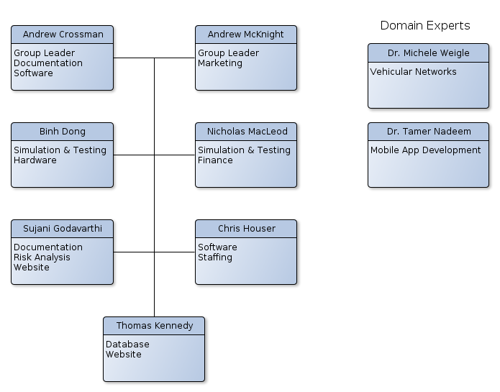

Group Leader

• Andrew Crossman

• Andrew McKnight

The group leaders, Andrew Crossman and Andrew McKnight, represent the project managers for Traffic Wizard. The group leaders are responsible for managing Team Blue and monitoring progress and development while ensuring communication and coordination within the team. Typically, the group leaders handle organizing the major presentable material and meetings.

Documentation Specialist

• Andrew Crossman

• Sujani Godavarthi

Documentation specialists are responsible for ensuring document-type deliverables are consistent and presentable. Traffic Wizard plans are among these documents, and are managed by the documentation specialists.

Marketing Specialist

• Andrew McKnight

The marketing specialist handles all research in terms of customer identification and market analysis. Promotion and marketing for Traffic Wizard itself is also handled by the marketing specialist, along with organization of marketing campaigns.

Software Specialist

• Andrew Crossman

• Chris Houser

The software specialists are responsible for design and analysis of the approach for implementation of the software components for Traffic Wizard. Software specialists are considered experts in terms of software development and work closely with the simulation and database specialists within the team. To ensure proper functionality of Traffic Wizard, more members of the team will be involved in software development (as computer science professionals) as needed.

Simulation and Testing Specialist

• Binh Dong

• Nicholas MacLeod

Much of Traffic Wizard’s innovations rely on thorough simulation and testing before they can be considered effective. The simulation and testing specialists have the responsibility of ensuring that the current version of the project is being properly simulated to demonstrate its functionality as well as testing all aspects of operations (concerning the mobile app and the server infrastructure).

Hardware Specialist

• Binh Dong

The hardware specialist is responsible for research on necessary hardware to initialize the Traffic Wizard project. As the project expands, the hardware specialist will be responsible for determining the required hardware to maintain network operations and ensure server scalability. These requirements will be defined per Traffic Wizard operating region.

Website Specialist

• Thomas Kennedy

• Sujani Godavarthi

The website specialists handle all aspects of the CS 410 Team Blue website that represents the Traffic Wizard product. This includes uploading all files relevant to the project as well as styling of the page. As new material is created to demonstrate progress on the project, the website specialists ensure that this content is available through the group website.

Risk Analysis Specialist

• Sujani Godavarthi

The risks analysis specialist is the team member who continuously assesses the risks of Traffic Wizard throughout the phases. Risks are analyzed through a risk matrix to visually represent the impact and probability of each determined risk – which is handled by the risk specialist.

Finance Specialist

• Nicholas MacLeod

The finance specialist is responsible for detailing the budget for Traffic Wizard in its respective phase. These details are found in the Funding Plan, which is handled by the finance specialist. Costs of hardware resources and staffing are analyzed within this document.

Staffing Specialist

• Chris Houser

The staffing specialist is responsible for the budget and hiring of employees to work on the project. Details for the expected hiring patterns are listed in the Staffing Plan – which is organized by the staffing specialist.

Database Specialist

• Thomas Kennedy

The database specialist maintains all aspects of the Traffic Wizard databases. These responsibilities include monitoring database activity and ensuring that the system is operationally stable.

Phase 1 – Project Prototyping:

In Phase 1, the Traffic Wizard team will build a simulated system for the expected environment for data exchange as a proof of concept for the app’s functionality. Building the prototype will require two software engineers in addition to the original team from Phase 0. Expected cost of hiring intern engineers is outlined in the Staffing Plan.

Increased staff:
- Software Engineer x 2

Software Engineer

*Assumed hire of intern engineer

The software engineer will be needed for the expected 6 month duration of the prototype phase in order to assist in building the algorithms and engines to simulate and process traffic data. Responsibilities will also include testing the prototype and running simulations of different scenarios.

Phase 2 – Project Development:

In Phase 2, the Traffic Wizard team will build the full scale server and databases for use as the foundation for the Traffic Wizard system. The amount of increased staff is larger in this stage than earlier phases. A Project Manager, Database Administrator, and two Software/Hardware Testers are needed for Phase 2, as well as two more Software Engineers in addition to the two from Phase 1. The expected cost of hiring the staff for Phase 2 is detailed in the Staffing Plan.

Increased staff:
- Project Manager x1
- Software Engineer x2
- Database Administrator x2
- Software/Hardware Tester x2

Project Manager

The Project Manager is responsible for team coordination and communication. They are also responsible for assigning tasks and managing project schedules. Reviewing all deliverables and organizing team collaboration are also some of their important duties as well.

Software Engineer

The Software Engineer is to again assist in development and refine of software engines and algorithms that are using for Traffic Wizard to function. Fixing bugs and assisting in the full scale deployment of virtual checkpoints (assigning latitude and longitude coordinates for each) are among their main duties.

Database Administrator

The Database Administrator handles all database operations. These responsibilities range from maintaining the stored information associated with each virtual checkpoint to ensuring that driver profiles and payment information are stored with best practices in security of information.

Software/Hardware Tester

The Software and Hardware Testers will be responsible for using the varied versions of the Traffic Wizard app throughout releases and providing thorough reports on usage and any issues. At the later stages of development, testing will open up to first a closed alpha testing for a set of chosen institutions and then an open beta test for the public to try the product.

Phase 3 – Production and Out-Years:

In Phase 3, the Traffic Wizard team will support and maintain the product after introducing it to the world and launching the app to be sold. Some staffing changes occur for this phase, as fewer people are required to monitor Traffic Wizard operations per regional center. Expansion into other regions is expected as the app grows, which will require this set of staff to be assigned at each added center.

Staffing per center:
- Project Manager x1
- Software Engineer x2
- Database Administrator x1

Staffing at Traffic Wizard main center:
- HR Manager x1
- Marketing Director x1
- Documentation Specialist x1

Project Manager

The Project Managers will continue to maintain team collaboration. Tasks to be completed by the Project Manager in Phase 3 include assigning work tasks such as software bug fixes and overseeing program operations from their respective center.

Software Engineer

The Software Engineers perform the necessary software maintenance for Traffic Wizard, which includes fixing glitches and improving features where necessary. When new releases are being deployed, Software Engineers are expected to test app functionality in Phase 3.

Database Administrator

The Database Administrator maintains their responsibility of monitoring the databases for virtual checkpoints and driver profiles. In this phase, each Database Administrator at a Traffic Wizard center will be monitoring database activity mostly for that respective region.

Human Resources Manager

The HR Manager will be located at the corporate center for Traffic Wizard and is responsible for administrative needs of the company and hiring employees.

Marketing Director

The Marketing Director will be based at the main Traffic Wizard center (the corporate center) and is responsible for promoting and maintaining a positive marketing image of the product. He/she will plan expansion campaigns to bring Traffic Wizard to new regions in the country as new centers are built.

Documentation Specialist

The Documentation Specialist will be based at the main Traffic Wizard center and is responsible for maintaining important documents for the company and app itself. Teams from each regional center will coordinate with the Documentation Specialist in order to create regional reports on activity.

Work Breakdown Structure

The planned breakdown for the necessary tasks in Phase 1, 2 and 3 is detailed in the work breakdown structure images below. The scheduled work plan will need to be utilized in order to complete the milestones in an efficient manner. Each phase is assigned a work breakdown structure specific to the tasks necessary for that stage of production.

Phase 1 – Project Prototyping:

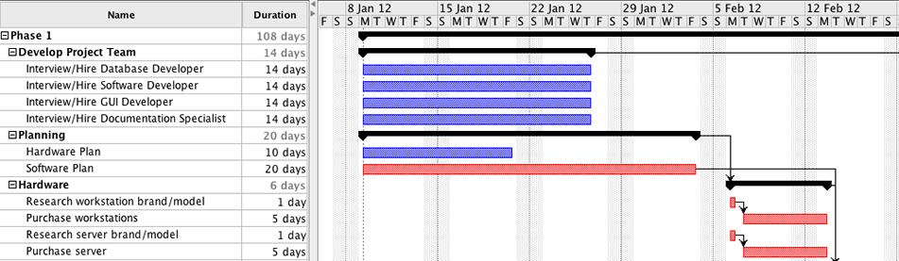

The prototyping stage will require planning for the required resources to build the prototype system.

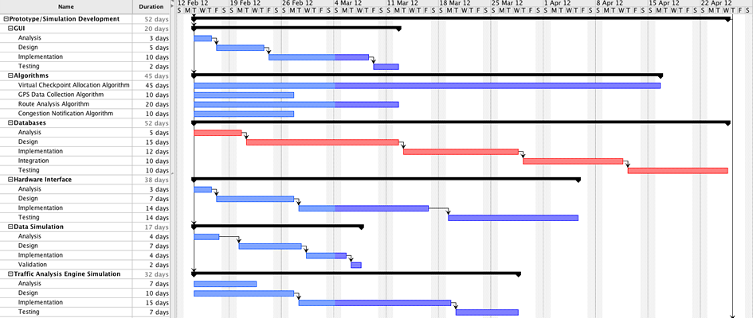

Development for the prototype stage includes most software functionality along with simulator engines for creating artificial driver data.

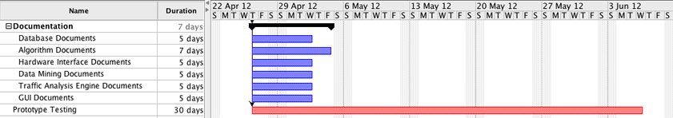

Documentation for Phase 1 is also a set of assigned tasks.

Phase 2 – Project Development:

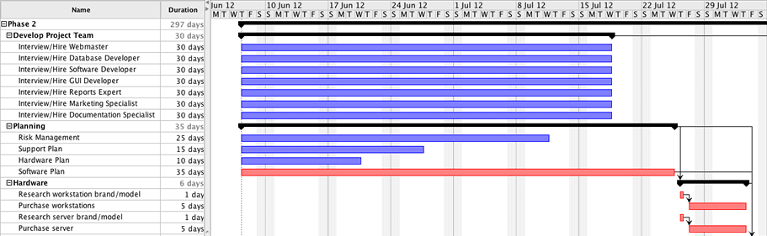

Planning for Phase 2 includes the hiring of a larger team to develop the product as well as preparing plans for production and purchasing required hardware.

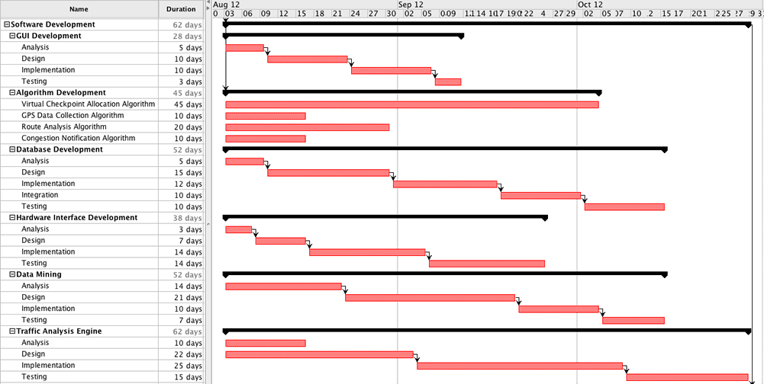

Development for Phase 2 is the most critical stage in the creation of the Traffic Wizard project. This stage defines the software functionality and brings our innovative concepts to their full scale form.

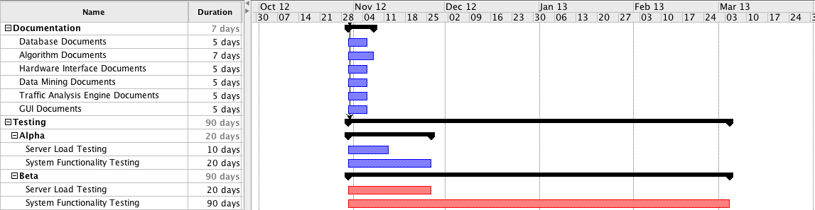

The testing stage of Phase 2 is also very critical, since this is where the Alpha and Beta testing phases take place. These tests are expected to last up to about 90 days in order to get proper patterning out of the collected data.

Phase 3 – Production and Out-Years:

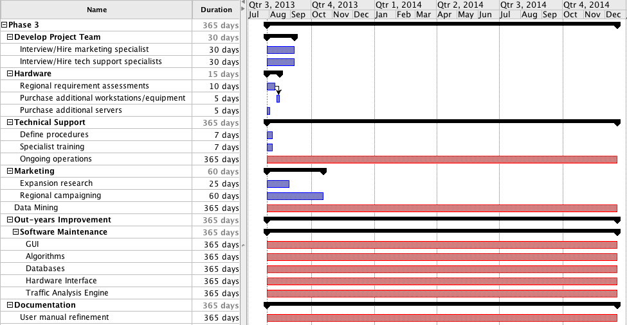

Phase 3 represents the ongoing maintenance and support of Traffic Wizard. This includes expansion in marketing, growth to other centers, providing support to customers, and fixing any discovered software glitches by releasing patches for the app.
Major Milestones

Each phase of production for Traffic Wizard is broken down into a set of milestones that need to be achieved in order to bring this project into reality. Each milestone represents the formation of a necessary component in order for Traffic Wizard to operate effectively.

Phase 0:

The initial phase is a conceptual phase in which the project is brainstormed and the problem area is researched thoroughly. The feasibility of the project is determined, as well as the intended customer and expected work breakdown for future phases. Milestones are defined for future phases and the Traffic Wizard app is designed to be prototyped for Phase 1.

Phase 1:

Phase 1 is the prototyping of the Traffic Wizard system, which is embodied by a scaled down system and set of databases to test functionality in a simulated environment. The milestones for this phase in development are listed below.
- Databases – Partial systems to represent a subset of the traffic data
- Data Simulation – Simulated data generated to represent real world driving scenarios and traffic conditions
- Algorithms – Developing algorithms to process simulated data
- Testing – Testing phone to server interface and observing data exchange

Phase 2:

Phase 2 is the full scale development of the Traffic Wizard app and system. This only includes building the foundation for the primary center in the expected initial region of Hampton Roads, Virginia. This will be the starting ground for Traffic Wizard and these milestones are necessary to bring the app to the public in a useable form.
- Databases – Virtual Checkpoint and Driver Profile databases
- Checkpoints – Initial assignment of virtual checkpoints to roadways
- User Interface – Development of GUI and app interfaces
- Analysis Engine – The processing system using developed algorithms
- Testing – Alpha and Beta testing phases to produce initial patterning of traffic and hopefully return customers

Phase 3:

The final phase represents the out-years for Traffic Wizard as it is sold to customers to be used across the country. While initially based in Hampton Roads, Traffic Wizard operations are expected to expand to other regions of the country in order to provide more efficient traffic updates to a wider range of drivers. The milestones that need to be maintained are described for this post-production phase,
- Support – Offering customer technical support and assistance
- Maintenance – Maintaining network and software to upkeep operations
- Marketing – Expansion campaigns to other regions of the United States

Progress Reports

Several documents will be utilized to represent certain aspects of Traffic Wizard operations. These include monthly progress reports, technical reports, budget reports, and corporate reviews. Reports are reviewed by the Project Manager at each center and managed by the Documentation Specialist at the main center.

Monthly Progress Reports

During development of the project, a series of reports will be generated to notate progress throughout each month of production. These are basically and overview of the various detailed reports such as budget and technical reports.

Technical Reports

The software development team will create reports to document the software issues and resolutions encountered for each stage of production. Mentions of hardware issues are also provided in these reports to be assessed for budgeting (for replacement or additional hardware).

Budget Reports

Documents for reporting budget activity are handled by the Project Manager. Changes to the status of the financial plan are detailed in these reports as well as expectations for impacts on production due to the financial status of the company.

Corporate Reviews

Teams at each center will be reviewed for performance and contribution to Traffic Wizard operations. These forms are also managed by the Project Manager and sent to the HR Manager at the main center when necessary.

