CORSICA Product Description
Red Team
Old Dominion University
May 8, 2014
CS 410 Lab 1

Table of Contents

1 INTRODUCTION (PATRICK)...................................................................................... 3

2 CORSICA PRODUCT DESCRIPTION (NICK).......................................................... 4

2.1 Key Product Features and Capabilities (NICK)................................................ 5

2.2 Major Components (Hardware/Software) (LATIMER).................................. 6

3 IDENTIFICATION OF CASE STUDY (LATIMER).................................................. 8

4 CORSICA PRODUCT PROTOTYPE DESCRIPTION (TONY).............................. 9

4.1 Prototype Architecture (Hardware/Software) (TONY).................................. 10

4.2 Prototype Features and Capabilities (BITASEME)........................................ 14

4.3 Prototype Development Challenges (LOOKMAI).......................................... 17

Glossary……………………………………………………………………………….……….. 19

References……………………………………………………………………………….…….. 21

Figures

Figure 1 - Hardware Components…………………………………………...…………...…. 7

Figure 2 - Real World Product and Prototype Comparison…………………...…………. 10

Figure 3 - Major Functional Components Diagram……………………………...……..… 11

Figure 4 - Description of Algorithms…………………………..………………………..…. 12

Figure 5 - Risk Table and Matrix……….……………………………...………….……..... 16

Figure 6 - Prototype Challenges………………………………………...………….……..... 17

CS 411W LAB I - PRODUCT DESCRIPTION DOCUMENT

1 INTRODUCTION (PATRICK)

Attending a university has become an important step in obtaining a successful job. The
Bureau of Labor Statistics has shown that citizens with a higher education not only made more,
but had a lower unemployment rate (2014). This has caused higher education to be more desirable. With the popularity of Universities increasing, so has the number of students that attend them. Universities, such as Old Dominion University (ODU), have the issue of courses reaching capacity due to their student population. This has led to the problem of the current class enrollment system becoming insufficient for handling course overflows.
The current enrollment system used by ODU is Banner. While most of the
management system is good, it lacks an efficient wait-list system. The wait-list system causes many problems for not only ODU’s Administration but also the students, faculty, advisors, and schedulers. The current course wait-list system results in excess student communication with faculty and Administration in order to facilitate the student's desire to be enrolled in a specific course when it is full. While the student and faculty body are attempting to resolve this issue, they are taken away from their other tasks. Implementing an improved wait-list feature to the current working course add/drop system will greatly reduce the number of these avoidable communications.
Understanding the issue, a new wait list system needs to be implemented. CORSICA or
COmputeR ScIenCe wAit-list, will be the solution to these issues. A student wishing to take a
Computer Science (CS) course at ODU will b put on an improved wait-list of which they can monitor its status and get notifications. This will increase the rate at which students can join a class if a space becomes available. The prototype is only for the CS department, however, it can be adopted to any department.

2 CORSICA PRODUCT DESCRIPTION (NICK)

CORSICA is a wait-list management system that will provide students a simple, fair, and effective way to wait for an available seat in a course. CORSICA will be available to Administrators, Advisors, Schedulers, Students, and Visitors as a service provided over the internet. CORSICA will send a notification to students on the wait-list when a seat becomes available for a course. This will reduce the stress that students would otherwise face when waiting for an available seat. In order to receive a notification, a course must be full and students must place their name on the wait-list. Once a seat becomes available, by another student dropping the course or having a course’s capacity raised, the system will send a notification to the first student on the wait-list. Notifications are sent via two ways, e-mail and/or text message. According to USA TODAY, the number of unattended voice-mails was down 8% from July 2011 to July 2012. Michael Tempora, Senior Vice President of Product Management at Vonage, stated "They hate the whole voice-mail introduction, prompts, having to listen to them in chronological order." The company has responded to the trend with a new voice-mail transcription service that converts voice messages for delivery as e-mail or text message (Yu, 2012). CORSICA will use email and/or text messages for the fastest and most efficient delivery.

2.1 Key Product Features and Capabilities (NICK)

CORSICA's main goal is to quickly and efficiently notify students when a seat for a course has become available. As students approach graduation, the importance to get into certain courses is very high and it is often these same courses that become full. Many students have to delay graduation simply because they were unable to get into a course or promptly get on the wait-list. With this scenario in mind, CORSICA has one objective: to provide students the opportunity to graduate on time.
One of the key features of CORSICA is the quick and efficient manner of the notification that students receive when a seat for a course becomes available. This notification can come in one or two ways, e-mail, and/or text message. After receiving this notification, students will have a 24 hour window to respond. This allows students enough time to respond if they still need a seat in that course. However, if they do not respond within 24 hours they will be removed from the wait-list, allowing the next student the opportunity to respond. The automated removal of students from the wait-list allows for the next student to be notified faster. If the Scheduler decides to close a wait-list, CORSICA will notify all the students on the wait-list that the wait-list has been closed. Another feature of CORSICA is that the Graphical User Interface (GUI) is handled over the internet. This allows users that have different web browsers the ability to use CORSICA. Other features include: the ability for students to sign up for as many wait-lists as they'd like, students can go onto the CORSICA website and view their position on a wait-list, and students can add or remove themselves from a wait-list. All of these features aid students in knowing when a seat for a course becomes available.
A major capability of CORSICA is to be able to handle courses that have lectures, labs and recitations. CORSICA will allow students to register for notifications when a seat for any lecture, lab and recitation opens; or students can register for a specific Course Registration Number (CRN) for each lecture, lab and recitation. The student will be given an error if he or she tries to register for one part of a course's wait-list that offers three parts, which includes: lecture, lab and recitation. Therefore, CORSICA will make the student register for three wait-lists or none of them. Another capability that CORSICA offers is allowing different levels of access depending on the credentials entered at log-in. The different types of users offered are Administrators, Advisors, Schedulers, Students, and Visitors. Administrators have full control over the system. This is important to have if a scheduler or advisor is using CORSICA in an unacceptable way, because the administrator can then delete one or both of them. Schedulers are important to CORSICA because they view course wait-list statistics for analytical purposes. Schedulers can view these statistics to assist them with knowing whether they should increase course capacity or decrease course capacity for a particular course. They can also manually open or close a wait-list for a course. Advisors have many different tasks including: the ability to view a student's position on a wait-list, the ability to add or remove a student on a wait-list, as well as the ability to move a student up or down on a wait-list. Students can view courses that have wait-lists, the number of students on the wait-list, as well as the wait-lists they are registered for. Visitors have limited functionality in CORSICA, unless they log-in. They will be able to view static pages, including: home page, about CORSICA, contact CORSICA, and CORSICA FAQS.

2.2 Major Components (Hardware/Software) (LATIMER)

In order to implement CORSICA, both hardware and software components will be required; let us first examine the necessary hardware. As illustrated in Figure 1 below, we will need three main pieces: a computer, an internet connection, and a server. 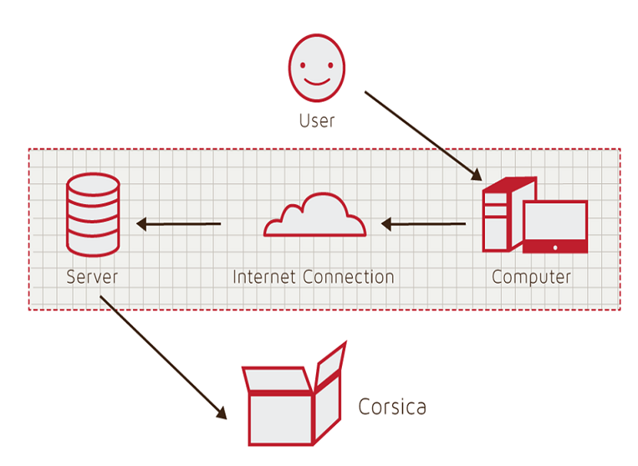
Figure 1
Hardware Components

The computer and internet connection are required in order to view/use and connect to the internet, respectively. The server will consist of both a web and database server - although this could potentially be broken up into two (or more) separate servers. The web server will be used to display and deliver web pages, while the database server will hold and manage the database.
For the software components, we will first need a database that contains all of the information relevant to CORSICA, such as student and course information. The database could possibly be created with MySQL, and manipulated using PHP, SQL, javascript, and HTML. We would require a number of interfaces for our different users, such as students or advisors; these GUIs would utilize HTML, CSS, and javascript. We would need a notification system in order to let students know by email and text that a seat has opened up in their desired class. We would require some kind of system (or algorithm) to handle the labs and recitations. And finally, we would need algorithms to make CORSICA work, from identifying open seats to loading an enrollment data file. The algorithms will be implemented with C++, and would consist of the following: Increase Course Capacity, Close Course, Notification, Add Student to Wait-list, Drop Student from Wait-list, Check for Open Seats, and Load Enrollment Data Files.

3 IDENTIFICATION OF CASE STUDY (LATIMER)

We are first developing CORSICA for the Old Dominion University Computer Science department with the assistance of our faculty mentor, Dr. Irwin Levinstein. Dr. Levinstein is an Associate Professor at ODU in Computer Science, as well as the course scheduler for the Computer Science department. The analysis component of CORSICA could potentially be of assistance to Dr. Levinstein in that it could determine how many seats should be added (or removed) from the different Computer Science courses. In addition to being of assistance to Dr. Levinstein, CORSICA aims to alleviate some of the headaches related to course registration time. For advisors and faculty, this would mean no longer being barraged with emails from students requesting to be allowed into classes that are full, and students would no longer have to keep a constant vigil on the number of available seats in a class.
If CORSICA functions as we envision and is a success, it could be used in other departments at ODU and eventually throughout the entire school. In addition, it could potentially be used at other universities, as well.

4 CORSICA PRODUCT PROTOTYPE DESCRIPTION (TONY)

Capabilities will be reduced in the CORSICA prototype in order to provide proof of concept. The Banner database of students and courses will be simulated with false data files during the demonstration as access will have not yet been granted. The Seat Analysis System will be omitted in the prototype as it does not contribute essential functionality. Simulation will show how CORSICA operates for various users: Administrator, Advisor, Scheduler, Student, and Visitor.
The CORSICA prototype will demonstrate the following functional goals and objectives: operate as a mainly automated system, make efficient use of current notification system (will be simulated), fair enrollment process, reserve seats for student users on course wait-lists, and trigger alerts. CORSICA will operate as an automated system while still accepting user requests / actions. Allowing the system to be mainly automated ensures the greatest ease of use for all users. We intend to tie into Old Dominion’s current alert system; specifically the text and email notification features. The current alert system sends text messages and emails to students in the event of school closures. Students are required to opt into the system by providing their contact information. In an effort to ensure fairness during course enrollment periods, CORSICA will reserve seats for student users on a course wait-list and block sign up attempts from students who are not. Finally, alerts will be triggered, by means of a pop up textbox, when an Administrator user or Scheduler changes course information to ensure all changes are intentional. Below, Figure 2 shows a comparison between the real world product and the prototype.

 | Real World Product | Prototype
Environments for all Users: | Yes | No  · Will demonstrate student, admin, and scheduler users
Notification System | Yes | No  · Will be simulated with text box
Check for available seats | Yes | Yes
Add Student to Wait-list | Yes | Yes
Drop Student from Wait-list | Yes | Yes
Fair process | Yes | Yes
Alert System | Yes | No  · Will be simulated with text box
Mostly automated | Yes | No  · Will rely heavily on user interaction
Link to Banner | Yes | No  · Will be loaded with data.txt files instead
Link to Leo-Online | Yes | No  · Will be simulated with command box menu
GUI | Yes | Very Basic (Text System)
Seat Analysis System | Yes | No

Figure 2
Real World Product and Prototype Comparison

4.1 Prototype Architecture (Hardware/Software) (TONY)

Figure 3 shows the CORSICA prototype will be comprised of four major components: a course database, back-end algorithms, a notification system, and a user interface. A user will interact with the prototype through the command prompt using basic I/O. The course database will be simulated with a text file. The file will contain all the information the prototype will require: Course name, Course sections, Course capacity, Number of students enrolled in the course, and the amount of available seats. The above information will be arbitrarily generated as CORSICA will not be granted access to actual course information during the prototype demonstration.
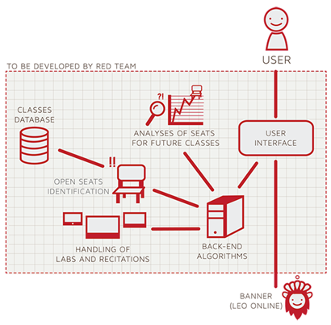
Figure 3
Prototype Major Functional Components Diagram

Various back-end algorithms will be used for the prototype. They include the following: Load Enrollment Data File, Open Course, Check for Open Seats, Add Student to Wait-list, Notification, Drop Student from Wait-list, Increase Course Capacity, and Close Course. Below in Figure 4 are explanations as to how the algorithms will function.

Algorithm | How it functions
Load Enrollment Data Files | Course data files are loaded into CORSICA.  Files contain course: Capacity, Number of Enrollments, and Available seats.
Open Course | An Administrator or Scheduler user logs into Banner and opens a course for students to enroll in.  Banner database is updated  CORSICA database is notified of change and is updated
Check for Open Seats | Once a course becomes full, a wait-list is activated for it by CORSICA  CORSICA will continually reference the current course capacity and amount of students enrolled.  If the amount of students enrolled is less than course capacity, a seat has become available.  CORSICA database updates  Calls notification algorithm
Add Student to Wait-list | Student X wishes to enroll in Course Y’s wait-list  CORSICA receives this request and adds Students X to wait-list queue  Course Y’s wait-list is updated
Notification | The check for open seats algorithm completes and returns true for an available seat  All students on the wait-list queue are notified of opening  Students respond
Drop Student from Wait-list | Student X wishes to be dropped from Course Y’s wait-list or the time window for that student has expired  CORSICA receives this request and removes Student X from the wait-list queue  Course Y’s wait-list is updated
Increase Course Capacity | Administrator logs into Banner and increases course capacity for Course Y  Banner database is updated  CORSICA database is notified of change and is updated
Close Course | An Administrator or Scheduler user logs into Banner and closes a course as an available option for students to enroll in  Banner database is updated  CORSICA database is notified of change is updated

Figure 4
Description of Algorithms

CORSICA will integrate with Old Dominion University’s current notification system. More information on the current system may be found here. The prototype will simulate the notification process with a prompt alerting the user that students have been notified.

4.2 Prototype Features and Capabilities (BITASEME)

The CORSICA prototype will aim to show consumers an example of the product’s functionality. The audience of users can be separated into five categories: an administrator, an advisor, a scheduler, a student, and a visitor. Each use case, defines the user to be the current use case user (ie. the Administrator Use Case would refer to the Administrator as “User”). For the prototype, only the Administrator, the Scheduler, and the Student use cases will be shown. How each audience can use CORSICA will be described below.
The following describes how an administrator can use CORSICA. Upon logging into CORSICA, the user will be greeted with a list of courses for the current semester and the corresponding wait-lists. The user will search for a student name to see their wait-list history. In this particular case, Student Latimer Gerle has been on 4 different wait-lists. The user can also search for a specific course. In this case, CS 250 is the searched class. The course description is then populated along with the current wait-list. The user can view the contents of the wait-list and manipulate it by changing the position of the students on it as well as removing students from the wait-list or even the wait-list itself. This marks the end of the Administrator prototype demonstration.
Scheduler exclusive abilities are discussed in the following use case. Upon logging into CORSICA, the user will be greeted with a list of courses for the current semester. These courses will be divided into those with wait-lists and those without wait-lists. The user can click on a particular wait-list to view details about the list such as who is on it, how many people are on it, and what class it is for. Wait-lists from previous semesters can also be viewed by searching for a list of wait-lists from previous semesters in the search bar. Using the same method, the user can also bring up wait-list statistics and analytics. To open and/or close a wait-list for a course, the user simply needs to search for the particular course and then perform the necessary function(s). This marks the end of the Scheduler prototype demonstration.
The following shows how a student can use CORSICA. Upon logging into CORSICA, the user will be greeted with the wait-list(s) that they are currently active on. The user can search the last name of an instructor to return results of all the wait-lists that belong to the course(s) that the instructor is currently teaching. The user can choose a course and then sign up to be on the wait-list. CORSICA will pop-up an alert box stating the course, the semester, and the spot on the wait-list that the user is attempting to sign up for. The user accepts the confirmation and is successfully added to the wait-list. This marks the end of the Student prototype demonstration.
These three prototype demonstrations are significant in showing how the problem is solved because potential customers (universities) can better make a decision on whether or not to buy the product and students can determine whether the product is something that they can get used to or to try to petition for it to be disbanded. The risks for CORSICA are listed below in Figure 5:

Customer Risks | Technical Risks
C1: Department Use Rejection | T1: Ability to Integrate with Banner
C2: Transition to New GUI | T2: Software Upgrades
C3: Cost of Product | T3: Availability of Server Storage
C4: Product Interest | T4: Security Vulnerability
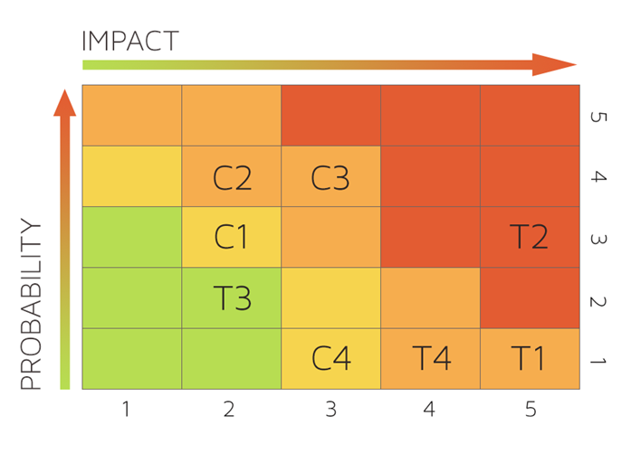
Figure 5
Risk Table and Matrix

Prototype Risk Mitigation Addressing: The prototype displayed it’s functionality to mitigate the customer risks listed above by showing ease-of-use and product effectiveness. A department use rejection risk is minimal considering the known demand for the product, and transitioning to a new GUI can, overtime, be trivial due to CORSICA updates. The risks that were not covered were the Technical Risks. Technical risks are dynamic with respect to the particular university. For T1, CORSICA is dependent on Banner so this risk should not be a major issue (if an issue at all). An update feature in the prototype was absent however it was not necessary to show the functionality. T3 and T4 are risks that are dependent upon the University using CORSICA, and as such, would be impossible to cover for every university around the world.

4.3 Prototype Development Challenges (LOOKMAI)

Objectives of the CORSICA prototype were listed in Section 4 in the comparison between the prototype and real-world product. For convenience, here are just the objectives below along with predicted challenges:

Objectives | Prototype | Challenges
Environments for all Users: | No  · Will demonstrate student, admin, and scheduler users | Working out all the bugs in CORSICA to allow all users to use CORSICA as intended
Notification System | No  · Will be simulated with text box | Allowing CORSICA to sync EXACTLY with the University’s Clock
Alert System | No  · Will be simulated with text box | Making the Alert System actually recognize each change to help ensure intentional changes
Mostly automated | No  · Will rely heavily on user interaction | Users need to be knowledgeable of CORSICA
Link to Banner | No  · Will be loaded with data.txt files instead | Using Black Box Testing to certify the text file compatibility
Link to LEO Online | No  · Will be simulated with command box menu | Maintaining LEO Online’s layout while appending the CORSICA option on the course registration screen
GUI | Very Basic (Text System) | Coding a GUI that looks professional and is simple to navigate

Figure 6
Prototype Challenges

Glossary

*Algorithm - A set of steps that are followed in order to solve a mathematical problem or to complete a computer process.

***Banner - Old Dominion University's centralized academic and administrative records system.

*Browser - A computer program that is used to find and look at information on the Internet.

**C++ - A general purpose programming language that is free-form and compiled.

**Cascading Style Sheets (CSS) - A style sheet language used for describing the look and formatting of a document written in a markup language.

*Computer - An electronic machine that can store and work with large amounts of information.

*Database - A collection of pieces of information that is organized and used on a computer.

*E-mail - A system for sending messages from one computer to another computer.

*Graphical User Interface (GUI) - A program that allows a person to work easily with a computer by using a mouse to point to small pictures and other elements on the screen.

HyperText Markup Language (HTML) - A computer language that is used to create documents or Web sites on the Internet.

*Internet - An electronic communications network that connects computer networks and organizational computer facilities around the world.

**Javascript - A dynamic computer programming language, used as part of web browsers, whose implementations allow client-side scripts to interact with the user.

*Laboratory - A room or building with special equipment for doing scientific experiments and tests.

*Lecture - A talk or speech given to a group of people to teach them about a particular subject.

**MySQL - A database management system.

*Notification - The act of notifying someone.

*ODU - Old Dominion University, a public 4-year university in Norfolk, Virginia.

**PHP - A server-side scripting language designed for web development.

*Prototype - An original or first model of something from which other forms are copied or developed.

*Recitation - A class period especially in association with and for review of a lecture.

*Server - The main computer in a network which provides files and services that are used by the other computers.

**SQL - A programming language designed for managing data held in a relational database management system.

*Text Message - A short message that is sent electronically to a cell phone or other device.

***University Identification Number (UIN) - A unique identification number given out to students at Old Dominion University.

*Wait-list - To be put on a waiting list.

*Found at http://www.merriam-webster.com/
** Found at http://en.wikipedia.org/wiki/
*** Found at https://www.odu.edu

References

1. (March 24, 2014). Employment Projections. Bureau of Labor Statistics. Retrieved May 1, 2014, from http://www.bls.gov/emp/ep_chart_001.htm

2. Yu, R. (2012, September 3). Voice mail in decline with rise of text, loss of patience. USATODAY.COM. Retrieved April 27, 2014, from http://usatoday30.usatoday.com/tech/news/story/2012-09-03/voicemail-decline/57556358/1

