Intelligent Cruise Control

2002
SBIR GRANT PROPOSAL

TABLE OF CONTENTS

1. | PROPOSAL COVER (FORM 9A) …………………………………………….. | 1
2. | PROPOSAL SUMMARY (FORM 9B) …………………………...…………… | 2
3. | TECHNICAL PROPOSAL ……………………………………………………. | 3
 | 3.1 Identification and Significance of the Innovation …………………………………………. | 3
 | 3.2 Technical Objectives ………………………………………………………………………. | 6
 | 3.3 Work Plan ………………………………………………………………………………….. | 8
 | 3.4 Related R/R&D …………………………………………………………………………….. | 10
 | 3.5 Key Personnel and Bibliography of Directly Related Work ………………………………. | 11
 | 3.6 Relationship with Phase II or Future R/R&D ……………………………………………… | 13
 | 3.7 Company Information and Facilities …………………………………………………………. | 14
 | 3.8 Subcontracts and Consultants ………………………………………………………………… | 15
 | 3.9 Commercial Applications and Potential ……………………………………………………... | 16
 | 3.10 Similar Proposals and Awards ………………………………………………………………... | 17
4. SUMMARY BUDGET (FORM 9C) ………………………………...…………... |  | 18
APPENDIX A: DETAILED PROJECT IMPLEMENTATION PLAN …………. |  | 20
 | A1 Phase I Implementation Plan ………………………………………………………………….. | 20
 | A2 Phase II Implementation Plan ………………………………………………………………… | 21
 | A3 Phase III Implementation Plan ………………………………………………………………… | 22
APPENDIX B: DETAILED BUDGET …………………………………..………... |  | 23
 | B1 Detailed Budget ………………………………………………………………………………... | 24
 | B2 Personnel Budget ………………………………………………………………………………. | 25
 | B3 Miscellaneous Budget ………………………………………………………………………….. | 26

1. Proposal Cover (Form 9A)

Subtopic Number
1. PROPOSAL NUMBER: 01-E4.03-1113
2. SUBTOPIC TITLE: Innovative Safety Measure to Prevent Highway Rear End Accidents
3. PROPOSAL TITLE:
Intelligent Cruise Control
4. SMALL BUSINESS CONCERN (SBC):
NAME: Intelligent Cruise Control
MAILING ADDRESS: Old Dominion University, Education Building, Room 250-6
CITY/STATE/ZIP: Norfolk, Virginia 23529
PHONE: 757-683-4832
FAX: 757-683-4900
EIN/TAX ID: 1364 DUNS + 4: 121154739 CAGE CODE: 6784
Number of employees: 2.5
5. Amount Requested $ 69,998 duratioN: 6 months
6. certifications: offeror certifies that:

As defined in Section 1 of the Solicitation, the offeror certifies:
a. Eligibility of the Principal Investigator Yes
As defined in Section 2 of the Solicitation, the offeror qualifies as a:
b. SBC Yes
Number of employees: 2.5
c. Socially and economically disadvantaged SBC No
d. Woman-owned SBC No
As described in Section 3 of this solicitation, the offeror meets the following requirements completely:
e. All eleven parts of the technical proposal included in part order Yes
f. Subcontracts/consultants proposed? Yes
i) If yes, limits on subcontracts/consultants met Yes
ii) If yes, copy of agreement enclosed Yes
g. Government equipment or facilities required? Yes
i) If yes, signed statement enclosed in Part 8 No

7. ACN NAME: Timothy Egan E-MAIL: brunelle@cs.odu.edu
8. ENDORSEMENTS:
PRINCIPAL INVESTIGATOR: CORPORATE BUSINESS OFFICIAL:

NAME: Kerry Frisby NAME: Janet Brunelle
TITLE: Project Manager TITLE: General Manager
PHONE: 757-693-4832 PHONE: 757-683-4832
E-MAIL: brunelle@cs.odu.edu E-MAIL: brunelle@cs.odu.edu
SIGNATURE: SIGNATURE:
DATE: December 10, 2002 DATE: December 10, 2002

NOTICE: For any purpose other than to evaluate the proposal, this data shall not be disclosed outside the Government and shall not be duplicated, used, or disclosed in whole or in part, provided that if a funding agreement is awarded to this proposer as a result of or in connection with the submission of these data, the Government shall have the right to duplicate, use, or disclose the data to the extent provided in the funding agreement. This restriction does not limit the Government's right to use Information contained in the data if it is obtained from another source without restriction. The data subject to this restriction are contained in pages of this proposal
2. Proposal Summary (Form 9B)

Subtopic Number
1. PROPOSAL NUMBER 01-E4.03-1112
2. SUBTOPIC TITLE: Innovative Safety Measure to Prevent Highway Rear End Accidents
3. PROPOSAL TITLE:
Intelligent Cruise Control
4. SMALL BUSINESS CONCERN (SBC):
NAME: Intelligent Cruise Control
MAILING ADDRESS: Old Dominion University, Education Building, Room 250-6
CITY/STATE/ZIP: Norfolk, Virginia 23529
PHONE: 757-683-4832
5. PRINCIPAL INVESTIGATOR/PROJECT MANAGER
NAME: Kerry Frisby
ADDRESS: Old Dominion University, Education Building, Room 250-6
CITY/STATE/ZIP: Norfolk, Virginia 23529
PHONE: 757-683-4832

6. TECHNICAL ABSTRACT (LIMIT 200 WORDS):
The purposed innovation is an implementation of the current cruise control and radar technology that will measures speeds and location of objects directly in front of vehicle to warn the driver of impending danger. This implementation is known as the intelligent cruise control (ICC). The ICC will allow current cruise control users the added convenience and safety of preventing highway rear end accidents. The ICC uses an audio indicator (buzzer) and visual indicator (light indicator) as preemptive measures to warn the driver of problem areas in front of him. A CPU will compute the data gathered from the radar and tell the system to light up the indicators when warranted and slow down the vehicle as a last resort. The ICC is not designed to change driving habits of drivers. Some of the risks associated with the ICC are the issue of liability, movement or bankrupt of suppliers, and voiding of original warranty. ICC-ODU,Inc will save 10% of budgets for risk factors incase of needing to switch suppliers due to relocation or finial difficulty of supplier. Also, we will offer our own warranty incase of problems after the product has been installed. Attached is our warranty statement. Finally, we will have business and professional insurance to pay for any legal problems that might be encountered.

7. POTENTIAL COMMERCIAL APPLICATIONS (LIMIT 200 WORDS):

ICC has devised a marketing plan that encompasses several potential customers. First, local computer shows are a venue for the target area demographics, age group 18-45, who want/need the newest gadget or toy in the market. The local computer shows in the Hampton Roads area are the least expensive marketing ploy. Second, would be the local high-end computer and electronic retail stores. Non-exclusive contracts would be set up for the distribution of the ICC. Finally, there is the marketing of car manufactory. The idea is the selling of safety for their high-end model cars.
The geographic areas of concentration would be Hampton Roads, Mid-Atlantic States, and Detroit (car manufactures).
Other possible applications include the use in passenger trucks and vehicles used for long distance driving.

3. Technical Proposal

3.1 Identification and Significance of the Innovation

The proposed innovation is an Intelligent Cruise Control System. This system is a modification of the current cruise control system. It will be modified by the adding of a radar system to the front of the vehicle. This radar system will be able to detect if there is another vehicle in the ongoing path of the vehicle in which you are traveling in. If a vehicle is detected, the radar will be able to determine the distance between you and the vehicle in front of you, the speed at which the vehicle is traveling, and how fast the distance between the two vehicles is decreasing. It will be able to do this with the help of the cruiser control computer. After all of this information has been calculated, the car will adjust your speed accordingly to maintain a safe following distance. Once the vehicle is no longer in your path, the cruise control computer will adjust your speed back to the original cruise control speed.
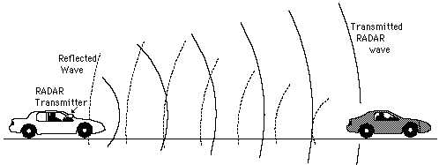

In today’s society, the unawareness and slow reaction time of driver when it comes to changing traffic patterns can make the highways a very dangerous place. When looking at accident statistic on today’s highways, we observe that rear end collisions are the most common with over two million accidents per year reported. This accounts for millions of dollars in accident cost.

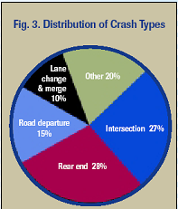

Each year manufactures manufacture fifty-five million cars. Seventy percent of those cars will come equipped with a standard cruise control system. This equates to thirty-eight and a half million cars produced each year with cruise control.

Currently cruise control is limited to the settings and to the actions of the user. The user must set the cruise control. In order to disengage it the user must change the settings by hand applying the break or applying the gas. If none of these settings are adjusted there is no way to prevent crashing into the car in front of you. Another activity is when you do adjust your cruise control; you must reset your cruise control back to your original cruise speed. The Intelligent Cruise Control System will eliminate some of this repeditive task making for a more relaxed and enjoyable ride.

3.2 Technical Objectives

The goal of the Intelligent Cruise control System is to assist all drivers in getting the maximum use out of their cruise control system, for safety as well as for convenience.
To reach this goal, ICC must:
- Use current radar systems
- Create software for the radar system
- Connect this system to current cruise control systems
- Make sure to provide a quality product

In order to achieve this goal, in phase I we must:
- Prove that this project is feasible
- Do extensive research on radar
- Prove that the type of radar is feasible
- Apply for necessary funding
- Do extensive research on the problem area

Product design

This product design shows how the components of a cruise control system are integrated with each other. To implement the safety part of the ICC system, the ICC radar, buzzer and light indicator has been added to the system. The cruise control computer is also upgraded to do more functions in order to take the needed action to maintain a safe following distance.

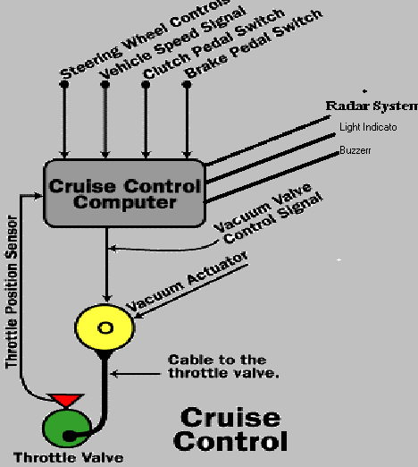

The final product design shows the location of the radar censor, the user interface design, as well as the light sensor and buzzer.

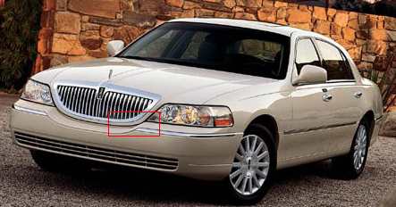

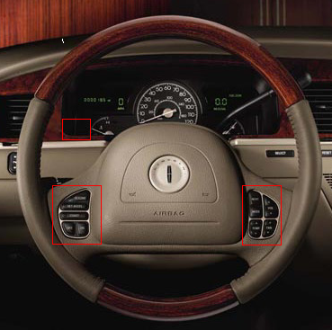

3.3 Work Plans

Phase 1 Implementation Plan

Phase I involves extensive research to determine the projects feasibility and research to help determine the exact resources that will be needed for the completion of this project. After this research is done, the project team will then evaluate and approve the feasibility, task and resources for the project.

Each evaluation method will be taken into consideration in determining the feasibility of the project. The resources the project will need will be determined by the individual task of the project. The resources will be chosen on the bases of merit and budget.

The project team will then create a prototype design with the resources obtained. Once the prototype design has been finished it will go through a series of test to determine of the design needs any changes. Once the test results are obtained from the design they, the test results, will be evaluated to see if there might be any "bugs" in the design. Once the design has finished testing the project team will then go into getting funding for the project. The team will contact companies and small business grants for funding for the project.

Phase I Evaluation Methods And Tools

Program Design Review

Our first initial Quality Assurance review will be the Program Design Review. In this first method we will review the design of the functionality of the coding for the Intelligent Cruise Control central processing unit. The review will be a 2-part process. They are as follows:

- This will review the design of the program. It will check to make sure all the proper functions for the unit will be in the code and that the proper data variables and types are there.
- The review will check for efficiency. It will check to make sure that the functionality of the unit is efficient. Efficiency for this system consist of:
  - Proper data within the right range is being pass
  - The functions have a small complexity for faster processing

Critical Design Review

This test will check the design of the system hardware. It will check to see if the design of the system is feasible. For the system to be feasible it must be a design within the constraints of the vehicle. This test will also take into account the design of the standard cruise control on vehicles to help in this review. The review will be a 3-part process:

- Review location design of the ICC. This will review the location on the vehicle to make sure the system isn't in a spot where improper connectivity is
- Design of the ICC system hardware to make sure that the system is created with environmental issues in mind.
- Test how easily the system design will install onto a car's Cruise Control.

This review will be done on each hardware component of the Intelligent Cruise Control.

Program Code Review

This review is a 2-part review of testing the coding of the system. They are as follows:

- The Program Code Review will review to see if the actual code and its algorithms are efficient. If the code does not pass this part of the review, more efficient algorithms will be added to the code.
- Check to see if the code created will properly run within the time constraint. The time constraint is the range of time in which the system should theoretically take to process the data and slow down the vehicle and alert the driver.

Final Implementation and Road Test

This final test will test to make sure that the final product is easy to implement. The mechanics will hook up the system and record on the difficulty level of installation. After the installation will be a road test of the system. The road test will be a 3-week test where the vehicle with the ICC will go on the highways and test to see if the system engages properly, if the system detects the car in front of it, and if the system takes proper action during different traffic changes. All this data will be recorded and will be used to see if the system can go to final production or back to The Program Code Review stage.

Start-up Staffing

General Manager
Janet Burnell

Project Manager
Kerry Frisby

Budget | Research
Marketing | Testing & Q.A.
Timothy Egan | Philip Elliott

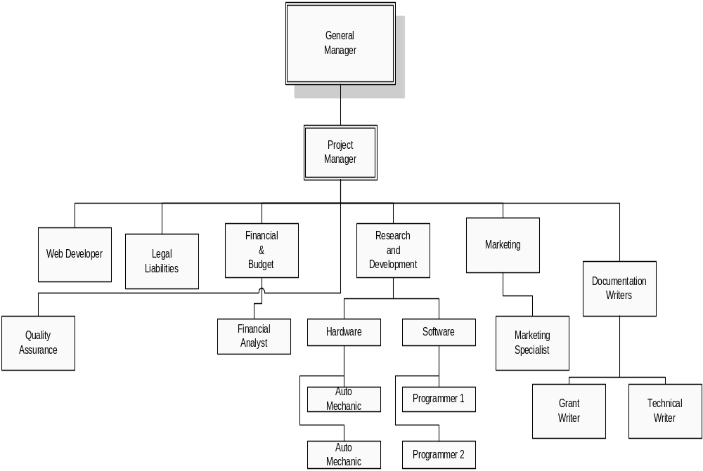Phase 1 Staffing Plan

3.4 Related R/R&D

There is currently two main automobile manufactures that are developing this technology. Our system employs the chaotic wave radar system. Mitsubishi is the current market leader in the implementation of the chaotic wave radar system. Mitsubishi will have Intelligent Cruise Control on their high-end model vehicles in 5 years. General Motors is working with the University of California, Berkeley to develop a similar system. Their prototype is exclusive being developed for the smart highway system. Virginia Tech is the local university that is helping with the smart highway system.

3.5 Key Personnel And Bibliography Of directly Related Work

ICC Personnel Bibliographies:

Phillip Elliott, Testing and Quality Assurance Manager
Phillip Elliott is the Testing and Quality Assurance Manager for the Intelligent Cruise Control, as well as the Web Master. He is currently studying at Old Dominion University in Norfolk, VA, and will be graduating in December 2003 with a Bachelor of Science degree in Computer Science. He has been employed with the New York Times Company since July 2002 as a Computer Scientist Student Trainee. Mr. Elliott has done extensive programming in various languages, including Visual C++, Pascal and Java and is currently studying for MSCE certification.

Tim Egan, Marketing Director

Timothy Egan is the marketing director of the Intelligent Cruise Control system as well as one of the primary researchers for the project. He is currently studying at ODU in Norfolk VA and will be graduation in December 2002 with a Bachelors of Science degree in Computer Science with a minor in Mathematics. He received an Associates of Science in Business Administration from Community College. Mr. Egan is also a current member of the Tidewater UNIX User Group (TWUUG). Mr. Egan has C++ programming experience and currently studying for the CCNA certification.

Kerry Frisby, Project Manager

Kerry Frisby is the Project Manager and Budget Officer of the Intelligent Cruise Control System. He is currently a student at ODU in Norfolk VA and will be graduation in May of 2003 with a Bachelors of Science degree in Computer Science with a minor in Computer Engineering.

Phase I Personnel Technical Requirements

Project Manager
Designs, plans, and coordinates work groups. Provides technical support to project team members. Handles complex application features and technical designs. May design and implement or assist with the design and implementation of the components required for complex application features. Requires a bachelor's degree in a related area and at least 7 years of experience in the field (negotiable). Generally manages a group of software developers/engineers, including hardware engineers. Relies on experience and judgment to plan and accomplish goals. Will be involved continuously throughout all phases of the ICC design and development, mainly part-time.

Computer Engineer
Reviews and analyzes programming systems including encoding, testing, debugging and documenting for the ICC. Designs, modifies, develops, writes and implements software programming applications required for ICC. Supports and/or installs software applications. Participates in the testing process through test review and analysis, test witnessing and certification of software. Requires a bachelor's degree in a related area and 3 years of experience in the field or in a related area. Has knowledge of commonly used concepts, practices, and procedures utilized within the technology field. Works under general supervision; typically reports to a manager. Will also be responsible for the hardware implementation of the technical hardware components. Should have basic understanding of automobiles.

Lawyer
Prepares and/or maintains documentation pertaining to programming, systems operation and user documentation of ICC. Translates business specifications into user documentation. Plans, writes, and maintains systems and user support documentation efforts. Has knowledge of commonly used concepts, practices, and procedures utilized within the technology field. Relies on instructions and pre-established guidelines to perform the functions of the job.
Creates, writes, negotiates and reviews hardware and/or software licensing contracts, purchasing contracts for required materials, and production and development contracts for ICC. Works with the ICC team in establishing agreements that reflect the interests of the company. Also works drafting licensing agreements. Requires a master’s degree. Must have at least 5 years of experience in contract administration, law practices, and technical writing. Must be state bar qualified. Must have a solid understanding of information and web technology. Relies on limited experience and judgment to plan and accomplish goals. Performs a variety of tasks. Works under general supervision; typically reports to a manager. A certain degree of creativity and latitude is required.

Finical / Marketing Specialist
Responsibilities include design, implementation, and analysis of budget, accounting, purchasing, and marketing aspects of product. Responsibilities also include purchasing and negotiating materials, equipment, and supplies from vendors. Evaluates vendor quotes and services to determine most desirable suppliers. Must be qualified CPA. Have 5 years of business experiences. Finally responsible for marketing acquiring media contracts, and implement of market strategies towards target demographic. Two years marketing, or similar experiences required. Works under general supervision; typically reports to a manager. A certain degree of creativity and latitude is required.

Test engineer
Responsibilities include design, development, implementation, and analysis of technical products, systems, and hardware for testing and quality assurance for the ICC. Develops test strategies and devices for ICC. Requires a bachelor's degree in test engineering and 3 years of experience in the field (destruction and non-destruction testing) or in a related area. Has knowledge of commonly used concepts, practices, and procedures utilized within the technology and automotive fields Works under general supervision; typically reports to a supervisor or manager.

Auto Mechanic
Responsibilities include design, development, implementation, and analysis of technical products, systems, and hardware for ICC. May develop a range of products. Requires 5 years of experience in the field or in a related area. Qualified ASI. Has knowledge of commonly used concepts, practices, and procedures utilized within the automotive field. Works under general supervision; typically reports to a supervisor or manager.

Web Developer
Responsible for the design, development, implementation, and analysis of company’s web page. Requires knowledge of commonly used concepts, practices, and net tools used in web page development. Also should have knowledge in java, html, vrml, and other web base languages. Works under general supervision; typically reports to supervisor or manager.

3.6 Relationship with Phase II or Future R/R&D
The ICC project team has a reliable implementation plan for Phases II and III of the product development. In Phase II the team will hire the necessary personnel as well as obtain all required resources. A Program Design Review (PDR) and Critical Design Review (CDR) will be implemented before the final management plan gains organization approval. The next milestone to be achieved after approval is the completion of software and hardware testing. To achieve this the team must integrate and test the software and hardware needed for a successful product. Once the testing is completed for the hardware and software, ICC-ODU,Inc. can begin to install the product and test in the “real world” environment. This process involves the installation of equipment in a test facility for proper testing of the integration between devices. Prior to testing completion of the installation, a Factory final implementation and road test will be conducted to ensure product quality. Once all testing methods have been exhausted and thoroughly analyzed, as well as all necessary modifications to the design made, the team can shift their efforts to Phase III of the product, the production phase.

Phase III involves the production of the ICC system. Prior to production of the first Intelligent Cruise Control, the team will complete the user manual for the product including a troubleshooting guide. The user manual is the most important interface between the product and the customer; therefore, a PDR will be conducted following the completion of the user manual to ensure its quality. Testing of the fully assembled Intelligent Cruise Control system will be conducted a vehicle with cruise control. If modifications are required after testing is completed in the model home, they will be implemented and the Intelligent Cruise Control can enter its final production phase for distribution to the consumer

3.7 Company Information and Facilities

The Intelligent Cruise Control will be conducting its Phase I, II, and III research and development operations in the Education Building of Old Dominion University in Norfolk, Virginia. Equipment, including chairs, tables, desks, electricity, and phone connections, will be provided by the University. The necessary hardware resources accounted for in the proposed budget will be housed here as well. These include computer systems and software, an Internet connection, and prototype development materials. Below is a floor plan of the Education Building. ICC operations will be conducted in room 209.

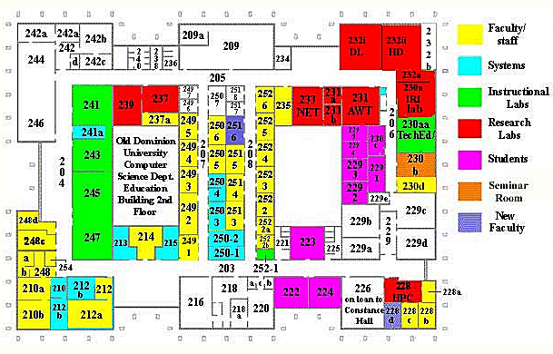

The Computer Productivity Initiative of Old Dominion University, whose mission is as follows, will supply additional resources:

The current Computer Science curriculum must be modified to help students better understand how to apply their education to real world problems. The primary objective of the Computer Productivity Initiative (CPI) is to identify and develop these modifications, portable to any CS program. A multi-year, coordinated project is introduced into the curriculum. Students from several courses coordinate and share information concerning the broad, ill-structured project topic/problem. Another links the courses involved in the CPI project through the tasking of one class. The tasking class is always one of the senior CPI courses, while the tasked classes include a sophomore and a junior level course. The two new senior level courses focus on such topics as technical research, market research, presentation skills, group collaboration, interviews, budgeting, proposal writing, presentation tools, scheduling, hardware availability research, system architectural design, requirements specification, simulation, prototyping, and cost estimation. Initial feedback from our students, potential employers and an external board of advisors confirms both that the most successful graduates may not be those with the best technical education and that this effort can provide that additional dimension to the traditional CS curriculum which better prepares students to contribute to the solution of ill-structured but real problems.

3.8 Subcontracts and Consultants

Mitsubishi understand that technology is the driving factor of change in our life. By bringing greater comfort to daily life, and maximizing customer satisfaction, integrate Mitsubishi Electric intergratestechnology and innovation to bring changes for the better. Mitsubishi will be contracted out to provide the chaotic radar unit. They offer design, prototyping, assembly, supply chain management, worldwide distribution, and after sales service. ICC-ODU, Inc. will use the risk fund to contract local legal help if need be and expertise in the field of cruise control.

3.8 Commercial Applications Potential

The commercial application potential has many applications for the future. The goal is to get it patented and sold to manufacturers. Approximately 55 million cars are manufactured each year. 70 percent will have cruise control installed as a standard feature. This equates to 38.5 million automobiles that will be equipped with cruise control. Our target of the market is 5% of the manufactured automobiles with cruise control. If the 5% percent goal is reached, then the total sales will be $3,850,000,000. The profit of the sales equals 962.5 million dollars. Given that we sell 1,000 units per day, the profit realize time frame is about 5 years. The main advantage in the potential is the savings of human life due to the inattentive driver. Other targeted areas of the market would be long distance drivers for companies like the Red Cross, postal carriers, and other professions, where the driver drives over long stretches of roadway for long periods of time.
The Intelligent Cruise Control foresees itself engaging with the smart high way system being developed by General Motors and Virginia Tech University. Application of this product will lead us to more innovative ideas to improve highway safety

3.11 Similar Proposals and Awards

The Personal Vehicle Diagnostic Interpreter

The Personal Vehicle Diagnostic Interpreter is a hand held device that connects to a vehicle and gives data on the status of the automobile's engine and other components of the vehicle.

The system connects through a port near the fuse box of most automobiles. The system does a diagnostic of vehicle and tells the user where the vehicle is experiencing problems. The system also gives the user recommendations of what action should be taken depending on the type of problem it is. It also tells the user if the problem can affect other areas of the vehicle

Creare, Inc.
Their system is "A Low Cost IR-Enhanced Video System for Early Obstacle Warning"

Optimus Corporation
They were awarded a grant for the "Development of a Pedestrian Alert System (PAS)"

MTL Systems, Inc.
Their system is a "Passenger Orientation and Situation Sensing System (POSSM)"

The Speed Monitoring System

The Speed Monitoring System is a system that is designed to increase driver’s awareness of their speed in school zones and other critical areas. The system consists of 2 road tubes for each lane of traffic and a speed display. When a vehicle drives over these road tubes the system calculates the vehicle's speed and displays it on a speed display board. Unlike most systems today it doesn't use radar so calibration is unneeded in bad weather and it is very inexpensive and portable. The purpose of this system is to prevent accidents in school zones and other critical zones.

4. Summary Budget (Form 9C)

FORM 9C – SBIR SUMMARY BUDGET
Proposal Number: 01-E4.03-1113
Small Business Concern:
NAME: Intelligent Cruise Control
MAILING ADDRESS: Old Dominion University, Education Building, Room 250-6
CITY/STATE/ZIP: Norfolk, Virginia 23529
PHONE: 757-683-4832

Employee |  | Annual
Test Engineer |  | 30,000
Web Developer |  | 30,000
Market Specialist |  | 50,000
Lawyer |  | 60,000
Auto Mechanic |  | 45,000
Project Manager |  | 60,000
Computer Engineer |  | 50,000
ODU (40%) |  | 130,000
Total |  | 455,000

 | Phase 1
Workers
 | Test Engineer | 4,000
 | Web Developer | 2,000
 | Market Specialist | 4,000
 | Lawyer | 4,000
 | Auto Mechanic | 2,000
 | Project Manager | 4,000
 | Computer Engineer | 4,000
 | ODU (40%) | 16,000
 | Total | 40,000
Risk | Risk (Padding) Fund | 10,000
Marketing
 | WNIS radio Ad (10) | 1,000
 | Newspaper Ad (2) | 3,000
 | Market Pro Shows (2) | 500
 | Local groups | 500
 | Total | 5,000
Supplies | Dell Dimension 8200 (4) | 7,200
 | HP Laser Jet 4100 (2) | 3,600
 | Craftsman Tool Set | 1,600
 | Craftsman Tool Drawer | 130
 | Miscellaneous Supplies | 6,270
 | Microsoft Office | 450
 | Microsoft Project | 600
 | Coffee Cup Html Editor | 50
 | Quicken | 100
 | Total | 12,000
Petty Cash | Cash | 5,000
Liability | Insurance | 5,000
Audit | Audit | 2,500
Internet | Installation | 200
 | Monthly Fee (6) | 300
 | Total | 500
Research
 | Cruise Control Units (4) | 2,000
 | Radar (4) | 6,000
 | Miscellaneous Research | 5,000
 | Test equipment | 5,000
 | Automotive supplies/parts | 2,000
 | Totals | 25,000
 | Totals | 100,000

 | Phase II and III
 |  |  | Phase 2 | Phase 3
Workers
 | Test Engineer |  | 30,000 | 40,000
 | Web Developer |  | 15,000 | 20,000
 | Market Specialist |  | 30,000 | 40,000
 | Lawyer |  | 30,000 | 40,000
 | Auto Mechanic |  | 15,000 | 20,000
 | Project Manager |  | 30,000 | 40,000
 | Computer Engineer |  | 30,000 | 40,000
 | ODU (40%) |  | 120,000 | 160,000
 | Total |  | 300,000 | 400,000
Risk | Risk (Padding) Fund |  | 100,000 | 100,000
Marketing
 | WNIS radio Ad (10) |  | 8,000 | 10,000
 | Newspaper Ad (2) |  | 23,000 | 30,000
 | Market Pro Shows(2) |  | 4,000 | 5,000
 | Local groups |  | 4,000 | 5,000
 | Total |  | 39,000 | 50,000
Supplies | Dell Dimension 8200 (4)
 | HP Laser Jet 4100 (2)
 | Craftsman Tool Set
 | Craftsman Tool Drawer
 | Miscellaneous Supplies
 | Microsoft Office
 | Microsoft Project
 | Coffee Cup Html Editor
 | Quicken
 | Total
Petty Cash | Cash |  | 10,000 | 25,000
Audit |  |  | 5,000 | 5,000
Internet | Installation |  | 200 | 200
 | Monthly Fee (6) |  | 300 | 300
 | Total |  | 500 | 500
Research
 | Cruise Control Units (4) |  | 15,000 | 20,000
 | Radar (4) |  | 45,000 | 60,000
 | Miscellaneous Research |  | 38,000 | 50,000
 | Test equipment |  | 38,000 | 50,000
 | Automotive supplies/parts |  | 53,000 | 7,000
 | Totals |  | 189,000 | 187,000
 | Totals |  | 750,000 | 1,000,000

Appendix A1: Phase I Implementation Plan

Task | Start Date | Finish Date
P1 1000 Finalize Software Specifications | 5-Jan-03 | 17-Jan-03
1100 Research | 5-Jan-03 | 17-Jan-03
1200 Approval | 17-Jan-03 | 13-Jan-03
1999 Final Spec | 17-Jan-03 | 17-Jan-03
P1 2000 Build Prototype | 12-Jan-03 | 30-Jun-03
2100 Coding | 12-Jan-03 | 30-Jun-03
2200 Preliminary Testing | 12-Jan-03 | 30-Jun-03
2999 Preliminary Testing Complete | 30-Jun-03 | 30-Jun-03
P1 3000 Prototype Testing | 3-Mar-03 | 1-Apr-03
3100 Rigorous Testing | 3-Mar-03 | 5-May-03
3200 Evaluate Test Results | 5-May-03 | 12-May-03
3300 Identify Bugs and Fixes | 1-Apr-03 | 12-May-03
3400 Change and Modify | 1-Apr-03 | 12-May-03
3999 Completion of Testing | 30-Jun-03 | 30-Jun-03
P1 4000 Funding Demonstration | 12-May-03 | 2-Jun-03
4100 Contact Potential Customers | 12-May-03 | 2-Jun-03
4200 Arrange Demonstrations | 12-Jun-03 | 30-Jun-03
4300 Perform Presentations | 2-Jun-03 | 30-Jun-03
4400 SBIR Grant Proposal Milestone | 2-Jun-03 | 30-Jun-03
4999 Obtain Funding | 30-Jun-03 | 30-Jun-03

Appendix A2: Phase II Implementation Plan

Task | Start Date | Finish Date
P2 1000 Final Management Plan | 1-Jul-03 | 15-Feb-04
1100 Resources and Hiring Process | 1-Jul-03 | 15-Feb-04
1200 Program Design Review (PDR) | 8-Aug-03 | 15-Feb-04
1999 Organization Approval | 1-Feb-03 | 15-Feb-04
P2 2000 Software Development | 16-Aug-03 | 16-Feb-04
2100 Software Integration | 16-Aug03 | 16-Dec-04
2200 Software Testing | 17-Jun-03 | 31-Jan-04
2300 Program Design Review (PDR) | 1-Feb-03 | 8-Aug-03
2400 Critical Design Review (CDR) | 1-Feb-03 | 8-Aug-03
2500 Evaluate Test Results | 31-Jul-04 | 16-Feb-05
2600 Identify Bugs and Fixes | 16-Aig-03 | 16-Feb-04
2700 Program Design Review (PDR) | 9-Aig-03 | 16-Feb-04
2800 Critical Design Review (CDR) | 9-Aug-03 | 16-Feb-04
2999 Completion of Testing | 16-Aug-0 | 16-Feb-04
P2 3000 Hardware Development | 16-Aug-03 | 16-Feb-04
3100 Hardware Integration | 16-Aug-03 | 16-Dec-04
3200 Hardware Testing | 17-Jul-03 | 31-Jan-04
3300 Program Design Review (PDR) | 1-Feb-03 | 8-Aug-03
3400 Critical Design Review (CDR) | 1-Feb-03 | 8-Aug-03
3500 Evaluate Test Results | 31-Jul-04 | 16-Feb-05
3600 Identify Bugs and Fixes | 16-Aug-03 | 16-Feb-05
3700 Program Design Review (PDR) | 9-Aug-04 | 16-Feb-05
3800 Critical Design Review (CDR) | 9-Aug-04 | 16-Feb-05
3999 Completion of testing | 16-Aug-04 | 16-Feb-05
P2 4000 Installation and Testing | 1-Sept-03 | 1-Apr-04
4100 Equipment Installation | 1-Sept-03 | 1-Mar-04
4200 Integration Testing | 1-Dec-03 | 15-Aug-04
4300 Evaluate Test Results | 15-Feb-04 | 1-Sep-04
4400 Identify Bugs and Fixes | 1-Sept-03 | 1-Sep-04
4500 Change and Modify | 1-Sept-03 | 16-Sep-04
4600 Factory Acceptance Test (FAT) | 9-Aug-03 | 16-Feb-04
4700 Critical Design Review (CDR) | 9-Aug-03 | 16-Feb-04
4999 Completion of Testing | 1-Mar-04 | Dec-04
P2 5000 Shift to Production Phase | 1-Mar-04 | 1-Dec-04
5100 Project Shut Down Management Plan | 1-Mar-04 | 1-Dec-04
5200 Develop Production Organization | 1-Mar-04 | 1-Dec-04
5999 Mass Production | 1-Jul-04 | 1-Dec-04

Appendix A3: Phase III Implementation Plan

Task | Start Date | Finish Date
P3 1000 Final Production Plan | 1-Jan-05 | 1-Jul-05
1100 First Product Off the Line | 15-Jan-05 | 15-Jan-05
1200 User Manual Documentation | 1-Jan-05 | 30-Jun-05
1300 Program Design Review (PDR) | 7-Jan-05 | 14-Jan-05
1400 Customer Acceptance Test (CAT) | 15-Jan-05 | 15-Apr-05
1500 Model ICC Testing/Debugging | 15-Jan-05 | 1-Jul-05
1999 Shift to Out-Years | 1-Jul-05 | 1-Jul-05

 | Detailed Budget
 | Phase I | Phase 1 | Phase 2 | Phase 3 | Total
Workers
 | Test Engineer | 4,000 | 30,000 | 40,000 | 74,000
 | Web Developer | 2,000 | 15,000 | 20,000 | 37,000
 | Market Specialist | 4,000 | 30,000 | 40,000 | 74,000
 | Lawyer | 4,000 | 30,000 | 40,000 | 74,000
 | Auto Mechanic | 2,000 | 15,000 | 20,000 | 37,000
 | Project Manager | 4,000 | 30,000 | 40,000 | 74,000
 | Computer Engineer | 4,000 | 30,000 | 40,000 | 74,000
 | ODU (40%) | 16,000 | 120,000 | 160,000 | 296,000
 | Total | 40,000 | 300,000 | 400,000 | 740,000
Risk | Risk (Padding) Fund | 10,000 | 100,000 | 100,000 | 300,000
Marketing
 | WNIS radio Ad (10) | 1,000 | 8,000 | 10,000 | 19,000
 | Newspaper Ad (2) | 3,000 | 23,000 | 30,000 | 56,000
 | Market Pro Shows(2) | 500 | 4,000 | 5,000 | 9,500
 | Local groups | 500 | 4,000 | 5,000 | 9,500
 | Total | 5,000 | 39,000 | 50,000 | 94,000
Supplies | Dell Dimension 8200 (4) | 7,200 |  |  | 7,200
 | HP Laser Jet 4100 (2) | 3,600 |  |  | 3,600
 | Craftsman Tool Set | 1,600 |  |  | 1,600
 | Craftsman Tool Drawer | 130 |  |  | 130
 | Miscellaneous Supplies | 6,270 |  |  | 6,270
 | Microsoft Office | 450 |  |  | 450
 | Microsoft Project | 600 |  |  | 600
 | Coffee Cup Html Editor | 50 |  |  | 50
 | Quicken | 100 |  |  | 100
 | Total | 12,000 |  |  | 12,000
Petty Cash | Cash | 5,000 | 10,000 | 25,000 | 40,000
Audit |  | 2,500 | 5,000 | 5,000 | 12,500
Internet | Installation | 200 | 200 | 200 | 600
 | Monthly Fee (6) | 300 | 300 | 300 | 900
 | Total | 500 | 500 | 500 | 1,500
Research
 | Cruise Control Units (4) | 2,000 | 15,000 | 20,000 | 37,000
 | Radar (4) | 6,000 | 45,000 | 60,000 | 111,000
 | Miscellaneous Research | 5,000 | 38,000 | 50,000 | 93,000
 | Test equipment | 5,000 | 38,000 | 50,000 | 93,000
 | Automotive supplies/parts | 7,000 | 53,000 | 7,000 | 67,000
 | Totals | 25,000 | 189,000 | 187,000 | 401,000
 | Totals | 100,000 | 750,000 | 1,000,000 | 1,850,000

