COVER SHEET FOR PROPOSAL TO THE NATIONAL SCIENCE FOUNDATION
PROGRAM ANNOUNCEMENT/SOLICITATION NO./CLOSING DATE/If not in response to a program announcement/solicitation enter NSF 00-2 |  |  |  |  |  |  |  |  |  |  |  |  |  |  |  |  |  |  |  |  |  |  |  |  | FOR NSF USE ONLY
NSF |  |  |  |  |  |  |  |  |  |  |  |  |  |  |  |  |  |  |  |  |  |  |  |  | NSF PROPOSAL NUMBER
04-604
FOR CONSIDERATION BY NSF ORGANIZATIONAL UNIT(S) (Indicate the most specific unit known, i.e., program, division, etc.)

C-5
DATE RECEIVED |  | NUMBER OF COPIES |  |  |  |  | DIVISION ASSIGNED |  |  |  |  | FUND CODE |  |  |  |  |  |  |  | DUNS # (Data Universal Numbering System) |  |  |  |  |  | FILE LOCATION
EMPLOYER IDENTIFICATION NUMBER (EIN) OR |  |  |  |  |  |  |  | SHOW PREVIOUS AWARD NO. IF THIS IS |  |  |  |  |  |  |  |  |  |  |  |  |  | IS THIS PROPOSAL BEING SUBMITTED TO ANOTHER FEDERAL
TAXPAYER IDENTIFICATION NUMBER (TIN) |  |  |  |  |  |  |  | A RENEWAL |  |  |  |  |  |  |  |  |  |  |  |  |  | AGENCY? YES NO IF YES, LIST ACRONYM(S)
1564-2014 |  |  |  |  |  |  |  | AN ACCOMPLISHMENT-BASED RENEWAL
NAME OF ORGANIZATION TO WHICH AWARD SHOULD BE MADE |  |  |  |  |  |  |  |  |  |  |  |  | ADDRESS OF AWARDEE ORGANIZATION, INCLUDING 9 DIGIT ZIP CODE
Old Dominion University CS Dept |  |  |  |  |  |  |  |  |  |  |  |  | Old Dominion University Office of Finance
AWARDEE ORGANIZATION CODE (IF KNOWN) |  |  |  |  |  |  |  |  |  |  |  |  | 102 Alfred B. Rollins, Jr. Hall
Automated Service Kiosk |  |  |  |  |  |  |  |  |  |  |  |  | Norfolk, VA 23529-0046
NAME OF PERFORMING ORGANIZATION, IF DIFFERENT FROM ABOVE |  |  |  |  |  |  |  |  |  |  |  |  | ADDRESS OF PERFORMING ORGANIZATION, IF DIFFERENT, INCLUDING 9 DIGIT ZIP CODE
PERFORMING ORGANIZATION CODE (IF KNOWN)
IS AWARDEE ORGANIZATION (Check All That Apply)
(See GPG II.D.1 For Definitions) FOR-PROFIT ORGANIZATION SMALL BUSINESS MINORITY BUSINESS WOMAN-OWNED BUSINESS

TITLE OF PROPOSED PROJECT Smart Design

REQUESTED AMOUNT  100,000  $ |  |  |  |  |  | PROPOSED DURATION (1-60 MONTHS)  6  months |  |  |  |  |  |  |  |  |  |  | REQUESTED STARTING DATE  September 2005 |  |  |  |  |  |  |  | SHOW RELATED PREPROPOSAL NO.,  IF APPLICABLE
CHECK APPROPRIATE BOX(ES) IF THIS PROPOSAL INCLUDES ANY OF THE ITEMS LISTED BELOW
BEGINNING INVESTIGATOR (GPG I.A.3) |  |  |  |  |  |  |  |  |  |  |  |  |  |  |  | VERTEBRATE ANIMALS (GPG II.D.12) IACUC App. Date
DISCLOSURE OF LOBBYING ACTIVITIES (GPG II.D.1) |  |  |  |  |  |  |  |  |  |  |  |  |  |  |  | HUMAN SUBJECTS (GPG II.D.12)
PROPRIETARY & PRIVILEGED INFORMATION (GPG I.B, II.D.7) |  |  |  |  |  |  |  |  |  |  |  |  |  |  |  | Exemption Subsection or IRB App. Date
NATIONAL ENVIRONMENTAL POLICY ACT (GPG II.D.10) |  |  |  |  |  |  |  |  |  |  |  |  |  |  |  | INTERNATIONAL COOPERATIVE ACTIVITIES: COUNTRY/COUNTRIES
HISTORIC PLACES (GPG II.D.10)

SMALL GRANT FOR EXPLOR. RESEARCH (SGER) (GPG II.D.12) |  |  |  |  |  |  |  |  |  |  |  |  |  |  |  | FACILITATION FOR SCIENTISTS/ENGINEERS WITH DISABILITIES (GPG V.G.)
 |  |  |  |  |  |  |  |  |  |  |  |  |  |  |  | RESEARCH OPPORTUNITY AWARD (GPG V.H)
PI/PD DEPARTMENT |  |  |  |  |  |  |  |  |  | PI/PD POSTAL ADDRESS
Computer Science |  |  |  |  |  |  |  |  |  | Janet Brunelle
PI/PD FAX NUMBER |  |  |  |  |  |  |  |  |  | Engineering & Computational Sciences Building, Room 3210
757 - 683 - 4900 |  |  |  |  |  |  |  |  |  | Norfolk, VA 23529-0046
NAMES (TYPED) |  |  |  |  |  |  |  |  |  | High Degree |  |  |  | Yr of Degree |  |  |  |  |  |  | Telephone Number |  |  | Electronic Mail Address
PI/PD NAME
Janet Brunelle |  |  |  |  |  |  |  |  |  |  |  |  |  |  |  |  |  |  |  |  | 757 - 683 - 4832 |  |  | brunelle@cs.odu.edu
CO-PI/PD
Mylene Cover |  |  |  |  |  |  |  |  |  |  |  |  |  |  |  |  |  |  |  |  | 757-683-4832 |  |  | mcover@cs.odu.edu
CO-PI/PD
CO-PI/PD
CO-PI/PD

NSF Form 1207 (10/99) Page 1 of 2

CERTIFICATION PAGE
Certification for Principal Investigators and Co-Principal Investigators
I certify to the best of my knowledge that:
(1) the statements herein (excluding scientific hypotheses and scientific opinions) are true and complete, and
(2) the text and graphics herein as well as any accompanying publications or other documents, unless otherwise indicated, are the original work of the
signatories or individuals working under their supervision. I agree to accept responsibility for the scientific conduct of the project and to provide the
required project reports if an award is made as a result of this proposal.
I understand that the willful provision of false information or concealing a material fact in this proposal or any other communication submitted to NSF is a
criminal offense (U.S.Code, Title 18, Section 1001).
Name (Typed) | Signature |  |  | Social Security No.* |  |  | Date
PI/PD
Janet Brunelle
Co-PI/PD
Mylene Cover
Co-PI/PD
Co-PI/PD
Co-PI/PD
Certification for Authorized Organizational Representative or Individual Applicant
By signing and submitting this proposal, the individual applicant or the authorized official of the applicant institution is: (1) certifying that statements made herein
are true and complete to the best of his/her knowledge; and (2) agreeing to accept the obligation to comply with NSF award terms and conditions if an award is
made as a result of this application. Further, the applicant is hereby providing certifications regarding Federal debt status, debarment and suspension, drug-free
workplace, and lobbying activities (see below), as set forth in the Grant Proposal Guide (GPG), NSF 00-2. Willful provision of false information in this application
and its supporting documents or in reports required under an ensuing award is a criminal offense (U.S. Code, Title 18, Section 1001).
In addition, if the applicant institution employs more than fifty persons, the authorized official of the applicant institution is certifying that the institution has
implemented a written and enforced conflict of interest policy that is consistent with the provisions of Grant Policy Manual Section 510; that to the best of his/her
knowledge, all financial disclosures required by that conflict of interest policy have been made; and that all identified conflicts of interest will have been
satisfactorily managed, reduced or eliminated prior to the institution’s expenditure of any funds under the award, in accordance with the institution’s conflict of
interest policy. Conflicts that cannot be satisfactorily managed, reduced or eliminated must be disclosed to NSF.
Debt and Debarment Certifications (If answer “yes” to either, please provide explanation.)

Is the organization delinquent on any Federal debt? |  |  |  |  |  | Yes |  |  | No
Is the organization or its principals presently debarred, suspended, proposed for debarment, declared ineligible,

or voluntarily excluded from covered transactions by any Federal Department or agency? |  |  |  |  |  | Yes |  |  | No
Certification Regarding Lobbying
This certification is required for an award of a Federal contract, grant or cooperative agreement exceeding $100,000 and for an award of a Federal loan or
a commitment providing for the United States to insure or guarantee a loan exceeding $150,000.
Certification for Contracts, Grants, Loans and Cooperative Agreements
The undersigned certifies, to the best of his or her knowledge and belief, that:
(1) No Federal appropriated funds have been paid or will be paid, by or on behalf of the undersigned, to any person for influencing or attempting to
influence an officer or employee of any agency, a Member of Congress, an officer or employee of Congress, or an employee of a Member of Congress in
connection with the awarding of any federal contract, the making of any Federal grant, the making of any Federal loan, the entering into of any cooperative
agreement, and the extension, continuation, renewal, amendment, or modification of any Federal contract, grant, loan, or cooperative agreement.
(2) If any funds other than Federal appropriated funds have been paid or will be paid to any person for influencing or attempting to influence an officer or
employee of any agency, a Member of Congress, and officer or employee of Congress, or an employee of a Member of Congress in connection with this
Federal contract, grant, loan, or cooperative agreement, the undersigned shall complete and submit Standard Form LLL, “Disclosure of Lobbying
Activities,” in accordance with its instructions.

(3) The undersigned shall require that the language of this certification be included in the award documents for all subawards at all tiers including

subcontracts, subgrants, and contracts under grants, loans, and cooperative agreements and that all subrecipients shall certify and disclose accordingly.
This certification is a material representation of fact upon which reliance was placed when this transaction was made or entered into. Submission of this
certification is a prerequisite for making or entering into this transaction imposed by Section 1352, Title 31, U.S. Code. Any person who fails to file the

required certification shall be subject to a civil penalty of not less than $10,000 and not more than $100,000 for each such failure.
AUTHORIZED ORGANIZATIONAL REPRESENTATIVE |  |  | SIGNATURE |  |  |  |  | DATE
NAME/TITLE (TYPED)
Janet Brunelle
TELEPHONE NUMBER |  | ELECTRONIC MAIL ADDRESS |  |  | FAX NUMBER
757 - 683 - 4832 |  | brunelle@cs.odu.edu |  |  | 757 - 683 - 4900
*SUBMISSION OF SOCIAL SECURITY NUMBERS IS VOLUNTARY AND WILL NOT AFFECT THE ORGANIZATION’S ELIGIBILITY FOR AN AWARD. HOWEVER, THEY ARE AN INTEGRAL PART OF THE NSF INFORMATION SYSTEM AND ASSIST IN PROCESSING THE PROPOSAL. SSN SOLICITED UNDER NSF ACT OF 1950, AS AMENDED.

Page 2 of 2

NSF Form 1207 (10/99) Page 1 of 2 (Scott) 1
1.0 Project Summary (Scott) 5
2.0 ASK Abstract (Scott) 6
3.0 Societal Problem(Scott) 7
3.0.1 Background (Scott) 7
3.0.2 Proposed Solution (Scott) 8
3.0.3 Public and Business Benefits (Scott) 12
4.0 ASK Objectives and Goals (Scott) 12
4.0.1 Phase 1 Technical Objective (Scott) 12
4.0.3 Goal Milestones (Scott) 12
5.0 SBIR proposal (Scott) 13
6.0 SBIR grant (Scott) 13
7.0 System Software (Keegan) 13
8.0 System Hardware (Keegan) 13
9.0 Lab Prototype (Enrique) 13
10.0 Contract with Best Buy (Scott) 13
11.0 Phase I Work Plan (Mylene) 13
11.1 Collection of Data (Scott) 14
11.2 Analysis of Data (Scott) 14
11.3 Notification (Scott) 14
11.4 Storage of Data (Scott) 14
11.5 View Data (Scott) 14
11.6 Phase I Overview (Scott) 14
11.6.1 Prototype Conceptual Overview (Enrique) 14
11.6.3 Phase 1 Prototype Diagram (Enrique) 15
12.0 Key Personnel (Keegan) 16
13.0 Relationship with Future Research and Development (Keegan) 17
14.0 Facilities Phase I (Keegan) 17
15.0 Consultants (Keegan) 17
16.0 Potential Applications (Keegan) 18
17.0 Management Plan (Mylene) 18
17.1 Program Identification (Mylene) 18
17.2 Program Management Overview (Mylene) 18
17.3 Corporate Structure (Mylene) 19
17.4 Management Approach (Mylene) 19
17.5 Program Team (Mylene) 20
17.6 Program Duration (Mylene) 21
17.7 Work Breakdown Structure (Mylene) 21
17.7.1 Phase 0 (Mylene) 21
17.7.2 Phase 1 (Mylene) 26
17.7.3 Phase 2 (Mylene) 29
17.7.4 Phase 3 (Mylene) 32
17.8 Program Planning (Mylene) 34
17.9 Progress Performance Assessment (Mylene) 34
17.10 Technical Progress and Reporting (Mylene) 35
17.11 Financial Management and Reporting (Mylene) 35
17.12 Profits and Cost (Mylene) 35
17.13 Monthly Progress Report (Mylene) 35
17.14 Reviews (Mylene) 36
18.0 Management Structure (Mylene) 36
18.1 Phase 0 (Mylene) 36
18.2 Phase I (Mylene) 36
18.3 Phase II (Mylene) 37
18.4 Phase III (Mylene) 38
19.0 Project Plan – Milestones and Deliverables (Mylene) 40
19.1 Phase 0 (Mylene) 40
19.2 Phase 1 (Mylene) 40
19.3 Phase 2 (Mylene) 41
19.4 Phase 3 (Mylene) 41
20.0 Communication Plan (Mylene) 41
21.0 Evaluation Plan (Jared) 42
21.1 Evaluation Plan for Phase 1 (Jared) 42
21.2 Phase I (Jared) 43
21.2.1 Personnel Factor (Jared) 43
21.2.2 Administrative Factor (Jared) 43
21.2.3 Financial Factor (Jared) 43
21.2.4 Marketing Factor (Jared) 44
21.2.5 Technical Factor (Jared) 44
21.3 Acceptance Criteria (Jared) 45
22.0 Marketing Plan (Enrique) 45
22.1 Initial Research: (Enrique) 45
22.2 Initial Target Market (Enrique) 45
22.3 Secondary Target Market: Office Max. (Enrique) 45
22.4 Preliminary Marketing Strategy: (Enrique) 45
22.5 Headquarters: (Enrique) 45
22.6 Kiosk Placement: (Enrique) 46
22.7 Promotion: (Enrique) 46
22.8 Product/Service: (Enrique) 46
23.0 Funding Plan (Jared) 46
23.1 Financial Summary (Jared) 47
23.2 Detailed Budget (Jared) 47
23.2.1 Phase 0 (Jared) 47
23.2.2 Phase 1 (Jared) 47
23.2.3 Phase 2 (Jared) 48
23.2.4 Phase 3 (Jared) 48
24.0 Resource Plan (Keegan) 49
24.1 Abstract: (Keegan) 49
24.2 Phase 0 (Keegan) 49
24.3 Phase 1 (Keegan) 49
24.4 Phase 2 (Keegan) 50
24.5 Phase 3 (Keegan) 51
25.0 Staffing/Organizational Plan (Enrique) 51
25.1 Phase 0 (Enrique) 51
25.2 Phase I (Enrique) 51
25.3 Phase II (Enrique) 53
25.4 Phase III (Enrique) 55
26.0 Risk Management Plan (Jared) 57
26.1 Our Risks: (Jared) 57
26.2 Risks and their Mitigation (Jared) 57
27.0 Glossary (Jared) 59
28.0 References (Jared) 59

1.0 Project Summary

Customer service has always been one of the top reason customer retention is poor in the retail industry. According to the Center for Entrepreneurship “Poor customer service is on the top five reasons why businesses fail. After a particularly bad experience with a service provider or customer service representative 85 % of customers take their business elsewhere. There have been many times when a customer needs assistance and there is no customer service representative to help the perspective buyer. Customers who are unhappy can spread harmful remarks about a company just because they were not able to find help.
Most companies spend a considerable amount of money and time on training employees to better help customers. This is money that can be saved if there was a way for a customer to receive help or information in the store without an employee’s attention. With the customers being able to buy almost any product online now a days customer service plays an important role in keeping the consumers satisfied. The retail industry is starting to incorporate the technology that is made available to customers of all ages. Some examples of this type of technology are point of sale (POS) systems, for monitoring sales and inventory, have become integrated with a great number of supermarkets.

Automated Service Kiosk is a simple and friendly user system for helping consumers and customers find the help with information about a specific product. When a customer has the need for help, from a store employee, while shopping for a new electronic device. The Automated Service Kiosk (ASK) terminal could be a simple touch screen that is placed though out the store for customers to use. The ASK terminal will be incorporated with a barcode scanner, which will allows the user to compare products on the go by simply scanning the barcodes of the products. The ASK terminals will interface through a LAN network to a retail store’s database that constantly monitors the products being sold. This will allow store employees to focus on the customer’s needs based on a priory system. The customers with the greater need for employee help could be easily located and assisted. This database also has the capacity to allow customers to give feed back to the company on shopping experience, bad customer service, the cleanliness of the store, and future products to carry.

The advantages of having an Automated Service Kiosk terminal are the information in data reports on how customers shopping. Managers no longer have to spend hours dealing with unhappy customers when the ASK terminals are in place. Manager will have the advantage to monitor customer satisfaction from their office in real time. The Automated Service Kiosk helps insure a company that customers won’t leave unhappy and offer customers a little savings on products they might need.

2.0 ASK Abstract

Poor customer service is a cause for low retention rates in any business. Listed as the number one reason why consumers leave a store, poor customer services easily spreads by word of mouth and can have detrimental effects on a business. If repeat customers spend 33% more than new customers, and it costs 6% more to sell an item to a prospective customer than it does an existing one, one can clearly see the benefits of retaining a solid customer base.
In store, many problems to the every-day shopper can arise. From not knowing all available options, not knowing item location, getting substandard or misinformation from store experts, to simply having a hard time finding a sales associate, many ailments plague today's customers. Our solution to this problem is the A.S.K., the Automated Service Kiosk. The A.S.K. will provide an in-store alternative source of knowledge to help customers quickly find answered they're seeking. The A.S.K. can offer a wide range of beneficial traits found currently unavailable in one all-inclusive solution. The traits, including product comparison, sale / coupon notification, location indicatory map, and a friendly and easy-to-use interface will brighten customers' shopping experiences drastically.
Direct benefits to stores also exist. Aside from an obvious increase in customer retention, the A.S.K. can provide predictive analysis and detailed information to stores letting them easily monitor what products are more popular than others and what changes might need to be made.

3.0 Societal Problem

Consumers flock to ATMs, Web sites, self-help kiosks and digital avatars to withdraw cash, buy gifts or get product support. Just ten years ago, we couldn't have imagined that technology advances would enable companies to automate services in such a way. Along with these advances comes a rise in expectations, consumers now want quality in their customer experiences. Customers are leaving the store when they cannot find items or locate a store employee. Companies want to move customers from their higher-cost channels, such as branches, to their lower-cost channels, like call centers, self-service Web sites and kiosks.

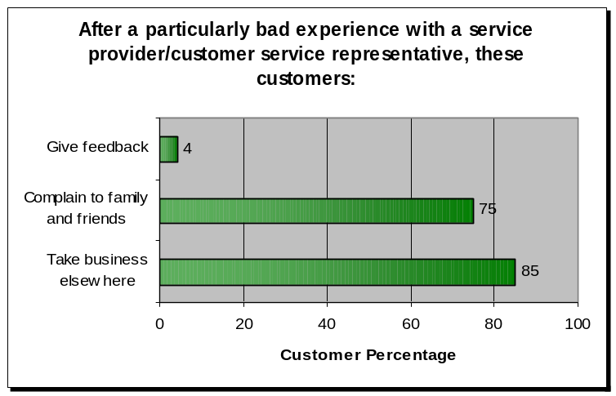
In today’s fast pace world two-income household have less time to spend together with family and friends. People are becoming impatient consumers that would rather spend the small amount of free time at home. Rather than waiting in line at a Best Buy, bank or other retailer.
Figure 1
Consumers are having more and more problems with finding employees to assist with purchases, the lack of visible prices on products, and long checkout lines. Customers are leaving when they cannot find products or if a product is rearranged. This type of confusion hurts a retail store and its consumers due to the lack of information. Consumers in a retail environment are unaware of all of their options. This can cause a great deal of consumers to walk out the store without buying a single product.

A company needs for a consumer to give feed back, companies need to work hard to achieve any level of feedback. Good customer service today must work beyond presenting a postcard or any other form at the information desk. Only 4% of customers give feedback (refer to figure 1) after a particular bad experience. Companies will need a friendly open environment which customers can trust and feel something will be done. Retail companies need to constantly collect loyal customer feedback, making the complaints to work for the companies. This any type of feed back, whether good or bad, is the greatest asset when it comes to a retail company’s customer service.

3.0.1 Background

The general purpose of customer service is to enable a business to better manage their customers through the introduction of reliable systems, processes and procedures for interacting with customers, according to the definition. In today’s competitive retail business environment, a successful customer service strategy cannot be implemented by only installing and integrating a customer service software package on a kiosk. There has to be an approach to customer service problems from everything like hardware and the customer.

“Kiosks” can refer to self-service computing terminals as well as free standing systems in retail environments. There are many different types of interactive kiosks like a touch screen product displays interactive employee human resource information stations. Kiosks can be found in many growing number of industries like, retail, banking, food service, and parking services. The information kiosks and the Internet kiosk systems use similar software and hardware but perform different functions. The Information kiosks are designed to provide access to one or more applications, such as browsing a store’s catalog or learning about a product’s services. The Internet kiosk provides on-demand access to a wide variety of Web sites, email, and many feature like a typical personal computer. Currently the differences between the Information kiosks and the Internet kiosk systems are blurring, with new kiosk systems providing services of both types of kiosks. The Interactive part of the kiosks system is to provide a self-contained computing terminal that will allow access to on-demand information and transactions. With all these types of services many self-serving kiosks can support the real world examples like airport self-check-in systems, retail product locators, and bill pay terminals. A valuable component to a retail store is the customer service in the e-commerce area. Fortune 500 retailers are looking towards in-store kiosks as a way to meet the expectation that newly informed online customers bring in the store.

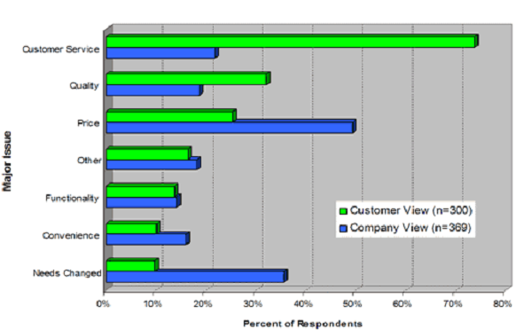
The customers want satisfaction which is an outcome derived from the performance or value of the product with their expectations of it. The saying that customers are satisfied when a product’s performance is above the customers’ expectation is proof. An example of how the perception of good customer service is a positive technique of improving sales is British Airways. They improved its sales and service by a company policy called “Putting People First”, which employees took the time to satisfy the customers needs first. A retail company can greatly benefit like British Airways when it has the goal to not just satisfy the customers but to go beyond the customers expectations. Companies are moving to automate some of their customer interactions, because personal customer service is expensive, and most employees can’t handle a lot of the tasks. Despite all the personal and technology it still can be difficult for large organizations to handle customers and there expectations.

3.0.2 Proposed Solution

Our proposed solution is to provide an in-store customer service terminal that will serve as an alternative source of knowledge and help for consumers.

The product will achieve the objectives of having a friendly customer interface. This is a personalized, tailored to the customers needs. The Automated Service Kiosk is menu driven to give the user-friendly interface a familiar feel to the software. One of the major characteristics will be the ability to display all available items in the store. This relates to the stock availability of a specific product. Along with the many other characteristics the software has the potential to produce a map of the store showing the desired product in a general location. If there is a need for a customer to compare product then ASK will compare the product and explain key terms, and give a quick overview of the product description. ASK will also notify the consumer of any sales or available coupons for a specific product the consumer might be interested purchasing. If there is a problem with any of the store employees, products, or the store itself the ASK terminal gives customers an outlet for voicing their in-store experiences. The ASK terminal provides an option to queue up for additional assistance from store associates.
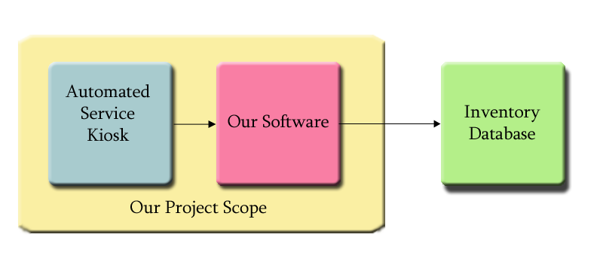
With the feature to display all the available items at a specific store or to notify a customer of product availability ASK will have to interface with an inventory database. The scope of our proposed solution (shown in figure 3) show that the Automated Service Kiosk terminal and the software developed by ASK will inter act with the specific stores database. To do this the ASK system consist of thin clients which are a client designed to be small so the bulk of the data processing occurs on the ASK terminals. The thin clients will connect though a local area network to the ASK server with the GUI and the Database interface, as shown in figure 4. The ASK server contains a internal inventory database that will update itself with the external server that belongs to the retail store. This will help the look up time, and any fault tolerance.

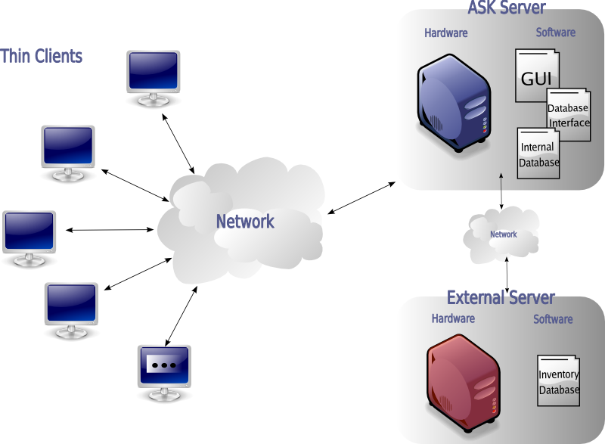

There are many software products that employ searchable inventory database systems. Some are very good but expensive its is our goal to create a system that to design a system that has the highest rank in usability and user friendliness. The most fundamental element of the inventory system and the most important is the database.

The ASK database will contain a copy of the stores inventory information that drives the stores retail business. A properly designed inventory database can be utilized in helping customers locate the products, compare the products and offer any customer incentives. The ASK database overview in figure 5, show how the inventory database interacts with the ASK database software. First, the inventory database will establish a connection with the ASK database integration software that connects to the ASK mysql database. The ASK kiosk uses the ASK interface software to connect to this mysql database. The predictive analysis that is part of the ASK software will interface with the stores inventory database to use variables like: product name, customer id, availability and location coupons to help the customer with all the needs of the customer.
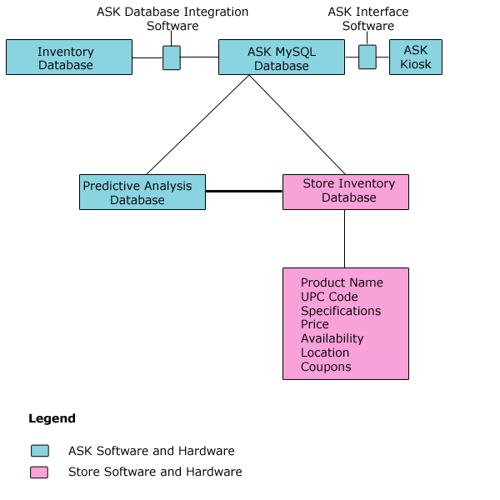

The customer shopping for a specific product can be limited to a certain amount of help. The customer can use the ASK terminal and will get a view of the main menu as shown to the left in figure #. The customer will have a choice to locate compare, or find a discount for a specific product. The customer can have the option to can two products in the store and this will cause the ASK terminal to interface with the databases to pull the information to help the customer make an informed decision.

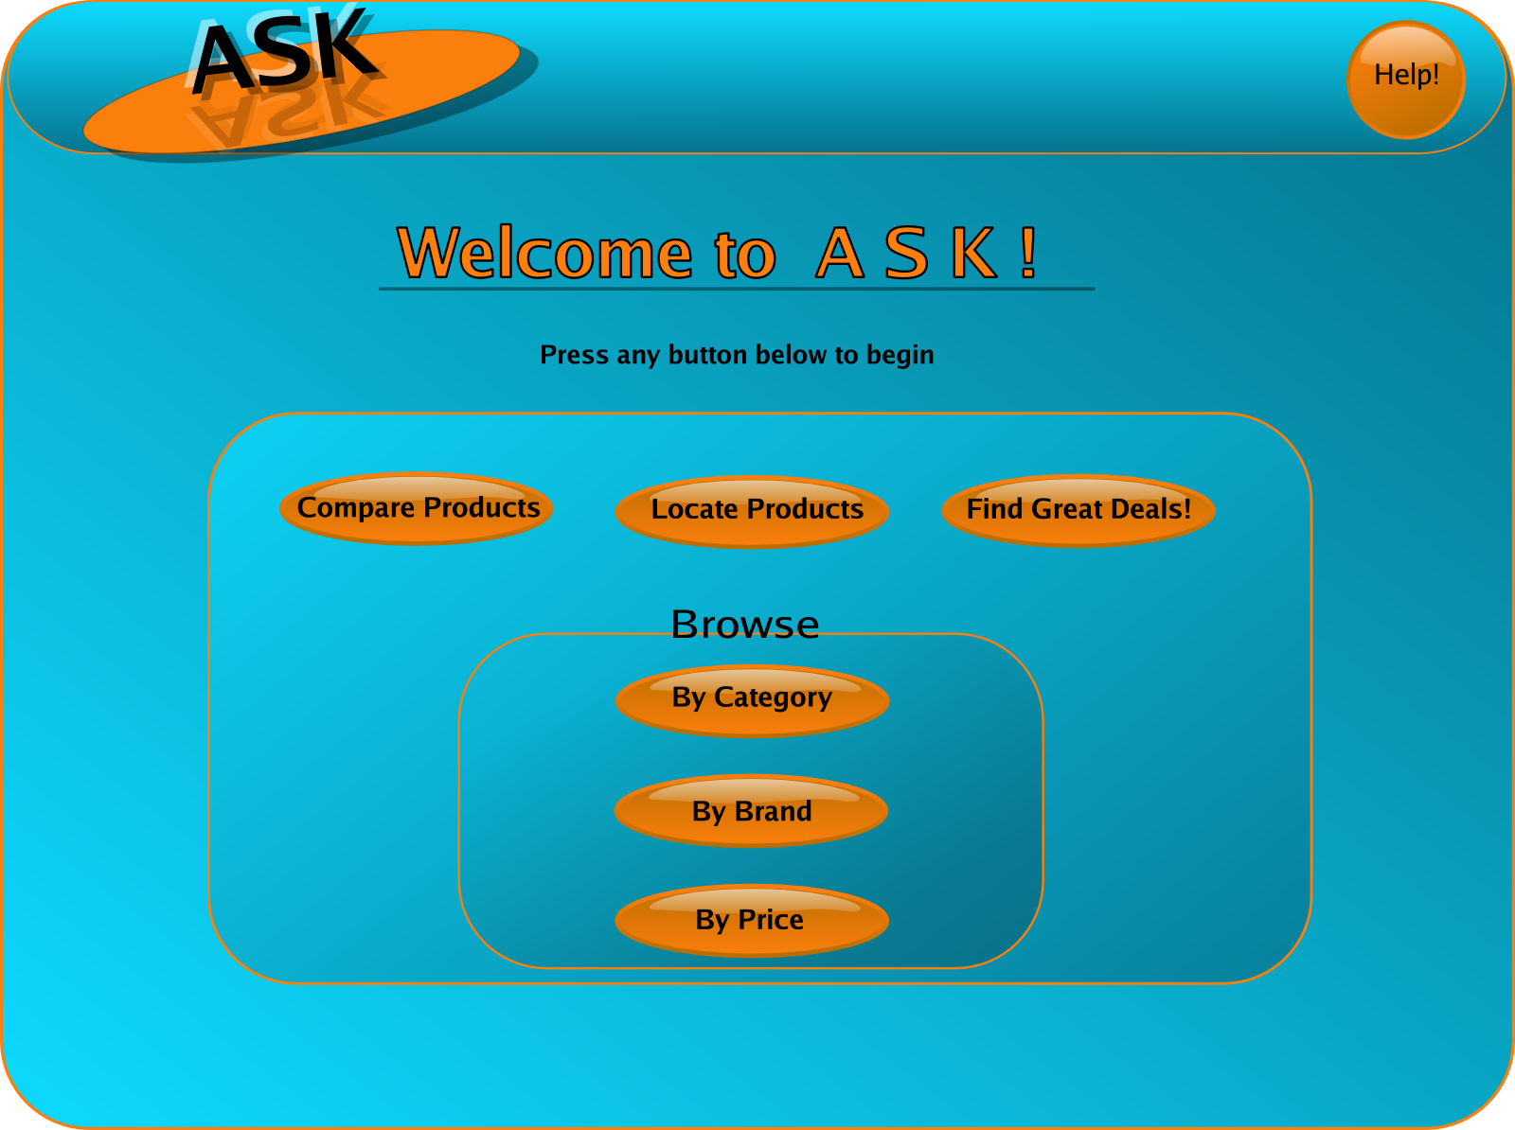

The figure below shows the GUI screen of what the comparison of two cameras and the information provide by the ASK software. The ASK terminal will provide two pictures of the products to be compared and below each of the specific products will list the specifications for each of them.

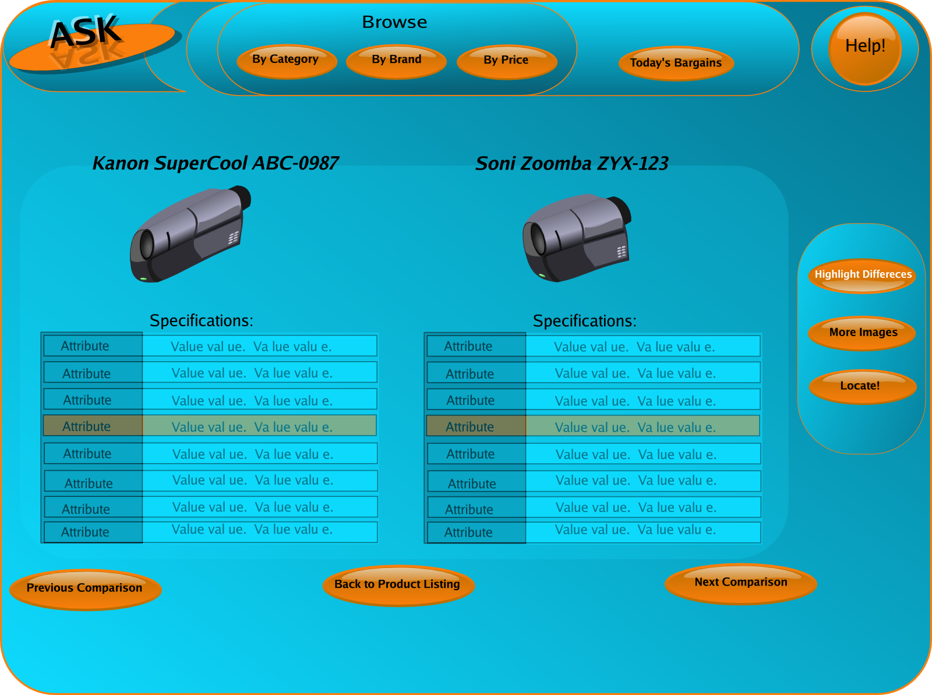

The location of each product will be displayed with a general map of the store and a reference point to where the customer is located. Once again ASK will display the product and the product name so the customer has the image of what they are looking to purchase.

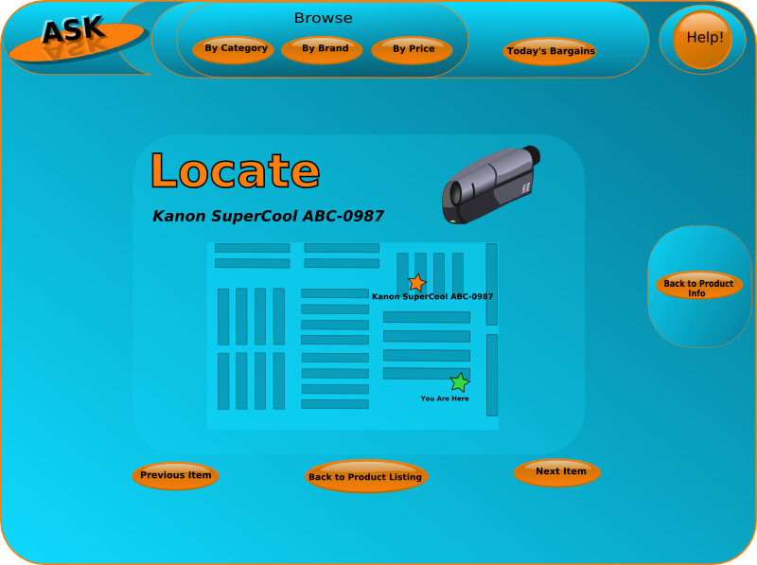

The great deals is to help the customer save money and some time by allowing the ASK software to use its predictive analysis features. This option will display some other products or ideas for the customer to use with the current selection by the customer.

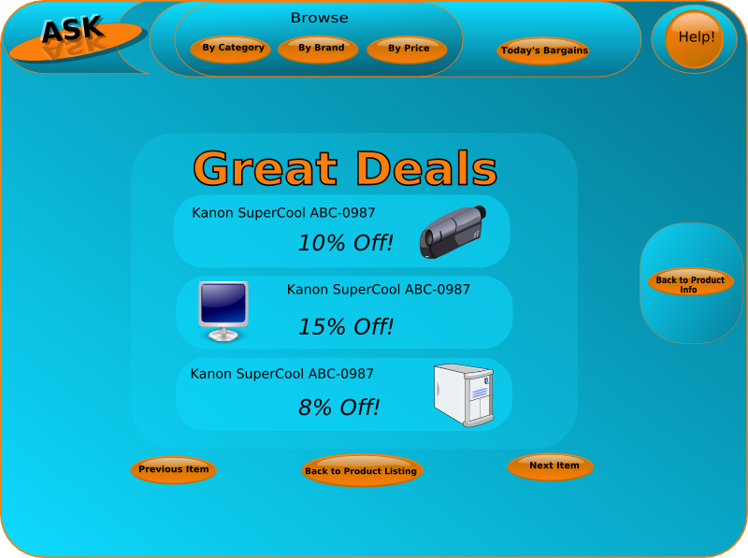

There is also a help and frequently asked question section to help the customer with terms and questions. This section will give general help to questions from a stored knowledge based articles located on the ASK server.

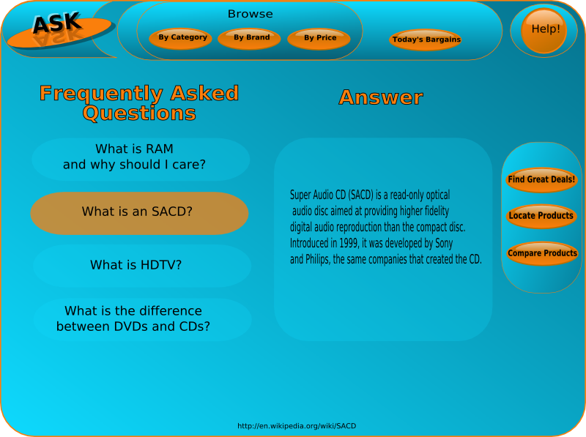

3.0.3 Public and Business Benefits

The advantages that kiosks with Automated Kiosks Service software bring to a retail company are significant and there has been an increasing amount of retail companies using different types of kiosks. There has been a recent surge in the use of interactive kiosks from a variety of businesses. The availability of Internet access helps provide kiosks users with a way to connect to store databases and other store terminals with a cost effective way. Today companies want to keep their customer because repeat customers spend 33% more than a new customer. By not holding on to the customers it will cost 6% more to a prospective customer than to an existing customer. Customer who have a good experience at a retail location with the help of an Automated Kiosks Service terminal are more likely to influence other customer up to 50 % as opposed to ads.

4.0 ASK Objectives and Goals

The goal of the Automated Service Kiosk is to provide the customers with an automated method of providing help and information to perspective customers. This main goal is to help companies save money and customer time. Management of time for customers is very valuable in today’s fast pace business world. There are many software products that employ searchable inventory database systems. Some are very good but expensive its is our goal to create a system that to design a system that has the highest rank in usability and user friendliness. ASK will be able to display all available itmes at a specific store and help customer by showing them what products are in the stock. ASK will help locat a specfic product for the customer and help compare two products for a customer to make a choice.

4.0.1 Phase 1 Technical Objective

The overall objective of the proposal is to develop the Automated Service Kiosks and data collection system for in-store customer service. The specific objectives are as follow is first to integrate existing inventory database into the Automated Service Kiosk knowledgeable data collection database systems. Second design a user friendly customer interface to make it easy and enjoyable for customers to use. Next design and organize queries to databases for product comparisons and search analyses this will help customers find other products that might be need for the customer to use with this product. Last is to create the ability to notify customers of rewards base on customers’ information.

4.0.3 Goal Milestones

Automated Service Kiosks intends the following goals to be completed by the conclusion of the project. ASK will submit a proposal to the National science Foundation to build a terminal with updates from inventory data. Design software that user-friendly for the in-store customer service kiosk based on the retail experts. Build a working lab prototype that meets a minimum system implementation will be designed, developed, constructed, and tested. Land a contract with Best Buy, or another retail chain, is a must for this product to be successful. This would involve a significant amount of work on the part of the software engineers to both build easy and user friendly friendly interface.

5.0 SBIR proposal

Automated Service Kiosks will submit a proposal to the National Science Foundation to build a sophisticated customer service kiosk terminal with inventory data recording. The writing of this proposal will be of special importance as the SBIR grant will provide the necessary funding to begin designing the system.

6.0 SBIR grant

The grant money that is received will be used to build the finest and best customer service terminal on the market. The grant money will be dispersed over two primary phases, which are the feasibility and design. First will be the feasibility development and system design phase. After that will come the system development and implementation phase which will conclude with a full working prototype that has undergone testing.

7.0 System Software

The Automated Service Kiosk team will design software for the in-store customer service kiosk based on the recomendations of retail experts and customer surveys. Included in this is the goal of designing an user friendly and easy to use GUI that will aid any person trying to retrieve data from the Automated Service Kiosk terminal.

8.0 System Hardware

Database and Network engineers will be employed to design the system including the kiosk interface with the existing store’s inventory database system. Major goals would include a working prototype and design plans for the finished, fully implemented system.

9.0 Lab Prototype

A working lab prototype that meets a minimum system implementation will be designed, developed, constructed, and tested.

10.0 Contract with Best Buy

A contract with Best Buy, or another retail chain, is a must for this product to be successful. This would involve a significant amount of work on the part of the software engineers to both build easy and user friendly friendly interface.

11.0 Phase I Work Plan

Phase 1 requires development of the system to a level that proves feasibility. Proof of feasibility is required for SBIR Phase 2 funding. Automated Service Kiosk will prove feasibility by providing a system that will simulate the concept of the in-store customer service system. This data will then be stored on a simplified server for later analysis by other store managers. A basic view of the data will be provided to prove the data is collected and validation.

The following System aspects will be validated as feasible in a lab environment. The collection of inventory data used to update and locate products for customers. The ability to analyze data and the quarries submitted by customers for predictive analysis. This will also help with the management reports on retail so that managers can make better informed decisions.

11.1 Collection of Data

The Automated Service Kiosk will collect data from the user to then access the correct database table to point to dynamic files for product information. ASK will collected inventory updates to load in to the database to access correct real-time data.

11.2 Analysis of Data

The analysis of the queries and hits submitted by consumers will be analyze for management reports on retail stock. This data can be used to better serve the consumer with quicker and more efficient advise.

11.3 Notification

The output of the data collected and analyzed will be either a coupon for the consumer based on the information provide and suggested product algorithms. The second type of out put can be a product comparison for a consumer to decide which is the deal for that particular product.

11.4 Storage of Data

Data will have to be stored on the ASK server because the interface with the stores inventory database will not be written to its tables. Any updates will be written to the ASK server and can be verified by an administrator for the correct information.

11.5 View Data

The data will be available for customers to view when they enter specific products to be search by the database. Customer will not have the ability to search though table of products. There will be a way for customers to search though a list of known products in the store to see if the specific product is available in stock.

11.6 Phase I Overview

In phase I ASK will need to prove that a initial prototype can be created. Phase I plan deals with creating the prototype to prove the concept of ASK. The ASK developers need to only prove that it can be achieve. ASK will prove that the objectives can be reached by research the current problems with customer service and how to automated them. Next to design a user friendly interface that is interactive with the customers. Then to integrate the software with the stores inventory database.

11.6.1 Prototype Conceptual Overview

The A.S.K. system can be prototyped during phase 1 of the SBIR process. This prototype will be a lab prototype to prove the concept of the system. The following items are required for the system and then followed by a brief description:

- Database system
- Kiosk (laptop)
- Software

Each of these components will be required for the prototype. Following is a brief description of each component.

- Database system
  - Item description, availability, location…
- Kiosk (laptop)
  - Hardware necessary to hold our software
- Software
  - Really simple software prototype showing basic item description and location.

11.6.3 Phase 1 Prototype Diagram

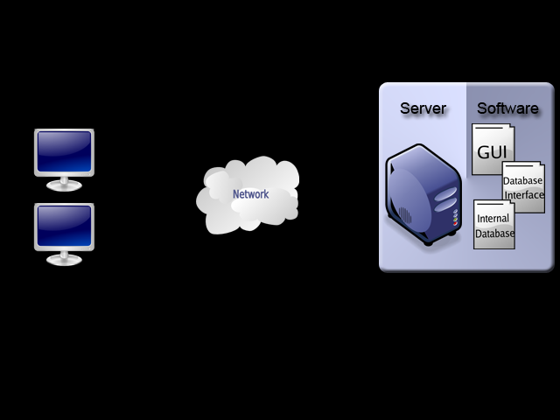

11.6.4 Related Research

For the ASK system to be both completely functional and efficient, a large quantity of research must be done. This section explains what research and why must be done in order to achieve the perfect solution.

User interface: As with all software, a user-friendly interface is a necessity. Research must be done to (a) determine the most effective and efficient layout for the GUI, to (b) alleviate problems non-technologically savvy users might encounter, to (c) provide an easy-to-read interface, and to (d) allow for ease of navigation. All of these areas will require research in order to provide our customers the best product available. Obviously, some of the research required will not be conducted until beta testing and even into Phases 2 and 3 when our product is live. We will accommodate our software and hardware to reflect the required changes deemed by research results. We will also have the availability of a user-input section in the ASK system for consumer insight as to how we can improve the ASK experience.

Database Interface: One of the largest risks of the ASK project is interfacing with an existing database. Research into current database structure and hierarchy will have to be done in order to ensure a time and operationally efficient database interface. Hands-on cooperation from the customer will be required, as will access to their inventory database(s). Since each company we target will have a different database structure, individual interfaces will be required, and thus research into the needs of the customer will be a necessity. Assuming customers will allow us access to their databases (not doing so would result in a failure of our system’s full potential), we can collaborate with them to provide the most efficient solutions.

Product Placement: One of the more simple research areas will be that of product in-store placement. The desired positions will be determined by both historical data and real-time information per store. Optimal locations will be in high-traffic areas but not so as to hinder tore movement. Clear advertisement in store will be required, with the use of posters and arrows or bright flashing lights. Since the kiosks will most likely be relatively small, store customers will need to be able to easily find and navigate a rout to a close kiosk. This will require research independent to each store since layouts and traffic flow vary greatly, and will be conducted both prior to and after store installment. The ability to maneuver kiosks around store with relative ease will help in this area of research.

Key Personnel

Mylene Cover – Project Manager

Mylene Cover is a full-time student at Old Dominion University. Mylene is a senior Computer Science major and intends to purse a MBA upon graduation. Prior to the fall semester in 2005 Mylene worked at the NASA's Goddard Space Flight Center in Greenbelt, MD. Mylene's experiences while working both at ODU and NASA have provided her with the necessary skills to be an awesome project manager for the A.S.K. team.

Scott Washburn – Software Engineer//Documentation Specialist

Scott Washburn is pursuing a major in Computer Science at Old Dominion University and a minor in Computer Engineering. Scott has gained much needed software experience working with the Old Dominion University Computer Science department's system group. Scott has a vast amount of experience and knowledge in this work environment, so he is clearly the best choice for the Software Specialist for A.S.K. In his spare time, Scott enjoys playing eighteen holes of golf in many local tournaments. Scott is currently on tour with the Micro Tour of Virginia where he was once in the top five scorers until injuries.

Enrique Polanco – Marketing Specialist

Enrique Polanco is a senior at Old Dominion University majoring in Computer Science. With a background in the international community Enrique is the number one choice for the marketing expert. Enrique is from Zaragoza, Spain. Enrique's future plans include first finishing his degree at ODU then continuing his education in graduate school.

Jared Miller – Technical Specialist

Jared Miller is a Computer Science major out of Virginia Beach. Jared plans to graduate in May 2007 with a Bachelor's Degree in Computer Science. Currently, Jared works for General Dynamics through the ODU Research Foundation. As an experienced programmer and researcher, Jared has the skills to handle the financial lead on the A.S.K

Keegan Morrison – Web Designer

In his third year as a Computer Science Major, Keegan Morrison works for Oceanography and is a Systems Administrator for the Old Dominion Computer Science Department. Keegan plans on going on to graduate school to pursue a doctorate in Oceanography. This and his continuous work at Systems give him the experience for the Web Master and the Hardware Specialist.

Janet Brunelle
Project Manager, Old Dominion University Computer Science

Dennis Ray
Software Expert, Old Dominion University Computer Science

Dr. Larry Filer
Marketing Expert, Old Dominion University College of Business

Relationship with Future Research and Development

Future research will provide massive insight into possible improvements of many aspects of the ASK system. If the product is accepted, consumers who use it will be able to provide feedback directly to an ASK terminal, which will let developers know what they think about the software, placement, and overall design.

It will also provide detailed information about store layout and ASK terminal placement. Less used terminals might be relocated to more high-traffic areas where current terminals do not exist. Though some research can be done pre-production, the most valuable data will come from analysis of terminal use.

Additionally, as stores’ databases improve, expand, and become more detailed, necessary adaptations will be made to the integration software so as to alleviate stress and reduce query time.

Facilities Phase I

Identify the facilities to be used at each performance site listed and, as appropriate, indicate their capacities, pertinent capabilities, relative proximity, and extent of availability to the project. Use “Other” to describe the facilities at any other performance sites listed and at sites for field studies. Use additional pages if necessary.

Laboratory: ODU CPI Department / Computer Science Department
Capabilities: All hardware / testing development
Proximity: on site
Availability: 24 hours a day

Clinical: None

Animal: None

Computers: In addition to ODUCS labs, all equipment is indicated in the Hard Resources section, divided by phase.
Capabilities: All software development
Proximity: on site
Availability: 24 hours a day

Office: Old Dominion University OCCS
Capabilities: All administrative/marketing work
Proximity: On-Site
Availability: 14 hours / day

Consultants

Professor Dennis Ray: Professor Dennis Ray of the Old Dominion University Computer Science received his Bachelors of Science in Marine Engineering in 1964 from the United States Naval Academy in Annapolis, MD. After that, he proceeded on to the United States Naval Postgraduate School in Monterey, CA, from where he received his MS in Computer Science. Professor Ray has taught at Old Dominion University for over 20 years, expressing interest in many subsidiaries of Artificial Intelligence, explicitly Expert Systems, Robotics, Computer Aided Education, and Vision Processing.
Professor Ray has provided much insight into many facets of Phase 0 of our project. Offering assistance from conception to the final presentation and nearly every point in between, he has shaped the ASK product into a feasible idea. He has provided insight into the project such that without it, the feasibility proof might not have come around, and has played an integral part to our success.

Dr. Larry Filer - Professor Filer received his Ph.D. and M.A. in Economics from the University of Kentucky in August of 1999. He received his B.A. in Economics from Westminster College (PA) in 1995. He teaches courses in the graduate program in economics, including International Finance, Advanced Macroeconomic Theory and Econometrics III. He also teaches Money and Banking at the undergraduate level and is the director of the Old Dominion University Fed Challenge Team.
Dr. Filer, our Marketing expert, provided much insight into handling both the marketing and fiscal sides the ASK project. In interviews and meetings, we queried him for advice, which he readily gave. His assistance to the group has made ASK the success it is.

Potential Applications

There are many potential benefits for customers who purchase an ASK system. The primary research benefits are predictive and past analysis. The ASK offers logging and specific information pertaining to items consumers look at, and can compare that to what items they leave the store with. It can also provide inventory analysis, including ascertain of which items are getting searched for the most and which items stores don’t have enough of.

Other areas of possible application include improvement of store flow and layout. Strategically places ASK terminals can help stores manage flow better by tracking usage per terminal. If it is know that specific areas of the store are traveled less, alterations to the floor layout could be considered to alleviate low sales for specific departments.

Management Plan

Program Identification

This Program Management Plan (PMP) is for the Automated Service Kiosk (ASK). The program will deliver the ASK hardware, software and documentation for the Automated Service Kiosk. The Computer Productivity Initiative group is responsible for the integration, acceptance testing and training of the Total Computing Environment.

Program Management Overview

Execution of the Program will be performed in accordance with the processes defined by the set of planning documents. These documents include Program Management Plan*, Development Plan, Evaluation Plan, Marketing Plan, Scheduling Plan, Organizational Plan, Financial Plan and Risk Management Plan (see Figure 1). The responsibilities of the Program Team, the capabilities of the system, and the Program deliverables are detailed under the contractual provisions, as well as the Automated Service Kiosk group’s technical, management, and cost proposals.

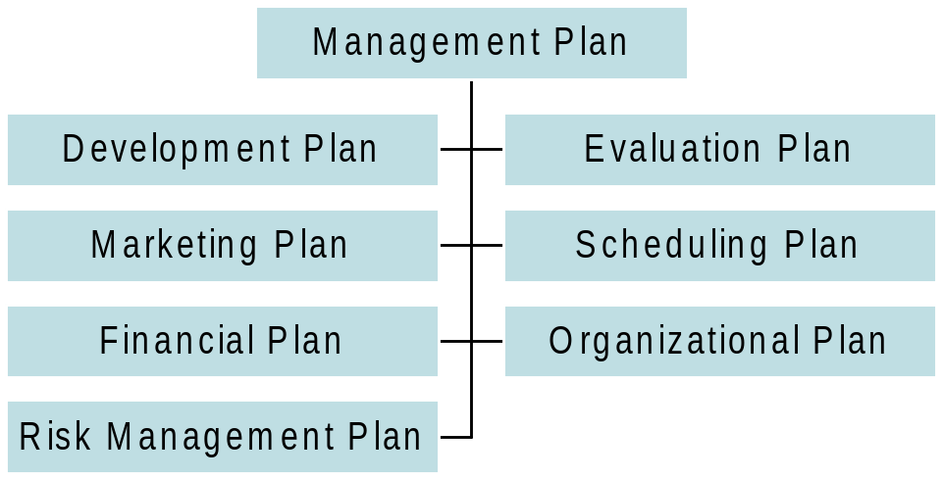

This Program Management Plan describes the management philosophy, program organization, schedule, and major milestones that serve as the guide for execution of the Program. The PMP also provides the customer and the quality team with the information they need to monitor and evaluate the progress of the effort. This plan provides the following pertinent information:

- Corporate Organization
- Program Team Organization With Areas of Responsibility
- Work Breakdown Structure
- Program Planning
- Progress Reporting and Team Management
- Detailed Program Schedule and Milestones

The Program Management Plan provides guidance for the content and execution of the following plans:

- Risk Management
- Financial
- Evaluation
- Development

Corporate Structure

The entirety of the Computer Productivity Initiative supports the Automated Service Kiosk Program. The Computer Productivity Initiative was started in 1995 by Old Dominion University under a grant by the National Science Foundation to give Computer Science students the opportunity to develop solutions to real world problems. Students would utilize the knowledge that they had gained in their undergraduate Computer Science program. The following is the Computer Productivity Initiative Automated Service Kiosk Corporate Organizational Structure:
- Old Dominion University.
- General Manager, Computer Productivity Initiative.
- Automated Service Kiosk Program Office. Automated Service Kiosk Program Office will execute the program and provide day-to-day senior management supervision, management, engineering, and administrative resources necessary to manage and administer the Automated Service Kiosk program.

Management Approach

The Automated Service Kiosk group’s management goal is to work closely with the customer to fully understand the system requirements and field a system that meets those requirements. The management approach to executing contracts at ASK is based on the philosophy that successful Programs are delivered by goal-oriented teams. A Program Manager (PM) will lead the Automated Service Kiosk team. The PM is responsible for all planning, programmatic, technical and financial aspects of the Program. The PM is the primary Point of Contact (POC) for the customer. The primary duties include supervision of all planning, scheduling, financial, and technical activities, and customer liaison. The PM is responsible for all Program-related decisions and commitments with approval, as required from the Corporate Management Team.

A key element of the Automated Service Kiosk group’s program management approach is to be directly involved with the customer in every step of the process. The ASK team encourages the customer to retain an active role in monitoring the program effort from proof of concept, to critical design, and continuing into production and the out years. The customer is encouraged to discuss technical details directly with members of the Program team, provide planning and schedule recommendations, and assist in resolution of technical and programmatic issues. In order to facilitate customer involvement, the ASK group will provide access to program information including, but not limited to:
- Program Plan and Schedules
- Program Status
- Profit
- Formal Review Material
- System Drawings and Documentation

Program Team

The Program Team is committed to provide the best value by delivering real world solutions utilizing advanced easy-to-use, low risk solutions at the lowest cost. This commitment is attainable because it is based on the re-use of existing technology that is field proven. Through strategic teaming and an extensive system selection process, the Computer Productivity Initiative has assembled a cohesive Program Team that is experienced with the implementation of each component that will comprise the Automated Service Kiosk Total Ship Computing Environment.

Project Manager

Overall management responsibility for the ASK is assigned to a Project Manager who is responsible for planning and coordination of the day-to-day aspects of the program. He is responsible for making sure the tasks are evenly distributed and that each of the team members is playing a vital role in the main project goal. His principal assistants are:
- Documentation Specialist. The DS provides overall direction for the documentation that is required for the ASK. The DS will ensure that everyone on the team has met the required documentation specifications, and that each person is aware of the tasks he/she has been assigned.
- Financial Specialist. The FS works in coordination with the rest of the team to devise a specific and schedule based budget plan, that will be reviewed by each of the team members and approved by both the PM and the customer.
- Hardware Specialist. The HS is responsible for making sure the team has full and complete knowledge of all the technical aspects of the problem’s solution. The HS researches what technology is available and what technologies are feasible to work with. The HS will also work in parallel as a liaison to outside sources that will offer insight into those areas that team members do not have relevant knowledge.
- Software Specialist. The SS is responsible for managing the creation of the major functional software components in the ASK program. He will ensure that each component meets the specification requirements. He is responsible for the development of system specifications, system design documents, interface documents, test plans, and procedures.
- Marketing Specialist. The MS is responsible for developing a marketing plan which includes the specification of an initial target market. The MS is responsible for the development of an in-depth plan on how to advertise and sell the ASK program to the specified target market.
- Web Master. The WM is responsible for the creation and maintenance of a product website which will include the display of all relevant documents and presentations. The WM will update the website on a weekly basis as new documents and milestones are reached.

Program Duration

The Automated Service Kiosk program is a project that is planned to span exactly 1148 working days. The program is divided into four phases. Phase 0 is conception of the project and will last 74 working days. Phase 1 is Proof of Concept where a lab prototype will be built along with the creation of several documents including a user’s manual. Phase 1 will last for 103 working days. Phase 2 is the Critical Design phase, where the program will develop and prepare the Automated Service Kiosk for the final phase. Phase 2 will last 522 working days. Phase 3 is considered to consist of producing a final product for sell to the target market. While Phase 3 will last 438 working days, it is understood that Phase 3 is production and out years which means the program will review its current state and plan for the future implementations and support.

Work Breakdown Structure

The program Work Breakdown Structure (WBS) reflects the budgeted cost versus resources required to complete each task. The WBS phase numbers are integrated as part of the master program schedule. Assuming the funding of SBIR, the budget is carefully planned out against the set deadlines set by SBIR proposal guidelines. The budgets are created by the Financial Planner, reviewed by the ASK program and set by the Program Manager. The WBS will be used to mark the different milestones throughout the phases and to make sure the team is on time and under budget at every possible mark. The WBS management tool that ASK will use is Microsoft Project.

Phase 0
ID | Name | Duration | Start | Finish
1 | Automated Service Kiosk | 79.d | 8/29/2005 8:00 | 12/15/2005 17:00
2 | Conception | 75.d | 8/29/2005 8:00 | 12/9/2005 17:00
3 | Develop Project Team | 3.d | 8/29/2005 8:00 | 9/1/2005 0:00
4 | Determine Team Members | 1.d | 8/31/2005 8:00 | 8/31/2005 17:00
5 | Define Group Meeting Times | 1.d | 8/31/2005 8:00 | 8/31/2005 17:00
6 | Determine Project | 2.d | 9/13/2005 15:00 | 9/15/2005 15:00
7 | Define Project | 7.d | 9/15/2005 8:00 | 9/25/2005 0:00
8 | Define Problem | 1.d | 9/13/2005 8:00 | 9/13/2005 17:00
9 | Define Objectives/ Goals | 1.d | 9/13/2005 8:00 | 9/13/2005 17:00
10 | Initial Research | 5.d | 9/13/2005 8:00 | 9/19/2005 17:00
11 | Determine Initial Solution | 2.d | 9/20/2005 8:00 | 9/22/2005 0:00
12 | Determine Solution Characteristics | 1.d | 9/23/2005 8:00 | 9/23/2005 17:00
13 | Planning | 28.d | 9/19/2005 8:00 | 10/27/2005 0:00
14 | Design | 5.d | 9/20/2005 8:00 | 9/27/2005 0:00
15 | Determine Project Manager | 2.d | 9/13/2005 8:00 | 9/15/2005 0:00
16 | Determine Initial Features of Terminal | 3.d | 9/26/2005 8:00 | 9/29/2005 0:00
17 | Marketing | 1.d | 9/26/2005 8:00 | 9/27/2005 0:00
18 | Determine Marketing Director | 1.d | 9/23/2005 8:00 | 9/24/2005 15:00
19 | Determine Poll Questions | 50.d | 9/26/2005 8:00 | 12/2/2005 17:00
20 | Determine Initial Target Market | 1.d | 9/23/2005 8:00 | 9/25/2005 15:00
21 | Financial | 1.d | 9/23/2005 8:00 | 9/25/2005 0:00
22 | Determine Financial Director | 1.d | 9/23/2005 8:00 | 9/24/2005 15:00
23 | Determine Target Price Point | 1.d | 9/28/2005 8:00 | 9/28/2005 17:00
24 | Technical | 16.d | 9/23/2005 8:00 | 10/15/2005 0:00
25 | Determine Technical Director | 1.d | 9/23/2005 8:00 | 9/26/2005 0:00
26 | Determine Experts Needed | 2.d | 9/23/2005 8:00 | 9/27/2005 0:00
27 | Obtain Experts | 2.d | 9/5/2005 8:00 | 9/7/2005 0:00
28 | Risks | 3.d | 9/23/2005 8:00 | 9/28/2005 0:00
29 | Determine Risk Director | 1.d | 9/26/2005 8:00 | 9/26/2005 17:00
30 | Communication | 13.d | 8/30/2005 8:00 | 9/16/2005 0:00
31 | Get Initial Website Requirements | 2.d | 9/2/2005 8:00 | 9/6/2005 0:00
32 | Create Team Website | 11.d | 9/2/2005 8:00 | 9/18/2005 0:00
33 | Create Forum | 2.d | 9/15/2005 8:00 | 9/16/2005 18:00
34 | Initial Research | 48.d | 9/14/2005 8:00 | 11/20/2005 0:00
35 | Design | 5.d | 9/12/2005 8:00 | 9/18/2005 0:00
36 | Determine Features of A.S.K.Terminal | 2.d | 9/22/2005 8:00 | 9/24/2005 0:00
37 | Determine What Features Competitors are Offering | 3.d | 9/22/2005 8:00 | 9/27/2005 0:00
38 | Marketing | 6.d | 9/23/2005 8:00 | 10/3/2005 0:00
39 | Determine Potential Market | 2.d | 9/14/2005 8:00 | 9/16/2005 0:00
40 | Competition | 3.d | 9/14/2005 8:00 | 9/18/2005 0:00
41 | Determine if Project Already Exists | 2.d | 9/14/2005 8:00 | 9/16/2005 0:00
42 | Determine Competitors | 1.d | 9/30/2005 8:00 | 10/2/2005 0:00
43 | Create Competition Matrix | 1.d | 9/30/2005 8:00 | 10/2/2005 0:00
44 | Run Forum | 2.d | 9/15/2005 8:00 | 9/18/2005 18:00
45 | Analyze Forum Results | 3.d | 9/21/2005 8:00 | 9/23/2005 17:00
46 | Technical | 9.d | 9/19/2005 8:00 | 9/30/2005 0:00
47 | Determine Potential Solutions | 15.d | 9/23/2005 8:00 | 10/14/2005 0:00
48 | Financial | 3.d | 9/30/2005 8:00 | 10/5/2005 0:00
49 | Determine Initial Product Costs | 2.d | 9/30/2005 8:00 | 10/4/2005 0:00
50 | Determine Protential Profit | 2.d | 11/3/2005 8:00 | 11/6/2005 0:00
51 | Risks | 6.d | 10/14/2005 8:00 | 10/23/2005 0:00
52 | Determine Risks | 4.d | 10/14/2005 8:00 | 10/20/2005 0:00
53 | Determine Risk Mitigation Plan | 4.d | 10/31/2005 8:00 | 11/4/2005 0:00
54 | Communication | 22.d | 10/28/2005 8:00 | 11/29/2005 0:00
55 | Create Team Website | 23.d | 9/19/2005 8:00 | 10/20/2005 0:00
56 | Create Look and Feel | 9.d | 9/19/2005 8:00 | 9/30/2005 0:00
57 | Add Links | 5.d | 9/23/2005 8:00 | 9/30/2005 0:00
58 | Add Content | 11.d | 9/23/2005 8:00 | 10/10/2005 0:00
59 | Feasibility Presentation | 7.d | 10/24/2005 8:00 | 11/2/2005 0:00
60 | Create Slides for Presentation | 5.d | 10/25/2005 8:00 | 10/31/2005 17:00
61 | Feasibility Presentation | 1.d | 11/2/2005 8:00 | 11/2/2005 17:00
62 | Plan Phases | 37.d | 9/12/2005 8:00 | 11/2/2005 0:00
63 | Planning | 6.d | 11/1/2005 8:00 | 11/8/2005 17:00
64 | Create WBS | 4.d | 11/8/2005 8:00 | 11/13/2005 17:00
65 | Determine Tasks | 2.d | 11/8/2005 8:00 | 11/10/2005 0:00
66 | Determine Resources | 2.d | 11/8/2005 8:00 | 11/10/2005 0:00
67 | Determine Task Dependencies | 2.d | 11/9/2005 8:00 | 11/11/2005 0:00
68 | Assign Resources to Tasks | 2.d | 11/9/2005 8:00 | 11/11/2005 0:00
69 | Level Resources | 2.d | 11/10/2005 8:00 | 11/11/2005 17:00
70 | Determine Overhead Equipment | 2.d | 10/13/2005 8:00 | 10/16/2005 0:00
71 | Determine Non-Development Human Resources | 1.d | 10/14/2005 8:00 | 10/17/2005 0:00
72 | Design | 1.d | 9/30/2005 8:00 | 10/3/2005 0:00
73 | Determine A.S.K. Initial Features | 2.d | 10/31/2005 8:00 | 11/2/2005 0:00
74 | Create Requirements Document | 2.d | 10/31/2005 8:00 | 11/2/2005 0:00
75 | Technical | 12.d | 10/27/2005 8:00 | 11/12/2005 0:00
76 | Determine A.S.K. Hardware | 3.d | 10/27/2005 8:00 | 11/1/2005 0:00
77 | Determine A.S.K. Software | 2.d | 10/31/2005 8:00 | 11/2/2005 0:00
78 | Determine Prototype Software Platform | 2.d | 11/2/2005 8:00 | 11/4/2005 0:00
79 | Determine Terminal Software Platform | 2.d | 11/2/2005 8:00 | 11/4/2005 0:00
80 | Determine Server/Database Hardware Platform | 2.d | 11/3/2005 8:00 | 11/5/2005 0:00
81 | Determine Prototype Hardware Platform | 2.d | 11/4/2005 8:00 | 11/7/2005 17:00
82 | Determine Production Hardware Platform | 2.d | 11/3/2005 8:00 | 11/5/2005 15:00
83 | Determine Server/Database Hardware | 2.d | 11/7/2005 8:00 | 11/8/2005 17:00
84 | Determine Prototype Software Platform | 2.d | 11/3/2005 8:00 | 11/6/2005 0:00
85 | Determine Production Software Platform | 1.d | 11/4/2005 8:00 | 11/6/2005 0:00
86 | Determine Server Load | 1.d | 11/4/2005 8:00 | 11/7/2005 0:00
87 | Determine Thin Client Software | 2.d | 11/3/2005 8:00 | 11/7/2005 0:00
88 | Financial Plan | 5.d | 10/31/2005 8:00 | 11/6/2005 0:00
89 | Funding Agency | 2.d | 10/31/2005 8:00 | 11/2/2005 0:00
90 | Determine Funding Agency | 1.d | 11/1/2005 8:00 | 11/1/2005 17:00
91 | Get Required Docs for SBIR from Funding Agency | 1.d | 11/2/2005 8:00 | 11/2/2005 17:00
92 | Determine Product Costs | 1.d | 11/2/2005 8:00 | 11/2/2005 17:00
93 | Determine Human Resource Costs | 1.d | 11/2/2005 8:00 | 11/2/2005 17:00
94 | Determine A.S.K. Server Costs | 1.d | 11/2/2005 8:00 | 11/2/2005 17:00
95 | Determine Overhead Equipment Costs | 1.d | 11/2/2005 8:00 | 11/2/2005 17:00
96 | Determine Non-Development Human Resources Costs | 1.d | 11/2/2005 8:00 | 11/2/2005 17:00
97 | Perform Cash Flow Analysis | 1.d | 11/2/2005 8:00 | 11/2/2005 17:00
98 | Determine Break Even | 1.d | 11/2/2005 8:00 | 11/2/2005 17:00
99 | Assess Financial Feasibility | 1.d | 11/2/2005 8:00 | 11/2/2005 17:00
100 | Marketing | 5.d | 10/31/2005 8:00 | 11/5/2005 0:00
101 | Determine Target Markets | 1.d | 10/21/2005 8:00 | 10/23/2005 17:00
102 | Determine Marketing Plan | 4.d | 10/24/2005 8:00 | 10/27/2005 17:00
103 | Communication | 4.d | 10/21/2005 8:00 | 10/27/2005 0:00
104 | Team Website | 4.d | 11/1/2005 8:00 | 11/7/2005 0:00
105 | Document Postion/ Management/ Versioning Functionality | 3.d | 11/1/2005 8:00 | 11/4/2005 0:00
106 | Risk Mitigation Database | 3.d | 11/2/2005 8:00 | 11/5/2005 0:00
107 | SBIR | 11.d | 11/15/2005 8:00 | 11/29/2005 17:00
108 | Determine Requirements | 2.d | 10/28/2005 8:00 | 11/1/2005 0:00
109 | Assign SBIR Team Responsibilities | 2.d | 10/4/2005 8:00 | 10/6/2005 0:00
110 | MileStone Presentation | 5.d | 11/16/2005 8:00 | 11/22/2005 17:00
111 | Presentation | 4.d | 11/14/2005 8:00 | 11/17/2005 17:00
112 | Create Slides | 3.d | 11/10/2005 8:00 | 11/14/2005 17:00
113 | Features | 2.d | 11/10/2005 8:00 | 11/11/2005 17:00
114 | Marketing | 2.d | 11/10/2005 8:00 | 11/11/2005 17:00
115 | Financial | 2.d | 11/10/2005 8:00 | 11/11/2005 17:00
116 | Technical | 2.d | 11/10/2005 8:00 | 11/11/2005 17:00
117 | Risks | 2.d | 11/10/2005 8:00 | 11/11/2005 17:00
118 | Create Powerpoint Presentation | 2.d | 11/14/2005 8:00 | 11/16/2005 0:00
119 | Ensure Website is Up to Par | 2.d | 11/10/2005 8:00 | 11/14/2005 0:00
120 | Create Handouts | 2.d | 11/14/2005 8:00 | 11/16/2005 8:00
121 | Documentation | 7.d | 11/10/2005 8:00 | 11/20/2005 0:00
122 | Create Overview and Abstract | 2.d | 11/10/2005 8:00 | 11/13/2005 0:00
123 | Create Funding Plan | 2.d | 11/10/2005 8:00 | 11/13/2005 0:00
124 | Create Marketing Plan | 3.d | 11/9/2005 8:00 | 11/12/2005 0:00
125 | Create Risk Mitigation Plan | 2.d | 11/10/2005 8:00 | 11/13/2005 0:00
126 | Create Technical Plan | 3.d | 11/9/2005 8:00 | 11/12/2005 0:00
127 | Milestone Presentation | 1.d | 11/15/2005 15:00 | 11/16/2005 15:00
128 | Approval Presentation | 71.d | 9/23/2005 8:00 | 12/31/2005 17:00
129 | Improve Milestone Presentation | 4.d | 11/16/2005 8:00 | 11/22/2005 0:00
130 | Improve WBS | 3.d | 11/16/2005 8:00 | 11/19/2005 0:00
131 | Improve Financial Plan | 3.d | 11/16/2005 8:00 | 11/19/2005 0:00
132 | Improve Marketing Plan | 3.d | 11/16/2005 8:00 | 11/21/2005 0:00
133 | Improve Risk Mitigation Plan | 2.d | 11/17/2005 8:00 | 11/19/2005 0:00
134 | Improve Technical Plan | 3.d | 11/16/2005 8:00 | 11/19/2005 0:00
135 | Create SBIR | 11.d | 11/18/2005 8:00 | 12/3/2005 0:00
136 | Overview | 1.d | 11/18/2005 8:00 | 11/21/2005 0:00
137 | Abstract | 2.d | 11/18/2005 8:00 | 11/22/2005 0:00
138 | Objectives and Goals | 2.d | 11/18/2005 8:00 | 11/22/2005 0:00
139 | Approach | 2.d | 11/18/2005 8:00 | 11/22/2005 0:00
140 | Resources | 2.d | 11/18/2005 8:00 | 11/22/2005 0:00
141 | Human Resources | 2.d | 11/18/2005 8:00 | 11/22/2005 0:00
142 | Schedule | 2.d | 11/18/2005 8:00 | 11/22/2005 0:00
143 | Financial Plan | 2.d | 11/18/2005 8:00 | 11/22/2005 0:00
144 | Marketing | 3.d | 11/22/2005 8:00 | 11/25/2005 0:00
145 | Risk Mitigation Plan | 3.d | 11/22/2005 8:00 | 11/25/2005 0:00
146 | Evaluation Methods | 1.d | 11/18/2005 8:00 | 11/20/2005 0:00
147 | Create Project Website | 11.d | 11/24/2005 8:00 | 12/9/2005 0:00
148 | Determine Website Structure | 2.d | 11/24/2005 8:00 | 11/27/2005 0:00
149 | Determine Website Hardware | 2.d | 11/25/2005 8:00 | 11/29/2005 0:00
150 | Create Look and Feel | 4.d | 11/24/2005 8:00 | 11/30/2005 0:00
151 | Move Documents to Website | 3.d | 11/28/2005 8:00 | 12/1/2005 0:00
152 | Create Flash Intro | 3.d | 11/30/2005 8:00 | 12/4/2005 0:00
153 | Final Presentation | 17.d | 11/25/2005 8:00 | 12/19/2005 17:00
154 | Create Slides | 4.d | 11/29/2005 8:00 | 12/5/2005 0:00
155 | Features | 1.d | 12/2/2005 8:00 | 12/5/2005 0:00
156 | Marketing | 4.d | 12/2/2005 8:00 | 12/8/2005 0:00
157 | Financial | 3.d | 12/7/2005 8:00 | 12/11/2005 0:00
158 | Technical | 3.d | 12/7/2005 8:00 | 12/11/2005 0:00
159 | Risks | 4.d | 12/6/2005 8:00 | 12/10/2005 0:00
160 | Create Powerpoint Presentation | 2.d | 12/9/2005 8:00 | 12/13/2005 0:00
161 | Improve Website | 2.d | 12/9/2005 8:00 | 12/13/2005 0:00
162 | Create Handouts | 2.d | 12/14/2005 8:00 | 12/16/2005 0:00
163 | Final Presentation | 1.d | 12/12/2005 8:00 | 12/12/2005 17:00
164 | Postmortem | 3.d | 12/12/2005 8:00 | 12/15/2005 0:00
165 | Fillout Postmortem Questionaire | 3.d | 12/12/2005 13:00 | 12/15/2005 12:00
166 | Hold Postmortem Meeting | 1.d | 12/12/2005 8:00 | 12/12/2005 17:00
167 | Project Report / Lessons Learned | 2.d | 12/13/2005 8:00 | 12/14/2005 17:00
168 | SBIR Submission | 1.d | 12/12/2005 8:00 | 12/12/2005 17:00
169 | SBIR Phase 1 Approval | 1.d | 12/12/2005 8:00 | 12/12/2005 17:00

Phase 1
ID | Name | Duration | Start | Finish
1 | Start Phase 1 | 1.d | 12/13/2005 8:00 | 12/13/2005 17:00
2 | Phase1 | 110.d | 12/12/2005 8:00 | 5/13/2006 17:00
3 | Develop Project Team | 1.d | 12/16/2005 13:00 | 12/19/2005 12:00
4 | Identify New Team Members | 1.d | 12/16/2005 13:00 | 12/19/2005 12:00
5 | Reassign Responsibilties as Needed | 3.d | 12/19/2005 8:00 | 12/21/2005 17:00
6 | Get New Member to Sign Project Charter | 9.d | 12/20/2005 8:00 | 12/30/2005 17:00
7 | Planning | 1.d | 12/29/2005 13:00 | 12/30/2005 12:00
8 | Define Approach | 1.d | 12/29/2005 13:00 | 12/30/2005 12:00
9 | Define Group Meeting Times | 1.d | 12/29/2005 13:00 | 12/30/2005 12:00
10 | Determine Communication Methods | 2.d | 12/29/2005 8:00 | 12/31/2005 17:00
11 | Define Functional Level Requirements | 1.d | 12/29/2005 13:00 | 12/30/2005 12:00
12 | Define Functional Level Requirements | 28.d | 12/29/2005 8:00 | 2/6/2006 17:00
13 | Functional Requirements Document | 6.d | 12/30/2005 8:00 | 1/8/2006 17:00
14 | Determine Development Platform | 3.d | 12/30/2005 8:00 | 1/3/2006 17:00
15 | Client | 4.d | 1/3/2006 8:00 | 1/8/2006 17:00
16 | Server | 4.d | 1/6/2006 8:00 | 1/11/2006 17:00
17 | ASK | 1.d | 1/10/2006 13:00 | 1/11/2006 12:00
18 | Requirements | 3.d | 1/10/2006 8:00 | 1/12/2006 17:00
19 | Hardware | 2.d | 1/12/2006 8:00 | 1/14/2006 12:00
20 | Client | 2.d | 1/13/2006 8:00 | 1/16/2006 17:00
21 | Define Client Hardware Requirements | 1.d | 1/13/2006 13:00 | 1/16/2006 12:00
22 | Create Client Hardware Requirements Doc | 1.d | 1/13/2006 13:00 | 1/16/2006 12:00
23 | Server | 9.d | 1/17/2006 8:00 | 1/27/2006 17:00
24 | Define Server Hardware Requirements | 2.d | 1/25/2006 8:00 | 1/26/2006 17:00
25 | Create Server Hardware Requirements Doc | 2.d | 1/26/2006 8:00 | 1/28/2006 17:00
26 | ASK | 6.d | 12/20/2005 8:00 | 12/27/2005 17:00
27 | Define ASK Terminal Hardware Requirements | 3.d | 1/27/2006 8:00 | 1/31/2006 17:00
28 | Create ASK Terminal Hardware Requirements Doc | 2.d | 1/31/2006 8:00 | 2/1/2006 17:00
29 | Software | 13.d | 1/31/2006 8:00 | 2/16/2006 17:00
30 | Client | 2.d | 2/2/2006 8:00 | 2/5/2006 17:00
31 | Define Client Software Requirements | 11.d | 2/3/2006 8:00 | 2/19/2006 17:00
32 | Create Client Software Requirements Doc | 2.d | 2/8/2006 8:00 | 2/9/2006 17:00
33 | Server | 49.d | 12/20/2005 8:00 | 2/25/2006 17:00
34 | Define Server Software Requirements | 4.d | 2/8/2006 8:00 | 2/13/2006 17:00
35 | Create Server Software Requirements Doc | 2.d | 2/13/2006 8:00 | 2/14/2006 17:00
36 | ASK | 4.d | 12/20/2005 8:00 | 12/24/2005 17:00
37 | Define ASK Software Requirements | 9.d | 2/14/2006 8:00 | 2/25/2006 17:00
38 | Create ASK Software Requirements Doc | 4.d | 2/21/2006 8:00 | 2/24/2006 17:00
39 | Create Requirements Doc | 2.d | 2/27/2006 8:00 | 2/28/2006 17:00
40 | Setup | 2.d | 3/1/2006 8:00 | 3/2/2006 17:00
41 | Hardware | 2.d | 3/1/2006 8:00 | 3/2/2006 17:00
42 | Client | 2.d | 3/2/2006 8:00 | 3/5/2006 17:00
43 | Setup PCs | 2.d | 3/2/2006 8:00 | 3/4/2006 17:00
44 | Install OS | 7.d | 3/3/2006 8:00 | 3/13/2006 17:00
45 | Install Oracle Software | 7.d | 3/3/2006 8:00 | 3/13/2006 17:00
46 | Install Development Software | 5.d | 3/6/2006 8:00 | 3/10/2006 17:00
47 | Install Oracle Queue Client | 3.d | 3/6/2006 8:00 | 3/8/2006 17:00
48 | Server | 3.d | 3/7/2006 8:00 | 3/9/2006 17:00
49 | Setup PC | 7.d | 3/8/2006 8:00 | 3/16/2006 17:00
50 | Install OS | 4.d | 3/9/2006 8:00 | 3/14/2006 17:00
51 | Install Oracle Software | 2.d | 3/9/2006 8:00 | 3/12/2006 17:00
52 | ASK | 23.d | 12/20/2005 8:00 | 1/19/2006 17:00
53 | Setup PC | 21.d | 3/10/2006 8:00 | 4/9/2006 17:00
54 | Install OS | 9.d | 3/21/2006 8:00 | 3/31/2006 17:00
55 | Install Development Software | 5.d | 3/20/2006 8:00 | 3/25/2006 17:00
56 | Install Oracle Client | 12.d | 3/20/2006 8:00 | 4/4/2006 17:00
57 | Design | 6.d | 3/21/2006 8:00 | 3/28/2006 17:00
58 | Client | 5.d | 3/21/2006 13:00 | 3/28/2006 12:00
59 | Batch Process | 1.d | 3/22/2006 13:00 | 3/23/2006 12:00
60 | Module to Pull Oracle Records | 12.d | 2/28/2006 8:00 | 3/15/2006 17:00
61 | Module to Send Oracle Records to Queue | 5.d | 3/21/2006 13:00 | 3/28/2006 12:00
62 | Server | 3.d | 3/23/2006 13:00 | 3/28/2006 12:00
63 | Module to Retrieve Product Record from Oracle Database | 2.d | 3/24/2006 8:00 | 3/27/2006 17:00
64 | Module to Format Product Record from Oracle Database | 2.d | 3/24/2006 8:00 | 3/27/2006 17:00
65 | Module to Populate Product Record from Oracle Database | 2.d | 3/24/2006 8:00 | 3/27/2006 17:00
66 | ASK | 2.d | 12/21/2005 8:00 | 12/22/2005 17:00
67 | Batch Process | 2.d | 3/23/2006 8:00 | 3/25/2006 12:00
68 | Module to Retrieve Product Information from Queue | 2.d | 3/27/2006 8:00 | 3/28/2006 17:00
69 | Module to Write Product Information to File | 2.d | 3/27/2006 8:00 | 3/28/2006 17:00
70 | Module to Retrieve Product Information from Queue | 3.d | 3/27/2006 8:00 | 3/29/2006 17:00
71 | Module to Write Product Information to File | 2.d | 3/28/2006 8:00 | 3/29/2006 17:00
72 | Real Time ASK | 2.d | 3/28/2006 8:00 | 3/29/2006 17:00
73 | GUI Screen | 11.d | 3/28/2006 8:00 | 4/11/2006 17:00
74 | Module for Menu Control | 4.d | 3/28/2006 8:00 | 3/31/2006 17:00
75 | Module to Read Product Information from File | 4.d | 3/28/2006 8:00 | 4/1/2006 17:00
76 | Module to Compare Product Information | 4.d | 3/28/2006 8:00 | 3/31/2006 17:00
77 | Module for ASK Search | 3.d | 3/29/2006 8:00 | 3/31/2006 17:00
78 | Module for Displaying Advertisement | 2.d | 3/31/2006 8:00 | 4/3/2006 17:00
79 | Module to Display Product Information | 2.d | 3/30/2006 8:00 | 4/1/2006 12:00
80 | Create Design Documents | 2.d | 3/30/2006 8:00 | 4/1/2006 12:00
81 | Development | 2.d | 4/3/2006 8:00 | 4/4/2006 17:00
82 | Client | 2.d | 4/3/2006 8:00 | 4/4/2006 17:00
83 | Batch Process | 2.d | 4/4/2006 8:00 | 4/5/2006 17:00
84 | Module to Pull Oracle Database Records | 2.d | 4/5/2006 8:00 | 4/6/2006 17:00
85 | Module to Send Product Information to Queue | 3.d | 4/5/2006 8:00 | 4/8/2006 17:00
86 | Unit Test Batch Process | 4.d | 4/6/2006 8:00 | 4/11/2006 17:00
87 | Server | 2.d | 4/11/2006 8:00 | 4/12/2006 17:00
88 | Module to Retrieve Product Information from Oracle Database | 1.d | 4/11/2006 13:00 | 4/12/2006 12:00
89 | Module to Format Product Information for Queue | 1.d | 4/11/2006 13:00 | 4/12/2006 12:00
90 | Module to Populate Queues With Product Information | 1.d | 4/11/2006 13:00 | 4/12/2006 12:00
91 | Unit Test Server Process | 1.d | 4/12/2006 13:00 | 4/13/2006 12:00
92 | ASK | 1.d | 4/12/2006 13:00 | 4/13/2006 12:00
93 | Batch Process | 1.d | 4/12/2006 13:00 | 4/13/2006 12:00
94 | Module to Retrieve Product Information from Queue | 1.d | 4/13/2006 13:00 | 4/14/2006 12:00
95 | Module to Write Product Information to File | 1.d | 4/13/2006 13:00 | 4/14/2006 12:00
96 | Module to Retrieve Product Information from Queue | 1.d | 4/13/2006 13:00 | 4/14/2006 12:00
97 | Module to Write Product Information to File | 1.d | 4/13/2006 13:00 | 4/14/2006 12:00
98 | Unit Test Client Batch Process | 3.d | 4/14/2006 8:00 | 4/18/2006 17:00
99 | Real Time ASK | 2.d | 4/13/2006 8:00 | 4/15/2006 12:00
100 | GUI Screen | 4.d | 4/14/2006 13:00 | 4/20/2006 12:00
101 | Module for Menu Control | 6.d | 4/14/2006 8:00 | 4/21/2006 17:00
102 | Module to Read Product Information from File | 4.d | 4/18/2006 8:00 | 4/23/2006 17:00
103 | Module to Compare Product Information | 3.d | 3/31/2006 8:00 | 4/4/2006 17:00
104 | Module for ASK Search | 3.d | 4/4/2006 8:00 | 4/6/2006 17:00
105 | Module for Displaying Advertisement | 11.d | 4/19/2006 8:00 | 5/3/2006 17:00
106 | Module to Display Product Information | 2.d | 4/20/2006 8:00 | 4/22/2006 17:00
107 | Unit Test ASK Software | 2.d | 4/20/2006 8:00 | 4/22/2006 17:00
108 | Testing | 6.d | 4/21/2006 8:00 | 4/29/2006 12:00
109 | Integration Test | 3.d | 4/24/2006 13:00 | 4/27/2006 12:00
110 | System Test | 2.d | 4/25/2006 13:00 | 4/27/2006 12:00
111 | Implementation | 1.d | 4/28/2006 13:00 | 5/1/2006 12:00
112 | Setup Prototype for Demo | 1.d | 4/28/2006 13:00 | 5/1/2006 12:00
113 | Production Readiness Test | 1.d | 5/2/2006 13:00 | 5/3/2006 12:00
114 | SBIR Phase 2 | 1.d | 5/5/2006 13:00 | 5/8/2006 12:00
115 | Create SBIR Grant Proposal | 2.d | 5/10/2006 8:00 | 5/11/2006 17:00
116 | SBIR Phase 2 Approval | 2.d | 5/12/2006 8:00 | 5/15/2006 17:00

Phase 2
ID | Name | Duration | Start | Finish
1 | ASK Phase 2 | 520.d | 5/8/2006 8:00 | 5/4/2008 12:00
2 | Develop Project Team | 14.d | 5/4/2006 13:00 | 5/24/2006 12:00
3 | Identify New Team Members | 1.d | 5/5/2006 8:00 | 5/6/2006 12:00
4 | Reassign Responsibilities as Needed | 1.d | 5/5/2006 8:00 | 5/6/2006 12:00
5 | Personnel | 12.d | 5/5/2006 8:00 | 5/22/2006 17:00
6 | Hire New Management Resources | 11.d | 5/5/2006 8:00 | 5/20/2006 17:00
7 | Get New Team Members to Sign Project Charter | 3.d | 5/19/2006 8:00 | 5/23/2006 17:00
8 | Planning | 15.d | 5/22/2006 8:00 | 6/11/2006 12:00
9 | Define Approach | 4.d | 5/22/2006 8:00 | 5/25/2006 17:00
10 | Determine Communication Methods | 3.d | 5/22/2006 8:00 | 5/24/2006 17:00
11 | Determine Development Approach | 3.d | 5/23/2006 8:00 | 5/25/2006 17:00
12 | Define Functional Level Requirements | 14.d | 5/30/2006 8:00 | 6/17/2006 9:00
13 | Define Functional Level Requirements | 9.d | 5/31/2006 9:00 | 6/13/2006 9:00
14 | Define Client Software Functional Level Requirements | 4.d | 5/31/2006 9:00 | 6/6/2006 9:00
15 | Define Server Software Functional Level Requirements | 2.d | 6/7/2006 9:00 | 6/9/2006 9:00
16 | Define A.S.K. Hardware Functional Level Requirements | 2.d | 6/8/2006 8:00 | 6/11/2006 9:00
17 | Define A.S.K. Software Functional Level Requirements | 2.d | 6/8/2006 8:00 | 6/11/2006 9:00
18 | Functional Requirements Document | 5.d | 6/12/2006 8:00 | 6/17/2006 9:00
19 | Requirements | 25.d | 6/16/2006 9:00 | 7/21/2006 9:00
20 | Hardware | 11.d | 6/16/2006 9:00 | 7/3/2006 9:00
21 | Client | 5.d | 6/16/2006 9:00 | 6/23/2006 9:00
22 | Define Client Hardware Requirements | 1.d | 6/23/2006 8:00 | 6/25/2006 9:00
23 | Create Client Hardware Requirements Doc | 3.d | 6/23/2006 9:00 | 6/28/2006 9:00
24 | Server | 5.d | 6/23/2006 9:00 | 6/30/2006 9:00
25 | Define Server Hardware Requirements | 2.d | 6/23/2006 9:00 | 6/27/2006 9:00
26 | Create Server Hardware Requirements Doc | 4.d | 6/26/2006 9:00 | 6/30/2006 9:00
27 | A.S.K. | 4.d | 6/29/2006 9:00 | 7/5/2006 9:00
28 | Define A.S.K. Hardware Requirements | 2.d | 6/30/2006 9:00 | 7/4/2006 9:00
29 | Create A.S.K. Hardware Requirements Doc | 3.d | 6/30/2006 9:00 | 7/5/2006 9:00
30 | Software | 11.d | 6/30/2006 8:00 | 7/16/2006 9:00
31 | Client | 4.d | 6/30/2006 9:00 | 7/6/2006 9:00
32 | Define Client Software Requirements | 2.d | 7/6/2006 8:00 | 7/8/2006 9:00
33 | Create Client Software Requirements Doc | 2.d | 7/7/2006 9:00 | 7/11/2006 9:00
34 | Server | 5.d | 7/10/2006 8:00 | 7/15/2006 9:00
35 | Define Server Software Requirements | 1.d | 7/14/2006 9:00 | 7/17/2006 9:00
36 | Create Server Software Requirements Doc | 4.d | 7/14/2006 9:00 | 7/20/2006 9:00
37 | A.S.K. | 4.d | 7/19/2006 9:00 | 7/25/2006 9:00
38 | Define A.S.K. Software Requirements | 3.d | 7/25/2006 9:00 | 7/28/2006 9:00
39 | Create A.S.K. Software Requirements Doc | 2.d | 7/28/2006 9:00 | 8/1/2006 9:00
40 | Create Requirements Doc | 4.d | 7/31/2006 9:00 | 8/4/2006 9:00
41 | Setup | 45.d | 8/3/2006 9:00 | 10/5/2006 9:00
42 | Hardware | 45.d | 8/3/2006 9:00 | 10/5/2006 9:00
43 | Client | 9.d | 8/31/2006 9:00 | 9/13/2006 9:00
44 | Purchase Development PCs | 8.d | 9/13/2006 8:00 | 9/23/2006 9:00
45 | Receive Development PCs | 2.d | 9/21/2006 8:00 | 9/24/2006 9:00
46 | Setup PC | 1.d | 9/22/2006 9:00 | 9/25/2006 9:00
47 | Server | 17.d | 9/22/2006 9:00 | 10/17/2006 9:00
48 | Define Server Requirements | 3.d | 10/17/2006 9:00 | 10/20/2006 9:00
49 | Choose Vendor | 2.d | 10/18/2006 9:00 | 10/20/2006 9:00
50 | Sign Contract | 2.d | 10/19/2006 9:00 | 10/23/2006 9:00
51 | Server Hardware | 14.d | 10/19/2006 9:00 | 11/8/2006 9:00
52 | Purchase Network Equipment | 12.d | 11/7/2006 9:00 | 11/23/2006 9:00
53 | Receive Network Equipment | 2.d | 11/23/2006 9:00 | 11/27/2006 9:00
54 | Install Network Equipment | 1.d | 11/24/2006 8:00 | 11/25/2006 9:00
55 | Test Network Equipment | 2.d | 11/23/2006 8:00 | 11/26/2006 9:00
56 | Test Internet Connectivity | 1.d | 11/24/2006 9:00 | 11/27/2006 9:00
57 | A.S.K. | 21.d | 11/27/2006 9:00 | 12/26/2006 9:00
58 | Components | 20.d | 12/25/2006 9:00 | 1/22/2007 9:00
59 | Procurement Planning | 3.d | 1/19/2007 9:00 | 1/24/2007 9:00
60 | Determine Requirements | 2.d | 1/24/2007 9:00 | 1/26/2007 9:00
61 | Create Statement of Work | 2.d | 1/25/2007 9:00 | 1/29/2007 9:00
62 | Solicitation Planning | 7.d | 1/25/2007 9:00 | 2/5/2007 9:00
63 | Identify Potential Resources | 5.d | 2/5/2007 8:00 | 2/10/2007 9:00
64 | Develop Evaluation Criteria | 3.d | 2/12/2007 8:00 | 2/14/2007 17:00
65 | Create RFP (Request for Proposal) | 3.d | 2/14/2007 8:00 | 2/17/2007 17:00
66 | Solicitation | 2.d | 2/15/2007 8:00 | 2/18/2007 17:00
67 | Send RFP to Vendors | 2.d | 2/19/2007 8:00 | 2/20/2007 17:00
68 | Proposals Received | 2.d | 2/16/2007 8:00 | 2/19/2007 17:00
69 | Solicitation Selection | 2.d | 2/20/2007 8:00 | 2/21/2007 17:00
70 | Select Vendor based on Criteria | 2.d | 2/21/2007 8:00 | 2/22/2007 17:00
71 | Contract Admin | 3.d | 2/21/2007 8:00 | 2/25/2007 17:00
72 | Create Formal Contract | 4.d | 2/23/2007 8:00 | 2/28/2007 17:00
73 | Send Contract to Vendor | 2.d | 3/1/2007 8:00 | 3/2/2007 17:00
74 | Prototype | 2.d | 3/2/2007 8:00 | 3/5/2007 17:00
75 | Receive Initial Prototype from Vendor | 2.d | 3/2/2007 8:00 | 3/5/2007 17:00
76 | Evaluate Prototype Received | 5.d | 3/5/2007 8:00 | 3/10/2007 17:00
77 | Contract Closeout | 3.d | 3/9/2007 8:00 | 3/13/2007 17:00
78 | Evaluate Contract Terms Being Met | 3.d | 3/13/2007 8:00 | 3/15/2007 17:00
79 | Formal Acceptance | 2.d | 3/16/2007 8:00 | 3/19/2007 17:00
80 | Install Development Software | 2.d | 3/15/2007 8:00 | 3/17/2007 17:00
81 | Design | 72.d | 3/16/2007 8:00 | 6/25/2007 17:00
82 | Client | 36.d | 3/16/2007 8:00 | 5/6/2007 9:00
83 | Server | 37.d | 5/4/2007 8:00 | 6/25/2007 17:00
84 | Development | 67.d | 6/25/2007 8:00 | 9/25/2007 17:00
85 | Client | 26.d | 9/25/2007 8:00 | 10/30/2007 17:00
86 | Server | 42.d | 10/30/2007 8:00 | 12/26/2007 17:00
87 | Testing | 20.d | 12/26/2007 8:00 | 1/22/2008 17:00
88 | Integration Test | 8.d | 1/22/2008 9:00 | 2/1/2008 9:00
89 | System Test | 12.d | 1/31/2008 9:00 | 2/18/2008 9:00
90 | User Documentation | 38.d | 2/15/2008 9:00 | 4/9/2008 9:00
91 | Installation Guide | 15.d | 4/8/2008 9:00 | 4/29/2008 9:00
92 | User Manual | 23.d | 4/8/2008 9:00 | 5/9/2008 9:00
93 | Implementation | 3.d | 4/9/2008 8:00 | 4/13/2008 9:00
94 | Setup Prototype for Demo | 3.d | 4/8/2008 9:00 | 4/11/2008 9:00
95 | Production Readiness Test | 1.d | 5/2/2008 8:00 | 5/4/2008 9:00
96 | Prototype Developed | 2.d | 5/6/2008 9:00 | 5/8/2008 9:00

Phase 3
ID | Name | Duration | Start | Finish
1 | Phase 3 | 437.d | 5/2/2008 9:00 | 1/5/2010 9:00
2 | Develop Project Team | 3.d | 5/5/2008 13:00 | 5/8/2008 13:00
3 | Identify New Team Members | 2.d | 5/5/2008 13:00 | 5/7/2008 13:00
4 | Reassign Responsibilities as Needed | 2.d | 5/6/2008 13:00 | 5/8/2008 13:00
5 | Prepare Production | 424.d | 5/7/2008 13:00 | 12/22/2009 13:00
6 | Manufacture | 182.d | 5/7/2008 13:00 | 1/16/2009 13:00
7 | Procurement Planning | 2.d | 5/8/2008 8:00 | 5/10/2008 13:00
8 | Determine Requirements | 2.d | 5/7/2008 13:00 | 5/9/2008 13:00
9 | Create Statement of Work | 1.d | 5/9/2008 8:00 | 5/10/2008 13:00
10 | Solicitation Planning | 2.d | 5/9/2008 13:00 | 5/13/2008 13:00
11 | Identify Potential Resources | 2.d | 5/12/2008 13:00 | 5/14/2008 13:00
12 | Develop Evaluation Criteria | 2.d | 5/13/2008 13:00 | 5/15/2008 13:00
13 | Create RFP (Request for Proposal) | 2.d | 5/14/2008 13:00 | 5/16/2008 13:00
14 | Solicitation | 6.d | 5/15/2008 13:00 | 5/23/2008 13:00
15 | Send RFP to Vendors | 1.d | 5/23/2008 13:00 | 5/26/2008 13:00
16 | Proposals Received | 5.d | 5/26/2008 8:00 | 5/31/2008 13:00
17 | Solicitation Selection | 1.d | 5/30/2008 13:00 | 6/2/2008 13:00
18 | Select Vendor based on Criteria | 3.d | 5/30/2008 13:00 | 6/4/2008 13:00
19 | Contract Admin | 4.d | 6/4/2008 13:00 | 6/10/2008 13:00
20 | Create Formal Contract | 4.d | 6/9/2008 8:00 | 6/13/2008 0:00
21 | Send Contract to Vendor | 1.d | 6/13/2008 13:00 | 6/16/2008 13:00
22 | Prototype | 73.d | 6/16/2008 8:00 | 9/25/2008 1:00
23 | Receive Initial Prototype from Vendor | 65.d | 9/24/2008 8:00 | 12/24/2008 1:00
24 | Evaluate Prototype Received | 7.d | 9/25/2008 8:00 | 10/5/2008 13:00
25 | Production | 73.d | 10/3/2008 8:00 | 1/13/2009 22:00
26 | Monitor Production | 65.d | 1/12/2009 8:00 | 4/13/2009 0:00
27 | Receive Ordered Products | 9.d | 4/10/2009 8:00 | 4/23/2009 0:00
28 | Contract Closeout | 8.d | 4/22/2009 13:00 | 5/4/2009 13:00
29 | Evaluate Products Received | 7.d | 5/1/2009 13:00 | 5/12/2009 13:00
30 | Evaluate Contract Terms Being Met | 2.d | 5/8/2009 13:00 | 5/12/2009 13:00
31 | Formal Acceptance | 1.d | 5/12/2009 13:00 | 5/13/2009 13:00
32 | Warehouse | 63.d | 5/13/2009 16:00 | 8/10/2009 16:00
33 | Procurement Planning | 7.d | 5/15/2009 16:00 | 5/26/2009 16:00
34 | Determine Requirements | 4.d | 5/26/2009 8:00 | 5/31/2009 13:00
35 | Create Statement of Work | 5.d | 6/1/2009 8:00 | 6/6/2009 13:00
36 | Solicitation Planning | 39.d | 6/5/2009 8:00 | 7/30/2009 1:00
37 | Identify Potential Resources | 4.d | 7/29/2009 8:00 | 8/4/2009 1:00
38 | Develop Evaluation Criteria | 4.d | 8/4/2009 8:00 | 8/8/2009 0:00
39 | Create RFP (Request for Proposal) | 2.d | 8/7/2009 13:00 | 8/11/2009 12:30
40 | Solicitation | 5.d | 8/11/2009 14:00 | 8/18/2009 14:00
41 | Send RFP to Vendors | 2.d | 8/17/2009 8:00 | 8/19/2009 3:00
42 | Proposals Received | 4.d | 8/18/2009 15:00 | 8/24/2009 15:00
43 | Solicitation Selection | 4.d | 8/25/2009 8:00 | 8/30/2009 14:00
44 | Select Vendor based on Criteria | 5.d | 8/28/2009 13:00 | 9/4/2009 12:00
45 | Contract Admin | 5.d | 9/4/2009 8:00 | 9/11/2009 0:00
46 | Create Formal Contract | 4.d | 9/10/2009 13:00 | 9/16/2009 13:00
47 | Send Contract to Vendor | 2.d | 9/16/2009 8:00 | 9/18/2009 1:00
48 | Contract Closeout | 2.d | 9/18/2009 13:00 | 9/22/2009 12:00
49 | Evaluate Warehouse Space | 4.d | 9/22/2009 8:00 | 9/26/2009 0:00
50 | Evaluate Contract Terms Being Met | 2.d | 9/24/2009 8:00 | 9/27/2009 12:00
51 | Formal Acceptance | 2.d | 9/24/2009 8:00 | 9/27/2009 0:00
52 | Coordinate Warehouse Vendor and Manufacturer | 5.d | 9/25/2009 8:00 | 10/2/2009 0:00
53 | Marketing | 134.d | 6/9/2009 8:00 | 12/12/2009 0:00
54 | Initial Rollout | 70.d | 7/31/2009 8:00 | 11/6/2009 0:00
55 | Distributors | 37.d | 8/7/2009 8:00 | 9/29/2009 0:00
56 | Determine Distributors/ Stores for Product | 12.d | 8/10/2009 8:00 | 8/26/2009 0:00
57 | Setup Distributor Agreements | 12.d | 8/11/2009 8:00 | 8/27/2009 0:00
58 | Setup Distributor and Warehouse Interface | 12.d | 8/11/2009 8:00 | 8/27/2009 0:00
59 | Advertising | 26.d | 9/9/2009 8:00 | 10/15/2009 0:00
60 | Determine Advertising Agency | 4.d | 9/9/2009 8:00 | 9/15/2009 0:00
61 | Prepare Advertising Materials | 23.d | 9/1/2009 8:00 | 10/2/2009 0:00
62 | Launch Marketing Campaign | 2.d | 9/1/2009 8:00 | 9/3/2009 0:00
63 | Nationwide Rollout | 65.d | 8/27/2009 8:00 | 11/26/2009 0:00
64 | Distributors | 44.d | 8/4/2009 8:00 | 10/4/2009 0:00
65 | Determine Distributors/ Stores for Product | 22.d | 8/28/2009 8:00 | 9/29/2009 0:00
66 | Setup Distributor Agreements | 12.d | 9/1/2009 8:00 | 9/17/2009 0:00
67 | Setup Distributor and Warehouse Interface | 12.d | 9/3/2009 8:00 | 9/19/2009 0:00
68 | Advertising | 23.d | 9/14/2009 8:00 | 10/15/2009 0:00
69 | Prepare Advertising Materials | 21.d | 10/9/2009 8:00 | 11/9/2009 0:00
70 | Launch Marketing Campaign | 2.d | 10/21/2009 8:00 | 10/23/2009 0:00
71 | Website | 72.d | 9/3/2009 8:00 | 12/13/2009 0:00
72 | Create Website Front-end | 65.d | 10/1/2009 8:00 | 12/31/2009 0:00
73 | Enable Online Purchasing | 9.d | 12/21/2009 8:00 | 1/1/2010 0:00

Program Planning

The Automated Service Kiosk Program Team office will maintain the program master schedule. The master schedule contains a line item for each WBS element and will be used to track the progress of each element. All deviations from the master schedule must be coordinated with the program office. It is the responsibility of each team member to call attention to possible schedule deviations at the earliest opportunity. The program office will coordinate the program schedule with Computer Productivity Initiative. The program will be developed in phases. Within each phase, formal reviews will be announced in advance of the starting date

Automated Service Kiosk will take a “top-down approach” to the Program Schedule, meaning that we will pace our workload to fit the overall Program requirements. Particular attention will be given to timely milestone completions. It is recognized that the schedule is particularly tight; containing critical program milestones throughout all four phases, and adequate personnel will be available in order to keep the program moving forward.

Progress Performance Assessment

All Automated Service Kiosk Team members will participate in progress reporting and team management. Automated Service Kiosk will track technical and financial progress of the program. Reviews will be held as mutually agreeable by the Automated Service Kiosk Team and Computer Productivity Initiative.
- Report on progress to date
- Present work to be performed during the next period before review
- Present status of all deliverables and review planned delivery dates
- Plan and coordinate activities, including date of next review
- Discuss technical or programmatic issues as necessary

In preparation for the meetings the Automated Service Kiosk Program Manager will collect the status data on all relevant ongoing activities, progress against schedule and budget, and planned activity for the next reporting period. Quality reviews of all program documentation and procedures will be held periodically. Continual quality reviews will be held by peer editing groups set by the PM. In particular, the quality program will be involved with program deliveries and milestones and will work off of the master program schedule to plan program audits. Technical, financial and quality progress and status reporting will be conducted according to the following general guidelines.

Technical Progress and Reporting

The schedule for the program is established during the planning phase and monitored throughout the performance period. The schedule contains an entry for each WBS element. The percentage of completion for each WBS element is determine as necessary to manage program progress and is reviewed before and after each milestone is completed.

Financial Management and Reporting

The financial profile for the Program is established during the planning phase and monitored throughout the performance period. This profile is generated by assigning a specific budget to accompany each WBS element. A master budget is prepared in accordance with the proposed funds and the WBS.

The PM is provided with an information package that identifies the spending budgets in relation to the WBS, in addition to the overall budget for the program, and a synopsis of all major deliverables and milestones. The PM uses this information to track the overall financial progress of the program on a weekly basis. An updated budget is automatically provided by the Financial Planner on a monthly basis, or upon the request from the PM. The PM uses the financial summary in conjunction with his assessments of technical progress to track the overall status of the efforts.

Profits and Cost

Profit will be viewed as all those monies incurred above and beyond the overall cost of the program. Profit will be reviewed upon later phases to monitor the financial success of the program.

Cost is calculated by the following formula:

Cost = Labor Costs * Time + Direct Costs + Indirect Costs

Monthly Progress Report

The Automated Service Kiosk team will submit a monthly progress reports. The report shall cover, at a minimum, the following:
- Progress Summary
- Milestone Deliverables, planned actual and forecast
- Cost and Profit report
- Dependencies: a ‘critical items list’ of all items which could jeopardize timely completion of the work or any significant parts of the program
- Risk Status
- Look Ahead (Future action and Forecast)
- Work Package/Activities planned, actual & forecast status
- Milestone/Deliverables planned, actual & forecast status
- Quality Actions (Reviews, audits)

Reviews

Reviews will play an integral part in the management and monitoring of all phases of the Automated Service Kiosk Program. Informal reviews with the Program team members will be held at all levels on a weekly basis to ensure that the program stays on track. Formal technical reviews will be held to ensure that the program is proceeding as planned. The PM will meet with each team section and ensure that they are up to speed with the course of the project. In turn, the team members will timely report all successes and difficulties they have encountered that have had any effect on the course of the project. Formal reviews will be completed at least every three months. The formal reviews will deal with those issues that can be fixed in the future, and will also use the evaluation plan as a way of gauging the success of the program through the current time.

Management Structure

The personnel needed for ASK will change as the project progresses. The personnel needed for each phase are shown below.

The personnel needed for ASK will change as the project progresses. The personnel needed for each phase are shown below.

Phase 0

During this phase, the ASK team will consist of five seniors in the Computer Science department at Old Dominion University. They will be responsible for developing the idea for this project and proving that it is a feasible project. Additional members of the team include Janet Brunelle, a professor in the CS department of ODU. The students will also seek outside sources to assist in the research and idea development. The outside sources include Dr. Larry Filer, a business professor at ODU and Dennis Ray, a professor in the CS department of ODU.

Phase I

Once the project has been approved and funded, the team for Phase I will consist of one junior project manager, one junior database specialist, two junior software engineers, one junior GUI programmer, and one senior software engineer. The term junior is used to indicate that these team members are actually still college students filling intern positions. Marketing and legal fees for this phase will be provided by Old Dominion University. Job descriptions and requirements of each position are outlined below.

Junior Project Manager (JPM):

Responsibilities include assembling the team, contracting with vendors for necessary supplies (Dell, MySQL, etc.), assign tasks to team members, oversee project to ensure it is on time and under budget, assist in the development of the product when needed, ensure all necessary deliverables and milestones are met, act as liaison between project team and upper management.

Required skills and experience: Undergraduate student majoring in Computer Science. Senior level status preferred. Previous experience in project management, personnel management, and scheduling preferred.

Junior Database Specialist (JDS):

Responsibilities include developing and building a database with linked tables for a PC, testing individual components of the database, testing entire database, and system testing.

Required skills and experience: Undergraduate student majoring in Computer Science. Senior level status preferred; previous experience in designing and implementing databases courses taken in database development such as CS450 at Old Dominion University.

Junior Software Engineer (JSE):

Responsibilities include developing interfaces between input and output devices, developing interface software between for a kiosk and for a database, testing of individual components of system, and complete prototype testing.

Required skills and experience: Undergraduate student majoring Computer Science. Senior level status preferred, experience in C++, Java, and other programming languages, hardware integration knowledge, and databases.

Junior GUI Programmer (JGP):

Responsibilities include designing and developing a number of GUI screens to be used in final product, integration of GUI screens with other components of the system, and testing each screen individually and each GUI as a whole.

Required skills and experience: Undergraduate student majoring in Computer Science. Senior level status preferred previous experience in graphical design and GUI development.

Phase II

By Phase II the members of the ASK team will have received bachelor’s degrees in Computer Science. For this reason, the term “junior” has been dropped from the title of each team member. To meet the development timeline, additional programmers will also be hired to assist in the development of the system. The team will consist of four software engineers, two technical writers, a project manager, a senior software engineer, a database specialist, two GUI programmers, one marketing manager, and a quality assurance manager. During this phase, the legal assistance will be provided by Old Dominion University. Job descriptions and requirements of each position are outlined below.

Software Engineer (SE):

Responsibilities include developing interfaces between input and output devices, developing interface software between for a kiosk and for a database, testing of individual components of system, and complete prototype testing.

Required skills and experience: Bachelors degree in Computer Science: experience in C++, Java, and other programming languages, hardware integration knowledge, and databases.

Technical Writer (TW):

Responsibilities include creating formal documentation for the ASK product, both for source code as well as design plans and such.

Required skills and experience: Knowledge of the product and general knowledge of the programming practices being used as well as a bachelor’s degree, preferably in English or writing.

Project Manager (PM):

Responsibilities include assembling the team, contracting with vendors for necessary supplies (Dell, MySQL, etc.), assign tasks to team members, oversee project to ensure it is on time and under budget, assist in the development of the product when needed, ensure all necessary deliverables and milestones are met, act as liaison between project team and upper management.

Required skills and experience: Bachelors degree in Computer Science. Previous experience in project management, personnel management, and scheduling preferred.

Senior Software Engineer (SSE):

Responsibilities include providing expertise and help to the software developers.

Required skills and experience: Bachelors degree in Computer Science and five years of work experience: experience in C++, Java, and other programming languages, hardware integration knowledge, and databases.

Database Specialist (DS):

Responsibilities include developing and building a database with linked tables for a PC, testing individual components of the database, testing entire database, and system testing.

Required skills and experience: Bachelors degree in Computer Science. Oracle certification preferred; previous experience in designing and implementing databases courses taken in database development such as CS450 at Old Dominion University.

GUI Programmer (GP):

Responsibilities include designing and developing a number of GUI screens to be used in final product, integration of GUI screens with other components of the system, and testing each screen individually and each GUI as a whole.

Required skills and experience: Bachelors degree in Computer Science, previous experience in graphical design and GUI development.

Marketing Manager (MM):

Responsibilities include coordinating the marketing activities of the ASK including: advertising, direct mailing, printing, customer events, and trade shows.

Required skills and experience: A bachelor's degree with 2 years of experience in the field or in a related area.

Quality Assurance Manager (QAM):

Responsibilities include providing advice on how the system is performing. This includes the publication of statistics regarding company performance against set parameters

Required skills and experience: A bachelor's degree with 2 years of experience in the field or in a related area.

Phase III

Phase III is the actual production of our product. During this phase, the necessary personnel become more customer oriented rather than technology oriented. The phase requires Customer Service personnel, Technical Support personnel, Production personnel, and managers for each of these areas. This phase also includes a Marketing Specialist and Legal Specialist. Also, instead of having a Project Manager, the staff will now be hired and maintained by a Human Resource Manager. Descriptions of each title are listed below.

Customer Service Representative:

Responsibilities include answering telephone call inquiries, and promoting ASK products and services, researching and resolving complaints to ensure customer retention and satisfaction.
Required skills and experience: A minimum of a high school diploma or its equivalent and 0-2 years of experience in the field or in a related area.

Technical Support:

Responsibilities include providing support to end users on a variety of issues, identifying, researching, and resolving technical problems, responding to telephone calls, email and personnel requests for technical support, documenting, tracking and monitoring the problem to ensure a timely resolution

Required skills and experience: An associate's degree in a related area and 0-2 years of experience in the field or in a related area.

Production Worker:

Responsibilities include preparing product for shipping, and packaging orders.

Required skills and experience: Requires a high school diploma or its equivalent.

Customer Service Manager:

Responsibilities include managing a staff of customer service representatives, ensuring that customers are retained, satisfied, and that their needs are fulfilled, designing and implementing improved process or operational policies.

Required skills and experience: A bachelor's degree in business, marketing, or related area, and at least 7 years of experience in the field.

Technical Support Manager:

Responsibilities include managing a team of support personnel who troubleshoot ASK issues, implementing policies and procedures regarding how problems are identified, received, documented, distributed, and corrected,

Required skills and experience: A bachelor's degree with at least 7 years of experience in the field.

Production Manager (PM):

Responsibilities include managing production workers, maintaining inventory of available products, overseeing packaging and shipping, ordering supplies for packaging.

Required skills and experience: A bachelor’s degree with at least 7 years of experience in the field.

Marketing Specialist (MS):

Responsibilities include coordinating the marketing activities of the ASK including: advertising, direct mailing, printing, customer events, and trade shows.

Required skills and experience: A bachelor's degree with 2 years of experience in the field or in a related area.

Legal Specialist (LS):

Responsible include providing legal advice to the organization, preparing resolutions and forms, and participating in major legal actions, and foreseeing and protecting the company against legal risks.

Required skills and experience: Must be a graduate of an accredited law school with 5-8 years of experience and admitted into the state bar.

HR Manager:

Responsible include recruitment and employment, maintaining personnel records, performing job evaluation, compensation management, benefits administration,

Required skills and experience: a bachelor’s degree with 2 years of experience in the field or related area.

Project Plan – Milestones and Deliverables

Following is a Gantt chart showing each task of the ASK and the time necessary to complete each task.

Phase 0

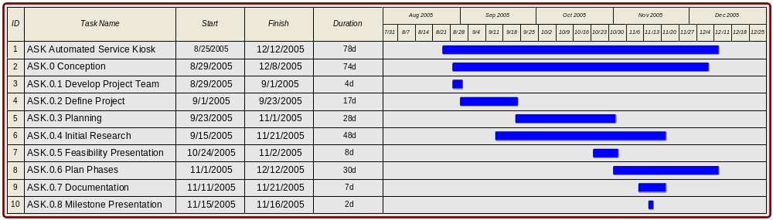

This Gantt chart represents the scheduling and milestones for Phase 0. The dates range from 8/25/2005 until 12/12/2005. The major milestones are denoted as tasks 3 – 10.

Phase 1

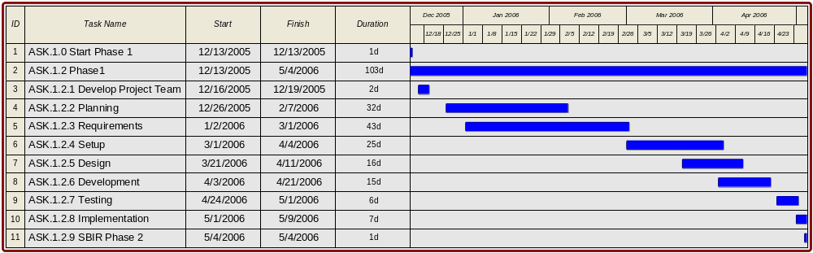

This Gantt chart represents the scheduling and milestones for Phase 1. The dates range from 12/13/2005 until 5/4/2006. The major milestones are denoted as tasks 3 – 11.

Phase 2

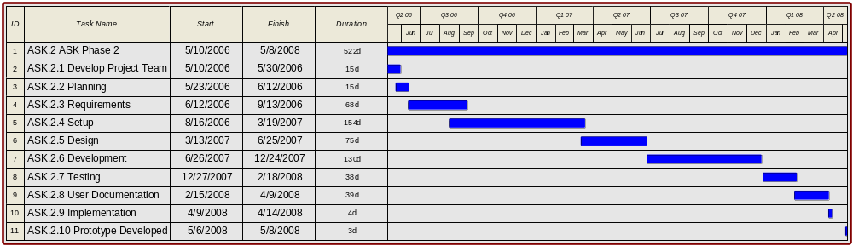

This Gantt chart represents the scheduling and milestones for Phase 2. The dates range from 5/10/2006 until 5/8/2008. The major milestones are denoted as tasks 3 – 10.

Phase 3

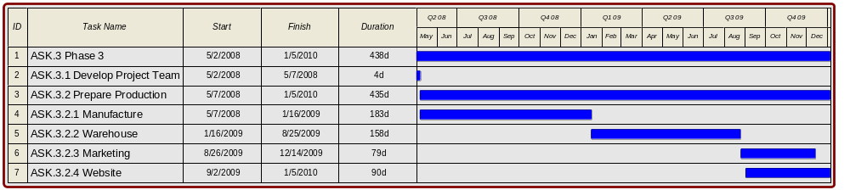

This Gantt chart represents the scheduling and milestones for Phase 3. The dates range from 5/2/2008 until 1/5/2010. The major milestones are denoted as tasks 3 – 7. For the scope of this course, the duration of the phase has been kept short. However, we would hope that the final phase of the project would continue on if the product were to be a real success.

Communication Plan

- The general manager and the project manager will meet with the legal analyst, marketing manager, finance manager and the technical director monthly or weekly as necessary. The project manager would prepare the agenda and it should include updating the project plan if necessary among other things.
- The legal analyst will meet the legal firm at least weekly to evaluate the progress of contractual issues.
- The legal analyst will meet the lobbying firm at least monthly to evaluate the progress towards a favorable mandate.
- The marketing manager would meet the project manager at least monthly to evaluate the progress towards getting a contract.
- The technical director and his team will meet every fortnight to evaluate quality, progress as per the project plan and conduct resource evaluation amongst other things.
- The financial manager will present a detailed budget report in a quarterly meeting with the project manager and the general manager.
Effective communication is achieved via meetings, emails, phone calls, messaging and mails amongst other means.

Evaluation Plan

The ASK project life cycle will be evaluated based on the individual and overall results of the four project phases. In order for this project to be deemed successful every phase of the project must be evaluated based on the WBS. The evaluation plan will adapt to accommodate changes during the life of the project. The evaluation plan focuses on the technical, marketing, financial, personnel, and administrative aspects of the project. To ensure quality standards are met, any deviation from the evaluation plan will be brought to the attention of the project manager for approval. A phase is successful when all the items for that phase are completed. Evaluation will occur whenever necessary, but no less often than every three months. The evaluation plan chart (figure 2) will be used as a template in evaluating all the phases of this project.

Evaluation Plan for Phase 1

Each phase will be evaluated based on the evaluation checklist for that phase. Evaluation will occur every 3 months or as deemed necessary by the PM. The evaluation checklist consists of five subcategories. They are as follows:

- Personnel Factor: each member of the team will be evaluated based on technical, communication, management (if applicable), and overall impact to the group.

- Administrative Factor: scheduling and task breakdown analysis is included in this evaluation factor.

- Financial Factor: the scheduled budget for the current phase will be evaluated for cost efficiency, and funding allocation.

- Marketing Factor: the current target market and an updated list of competitors will be validated.

- Technical Factor: the components of the software, hardware and overall system will be evaluated for completion, testing, and integration.

Technical Factor
Marketing Factor
Financial Factor
Evaluation Checklist
(Phase 0, 1, 2 or 3)
Personnel Factor
Administrative Factor
Phase 0
Phase 1
Phase 2
Phase 3

Phase I

Personnel Factor

Although a team is evaluated by its overall results rather than individual team member’s results, the team’s success is limited by the least contributing team member. In order to meet the set quality standards, each member of the team will be evaluated based on technical, communication, management (if applicable), and overall impact to the group.

Success is when the following are obtained:
• Cooperation between members
• Communication between members
• Each members’ contributions are satisfactory

Administrative Factor

Project development can cause some legal, environmental and safety concerns. This guideline will focus on satisfying those concerns as well as patent and trade secret protection.
This is also where scheduling and task breakdown analysis are performed.

Success is when the following are obtained:
• Schedule for meetings
• Every meeting is documented

Financial Factor

One of the most important resources in project development is money. Without it, a project will most likely not survive the next phase. The evaluation guideline will include the net present value of the investment, impact on cash flow, and time until break-even. Delays in project delivery date can strain the project funds; the availability of financial resources will be measured. Forecasting of the overall funding needed for the project delay will be determined for smooth project continuance.

Success is when the following are obtained:
• Budget that meets the SBIR funding allocated (if budget is over, another funding agency is needed to help cover the cost)
• Budget broken down by phase
• Breakeven point

Marketing Factor

Although the marketing aspect is not of significant concern for Phase I, it should still be evaluated based on the approaches in market penetration.

Success is when the following are obtained:
• Target Market is still valid
• Competition still exists

Technical Factor

There are three components in determining the technical success of the project: hardware, software, and system (integration).

Software:
Software will manage and evaluated under the Capability Maturity Model Integration (CMMI: http://www.sei.cmu.edu/cmmi/cmmi.html).
Testing will be performed whenever new features are added to ensure functionality. Integration testing will be performed at every level of development.

Hardware:
The hardware used will undergo stress testing (to ensure that everything remains in working order under a heavy load). The network infrastructure will be tested to determine if bandwidth is sufficient.

System:
The system will be tested to ensure that the software and hardware components work together seamlessly to provide a quality product. Rigorous in-house testing will be performed on a regular basis and in fact may encapsulate both the hardware and software testing once both facets of the project are sufficiently complete.

In addition to in-house testing, we plan on incorporating a beta testing program in the field itself. These tests will be in the form of in-store trials and polls. We hope to be able to set up our product in selected Best Buy locations. This would allow us to see what does and does not work and would allow us to demonstrate the effectiveness of our product to Best Buy. Coupons could be offered to those customers willing to participate in a usability survey, but we will be able to glean useful information just from analyzing the actions customers take with our product.

From these tests and polls, we will evaluate the usability and effectiveness of our product. The testing will also evince aspects of our product that can be improved. Best Buy will gain an appreciation for the benefits our product will provide.

Beta testing plan

The following will be tested:
- Product’s functionality
- Product’s user-friendliness
- User documentation

Each beta tester will receive the following:
- Basic instructions
- User Manual (in the form of the terminal’s online help system)
  - Sample walk-through of the product’s
  - Will include troubleshooting instructions
  - Designed in a user-friendly format
- Feedback and Comment Form (in return for coupons, for example)

Acceptance Criteria

CMMI will dictate the acceptance of our software components. Our integrated system will have to pass rigorous in-house testing as well as in-store beta testing. In regards to the beta tests, 75% of those polled must react positively for the product to be considered a success.

Success is when the following are obtained:
- Functional prototype software
- Functional prototype hardware
- Functional integration of hardware and software
- Technical documentation for software and hardware
- Secured SBIR grant for Phase II

Marketing Plan

Initial Research:

Our initial research showed that many stores do not deliver a good or acceptable customer service. It also showed that if we could make the customer’s experience more enjoyable in the store and provide locations for desired items, then shoppers would be more likely to come back to that store. Research also showed that customer service among the top 5 reasons because businesses fail.

Initial Target Market

We decided on Best Buy Inc. as our Primary Target Market based on the follow information: Best Buy Inc. is large corporation that is interested in new innovative ways of providing the shopper with what it wants and needs. Best Buy currently does have a convenient database storing most of the information that we need.

Secondary Target Market: Office Max.

Preliminary Marketing Strategy:

A single Best Buy store in the Hampton Roads Area will be our first step in reaching our goal of having A.S.K. in every Best Buy store. We will use this Best Buy as our beta-testing ground. We will supply the Best Buy with the kiosks at a reduced or no lease fee for the first year, or until preliminary testing is complete, whichever comes first. After several rounds of testing we will determine the status of A.S.K. If acceptable, we will expand to multiple Best Buy stores in the Hampton Roads area. Once A.S.K. is well established in the Hampton Roads area, we will expand to selected areas, from further market research, where we feel A.S.K. will have the largest impact. We will continue to add A.S.K. to Best Buy stores until there is an A.S.K. presence in almost all areas of the United States.

Headquarters:

We are planning to place our headquarters in TBA. We will have Marketing Reps that will travel to individual stores to assist in A.S.K. marketing. We will have Tech Training Reps that will travel to individual stores to train Best Buy employees on most aspects of A.S.K. Kiosk operation. We will have Kiosk Repair Techs that will travel to individual stores for major repair problems with A.S.K. Kiosk unexpected errors. We will also provide 24-hour A.S.K. Tech support by phone and web chat.

Kiosk Placement:

We recommend that at least one Kiosk be placed at the main entrance area to the store. Additional Kiosk placement will vary depending on the store’s layout.

Promotion:

Due to the type of service we are offering we must make direct contact with Best Buy by means of a Marketing Representative. We will need well trained Marketing Reps to approach, persuade, and educate the Best Buy managers that our service will increase sales, by increasing shopper loyalty and increasing the amount of items that the shopper purchases. We may also provide a low cost or free, trial period to entice early stores to place A.S.K. in their stores.

Product/Service:

Our service and products that we are providing are as follows:
- • A.S.K. Database of Items
- • A.S.K. Kiosks
- • A.S.K. in-store Servers
- • A.S.K. Web Site connection
- • A.S.K. Tech Support
- • Regular In store Maintenance of Kiosk and Server
- • A.S.K. Integrated Associate Caller Queue

Funding Plan

The PRS team will submit a Small Business Innovative Research (SBIR) grant proposal for phase I and phase II to the National Science Foundation. We will apply for government loans to help fund phase III.

The NSF (National Science Foundation) helps the small business prepare for product commercialization by providing grants to help for product conceptualization, feasibility and prototyping. The goals of the SBIR are to increase private sector commercialization of innovations derived from federal research and development (R&D), to use small business to meet federal R&D needs, to stimulate small business innovation in technology, and to foster and encourage participation by minority and disadvantaged persons in technological innovation. Under the NSF’s Division of Design, Manufacture and Industrial Innovation is the topic Information-Based Technologies (IT). This topic solicits information technology proposals that can enhance the quality of business and commerce, industrial processes, scientific and engineering analysis, education, work life, healthcare, and personal endeavors. This topic is comprised of Organization and Processes, Human Computer Interaction, Applications, Platforms, Infrastructure, and Education Applications subtopics.

Our product can help stores provide a better shopping experience for their customers. The nature of our product fits the goal of the Human Computer Interaction subtopic, which is to make people more productive by the use of information devices. This subtopic covers the design, evaluation and implementation of interactive computing systems for human use.

Funding Agency: National Science Foundation SBIR
Division: Division of Design, Manufacture, and Industrial Innovation
Topic: Information-Based Technologies (IT)
Subtopic: Human Computer Interaction
Area: Commercial Customer Assistance Tools

Deadline: December 12, 2005
Mission Statement: “To promote the progress of science; to advance the national health, prosperity, and welfare; and to secure the national defense.”
Awards (maximum):
Phase I $100,000
Phase II $750,000

Financial Summary

Funding is an obvious hurdle to the success of any large project. Because of this the ASK group has spent much time developing a budget that will allow the completion of all major goals and that will be flexible enough to account for any unforeseen problems. The funding that the group is basing its budget on will all be allocated from the SBIR grant.

In order to raise any extra funding, a small business loan will be secured for the amount needed. Another potential source for additional funding would be a contract with our initial customer (most likely Best Buy). Each department's monetary need has been over-estimated by a reasonable amount and so there will likely be some small amount of surplus at the conclusion of each phase. This surplus could be used to help meet any unforeseen needs in the event that no loan is obtained.

Detailed Budget

Phase 0

Phase 0 has no budget

Phase 1

For Phase I, our team will consist of the same team members, each with their own additional roles. This phase's budget reflects this as Mylene will take both the role of Junior Project Manager and Junior Software Engineer, Keegan will be the Senior Software Engineer, Jared will become the Junior GUI Programmer, Enrique will be another Junior Software Engineer and Scott will take on the Junior Database Specialist.

$12,896
Overhead – 40%
69
31
69
28
103
Employment Duration
$45,813
$15,254
$15,254
$15,254
$15,254
Yearly Salary
1
1
2
1
1
Needed
$45,136
Total Cost
$8,772
Junior Software Engineer
$1,970
Junior GUI Programmer
$13,171
Senior Software Engineer
$1,780
Junior Database Specialist
$6,547
Junior Project Manager
Cost of Employment
Title

Phase 2

In this phase, our team will be augmented with additional employees. We will add the following to the team: A Senior Software Engineer, two Software Engineers, two Technical Writers, a Quality Assurance Manager, a Marketing Manager, and a GUI Programmer. The original team members' Junior status has been abandoned, and both Keegan and Enrique will now act as Software Engineers. This Phase's budget reflects these changes.

$92,874
298
$74,498
1
Marketing Manager
$40,178
121
$39,846
2
Technical Writer
$67,753
186
$87,423
1
Quality Assurance Manager
$330,690
Overhead – 40%
520
184
184
247
247
Employment Duration
$84,546
$56,743
$95,940
$73,533
$50,162
Yearly Salary
1
2
1
1
4
Needed
$1,157,416
Total Cost
$73,554
Database Analyst/Specialist
$87,006
GUI Programmer
$183,183
Project Manager
$75,678
Senior Software Engineer
$206,500
Software Engineer
Cost of Employment
Title

Phase 3

The work force for this phase is vastly different from the other phases, and these differences will be reflected in the budget. Mylene will become the Human Resources Manager, Jared the Customer Service Manager, Keegan the Technical Support Manager, Scott the Production Manager, and Enrique the Marketing Specialist. In addition, the following positions will be added: ten Customer Service Representatives, ten Technical Support Personnel, five Production Staff, and a Legal Specialist.

$47,994
Annual
$47,994
10
Technical Support
$27,804
Annual
$27,804
10
Customer Service Representative
$80,668
Annual
$80,668
1
Legal Specialist
$24,876
Annual
$24,876
10
Production Staff
$569,363.20
Overhead – 40%
Annual
Annual
Annual
Annual
Annual
Employment Duration
$35,357
$61,112
$89,734
$63,258
$86,539
Yearly Salary
1
1
1
1
1
Needed
$1,992,771.20
Total Cost
$ 89,734
Technical Support Manager
$61,112
Production Manager
$35,357
Marketing Specialist
$63,258
Customer Service Manager
$86,539
Human Resources Manager
Cost of Employment
Title

Resource Plan

Abstract:

The purpose of this document is to, in detail; describe hard resource requirements per phase. This document is broken down into 6 sections, Abstract, Phases 0 – 3, and production out-years. Each phase will have descriptions of requirements along with relative cost.

Phase 0

The initial phase, Phase 0, requires no hard resources, only human resources.

Phase 1

In Phase 1 we will develop a basic lab prototype.

Hard Resources Required for Phase 1:
Phase 1
Resource | Product | Units | Cost
Terminal Operating System | *nix | 1 | Free
Compiler | GCC | 1 | Free
Mock Records Server | Dell PowerEdge 2850 | 1 | $5,000
Mock Database | MySQL | 1 | Free
Mock Inventory Database Server | Dell PowerEdge 2850 | 1 | $5,000
Mock Database | MySQL | 1 | Free
Employee Workstations | Dell Precision 380 | 5 | $7,423
Prototype Terminal Thin Client | Dell Dimension B110 | 1 | $1,200
Prototype Terminal Monitor | Planar PT1500MU | 1 | $499
Prototype Housing |  | 1 | $200
Installation & Extras |  | - | $1,000
Total |  |  | $20,322

- Terminal Operating System (*nix) – This is the operating system that will be installed on the thin client terminals, which users will interact with. The OS will be a *nix based distro, and will have no cost
- gcc compiler – The compiler used for compiling code will be gcc based, and will have no cost
- Mock mysql database – an emulation of a store inventory database. Since we’re using mysql, there will be no cost of the database itself.
- Mock records server – The records server we’ll use to store tracking information
- Mock inventory database server – A mock mysql driven database server we’ll design our interface around.
- Employee Workstations – For employees to use, one for each team member.

Since phase 1 is proof of concept, and only one basic lab prototype is created, the main cost will be staffing resources, which are outlines in another document. To save cost and reduce conflict, the ASK project team has decided to use a *nix based distro operating system. In addition to that, the team has decided to use a mock mysql server, even though most likely we will interface with Oracle databases. The hierarchy of both databases is quite similar, and only minor modifications will be required to move to Oracle. However, since hardware issues should be considered early on, production servers will be used.

Phase 2
In phase 2, we will develop an actual working prototype

Hard resources required for Phase 2:

Phase 2
Resource | Product | Units |  | Cost
Terminal Operating System | *nix | 5 |  | free
Compiler | GCC | 1 |  | free
Database | MySQL | 5 |  | free
Network Switch | Cisco Catalyst 2950-24 | 1 |  | $550
Network Integration Materials | Cables, etc | 1 |  | $1,000
ASK Terminal Thin Client | Dell Dimension B110 | 5 | $1,200 | $6,000
ASK Terminal Monitor | Planar PT1500MU | 5 | $499 | $2,495
ASK Records Server | Dell PowerEdge 2850 | 2 | $5,000 | $10,000
Employee Workstations | Dell Precision 380 | 5 | $1,484 | $7,423
ASK Terminal Housing |  | 5 | $200 | $1,000
Beta Testing Costs |  |  |  | $100,000
Total |  |  |  | $128,468
Store inventory database server (only if needed) | Dell PowerEdge 2850 | 1 |  | $5,000
Store inventory database (only if needed) | Oracle Enterprise License | 1 |  | $40,000
Total with optional database server |  |  |  | $173,468

- Network Switch – Used to integrate thin clients and servers in store.
- Network Integration Materials – Cables, miscellaneous connectors, etc
- ASK Terminals – Including the thin clients and touch screen terminals, this is the device customers will interface with in store.
- Store inventory database server – on the assumption that not all stores have a database server, we can provide one.
- Store inventory database – on the assumption that not all stores have an oracle database, we can provide one
- Beta Testing Costs – Incentives for testers and other costs associated with beta testing.

As in phase 1, a mock mysql database server will be used. If server load or integration is a larger issue than expected, an Oracle database license can be purchased. We will be developing 5 terminals to create one full store replica (the suggested amount of terminals initially per store is 5). This will help us prepare ourselves for store integration. We will also be requiring two records servers, one for interfacing with the store database, and one for predictive analysis / customer query tracking.

Phase 3

Phase three will involve production out years, in which we will produce, test, and ship final versions of the ASK software and hardware.

Phase 3
Resource | Product | Units |  | Cost
Terminal Operating System | *nix | 10 |  | free
Compiler | GCC | 1 |  | free
Network Switch | Cisco Catalyst 2950-24 | 1 |  | $550
Network Integration Materials | Cables, etc | 1 |  | $1,000
ASK Terminal Thin Client | Dell Dimension B110 | 5 | $1,200 | $6,000
ASK Terminal Monitor | Planar PT1500MU | 5 | $499 | $2,495
ASK Records Server | Dell PowerEdge 2850 | 2 | $5,000 | $10,000
ASK Terminal Housing |  | 5 | $200 | $1,000
Employee Workstations | Dell Precision 380 | 5 | $1,484 | $7,423
Total |  |  |  | $28,468

- Network Switch – Used to integrate thin clients and servers in store.
- Network Integration Materials – Cables, miscellaneous connectors, etc
- ASK Terminals – Including the thin clients and touch screen terminals, this is the device customers will interface with in store.

Since this is the phase in which the ASK product will go live in stores, in addition to the previous phases, we have allocated overhead to cover beta testing costs. We also provide an additional 5 terminals as required, and the Oracle database software and server are available is a store needs them.

Staffing/Organizational Plan

The personnel needed for A.S.K. will change as the project progresses. The personnel needed fore each phase are shown below.

Phase 0

During this phase, the A.S.K. team will consist of five students in the Computer Science department at Old Dominion University. They will be responsible for developing the idea for this project and proving its feasibility. Additional members of the team include our General Manager, Janet Brunelle, a professor in the CS department of ODU.

Phase I

Once the project has been approved and funded, the team for Phase I will consist of one project manager, one database and network lead, one webmaster and GUI development lead, one quality assurance manager and research lead, one finance and accounting manager and one marketing and sales manager. The students in the Computer Science department at Old Dominion University will fill these positions. We will also need one database expert, one web application expert, one network expert, and a Best Buy representative. Marketing and legal fees for this phase will be provided by Old Dominion University. Job descriptions and requirements of each position are outlined below.
Project Manager:
Responsibilities include assembling the team, contracting with vendors for necessary supplies (Kiosk supplier, Dell, Microsoft), assign tasks to team members, oversee project to ensure it is on time and budget, assist in the development of the product when needed, ensure all necessary deliverables and milestones are met, act as liaison between project team and upper management.
Require skills and experience: Undergraduate student majoring in Computer Science. Senior level status preferred. Previous experience in project management, personnel management, and scheduling preferred.
Database and Network Lead:
Researches the latest database development technologies and network technologies. Develops and implements policies and procedures for ensuring the security and integrity of the database. Implements data models and database designs. Communicates with the database and network experts when problems or questions arise in the project. Act as a liaison between the experts and the team leads.
Required skills and experience: Undergraduate student majoring in Computer Science. Senior level status preferred. Previous experience in database and network development a plus.
Webmaster and GUI Development Lead:
Develops and maintains the A.S.K.'s web portal. Performs backups and ensures user accessibility to the site. Monitors site traffic and helps scale site capacity to meet traffic demands and performance. Designs the look and feel for the site. Leads development effort for all web and kiosk screen design. Works with the Program Manager, Database and Network Lead to ensure requirements are being met. Designs and develops a number of GUI screens to be used in test product.
Required skills and experience: Undergraduate student majoring in Computer Science. Senior level status preferred, working knowledge of HTML, JavaScript, SQL, graphical design and GUI development a plus.
Quality Assurance Manager and Research Lead:
Leads research efforts in phase 0 and 1. Develops, publishes, and implements test plans. Writes and maintains test automation. Develops quality assurance standards. Defines and tracks quality assurance metrics such as defect densities and open defect counts. Directs efforts of network, database, interface and system integration testing.
Required skills and experience: Undergraduate student majoring in Computer Science. Senior level status preferred; experience coding in C, C++ and Java a plus. Academic knowledge of quality assurance methodologies such as CS350 is a must. Relies on experience and judgment to plan and accomplish goals.
Finance and Accounting Manager:
Manages the general accounting function. Designs and analyzes budget, accounting and purchasing. Purchases and negotiates materials, equipments and supplies from vendors. Evaluates vendor quotes and services to determine most desirable suppliers. Maintains budget and provides Program Manager and General Manager with monthly financial reports. Tracks cost and labor on a weekly basis.
Required skills and experience: Undergraduate student majoring in Computer Science. Senior level status preferred, working experience in Microsoft Excel a must; previous experience in general accounting a plus.
Marketing and Sales Manager:
Manages and executes new sales/service initiatives for a particular market; implements marketing strategies for the target demographics. Manages and executes new sales/service initiatives for a particular market.
Required skills and experience: Undergraduate student majoring in Computer Science. Senior level status preferred, experience in marketing and sales a plus. Good verbal and communication skills a must.
Database Expert:
Assists Database and Network Lead in development of database and security measures for database, assists in creation of data flow diagrams and decomposition diagrams, reviews final database plan for possible flaws in design or implementation.
Required skills and experience: A bachelor’s degree in computer science with at least two years experience in developing and maintaining databases. Has experience in writing SQL, RDBMS, packages and functions.
Network Expert:
Assists Database and Network Lead in developing a robust network plan, assists in developing a security protocol, review final network plan for inconsistencies and possible problems.
Required skills and experience: A bachelor’s degree in computer science with at least two years experience in setting up and testing internal networks. Working experience in network protocols a plus.

Phase II

By Phase II the members of the A.S.K. team will have received a bachelor’s degree in Computer Science. In addition to Webmaster and GUI Development Lead, Quality Assurance Manager and Research Lead, Finance and Accounting Manager, Marketing and Sales Manager, whose job descriptions are mentioned in Phase I, we have to hire additional staff to meet the development timeline and to assist in the development of the system. The new staff will consist of one network engineer, one software engineer, one junior programmer, two web programmers, one touch screen programmer, one SQL/DB programmer and one software engineer who specialize in testing. During this phase, the legal and marketing assistance will be provided by Old Dominion University. Job descriptions and requirements of each new position are outlined below.
Software Engineer:
Designs, modifies, develops, writes and implements software programming applications. Supports and/or installs software applications/operating systems. Participates in the testing process through test review and analysis, test witnessing and certification of software. Participate in Alpha & Beta coordination/support.
Required skills and experience: A Bachelor’s Degree from an accredited college or university with a major in Computer Science, Information Systems, Engineering, Business, or other related scientific or technical discipline. C, C++, C# and other programming languages a must.
Network Engineer:
Plans and evaluates network systems and makes recommendations for resources required to maintain and/or expand service levels. Provide highly skilled technical assistance in network planning, engineering and architecture. Develops technical standards and interface application; identify and evaluate new products; provide solutions for network problems; interfaces with customers to determine system needs. Build A.S.K. network tiers and set up development network.
Required skills and experience: A Bachelor’s Degree from an accredited college or university with a major in Computer Science, Information Systems, Engineering, Business, or other related scientific or technical discipline, or equivalent work experience desired. 4+ years of data communications experience required. Advanced network skills, experience with firewall setup and maintenance and networking concepts required.
Junior Programmer:
Responsibilities include developing interfaces between input and output devices, developing sensor scanning and recognition software, testing of individual components of system, and complete prototype testing.
Required skills and experience: Undergraduate student majoring Computer Science. Senior level status preferred, experience in C++, C#, SQL, and other programming languages a must.
Web Programmers:
Designs, develops, and implements software packages for web sites. Troubleshoots debugs and implements software code. Reviews and analyzes programming systems including encoding, testing, debugging and documenting for A.S.K. Supports and/or installs software applications. Participates in the testing process through test review and analysis, test witnessing and certification of software. Configures the software and website. Develops, implements, and maintains firewall technologies that secure A.S.K.’s website. Defines network security issues, develops plans and procedures, and ensures safety and privacy of the newly developed Internet and Intranet sites. Creates, modifies and deletes user profiles and other access controls. Reviews security logs and violation reports.
Required skills and experience: A Bachelor’s Degree from an accredited college or university with a major in Computer Science, Information Systems, Engineering, Business, or other related scientific or technical discipline. Minimum of 3 years of experience in Web application development a must. Has knowledge of standard concepts, practices, and procedures within web development field (i.e., SQL, C++, C#, HTML, CGI and JavaScript).

Touch Screen Programmer:
Designs, develops and test kiosk applications using a number of visual components. Designs and develops several interface touch screens for A.S.K. kiosks. Integrates GUI screens with existing database. May participate in the testing and enhancing of components.
Required skills and experience: A Bachelor’s Degree from an accredited college or university with a major in Computer Science, Information Systems, Engineering, Business, or other related scientific or technical discipline; 1-3 years of experience in GUI development; C, C++, C# language programming, XMotif programming interfaces and GUI API packages a plus.
SQL/DB programmer:
Reviews, evaluates, designs, implements and maintains A.S.K.’s database[s]. Identifies data sources, constructs data decomposition diagrams, provides data flow diagrams and documents the process. Writes codes for database access, modifications, and constructions including stored procedures. Reviews and analyzes programming systems including encoding, testing, debugging and documenting for A.S.K. data process and database. Supports and installs database applications. Participates in the testing process through test review and analysis. Develops technical specifications.
Required skills and experience: A Bachelor’s Degree from an accredited college or university with a major in Computer Science, Information Systems, Engineering, Business, or other related scientific or technical discipline; minimum of 3 years of experience in database development required. Experience with MS SQL DTW/Stored Procedures, MS SQL Server, and MS2000 SQL Suite a plus.
Test Engineer:
Review codes, test results and produces test result documentation. Evaluates, recommends, and implements automated test tools and strategies. Develops, maintains, and upgrades automated test scripts and architectures for application products. Also writes, implements, and reports status for system test cases for testing. Analyzes test cases and provides regular progress reports.
Required skills and experience: A Bachelor’s Degree from an accredited college or university with a major in Computer Science, Information Systems, Engineering, Business, or other related scientific or technical discipline. A minimum of 2 years of experience in either software testing or development; C, C++, C# code is required. Must have experience in system level testing including test planning, test cases design, test execution and test automation. Familiar with test case tracking tools and test management systems, like TIMS. Excellent interpersonal and sound written communication skills are essential.

Phase III
Phase III is the actual production of our product. During this phase, the necessary personnel become more customer oriented rather than technology oriented. In addition to Webmaster and GUI Development Lead, Quality Assurance Manager and Research Lead, Finance and Accounting Manager, Marketing and Sales Manager, whose job descriptions are mentioned in Phase I, and Software Engineer and Network Engineer, whose job descriptions are mentioned in Phase II, Phase III requires one Technical Support representative, Customer Service Representative, Customer Field Representative, Field technician and Sales representative. We will also need a Network Engineer, Database Administrator, Software Engineer, Web Master, Document Specialist and a Lawyer. Descriptions of each new title are listed below.
Technical Support Representative:
Provides support to end users on a variety of issues, identifies, researches, and resolves technical problems, responds to telephone calls, emails and personnel requests for technical support, documents, tracks and monitors the problem to ensure a timely resolution
Required skills and experience: An associate's degree in a related area and 0-2 years of experience in the field or in a related area.
Customer Service Representative:
Manages telephone call inquiries, and promotes A.S.K. products and services, researches and resolves complaints to ensure customer retention and satisfaction.
Required skills and experience: A minimum of a high school diploma or its equivalent and 0-2 years of experience in the field or in a related area.
Customer Field Representative:
Handles customer relations and Promotes A.S.K. products and services off-site, researches and resolves complaints to ensure customer retention and satisfaction.
Required skills and experience: A minimum of a high school diploma or its equivalent and 0-2 years of experience in the field or in a related area
Field Technician:
Installs and performs maintenance on kiosks and servers. Travel from site to site to resolve problems. On-call shifts including weekends and holidays are possible.
Required skills and experience: Requires a minimum of high school degree with 1-3 years of experience in related field. Kiosk troubleshooting and maintenance experience a plus.
Sales Representative:
Develops new prospects and interacts with existing and potential customers to increase sales of A.S.K.’s products and/or services.
Required skills and experience: A minimum of an associate's degree or its equivalent with 0-2 years of experience in the field or in a related area.
Network Engineer:
Provide rapid recovery of A.S.K. network. Works to ensure that the site network and network management environment is reliable and that performance exceeds expected service level. Uses established commercial best practices to develop templates and documentation to improve operational procedures. Responsible for the implementation of engineering process that provide for a timely and appropriate integration of all engineering disciplines to ensure a network system meets all requirements including Service Level Agreements. Identifies and evaluates problems. Determines the risk areas and mitigates their impact. Implement and maintain management systems to support fault detection, correlation, performance metrics, and reporting to support service level agreements. Reviews and maintains configuration standards for network equipment. Serves as an escalation point for network issues, including backbone routing, customer router configuration, and Internet related services. Provides mentorship and guidance to technicians with implementation and maintenance of the network.
Required skills and experience: A Bachelor’s Degree from an accredited college or university with a major in Computer Science or equivalent experience in related field. 3-5 years experience that includes operational support, hands-on implementing and configuration of network devices such as servers, routers, hubs, switches, UPS, desktop computers, and cabling in LANBAN/MAN/WAN environment. Strong knowledge of trouble ticketing software and network monitoring solutions. Strong communication, writing and editing skills needed to transfer information to individuals involved, in the networking process. Strong problem solving and troubleshooting skills required. Ability to lift up to 50 lbs a must.
Database Administrator:
Manages development of database projects. Administers, maintains, develops and implements policies and procedures for ensuring the security and integrity of the company database. Supports application developers in planning preparations, load analysis, and backup and recovery of data. Implements data models and database designs, data access and table maintenance codes; resolves database performance issues, database capacity issues, replication, and other distributed data issues. Develops, implements, and maintains database back-up and recovery procedures for processing environments; and ensures data integrity, security, and recoverability are built into the database applications.
Required skills and experience: A Bachelor’s Degree from an accredited college or university with a major in Computer Science, Information Systems, Engineering, Business, or other related scientific or technical discipline. Must have at least five years of experience with database management systems, system design and analysis, operating systems software; and internal and data manipulation languages.
Software Engineer:
Contribute to project planning prior to Execution Commit (e.g. schedules, equipment needs/costs, strategy, understand scale, performance, inter-operability and RAS objectives). Develop solution level test strategies and test plans, based on Product requirements, System Functional Specification documents and customers deployment scenarios. Design & write test cases reflecting the documented test plan. Execute test cases per test plan, collecting data on faults and reporting. Regularly assess progress and prepare test status report for management. Support the design team in debugging issues; isolate root cause of issues and partner with design team on resolution. Plan regression strategy. Complete automated regression scripts per test plan. Interface with Customer Eng., Marketing and Sales to understand customer problems and requirements and provide raw material for training and documentation. Review documentation material and provide input to solution design guides etc. Work with development teams across the organization and identify gaps in overall testing for the solution.
Required skills and experience: A bachelor's degree in Computer Science or equivalent programming experience is desired, 3-4 years of experience in programming languages such as C, C++, C# and development tools a must. Strong verbal and written communication required.
Webmaster:
Develops and maintains the A.S.K.'s portal. Performs backups and ensures user accessibility to the site. Monitors site traffic and helps scale site capacity to meet traffic demands performance. Improves the application's efficiency and designs the look and feel for the site.
Required skills and experience: A bachelor's degree in Computer Science or in a related area of specialty and 2-4 years of experience in Web application development. Has knowledge of standard concepts, practices, and procedures within a particular field (i.e., SQL, C++, HTML, CGI and JavaScript). .
Lawyer
Creates, writes, negotiates and reviews hardware and/or software licensing contracts, purchasing contracts for required materials, and production and development contracts for A.S.K. Works with the A.S.K. team in establishing agreements that reflect the interests of the company. Also works on copyright and patent documentation.
Required skills and experience: Must be a graduate of an accredited law school with 5-8 years of experience and admitted into the state bar. Experiences in Information Technology field a plus.

Risk Management Plan

Our Risks:

L
i
k
e
l
i
h
o
o
d
Figure -
 | 6 |  | 2 | 1
 |  |  | 4 | 3
9 |  | 7 |  | 5
10 |  |  | 8

C o n s e q u e n c e

Every project has risks, and ours is no exception. Our risks are rated based on two factors: likelihood and consequence. Every risk gets a value from one to five (five being the most significant) for both factors. Using these two aspects as our axes, we have mapped the risks onto the matrix in figure #. To determine the severity of each risk, we multiply the two numbers together.

Risks and their Mitigation

Here are our most significant risks, in order of severity, each listed with its own plan of mitigation:

Our most significant risk is that of database availability and integration. Basically, our product cannot operate without access to an inventory database. Therefore we will create an effective database interface, as well as provide our own alternative inventory database if the customer in question does not have their own. With a likelihood of 4 and a consequence value of 5, this risk’s total severity is marked as 20.

Our second risk is real-time lookup speed, or rather the lack thereof. Customers will not use our product if they become frustrated with its slowness in responding to queries. Our database will be large and complex and network traffic may be high, so slow lookup speed is a real possibility. In order to mitigate this we will increase the bandwidth for our product’s network and develop a tuned/optimized database. This risk has a likelihood of 4 and a consequence value of 4, leaving it with a total score of 16.

Server load is another issue. If our server becomes overworked, it will not be able to keep up with user demand satisfactorily. If our product becomes popular and many terminals are utilized, there will be a great deal of load put on the server. Therefore, we will provide a backup server to share the load with the principal server when necessary. This risk gets a 3 for likelihood and a 5 for consequence, achieving a 15 for overall severity.

Complexity of maintenance is yet another risk. The more complex a system is, the more complex the maintenance of such a system tends to be. We will therefore focus on creating a system based on simplicity. This should keep the complexity of the system down, as well as the complexity of its maintenance. We will also provide the personnel necessary to complete maintenance when necessary. This risk gets a 3 for likelihood and a 4 for consequence, achieving a 12 for overall severity.

The competition meeting the needs our defined problem presents is another important risk. If there exists a product that provides the same functionality as our own, we will have a serious problem with competition, especially if there are price differences between the competing products. We will therefore be providing features that are not supported by other products, as well as keeping our prices modest. This risk gets a 2 for likelihood and a 5 for consequence, achieving a 10 for overall severity.

Unforeseen testing expenses are another issue. No one can predict the future. Some events will occur that will not have been expected. These events may very well incur some necessary spending. Consequently, we will have money reserves set aside for unexpected situations. We will have alternate sources of funding lined up. This risk gets a 4 for likelihood and a 2 for consequence, achieving an 8 for overall severity.

Customer acceptance is the next risk to address. Some people are afraid, skeptical, or untrusting of new technology. These people may not be keen on the idea of using our product. Therefore, we will strive to provide a product that is not intimidating and that is user friendly in every respect. We will provide a virtual guided tour for users to take advantage of, as well as staff training manuals. This risk gets a 2 for likelihood and a 3 for consequence, achieving a 6 for overall severity.

Our product relies on information provided by an external database. If the information we receive from said database is incorrect, we run the risk of propagating the misinformation to the customer. However, there is little we can do to avoid this other than providing our own inventory database at an extra cost. This risk gets a 1 for likelihood and a 4 for consequence, achieving a 4 for overall severity.

Network downtime is yet another issue. If the store’s network goes down, our product will not be able to function. Therefore, our product will be designed in such a way that it will not make the chance of network problems more likely. This risk gets a 2 for likelihood and a 1 for consequence, achieving a 2 for overall severity.

Power outages are our last identified risk. If the store’s electricity goes out, our product will not be able to function. There really is nothing we can do about this risk, though. However, should this event occur, there will be very little functioning at the store at all, so our product’s lack of functionality will not be significant. This risk gets a 1 for likelihood and a 1 for consequence, achieving a 1 for overall severity.

Glossary

ASK-Automated Service Kiosk

Database-“a collection of records stored in a computer in a systematic way, such that a computer program can

consult it to answer questions.”[http://en.wikipedia.org/wiki/Database]

GCC- Open-Source (and free) compiler

GUI (Graphical User Interface)
“a method of interfacing with a computer through a metaphor of direct manipulation of graphical images and widgets in addition to text.” [http://en.wikipedia.org/wiki/Graphical_user_interface]

Kiosk Electronic information center

MySQL-Open-Source (and free) Database software

Thin Client-A terminal that relies on a server for its processing power

References

Belmont University: Center for Entrepreneurship 09/22/2005 [http://forum.Belmont.edu/cornwall/archives/003452.html]

CRMGURU.com
[http://www.rightnow.com/resource/RN_LoyaltyCRMGuru.html]

ITESGrads
[http://www.bpoindia.org/research/customer-retention.shtml]

2004 Customer Service Survey Results
[http://www.amdocs.com/documents/survey-results.html]

Strategiy.com
[http://www.strategiy.com/feature.asp?id=20051003030433]

Stylus Systems, Inc. [http://www.outsource2india.com/services/customer_interaction_services.asp]

Kiosk Market Sales
[http://www.kioskmarketplace.com/news_story.htm?i=22182]

Inter-media Kiosks
[http://www.intermediakiosks.com/news/03-09-26_pressrelease.html]

Reseller Rating
[http://www.resellerratings.com/seller1823.html]

JBS Interactive
[http://www.jbsinteractive.com/opportunities.html]

Dell.com
[http://www.dell.com]

3Com
[http://www.3com.com/]

Salary.com
[http://www.salary.com]

