- Uninformed and Informed Search
For the graph and the heuristic function given below, use the different search algorithms to find the path from A (starting node/initial state) to H (final node/goal state). Also, show the order in which the nodes are expanded as well as the contents of the fringe after each expansion. Note: When there is a tie for expansion, use the following priority order: A > B > C > D > E > F > G > H.

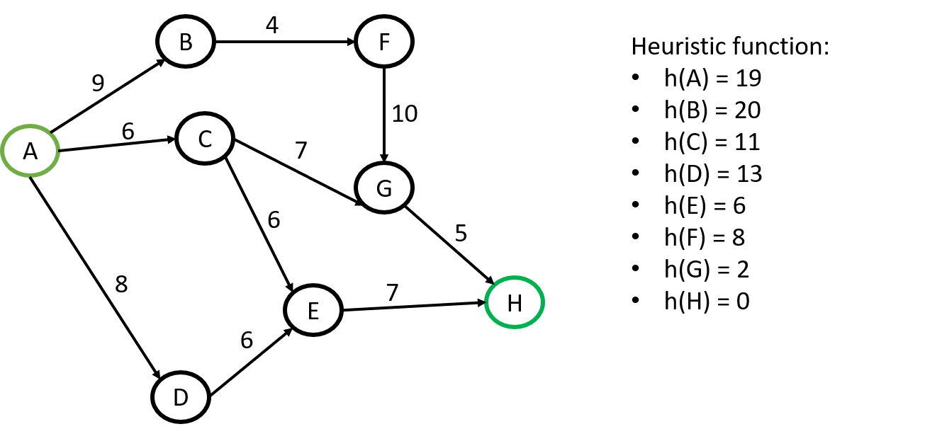

- DFS
- BFS
- Uniform Cost Search
- Greedy Best-First Search

- Differential Evolution
Minimize the following function:
$f\left(x\right)=x_{1}-x_{2}, 0<x_{1},x_{2}<1$
Assume the population size n = 8, and number of cycles = 4. Show each step.

